|  |
| --- |
|  |

Lesson 13: Rotations

Student Outcomes

* Students manipulate rotations by each parameter: center of rotation, angle of rotation, and a point under the rotation.

Lesson Notes

Lesson 13 takes a close look at the precise definition of rotation. Students learn how to rotate a figure about a center of rotation for a given number of degrees and in a given direction. Students also learn how to determine the angle of rotation and center of rotation for a given figure and its image.

Teachers should continue to stress the point that rotations preserve the lengths of segments (distance-preserving) and the measures of the angles of the figures being rotated (angle-preserving).

Rotations are one of the three basic rigid motions used to form the definition of one of the main ideas in geometry: congruence. Essential to students’understanding of the definition of congruence is the realization (1) that rotations preserve distances and angle measures and (2) that a rotation of any angle size can be performed at any point in the plane.

The lesson begins with an Exploratory Challenge where students cut out a angle to apply to a figure as its degree of rotation. With the help of a ruler, students transform the vertices of the figure to create the image after the rotation. This hands-on exercise demonstrates a basic way of performing a rotation. In the Discussion, students use a point on a given figure, the center of rotation, and the respective point in the image to determine the angle of rotation. They test several sets of points to verify that the angle measure is preserved. Then, students learn how to find the center of rotation using what they know about perpendicular. Students practice these two new skills before learning the precise definition of rotation. This definition incorporates a center of rotation, an angle of rotation, and exactly how the points move across the plane (along a circular path of a given radius). Students practice their updated understanding of rotations in the Lesson 13 Problem Set.

Note that the study of transformations over the next several lessons involves significant use of compass and straightedge constructions. This is done to build deep understanding of transformations and also to lend coherence between clusters within the G-CO domain, connecting transformations (**G-CO.A**), congruence (**G-CO.B**), and transformations (**G-CO.D**). Additionally, students develop in their ability to persist through challenging problems (MP.1). However, if students are struggling, it may be necessary to modify the exercises to include the use of graph paper, patty paper, or geometry software (such as the freely available Geogebra).

Classwork

Exploratory Challenge (10 minutes)

**MP.5**

Students apply a rotation to a figure using the cut out of an angle and a ruler.

* Consider whether all the tools in the exercise are necessary. How could the exercise be modified?

**MP.6**

**&**

**MP.7**

* + *With the use of a compass or protractor instead of the given angle*
* Try the rotation again using a different center of rotation, either one of the vertices of the pre-image or a point on the opposite side of the figure from point . Discuss the effects of changing the center of rotation.

Exploratory Challenge

You will need a pair of scissors and a ruler.

Cut out the angle at the right and use it as a guide to rotate the figure below counterclockwise around the given center of rotation (Point ).

* 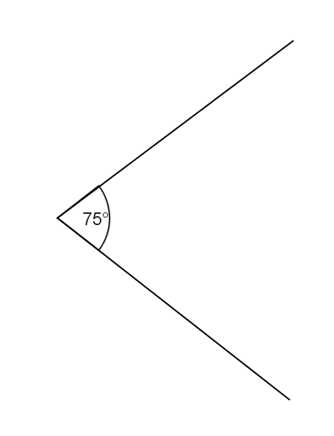Place the vertex of the angle at point .
* Line up one ray of the angle with vertex on the figure. Carefully measure the length from point to vertex .
* Measure that same distance along the other ray of the reference angle, and mark the location of your new point, .
* Repeat these steps for each vertex of the figure, labeling the new vertices as you find them.
* 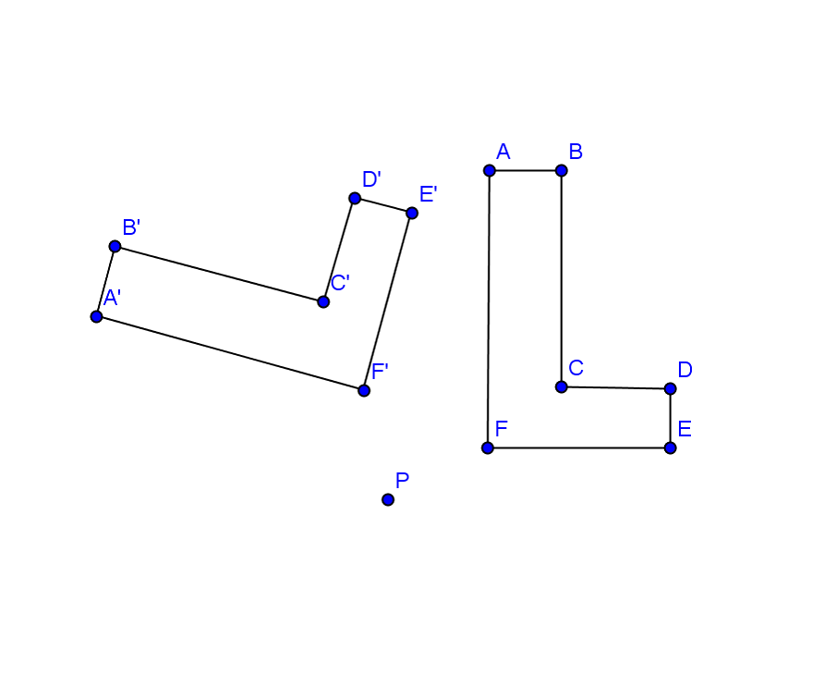Connect the six segments that form the sides of your rotated image.

Discussion (12 minutes)

Discussion

In Grade 8, we spent time developing an understanding of what happens in the application of a rotation by participating in hands-on lessons. Now, we can define rotation precisely.

The notion of the entire plane being subject to the transformation is new and should be reinforced. However, note that neither the figure nor the plane is actually moved in the transformation. The image represents the output after applying the transformation “rule” to the input points.

In the definition below, students may benefit from some discussion using a visual of a clock. Discuss the intuitive notion of directions on a clock before the more formal definition.

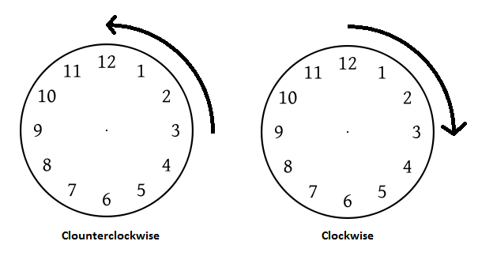

Clockwise

Counterclockwise

First, we need to talk about the direction of the rotation. If you stand up and spin in place, you can either spin to your left or spin to your right. This spinning to your left or right can be rephrased using what we know about analog clocks: spinning to your left is spinning in a counterclockwise direction and spinning to your right is spinning in a clockwise direction. We need to have the same sort of notion for rotating figures in the plane. It turns out that there is a way to always choose a “counterclockwise half-plane” for any ray: The counterclockwise half-plane of a ray is the half-plane of that lies to the left as you move along in the direction from to .(The “clockwise half-plane” is then the half-plane that lies to the right as you move along in the direction from to .) We use this idea to state the definition of rotation.

For , the rotation of degrees around the center is the transformation of the plane defined as follows:

1. For the center point , , and

For any other point , is the point that lies in the counterclockwise half-plane of , such that and .

A rotation of degrees around the center is the identity transformation, i.e., for all points in the plane, it is the rotation defined by the equation .

A rotation of around the center is the composition of two rotations of around the center . It is also the transformation that maps every point (other than ) to the other endpoint of the diameter of circle with center and radius .

* A rotation leaves the center point fixed. states exactly that. The rotation function with center point that moves everything else in the plane , leaves only the center point itself unmoved.
* For every other point , every point in the plane moves the exact same degree arc along the circle defined by the center of rotation and the angle .
* Found by turning in a counterclockwise direction along the circle from to , such that — all positive angle measures assume a counterclockwise motion; if citing a clockwise rotation, the answer should be labeled with “CW”
* is the point that lies in the counterclockwise half-plane of ray such that . Visually, you can imagine rotating the point in a counterclockwise arc around a circle with center and radius to find the point .
* — the point is the point on the circle with center and radius such that the angle formed by the rays and has an angle measure .

A composition of two rotations applied to a point is the image obtained by applying the second rotation to the image of the first rotation of the point. In mathematical notation, the image of a point after “a composition of two rotations of around the center ” can be described by the point . The notation reads, “Apply to the point .” So, we lose nothing by defining to be that image. Then, for all points in the plane.

In fact, we can generalize this idea to define a rotation by any positive degree: For , a *rotation of around the center*  is any composition of three or more rotations, such that each rotation is less than or equal to a rotation and whose angle measures sum to . For example, a rotation of is equal to the composition of three rotations by about the same center, the composition of five rotations by ,,,, and about the same center, or the composition of rotations by about the same center.

Notice that we have been assuming that all rotations rotate in the counterclockwise direction. However, the inverse rotation (the rotation that “undoes” a given rotation) can be thought of as rotating in the clockwise direction. For example, rotate a point by around another point to get the image . We can “undo” that rotation by rotating by in the clockwise direction around the same center . Fortunately, we have an easy way to describe a “rotation in the clockwise direction.” If all positive degree rotations are in the counterclockwise direction, then we can define a negative degree rotation as a rotation in the clockwise direction (using the clockwise half-plane instead of the counterclockwise half-plane). Thus, is a rotation in the clockwise direction around the center . Since a composition of two rotations around the same center is just the sum of the degrees of each rotation, we see that

for all points in the plane. Thus, we have defined how to perform a rotation for by any number of degrees—positive or negative.

As this is our first foray into close work with rigid motions, we emphasize an important fact about rotations. Rotations are one kind of rigid motion or transformation of the plane (a function that assigns to each point of the plane a unique point ) that preserves lengths of segments and measures of angles. Recall that Grade 8 investigations involved manipulatives that modeled rigid motions (e.g., transparencies) because you could actually *see* that a figure was not altered, as far as length or angle was concerned. It is important to hold onto this idea while studying all of the rigid motions.

Constructing rotations precisely can be challenging. Fortunately, computer software is readily available to help you create transformations easily. Geometry software (such as Geogebra) allows you to create plane figures and rotate them a given number of degrees around a specified center of rotation. The figures below were rotated using Geogebra. Determine the angle and direction of rotation that carries each pre-image onto its (dashed-line) image. Assume both angles of rotation are positive. The center of rotation for the Exercise 1 is point and for Figure 2 is point .

(Remind students that identifying either CCW or CW degree measures is acceptable; if performing a 30˚ rotation in the clockwise direction, students can label their answers as “ CW” or “.”)

Exercises 1–3 (10 minutes)

Exercises 1–3

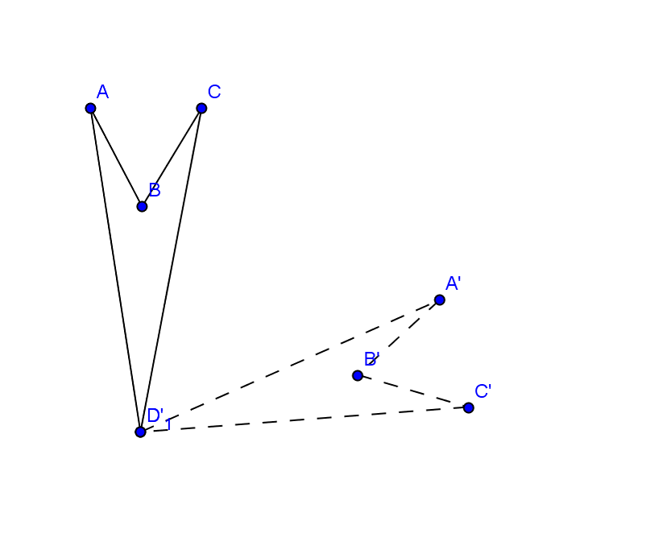 or CW or

To determine the angle of rotation, you measure the angle formed by connecting corresponding vertices to the center point of rotation. In Exercise 1, measure . What happened to ? Can you see that is the center of rotation, therefore, mapping onto itself? Before leaving Exercise 1, try drawing . Do you get the same angle measure? What about ?

Try finding the angle and direction of rotation for Exercise 2 on your own.

Remind students that the solid-lined figure is the pre-image, and the dotted-line figure is the image.

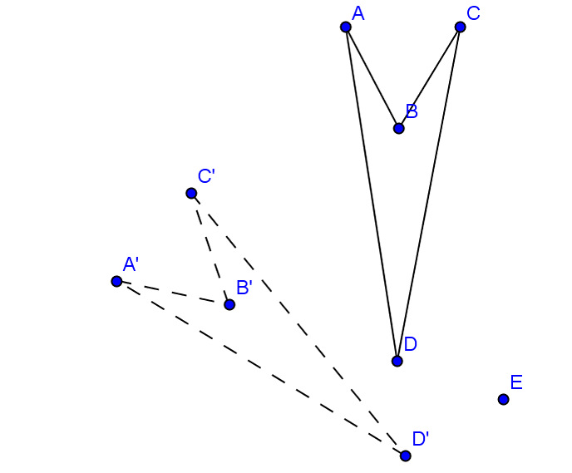

or CW or

Did you draw or ?

Now that you can find the angle of rotation, let’s move on to finding the center of rotation. Follow the directions below to locate the center of rotation taking the figure at the top right to its image at the bottom left.

1. 

**MP.5**

1. Draw a segment connecting points and .
2. Using a compass and straightedge, find the perpendicular bisector of this segment.
3. Draw a segment connecting points and .
4. Find the perpendicular bisector of this segment.
5. The point of intersection of the two perpendicular bisectors is the center of rotation. Label this point .

Justify your construction by measuring angles and . Did you obtain the same measure?

Yes

This method works because a *chord* of a circle is a segment joining two points on a circle. The endpoints of the chord are equidistant from the center of the circle. The perpendicular bisector of a chord (being the set of ALL points equidistant from the endpoints) includes the center of the circle. Since students may have had limited experience studying circles, they may have difficulty understanding why this works. You may consider pointing out or sketching the circle that has the center of rotation as its center for each of the examples to supply some justification for why it works.

Exercises 4–5 (8 minutes)

Exercises 4–5

Find the centers of rotation and angles of rotation for Exercises 4 and 5.

1. 

Either or CW or .



or CW or .

Lesson Summary

A rotation carries segments onto segments of equal length.

A rotation carries angles onto angles of equal measure.

Exit Ticket (5 minutes)

Name ___________________________________________________ Date____________________

Lesson 13: Rotations

Exit Ticket

Find the center of rotation and the angle of rotation for the transformation below that carries onto .

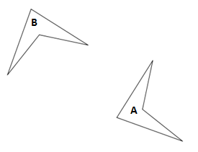

Exit Ticket Sample Solution

Find the center of rotation and the angle of rotation for the transformation below that carries onto .

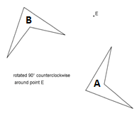

or CW or

Problem Set Sample Solutions

1. Rotate the triangle around point using a compass and straightedge only.

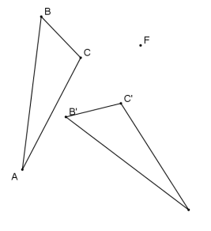

1. Rotate quadrilateral around point using a straightedge and protractor.

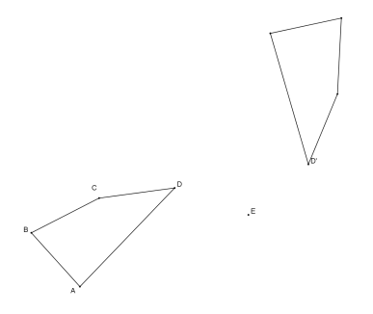

1. On your paper, construct a angle using a compass and straightedge. Rotate the angle around its vertex, again using only a compass and straightedge. What figure have you formed, and what are its angles called?

The figure formed is an X, and the angles are called vertical angles.

1. Draw a triangle with angles , , and using only a compass and straightedge. Locate the midpoint of the longest side using your compass. Rotate the triangle around the midpoint of the longest side. What figure have you formed?

The figure formed is a rectangle.

1. On your paper, construct an equilateral triangle. Locate the midpoint of one side using your compass. Rotate the triangle around this midpoint. What figure have you formed?

The figure formed is a rhombus.

1. 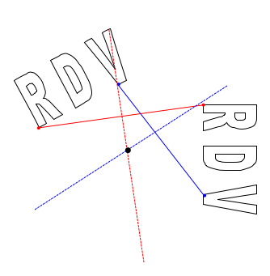Use either your own initials (typed using WordArt on a Microsoft Word) or the initials provided below. If you create your own WordArt initials, copy, paste, and rotate to create a design similar to the one below. Find the center of rotation and the angle of rotation for your rotation design.