Lesson 12: Transformations—The Next Level

Classwork
Opening Exercises 1–2
- Find the measure of each lettered angle in the figure below.
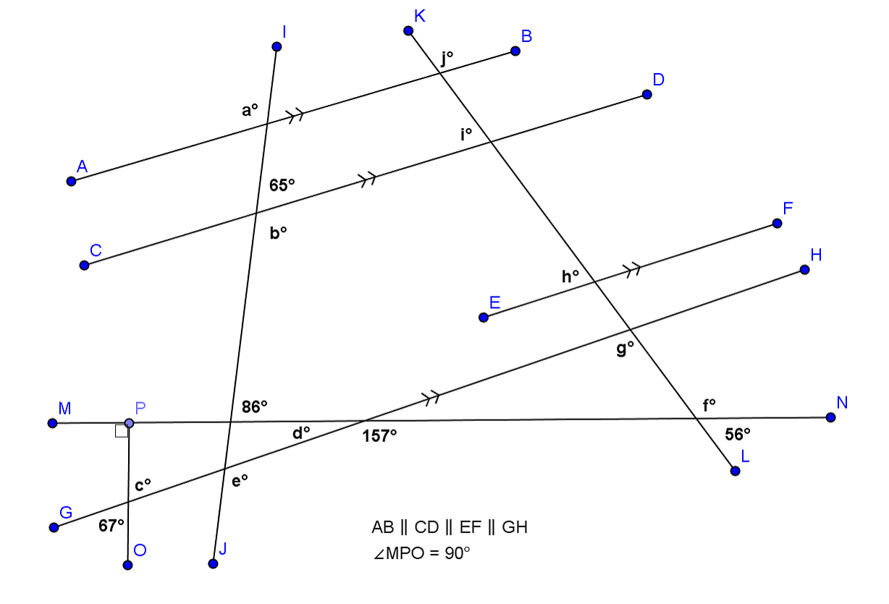

a = b = c = d = e =

f = g = h = i = j =

- Given: $m∠CDE=m∠BAC$
Prove: $m∠DEC=m∠ABC$

Mathematical Modeling Exercise
You will work with a partner on this exercise and are allowed a protractor, compass, and straightedge.
- Partner A: Use the card your teacher gives you. Without showing the card to your partner, describe to your partner how to draw the transformation indicated on the card. When you have finished, compare your partner’s drawing with the transformed image on your card. Did you describe the motion correctly?
- Partner B: Your partner is going to describe a transformation to be performed on the figure on your card. Follow your partner’s instructions and then compare the image of your transformation to the image on your partner’s card.

Discussion
Explaining how to transform figures without the benefit of a coordinate plane can be difficult without some important vocabulary. Let’s review.
The word transformation has a specific meaning in geometry. A transformation $F$ of the plane is a function that assigns to each point $P$ of the plane a unique point $F(P)$ in the plane. Transformations that preserve lengths of segments and measures of angles are called . A dilation is an example of a transformation that preserves
measures but not the lengths of segments. In this lesson, we will work only with rigid transformations. We call a figure that is about to undergo a transformation the while the figure that has undergone the transformation is called the .
Rotation

Reflection

Translation

Using the figures above, identify specific information needed to perform the rigid motion shown.
For a rotation, we need to know:
For a reflection, we need to know:
For a translation, we need to know:

Geometry Assumptions
We have now done some work with all three basic types of rigid motions (rotations, reflections, and translations). At this point, we need to state our assumptions as to the properties of basic rigid motions:
  - Any basic rigid motion preserves lines, rays, and segments. That is, for a basic rigid motion of the plane, the image of a line is a line, the image of a ray is a ray, and the image of a segment is a segment.
  - Any basic rigid motion preserves lengths of segments and angle measures of angles.

Relevant Vocabulary
Basic Rigid Motion: A basic rigid motion is a rotation, reflection, or translation of the plane.
Basic rigid motions are examples of transformations. Given a transformation, the image of a point $A$ is the point the transformation maps $A$ to in the plane.
Distance-Preserving: A transformation is said to be distance-preserving if the distance between the images of two points is always equal to the distance between the pre-images of the two points.
Angle-Preserving: A transformation is said to be angle-preserving if (1) the image of any angle is again an angle and (2) for any given angle, the angle measure of the image of that angle is equal to the angle measure of the pre-image of that angle.

Problem Set

An example of a rotation applied to a figure and its image are provided. Use this representation to answer the questions that follow. For each question, a pair of figures (pre-image and image) are given as well as the center of rotation. For each question, identify and draw the following:
    - The circle that determines the rotation, using any point on the pre-image and its image.
    - An angle, created with three points of your choice, which demonstrates the angle of rotation.
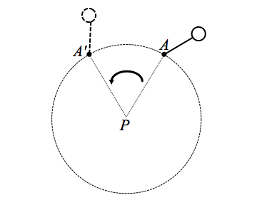
Example of a Rotation:
Pre-image: (solid line)
Image: (dotted line)
Center of rotation: $P$
Angle of rotation: $∠APA'$

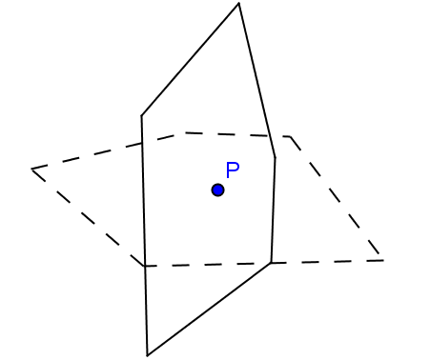
- Pre-image: (solid line)
Image: (dotted line)
Center of rotation: $P$

Angle of rotation: _______________

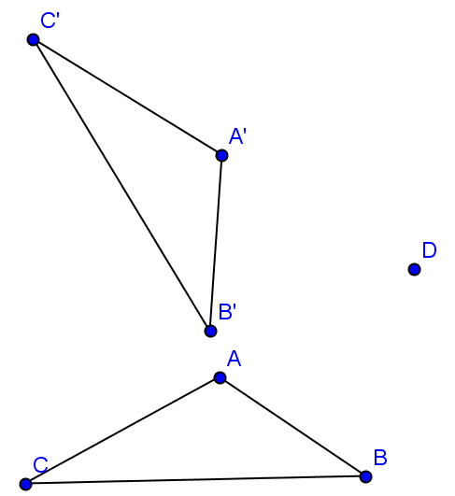

- Pre-image: $△ABC$
Image: $△A'B'C'$
Center: $D$

Angle of rotation: _______________

