Lesson 12: Transformations—The Next Level

Student Outcome
- Students discover the gaps in specificity regarding their understanding of transformations.
- Students identify the parameters needed to complete any rigid motion.

Lesson Notes
Transformations follow the unknown angles topic. Students enter high school Geometry with an intuitive understanding of transformations, as well as knowing how to illustrate transformations on the coordinate plane. However, they lack a comprehensive understanding of the language of transformations. This topic provides students with the language necessary to speak with precision about transformations and ultimately leads to defining congruence.
The Mathematical Modeling Exercise of this lesson builds fluency by reviewing rotations, reflections, and translations, in addition to probing for gaps in students’ knowledge. During this partner exercise, one partner is provided the details of a given transformation; the other partner has the pre-image and must try to perform the transformation based on his partner’s verbal description (they can pretend as if they are working over the phone). The purpose of this exercise is to have students realize that they may have an intuitive sense of the effect of a given transformation but that making a precise verbal description that another student can follow requires much more effort. In the Discussion, students have the opportunity to describe what they need to know to make each type of transformation happen. The lesson ends with a Problem Set on rotations as a pre-cursor to Lesson 13.

Classwork
Opening Exercises 1–2 (12 minutes)
Students take a quiz on content from Lessons 6–11. Below are sample responses to the quiz questions:
Opening Exercises 1–2
MP.7
&
MP.8
- Find the measure of each lettered angle in the figure below.

$$a=115$$ | $$b=115$$ | $$c=67$$ | $$d=23$$ | $$e=117$$
$$f=124$$ | $$g=101$$ | $$h=79$$ | $$i=79$$ | $$j=101$$

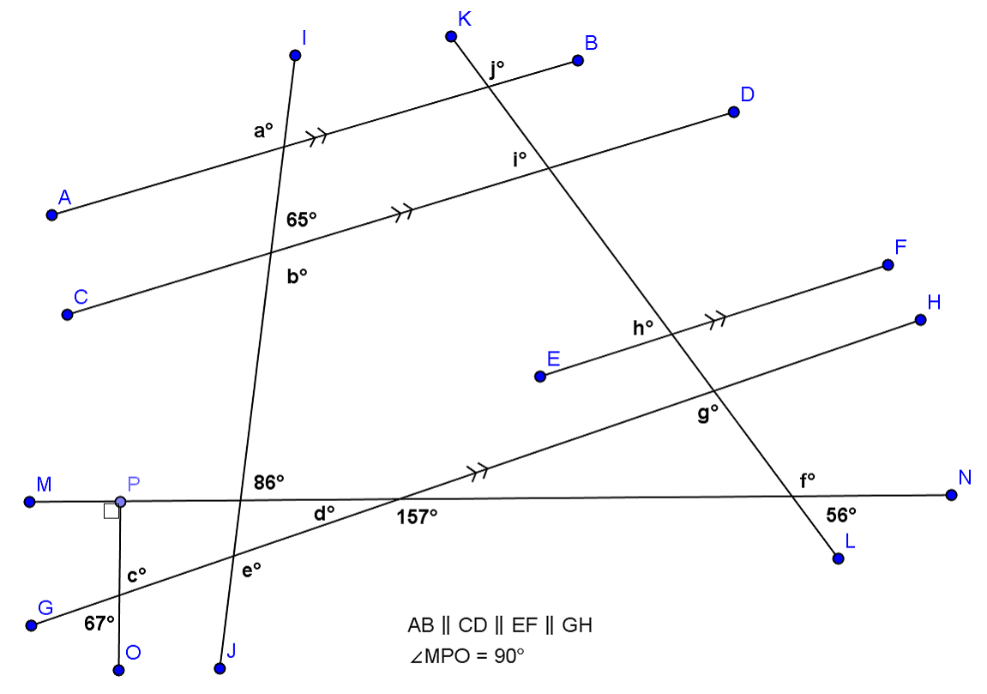

MP.7
&
MP.8

- Given: $m∠CDE=m∠BAC$
Prove: $m∠DEC=m∠ABC$

$m∠CDE=m∠BAC$ Given
$m∠CDE+m∠DCE+m∠DEC=180°$ Sum of the angle measures in a triangle is $180°$
$m∠BAC+m∠DCE+m∠ABC=180°$ Sum of the angle measures of a triangle is $180°$
$m∠CDE+m∠DCE+m∠DEC$ Substitution property of equality
$$m∠BAC+m∠DCE+m∠ABC$$
$m∠DEC=m∠ABC$ Subtraction property of equality

Mathematical Modeling Exercise (15 minutes)
Students discover what they do not know about rotations, reflections, and translations through a partner exercise. The cards mentioned are in the Lesson 12 supplement; there are three pairs of cards. Photocopy and split the pair of images from each transformation card. For the first round of the activity, assign Partner A with pre-image/image cards, assign Partner B with the pre-image cards. Switch card assignments after the first round.

Mathematical Modeling Exercise
You will work with a partner on this exercise and are allowed a protractor, compass, and straightedge.
- Partner A: Use the card your teacher gives you. Without showing the card to your partner, describe to your partner how to draw the transformation indicated on the card. When you have finished, compare your partner’s drawing with the transformed image on your card. Did you describe the motion correctly?
- Partner B: Your partner is going to describe a transformation to be performed on the figure on your card. Follow your partner’s instructions and then compare the image of your transformation to the image on your partner’s card.

Discussion (15 minutes)
It is critical that students understand transformations as functions that take a set of points as inputs, apply a given “rule” and output a new location for the image of the input points. The input points DO NOT MOVE, nor does the plane. (An analogy can be made to documents faxed to another location. The person sending the fax still retains the original. The machine simply sends an image to another location.) In addition, students must understand that two transformations are the same if they produce the same image. Remind students that the function $f\left(x\right)=x^{2}-1$ is equivalent to the function $g\left(x\right)=(x+1)(x-1)$. Although different procedures are followed to obtain the values of $f\left(x\right)$ and $g\left(x\right)$, given the same input, both output values will be identical; therefore, the two functions are equal. This applies to geometric functions as well.
Discussion
Explaining how to transform figures without the benefit of a coordinate plane can be difficult without some important vocabulary. Let’s review.
The word transformation has a specific meaning in geometry. A transformation $F$ of the plane is a function that assigns to each point $P$ of the plane a unique point $F(P)$ in the plane. Transformations that preserve lengths of segments and measures of angles are called basic rigid motions . A dilation is an example of a transformation that preserves angle measures but not the lengths of segments. In this lesson, we will work only with rigid transformations. We call a figure that is about to undergo a transformation the pre-image , while the figure that has undergone the transformation is called the image .
Rotation

Reflection

Translation

Using the figures above, identify specific information needed to perform the rigid motion shown.
For a rotation, we need to know:
Center of rotation, direction (Clockwise (CW) or Counterclockwise (CCW)) and number of degrees rotated.

For a reflection, we need to know:
The line of reflection acts as the perpendicular bisector of each segment that joins a given vertex of the pre-image with the respective vertex of the image.

For a translation, we need to know:
The point $P$ to be translated, the length and degree measure of the angle that the vector makes with the line that passes through $P$ and the endpoint of the vector.

Geometry Assumptions
We have now done some work with all three basic types of rigid motions (rotations, reflections, and translations). At this point, we need to state our assumptions as to the properties of basic rigid motions:
  - Any basic rigid motion preserves lines, rays, and segments. That is, for a basic rigid motion of the plane, the image of a line is a line, the image of a ray is a ray, and the image of a segment is a segment.
  - Any basic rigid motion preserves lengths of segments and measures of angles.

Relevant Vocabulary
Basic Rigid Motion: A basic rigid motion is a rotation, reflection, or translation of the plane.
Basic rigid motions are examples of transformations. Given a transformation, the image of a point $A$ is the point the transformation maps $A$ to in the plane.
Distance-Preserving: A transformation is said to be distance-preserving if the distance between the images of two points is always equal to the distance between the pre-images of the two points.
Angle-Preserving: A transformation is said to be angle-preserving if (1) the image of any angle is again an angle and (2) for any given angle, the angle measure of the image of that angle is equal to the angle measure of the pre-image of that angle.

Exit Ticket (3 minutes)

Name ___________________________________________________ Date____________________
Lesson 12: Transformations—The Next Level

Exit Ticket

How are transformations and functions related? Provide a specific example to support your reasoning.

Exit Ticket Sample Solution

How are transformations and functions related? Provide a specific example to support your reasoning.
Transformations ARE functions. They take a set of points as inputs, apply a given rule, and output a new location for the image of the input points. Examples are a reflection across a line of reflection and a rotation of $30$ degrees around a point of a given figure.

Problem Set Sample Solutions

An example of a rotation applied to a figure and its image is provided. Use this representation to answer the questions that follow. For each question, a pair of figures (pre-image and image) are given as well as the center of rotation. For each question, identify and draw the following:
- The circle that determines the rotation, using any point on the pre-image and its image.
- An angle, created with three points of your choice, which demonstrates the angle of rotation.

Example of a Rotation:
Pre-image: (solid line)
Image: (dotted line)
Center of rotation: $P$
Angle of rotation: $∠APA'$
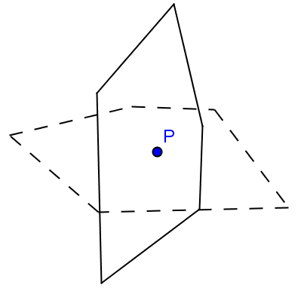

- Pre-image: (solid line)
Image: (dotted line)
Center of rotation: $P$

Angle of rotation: $90°$, $270°$ CW

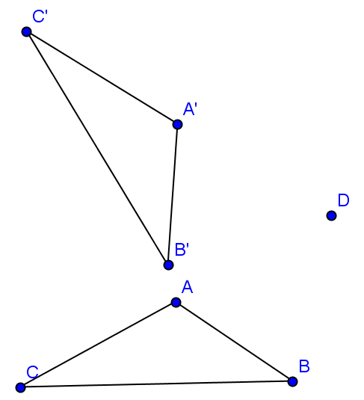

- Pre-image: $△ABC$
Image: $△A'B'C'$
Center: $D$

Angle of rotation: $300°$, $60°$ CW

