

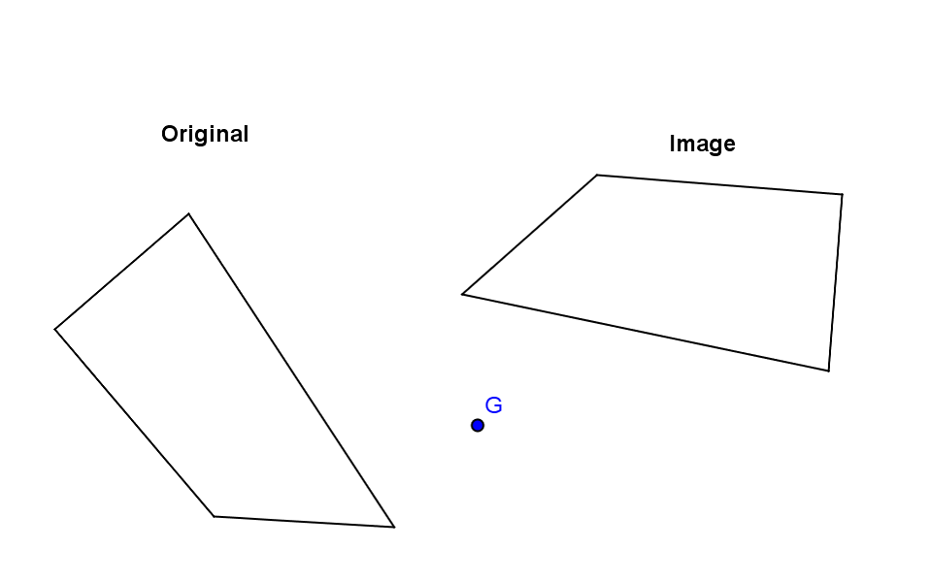

**Pre-Image**

**Image**

**Pre-Image**

