Lesson 11: Unknown Angle Proofs—Proofs of Known Facts

Classwork
Opening Exercise
A proof of a mathematical statement is a detailed explanation of how that statement follows logically from other statements already accepted as true.
A theorem is a mathematical statement with a proof.

Discussion
Once a theorem has been proved, it can be added to our list of known facts and used in proofs of other theorems. For example, in Lesson 9 we proved that vertical angles are of equal measure, and we know (from earlier grades and by paper cutting and folding) that if a transversal intersects two parallel lines, alternate interior angles are of equal measure. How do these facts help us prove that corresponding angles are congruent?

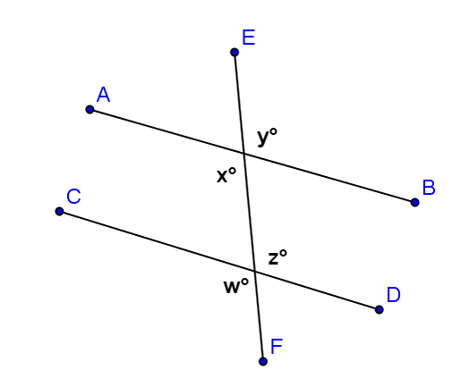
In the diagram to the right, if you are given that $\overline{AB}∥\overline{CD}$how can you use your knowledge of the congruence of vertical angles and alternate interior angles to prove that $x=w$?

You now have available the following facts:
- Vertical angles are equal in measure.
- Alternate interior angles are equal in measure.
- Corresponding angles are equal in measure.
Use any or all of these facts to prove that interior angles on the same side of the transversal are supplementary. Add any necessary labels to the diagram below, and then write out a proof including given facts and a statement of what needs to be proved.

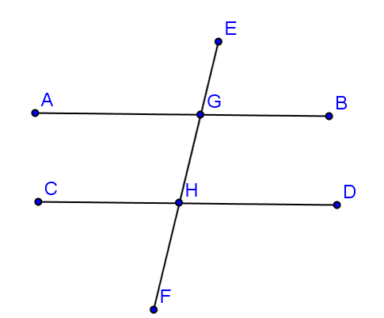
Given: $\overline{AB}∥\overline{CD}$, transversal $\overline{EF}$
Prove: $m∠BGH+m∠DHG=180°$

Now that you have proven this, you may add this theorem to your available facts.
- Interior angles on the same side of the transversal that intersects parallel lines sum to $180°$.

Use any of these four facts to prove that the three angles of a triangle sum to $180°$. For this proof, you will need to draw an auxiliary line, parallel to one of the triangle’s sides and passing through the vertex opposite that side. Add any necessary labels and write out your proof.
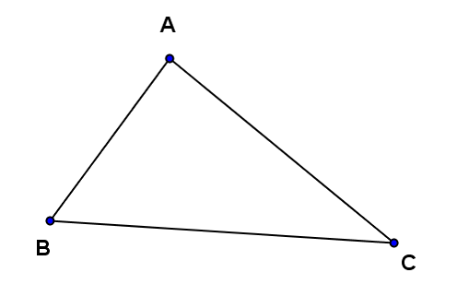

Let’s review the theorems we have now proven:
- Vertical angles are equal in measure.
- A transversal intersects a pair of lines. The pair of lines is parallel if and only if,
  - Alternate interior angles are equal in measure.
  - Corresponding angles are equal in measure.
- Interior angles on the same side of the transversal add to 180°. The sum of the degree measures of the angles of a triangle is $180°$.

Side Trip: Take a moment to take a look at one of those really famous Greek guys we hear so much about in geometry, Eratosthenes. Over $2,000$ years ago, Eratosthenes used the geometry we have just been working with to find the diameter of Earth. He did not have cell towers, satellites, or any other advanced instruments available to scientists today. The only things Eratosthenes used were his eyes, his feet, and perhaps the ancient Greek equivalent to a protractor.
Watch this video to see how he did it, and try to spot the geometry we have been using throughout this lesson.
Eratosthenes solves a puzzle

Example 1
Construct a proof designed to demonstrate the following:
If two lines are perpendicular to the same line, they are parallel to each other.
(a) Draw and label a diagram, (b) state the given facts and the conjecture to be proved, and (c) write out a clear statement of your reasoning to justify each step.

Discussion
Each of the three parallel line theorems has a converse (or reversing) theorem as follows:
Original | Converse
If two parallel lines are cut by a transversal, then alternate interior angles are congruent. | If two lines are cut by a transversal such that alternate interior angles are congruent, then the lines are parallel.
If two parallel lines are cut by a transversal, then corresponding angles are congruent. | If two lines are cut by a transversal such that corresponding angles are congruent, then the lines are parallel.
If two parallel lines are cut by a transversal, then interior angles on the same side of the transversal add to $180°$. | If two lines are cut by a transversal such that interior angles on the same side of the transversal add to $180°$, then the lines are parallel.
Notice the similarities between the statements in the first column and those in the second. Think about when you would need to use the statements in the second column, i.e., the times when you are trying to prove two lines are parallel.

Example 2
In the figure at the right, $x=y$.
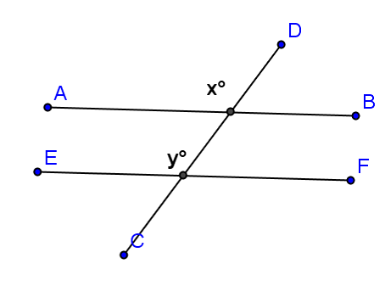
Prove that $\overline{AB}∥\overline{EF}$

Problem Set

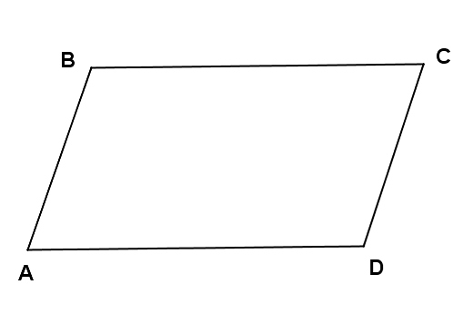
- Given: $∠C$ and $∠D$ are supplementary and $m∠B=m∠D$.
Prove: $\overline{AB}∥\overline{CD}$

- A theorem states that in a plane, if a line is perpendicular to one of two parallel lines and intersects the other, then it is perpendicular to the other of the two parallel lines.
Prove this theorem. (a) Construct and label an appropriate figure, (b) state the given information and the theorem to be proven, and (c) list the necessary steps to demonstrate the proof.

