|  |
| --- |
|  |

Lesson 11: Unknown Angle Proofs—Proofs of Known Facts

**Student Outcomes**

* Students write unknown angle proofs involving known facts.

Lesson Notes

In this last lesson on unknown angle proofs, students use their proof-writing skills to examine facts already familiar to them (i.e., the sum of angles of a triangle is and vertical angles are congruent). This offers students a *why* and a *how* to this body of information. Proving known facts also makes students aware of the way this list grows because proving one fact allows the proof of the next fact.

Students begin by reviewing the Problem Set from Lesson 10. Then, they explore a known fact: Opposite angles of parallelograms are equal in measure. After working through the proof as a whole class, the teacher should point out that although we have a body of familiar geometry facts, we have never explored them to make sure they were true. Demonstrate with the examples provided that it is possible to use one basic fact to build to the next. After the notes, share the video clip about Eratosthenes and his use of geometry (especially the use of alternate interior angles in the thought process) to find the circumference of Earth. Then, do Example 1 and also discuss the use of the converse parallel line theorems and their abbreviations. Consider demonstrating why the converse holds true, for example, by asking a helper to hold up a ruler (the transversal) and a second helper to hold two rulers, one in each hand. Ask them to show what the rulers do to test a converse parallel line theorem. End class with the problem set assignment.

Classwork

*Note to Teacher:*

Remind students that a theorem is often stated as an “If-then,” as:

If “hypothesis,” then “conclusion.”

Opening Exercise (8 minutes)

Review the Problem Set from Lesson 10. Students engage in a whole-class discussion about proving known facts, beginning with a specific example.

Opening Exercise

A proof of a mathematical statement is a detailed explanation of how that statement follows logically from other statements already accepted as true.

A theorem is a mathematical statement with a proof.

Consider taking a moment to mention that theorems can be stated without reference to any specific, labeled diagram. However, we cannot take steps to prove a statement without a way of referring to parts. Students will observe situations where the labels are provided and situations where they must draw diagrams and label parts.

Discussion (15 minutes)

Students use the facts already provided in a list to prove each successive fact.

Discussion

Once a theorem has been proved, it can be added to our list of known facts and used in proofs of other theorems. For example, in Lesson 9 we proved that *vertical angles are of equal measure*, and we know (from earlier grades and by paper cutting and folding) that *if a transversal intersects two parallel lines, alternate interior angles* *are of equal measure*. How do these facts help us prove that corresponding angles are congruent?

*Answers may vary.*

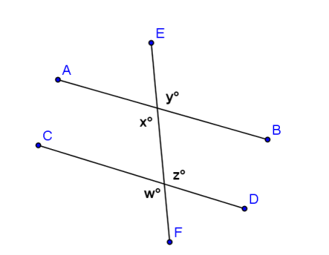In the diagram to the right, if you are given that , how can you use your knowledge of the congruence of vertical angles and alternate interior angles to prove that ?

(Vertical angles are congruent); (Alternate interior angles);   
 (Substitution)

You now have available the following facts:

* Vertical angles are equal in measure.
* Alternate interior angles are equal in measure.
* Corresponding angles are equal in measure.

Use any or all of these facts to prove that *interior angles on the same side of the transversal are supplementary*. Add any necessary labels to the diagram below, and then write out a proof including given facts and a statement of what needs to be proved.

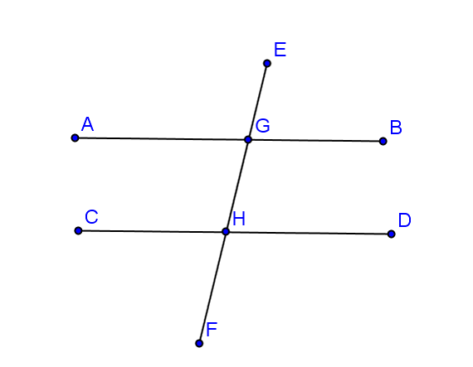

Given: , transversal

Prove:

Given

*Linear pairs form supplementary angles*

*If parallel lines are cut by a transversal, then alternate interior angles are equal in measure*

*Substitution property of equality*

Now that you have proven this, you may add this theorem to your available facts.

* Interior angles on the same side of the transversal that intersects parallel lines sum to .

Use any of these four facts to prove that the three angles of a triangle sum to . For this proof, you will need to draw an auxiliary line parallel to one of the triangle’s sides and passing through the vertex opposite that side. Add any necessary labels, and write out your proof.

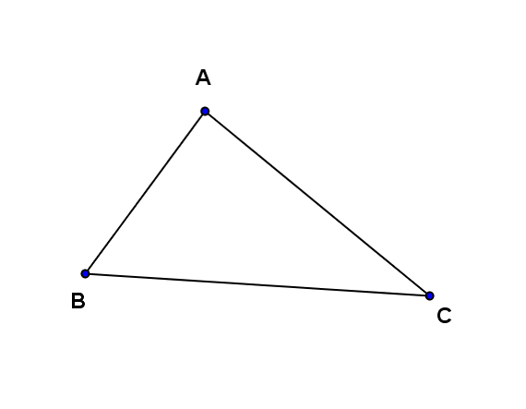

***J***

***K***

**MP.7**

Draw in auxiliary line so that .

Angles on a line sum to

If parallel lines are cut by a transversal, then alternate interior angles are equal in measure

If parallel lines are cut by a transversal, then alternate interior angles are equal in measure

Substitution property of equality

Let’s review the theorems we have now proven:

* Vertical angles are equal in measure.
* A transversal intersects a pair of lines. The pair of lines is parallel if and only if,
* Alternate interior angles are equal in measure.
* Corresponding angles are equal in measure.
* Interior angles on the same side of the transversal add to. The sum of the degree measures of the angles of a triangle is .
* What is the absolute shortest list of facts from which all other facts can be derived?

*Side Trip:* Take a moment to take a look at one of those really famous Greek guys we hear so much about in geometry, Eratosthenes. Over years ago, Eratosthenes used the geometry we have just been working with to find the circumference of Earth. He did not have cell towers, satellites, or any other advanced instruments available to scientists today. The only things Eratosthenes used were his eyes, his feet, and perhaps the ancient Greek equivalent to a protractor.

Watch this video to see how he did it, and try to spot the geometry we have been using throughout this lesson.

[Eratosthenes solves a puzzle](http://youtu.be/wnElDaV4esg)

Examples 1–2 (17 minutes)

Students try one example and discuss the converse of parallel line theorems.

Example 1

Construct a proof designed to demonstrate the following:

*If two lines are perpendicular to the same line, they are parallel to each other.*

(a) Draw and label a diagram, (b) state the given facts and the conjecture to be proved, and (c) write out a clear statement of your reasoning to justify each step.



Given: ,

Prove:

; *Perpendicular lines form angles.*

*Transitive property (since and )*

If two lines are cut by a transversal such that a pair of corresponding angles are equal in meaure, then the lines are parallel

Discussion

Show a brief example of one parallel line theorem in both directions, the original theorem and its converse, to ensure students understand how to use the converse (one way is using the student helpers mentioned in the overview).

Each of the three parallel line theorems has a converse (or reversing) theorem as follows:

|  |  |
| --- | --- |
| Original | Converse |
| If two parallel lines are cut by a transversal, then alternate interior angles are congruent. | If two lines are cut by a transversal such that alternate interior angles are congruent, then the lines are parallel. |
| If two parallel lines are cut by a transversal, then corresponding angles are congruent. | If two lines are cut by a transversal such that corresponding angles are congruent, then the lines are parallel. |
| If two parallel lines are cut by a transversal, then interior angles on the same side of the transversal add to . | If two lines are cut by a transversal such that interior angles on the same side of the transversal add to , then the lines are parallel. |

Notice the similarities between the statements in the first column and those in the second. Think about when you would need to use the statements in the second column, i.e., the times when you are trying to prove two lines are parallel.

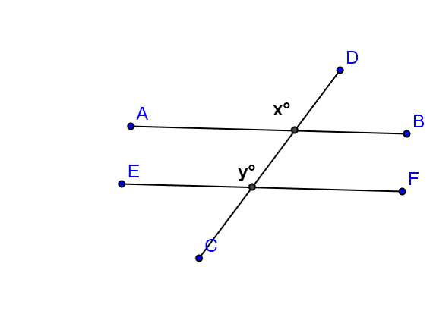Example 2

In the figure at the right, .

Prove that .

Given

If two lines are cut by a transversal such that a pair of corresponding angles are equal in meaure, then the lines are parallel

Exit Ticket (5 minutes)

Name ___________________________________________________ Date____________________

Lesson 11: Unknown Angle Proofs—Proofs of Known Facts

Exit Ticket

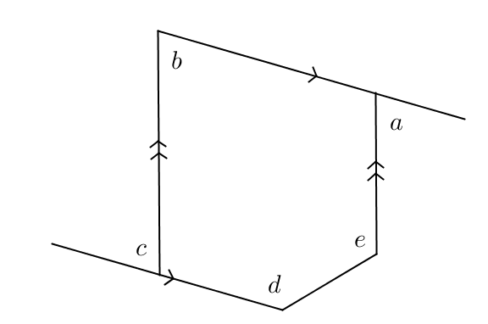In the diagram at the right, prove that .

Exit Ticket Sample Solution

In the diagram at the right, prove that .

Draw auxiliary lines, and label ∠s as shown.

*If parallel lines are cut by a transversal, then alternate interior angles are equal in measure*

*Angle postulate*

*If parallel lines are cut by a transversal, then corresponding angles are equal in measure*

*Linear pairs form supplementary angles.*

*Substitution property of equality*

Problem Set Sample Solutions

1. 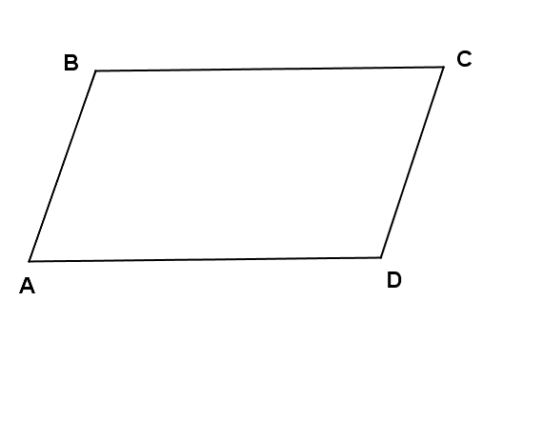Given: and are supplementary and .

Prove:

and are supplementary Given

*Definition of supplementary angles*

*Given*

*Substitution*

If two lines are cut by a transversal such that a pair of interior angles on the same side are supplementary, then the lines are parallel

1. A theorem states that in a plane, if a line is perpendicular to one of two parallel lines and intersects the other, then it is perpendicular to the other of the two parallel lines.

Prove this theorem. (a) Construct and label an appropriate figure, (b) state the given information and the theorem to be proven, and (c) list the necessary steps to demonstrate the proof.



Given: , , intersects

Prove:

, Given

*Definition of perpendicular lines*

*If parallel lines are cut by a transversal, then corresponding angles are equal in measure*

If two lines intersect to form a right angle, then the two lines are perpendicular