Lesson 10: Unknown Angle Proofs—Proofs with Constructions

Classwork
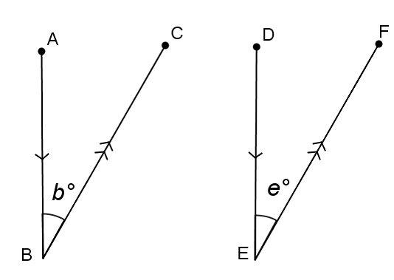
Opening Exercise
In the figure on the right, $\overline{AB}∥\overline{DE}$ and $\overline{BC}∥\overline{EF}$. Prove that $b=e$ (Hint: Extend $\overline{BC}$ and $\overline{ED}$.)

Proof:

In the previous lesson, you used deductive reasoning with labeled diagrams to prove specific conjectures. What is different about the proof above?
Adding or extending segments, lines, or rays (referred to as auxiliary lines) is frequently useful in demonstrating steps in the deductive reasoning process. Once $\overline{BC}$ and $\overline{ED}$ were extended, it was relatively simple to prove the two angles congruent based on our knowledge of alternate interior angles. Sometimes there are several possible extensions or additional lines that would work equally well.
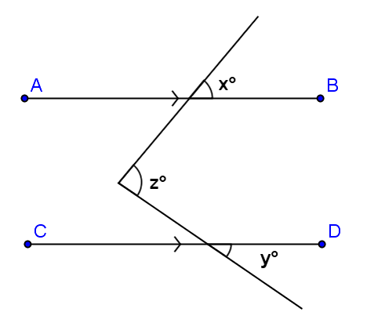
For example, in this diagram, there are at least two possibilities for auxiliary lines. Can you spot them both?

Given: $\overline{AB}∥\overline{CD}$.
Prove: $z=x+y$.

Discussion
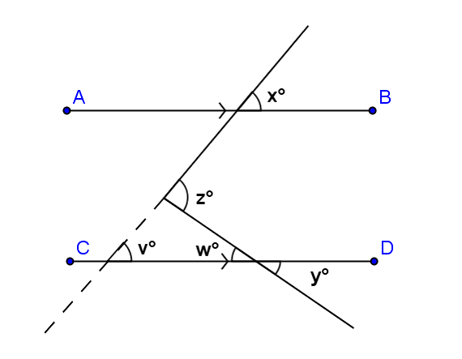
Here is one possibility:
Given: $\overline{AB}∥\overline{CD}$.
Prove: $z=x+y$.
Extend the transversal as shown by the dotted line in the diagram. Label angle measures $v$ and $w$, as shown.
What do you know about $v$ and $x$?
About angles $w$ and $y$? How does this help you?

Write a proof using the auxiliary segment drawn in the diagram to the right.

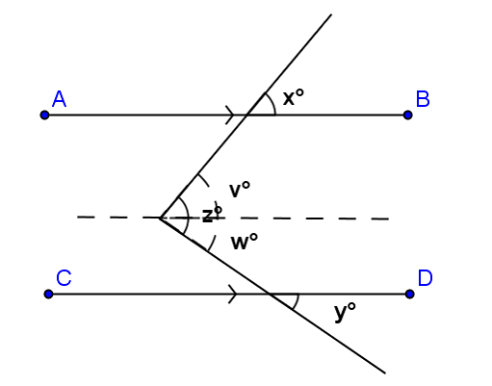
Another possibility appears here:
Given: $\overline{AB}$ || $\overline{CD}$.
Prove: $z = x + y$.
Draw a segment parallel to $\overline{AB}$ through the vertex of the angle measuring $z$ degrees. This divides it into angles two parts as shown.
What do you know about angles $v$ and $x$?
About $w$ and $y$? How does this help you?

Write a proof using the auxiliary segment drawn in this diagram. Notice how this proof differs from the one above.

What do you know about $v$ and $x$?

About $w$ and $y$? How does this help you?

Write a proof using the auxiliary segment drawn in this diagram. Notice how this proof differs from the one above.

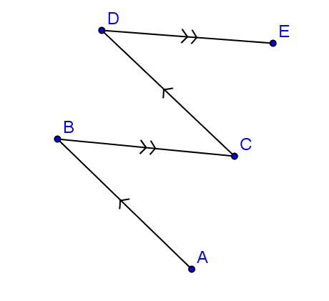
Examples
- In the figure at the right, $\overline{AB}∥\overline{CD}$ and $\overline{BC}∥\overline{DE}$.
Prove that $m∠ABC=m∠CDE$.
(Is an auxiliary segment necessary?)

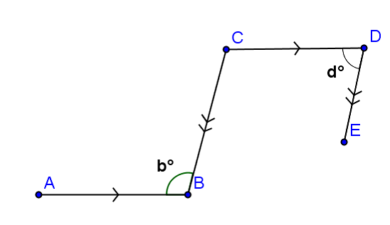
- In the figure at the right, $\overline{AB}∥\overline{CD}$ and $\overline{BC}∥\overline{DE}$.
Prove that$b+d=180$.

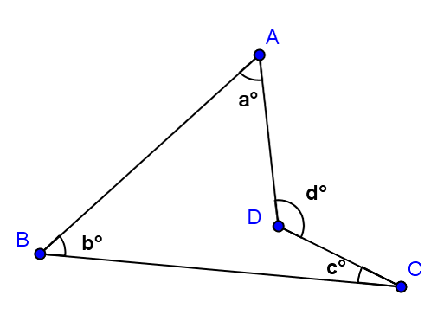
- In the figure at the right, prove that $d=a+b+c$.

Problem Set
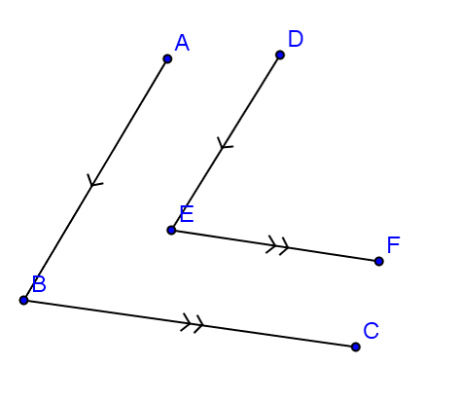
- In the figure to the right, $\overline{AB}∥\overline{DE}$ and $\overline{BC}∥\overline{EF}$.
Prove that $m∠ABC=m∠DEF$.

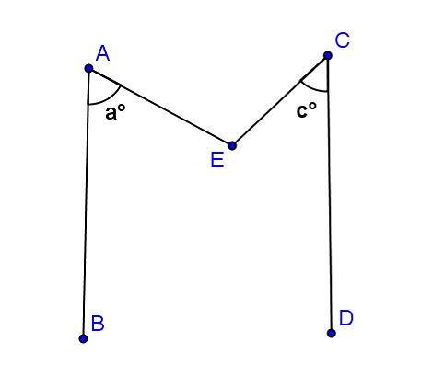
- In the figure to the right, $\overline{AB}∥\overline{CD}$.
Prove that $m∠AEC=a°+c°$.

