|  |
| --- |
|  |

Lesson 10: Unknown Angle Proofs—Proofs with Constructions

**Student Outcome**

* Students write unknown angle proofs involving auxiliary lines.

Lesson Notes

On the second day of unknown angle proofs, students incorporate the use of constructions, specifically auxiliary lines, to help them solve problems. In this lesson, students refer to the same list of facts they have been working with in the last few lessons. What sets this lesson apart is that necessary information in the diagram may not be apparent without some modification. One of the most common uses for an auxiliary line is in diagrams where multiple sets of parallel lines exist. Encourage students to mark up diagrams until the necessary relationships for the proof become more obvious.

Classwork

Opening Exercise (7 minutes)

Review the Problem Set from Lesson 9. Then, the whole class works through an example of a proof requiring auxiliary lines.

Opening Exercise

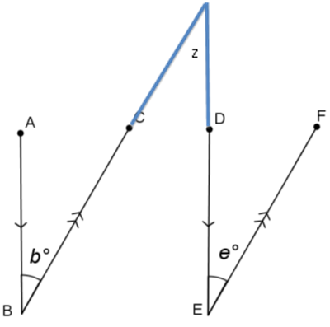

In the figure to the right, and . Prove that . (Hint: Extend and .)

*Proof:*

If parallel lines are cut by a transversal, then alternate interior angles are equal in measure

If parallel lines are cut by a transversal, then alternate interior angles are equal in measure

Transitive property

In the previous lesson, you used deductive reasoning with labeled diagrams to prove specific conjectures. What is different about the proof above?

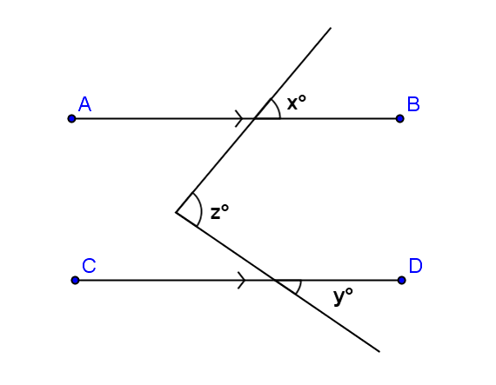Drawing or extending segments, lines, or rays (referred to as auxiliary lines) is frequently useful in demonstrating steps in the deductive reasoning process. Once and were extended, it was relatively simple to prove the two angles congruent based on our knowledge of alternate interior angles. Sometimes there are several possible extensions or additional lines that would work equally well.

For example, in this diagram, there are at least two possibilities for auxiliary lines. Can you spot them both?

Given: .

Prove: *.*

Discussion (9 minutes)

Students explore different ways to add auxiliary lines (construction) to the same diagram.

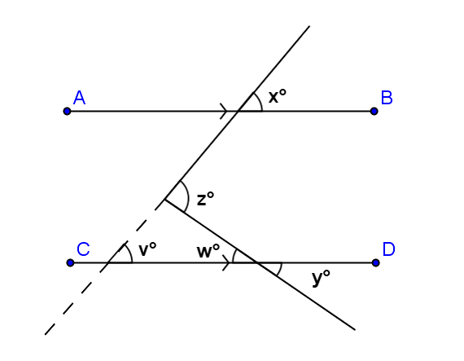Discussion

*Here is one possibility:*

Given: .

Prove: .

Extend the transversal as shown by the dotted line in the diagram. Label angle measures and , as shown.

What do you know about and ?

About and ? How does this help you?

Write a proof using the auxiliary segment drawn in the diagram to the right.

Exterior angle of a triangle equals the sum of the two interior opposite angles (remote) interior

If parallel lines are cut by a transversal, then corresponding angles are equal in measure

**MP.7**

If parallel lines are cut by a transversal, then corresponding angles are equal in measure

Angle addition postulate

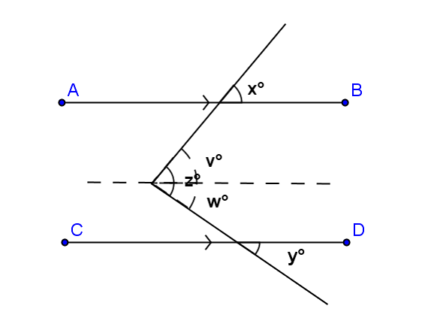 Substitution property of equality

*Another possibility appears here:*

Given: .   
Prove: .

Draw a segment parallel to through the vertex of the angle measuring degrees. This divides it into angles two parts as shown.

What do you know about and ?

They are equal since they are corresponding angles of parallel lines crossed by a transversal.

About and ? How does this help you?

They are also equal in measure since they are corresponding angles of parallel lines crossed by a transversal.

Write a proof using the auxiliary segment drawn in this diagram. Notice how this proof differs from the one above.

If parallel lines are cut by a transversal, the corresponding angles are equal.

If parallel lines are cut by a transversal, the corresponding angles are equal.

Angle addition

Substitution

**Examples (25 minutes)**

Examples

1. 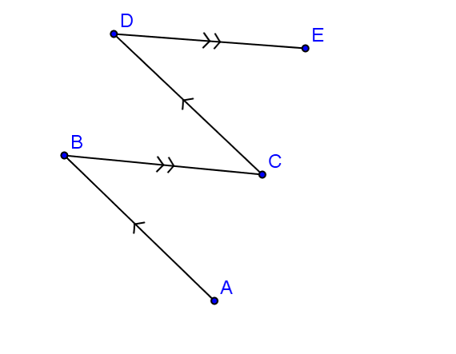In the figure at the right, and .

Prove that .

(Is an auxiliary segment necessary?)

*If parallel lines are cut by a transversal, then alternate interior angles are equal in measure*

*If parallel lines are cut by a transversal, then alternate interior angles are equal in measure*

*Transitive property*

1. In the figure at the right, and .

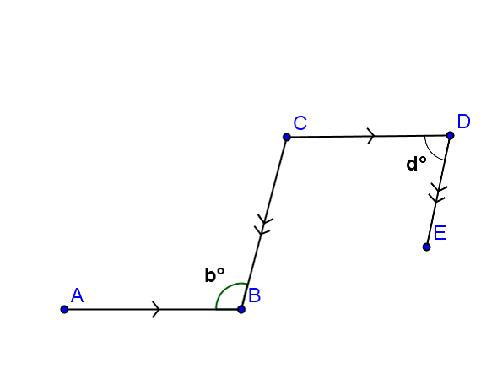

c°

Prove that .

Label .

If parallel lines are cut by a transversal, then alternate interior angles are equal in measure

If parallel lines are cut by a transversal, then same-side interior angles are supplementary.

Substitution property of equality

1. In the figure at the right, prove that .

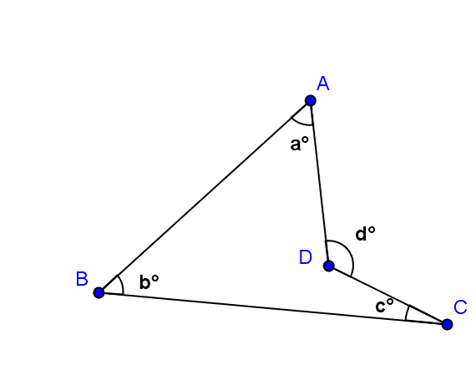

Label and .

Exterior angle of a triangle equals the sum of the two interior opposite angles

Exterior angle of a triangle equals the sum of the two interior opposite angles

Substitution property of equality

Exit Ticket (5 minutes)

Name ___________________________________________________ Date____________________

Lesson 10: Unknown Angle Proofs—Proofs with Constructions

Exit Ticket

Write a proof for each question.

1. In the figure at the right, . Prove that .

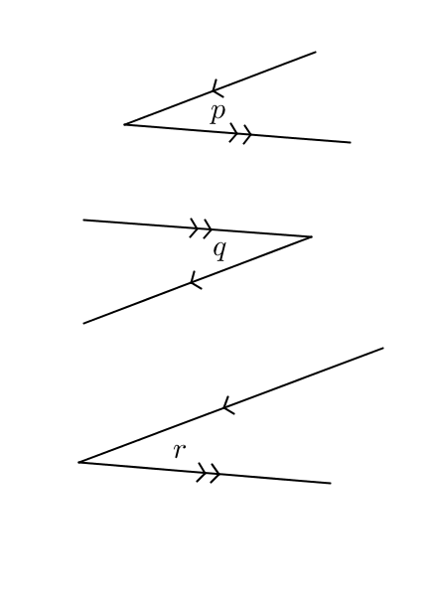

1. Prove .

Exit Ticket Sample Solutions

Write a proof for each question.

1. In the figure at the right, . Prove that .

Write in angles and .

Vertical angles are equal in measure.

If parallel lines are cut by a transversal, then alternate interior angles are equal in measure

Vertical angles are equal in measure.

Substitution property of equality

1. 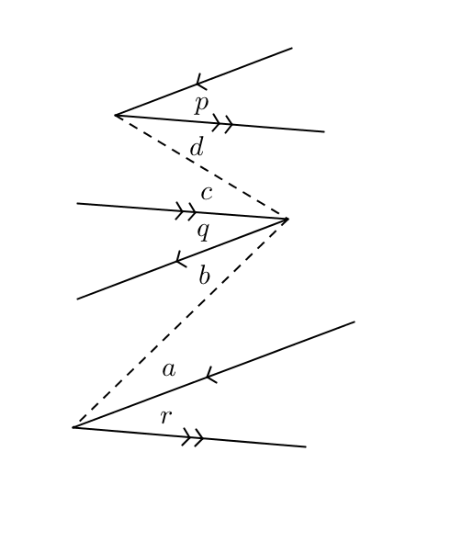Prove .

Mark angles , , c and .

*If parallel lines are cut by a transversal, then alternate interior angles are equal in measure*

*If parallel lines are cut by a transversal, then alternate interior angles are equal in measure*

*Subtraction property of equality*

*If parallel lines are cut by a transversal, then alternate interior angles are equal in measure*

*If parallel lines are cut by a transversal, then alternate interior angles are equal in measure*

*Subtraction property of equality*

*Substitution property of equality*

Problem Set Sample Solutions

1. In the figure to the right, and .

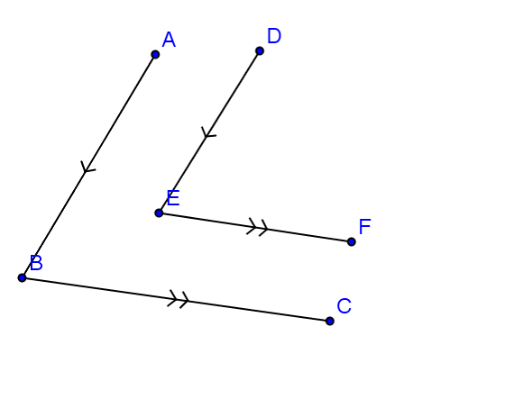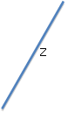

Prove that .

Extend through , and mark the intersection with as .

*If parallel lines are cut by a transversal, then corresponding angles are equal in measure*

*If parallel lines are cut by a transversal, then corresponding angles are equal in measure*

*Transitive property*

1. In the figure to the right, .

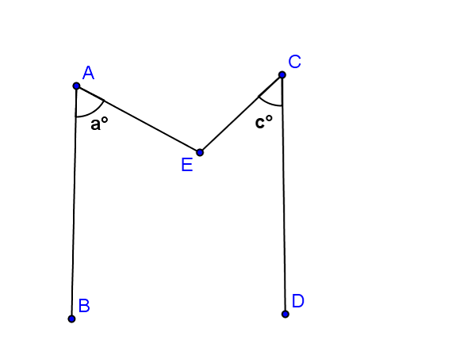

Prove that .

Draw in line through parallel to and ;

Add point .

*If parallel lines are cut by a transversal, then alternate interior angles are equal in measure*

*If parallel lines are cut by a transversal, then alternate interior angles are congruent equal in measure*

*Angle addition postulate*