Lesson 9: Unknown Angle Proofs—Writing Proofs

Classwork

Opening Exercise

One of the main goals in studying geometry is to develop your ability to reason critically, to draw valid conclusions based upon observations and proven facts. Master detectives do this sort of thing all the time. Take a look as Sherlock Holmes uses seemingly insignificant observations to draw amazing conclusions.

[Sherlock Holmes: Master of Deduction!](http://youtu.be/o30UY_flFgM)

Could you follow Sherlock Holmes’ reasoning as he described his thought process?

Discussion

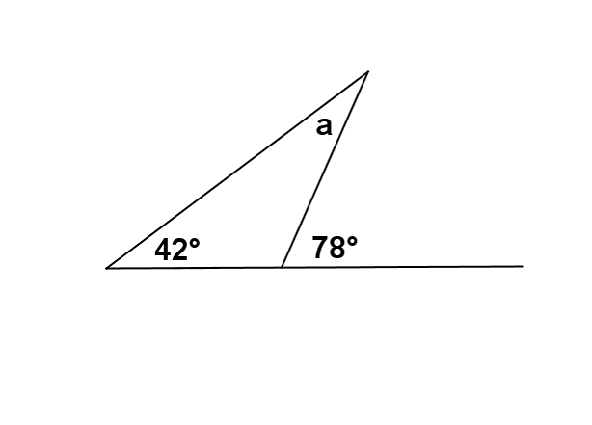In geometry, we follow a similar deductive thought process, much like Holmes’ uses, to prove geometric claims. Let’s revisit an old friend—solving for unknown angles. Remember this one?

You needed to figure out the measure of , and used the “fact” that an exterior angle of a triangle equals the sum of the measures of the opposite interior angles. The measure of must, therefore, be .

Suppose that we rearrange the diagram just a little bit.

Instead of using numbers, we will use variables to represent angle measures.

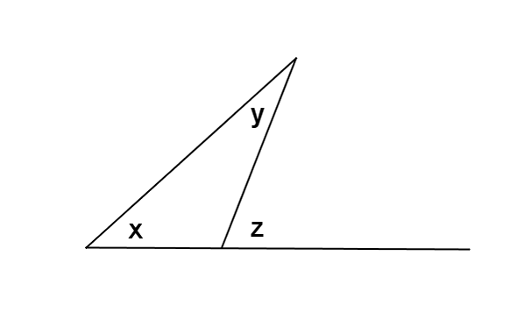

Suppose further that we already have in our arsenal of facts the knowledge that the angles of a triangle sum to . Given the labeled diagram at the right, can we prove that (or, in other words, that the exterior angle of a triangle equals the sum of the remote interior angles)?

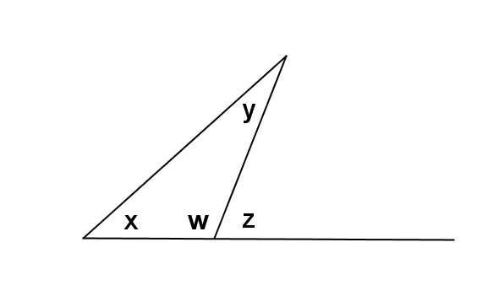*Proof:*

Label , as shown in the diagram.   
  
  
  
  
  
  
  
 Sum of the angle measures in a triangle is

Linear pairs form supplementary angles.

Substitution property of equality

Subtraction property of equality

Notice that each step in the proof was justified by a previously known or demonstrated fact. We end up with a newly proven fact (that an exterior angle of *any* triangle is the sum of the measures of the opposite interior angles of the triangle). This ability to identify the steps used to reach a conclusion based on known facts is ***deductive reasoning*** (i.e., the same type of reasoning that Sherlock Holmes used to accurately describe the doctor’s attacker in the video clip.)

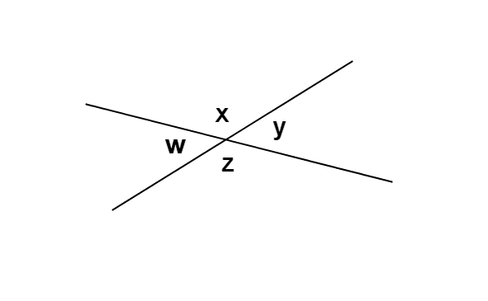Exercises

1. You know that angles on a line sum to .

Prove that vertical angles are congruent.

Make a plan:

* What do you know about and ? and ?
* What conclusion can you draw based on both bits of knowledge?
* Write out your proof:

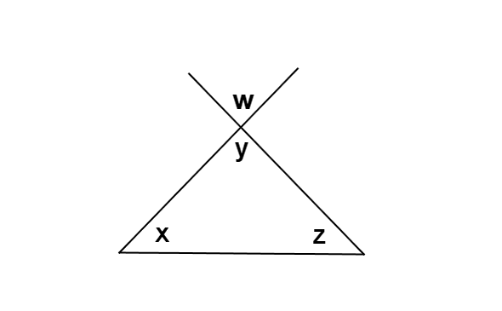

1. Given the diagram to the right, prove that   
   (Make a plan first. What do you know about ,, and ?)

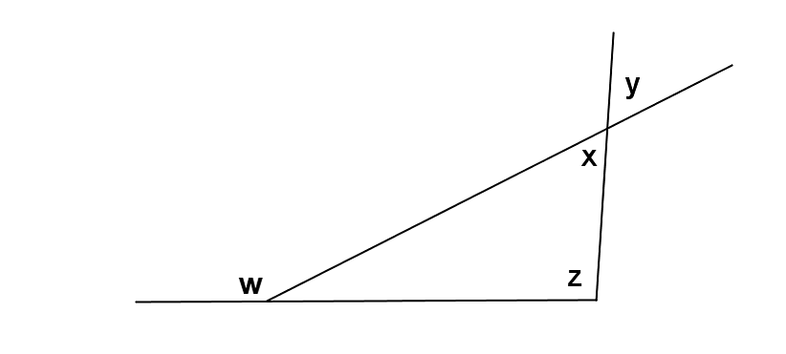

Given the diagram to the right, prove that *.*

1. 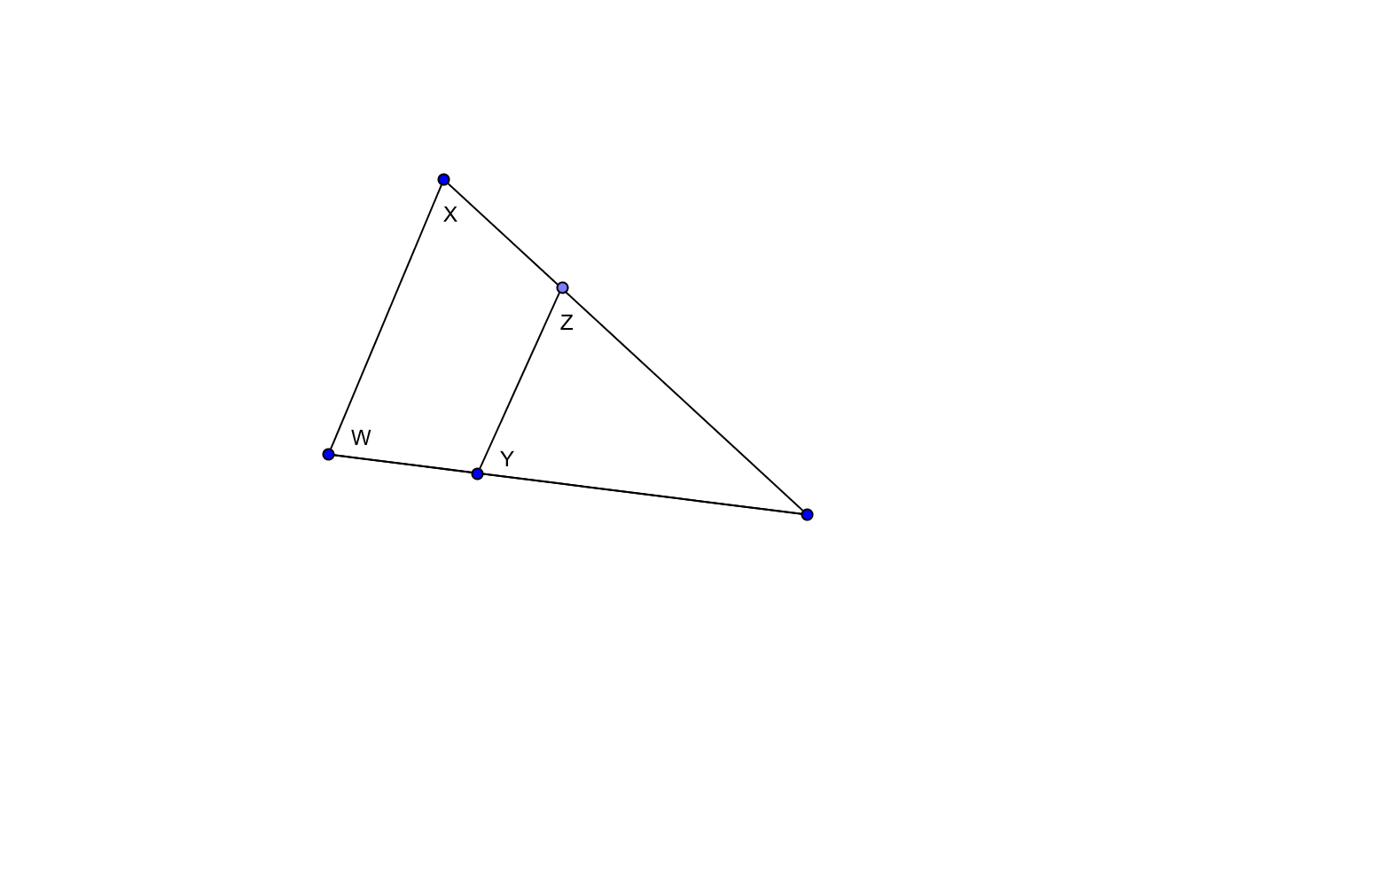In the diagram to the right, prove that . (You will need to write in a label in the diagram that is not labeled yet for this proof.)

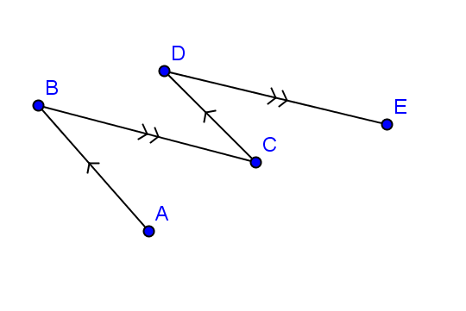

1. In the figure to the right, ⎟⎟ and ⎟⎟ .   
   Prove that .

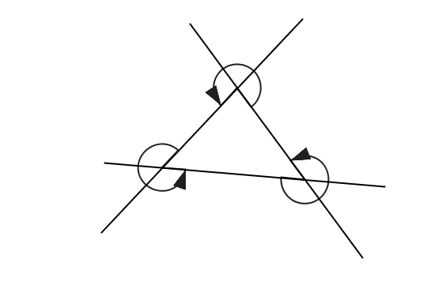

1. In the figure to the right, prove that the sum of the angles marked by arrows is .

(You will need to write in several labels into the diagram for this proof.)

1. 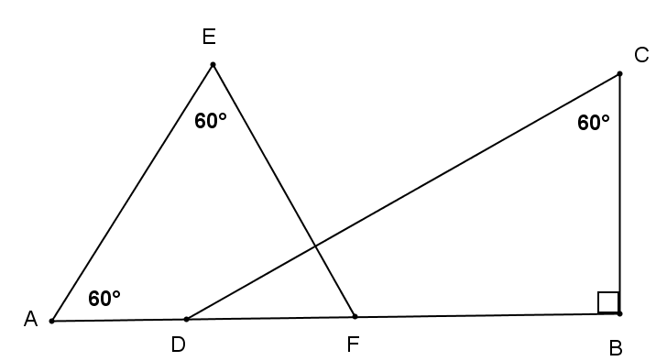In the figure to the right, prove that ⊥ .

Problem Set

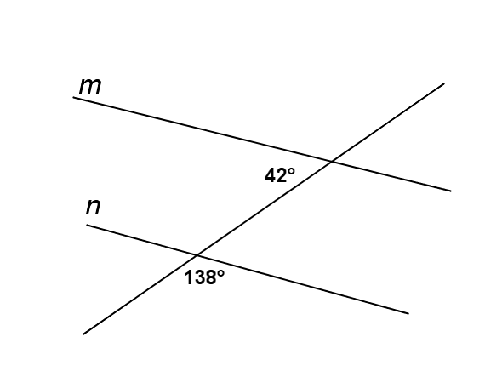

1. In the figure to the right, prove that .

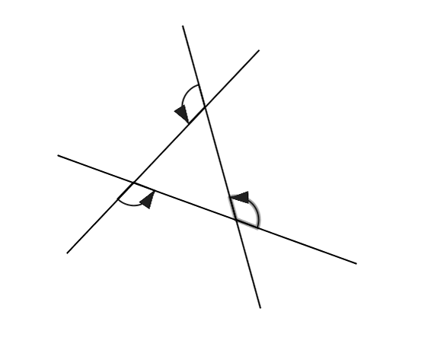

1. In the diagram to the right, prove that the sum of the angles marked by arrows is .



1. In the diagram at the right, prove that .