|  |
| --- |
|  |

Lesson 9: Unknown Angle Proofs—Writing Proofs

Student Outcomes

* Students write unknown angle proofs, using already accepted geometry facts

Lesson Notes

In Lesson 9, students make the transition from unknown angle problems to unknown angle proofs. Instead of solving for a numeric answer, students need to justify a particular relationship. Students are prepared for this as they have been writing a reason for each step of their numeric answers in the last three lessons.

Begin the lesson with a video clip about Sherlock Holmes. Holmes examines a victim and makes deductions about the victim’s attacker. He makes each deduction based on several pieces of evidence the victim provides. The video clip sets the stage for the deductive reasoning students must use to write proofs. Each geometric conclusion must be backed up with a concrete reason, a fact that has already been established. Following the video clip, lead the class through the example proof, eliciting the similarities and differences between the sample problem and subsequent proof questions. Emphasize that the questions still draw on the same set of geometric facts used to solve problems and steps that are purely algebraic (some kind of arithmetic) do not require a justification. Students attempt an example and review together before beginning the exercises.

As students embark on the exercises, teachers can periodically review or ask for student solutions to ensure that they are formulating their steps clearly and providing appropriate reasons.

Note that in writing proofs, students draw upon many of the properties that they learned in middle school; some instruction on these may be necessary. A chart of frequently used properties is provided at the end of this lesson that may be used to supplement instruction or for student reference. Note that although the concept of congruence has not yet been discussed, the first three properties (Reflexive, Transitive, and Symmetric) hold for congruence as well.

Classwork

Opening Exercise (5 minutes)

Students watch video clip:

* In this example, students will watch a video clip and discuss the connection between Holmes’s process of identifying the attacker and the deduction used in geometry.
* Emphasize that Holmes makes no guesses and that there is a solid piece of evidence behind each conclusion.

**Opening Exercise**

**One of the main goals in studying geometry is to develop your ability to reason critically, to draw valid conclusions based upon observations and proven facts. Master detectives do this sort of thing all the time. Take a look as Sherlock Holmes uses seemingly insignificant observations to draw amazing conclusions.**

[**Sherlock Holmes: Master of Deduction!**](http://youtu.be/o30UY_flFgM)

**Could you follow Sherlock Holmes’s reasoning as he described his thought process?**

**Discussion (10 minutes)**

Students examine the similarities and differences between unknown angle problems and proofs.

Remind students that they are drawing on the same set of facts they have been using in the last few days. Tell students that the three dots indicate that the proof has been completed.

**Discussion**

In geometry, we follow a similar deductive thought process (much like Holmes’ uses) to prove geometric claims. Let’s revisit an old friend—solving for unknown angles. Remember this one?

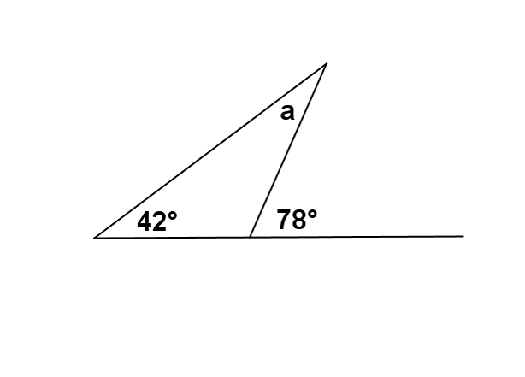

You needed to figure out the measure of , and used the “fact” that an exterior angle of a triangle equals the sum of the measures of the opposite interior angles. The measure of ∠ must, therefore, be .

Suppose that we rearrange the diagram just a little bit.

Instead of using numbers, we will use variables to represent angle measures.

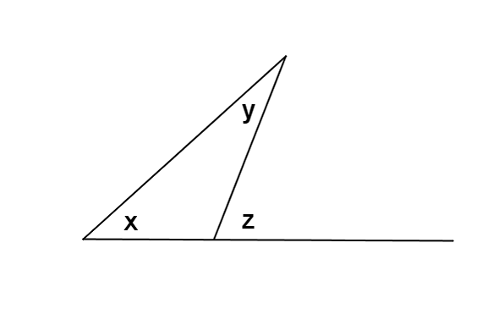

Suppose further that we already know that the angles of a triangle sum to . Given the labeled diagram at the right, can we prove that (or, in other words, that the exterior angle of a triangle equals the sum of the measures of the opposite interior angles)?

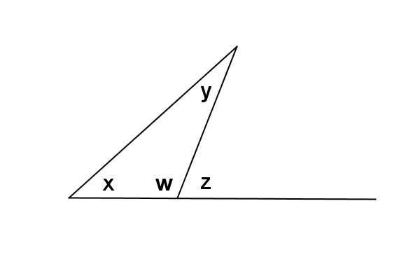Proof:

Label , as shown in the diagram.

Sum of the angle measures in a triangle is

Linear pairs form supplementary angles

Substitution property of equality

Subtraction property of equality

Notice that each step in the proof was justified by a previously known or demonstrated fact. We end up with a newly proven fact (that an exterior angle of any triangle is the sum of the measures of the opposite interior angles of the triangle). This ability to identify the steps used to reach a conclusion based on known facts is *deductive reasoning* (i.e., the same type of reasoning that Sherlock Holmes used to accurately describe the doctor’s attacker in the video clip.)

Exercises (25 minutes)

Exercises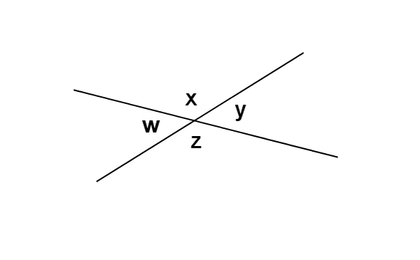

1. You know that angles on a line sum to .

**Prove that vertical angles are equal in measure.**

**Make a plan:**

* **What do you know about and ? and ?**

They sum to .

*Note to Teacher:*

There are different ways of notating the “Given” and “Prove.” Alternate pairings include “Hypothesis/ Conclusion” and “Suppose/ Then.” The point is that we begin with what is observed and end with what is deduced.

* **What conclusion can you draw based on both pieces of knowledge?**

**MP.7**

**&**

**MP.8**

* **Write out your proof:**

*Linear pairs form supplementary angles*

*Linear pairs form supplementary angles*

*Substitution property of equality*

*Subtraction property of equality*

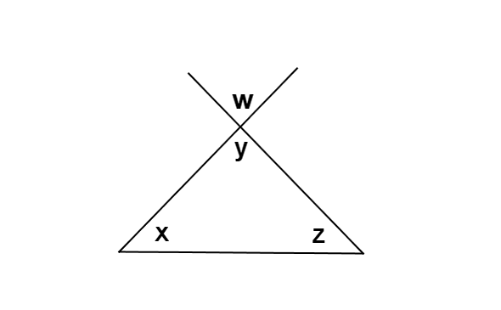

1. Given the diagram to the right, prove that .   
   (Make a plan first. What do you know about , , and ?)

*Sum of the angles of a triangle is .*

*Vertical angles are equal in measure.*

*Substitution property of equality*

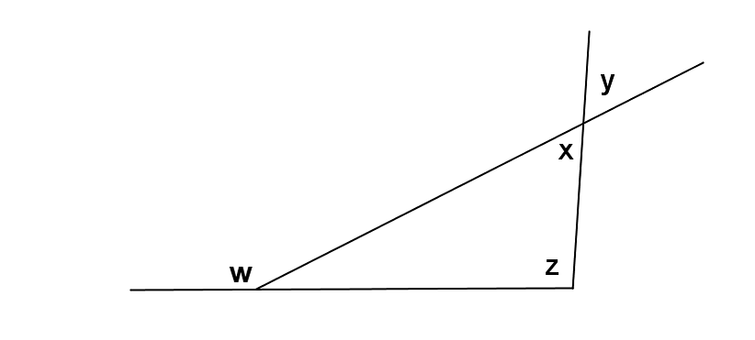Given the diagram to the right, prove that .

*Exterior angle of a triangle equals the sum of the   
two interior opposite angles*

*Vertical angles are equal in measure*

*Substitution property of equality*

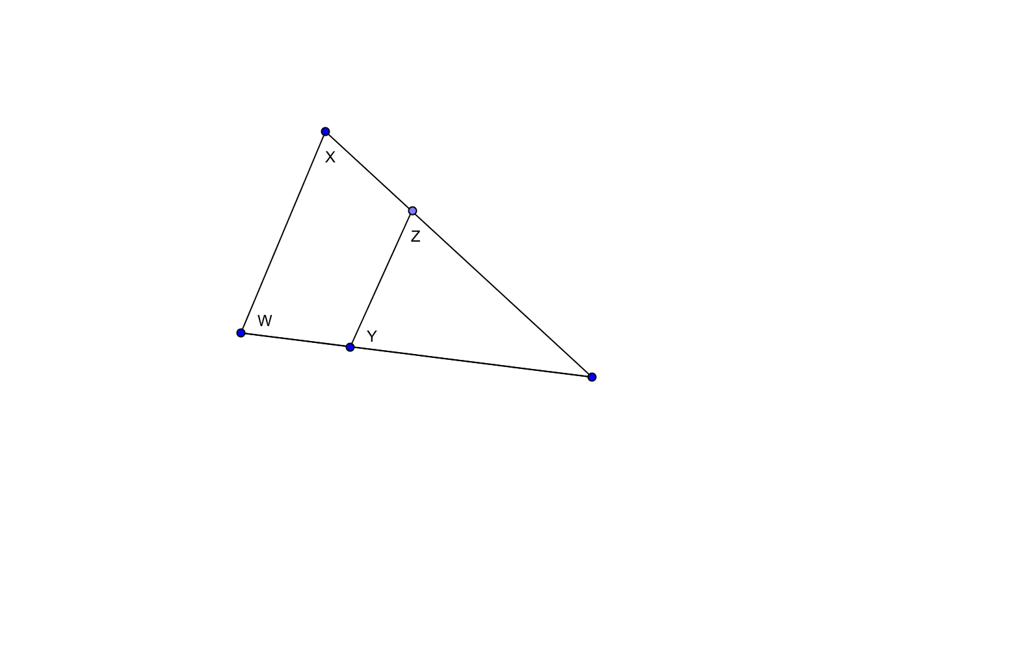

1. In the diagram to the right, prove that .  
   (You will need to write in a label in the diagram that is not labeled yet for this proof.)

*Exterior angle of a triangle equals the sum of the two interior opposite angles*

*Exterior angle of a triangle equals the sum of the two interior opposite angles*

*Substitution property of equality*

*Subtraction property of equality*

1. 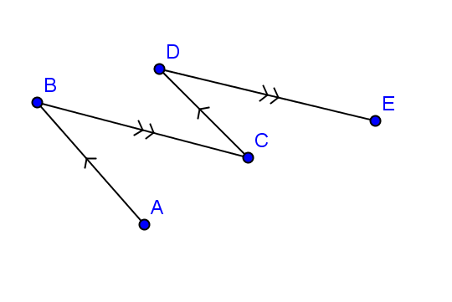In the figure to the right, and .  
   Prove that .

*When two parallel lines are cut by a transversal, the alternate interior angles are equal in measure.*

*When two parallel lines are cut by a transversal, the alternate interior angles are equal in measure.*

*Substitution property of equality*

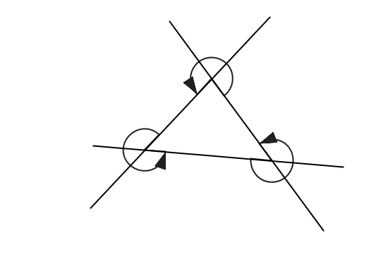

1. The figure to the right, prove that the sum of the angles marked by arrows is .

(You will need to write in several labels into the diagram for this proof.)

Angles at a point sum to

Angles at a point sum to

Angles at a point sum to

Substitution property of equality

Sum of the angle measures in a triangle is

Subtraction property of equality

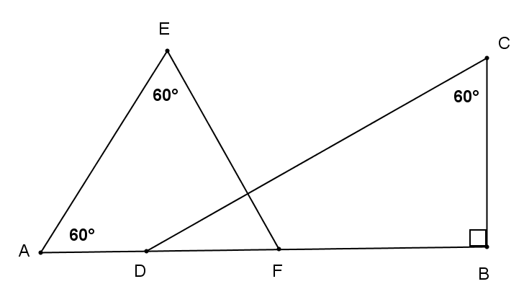

1. In the figure to the right, prove that .

Draw in label .

*Sum of the angle measures in a triangle is*

*Subtraction property of equality*

*Sum of the angle measures in a triangle is*

*Subtraction property of equality*

*Sum of the angles of a triangle equals .*

*Subtraction property of equality*

*Perpendicular lines form angles.*

Exit Ticket (5 minutes)

Name Date

Lesson 9: Unknown Angle Proofs—Writing Proofs

Exit Ticket

In the diagram to the right, prove that the sum of the labeled angles is .

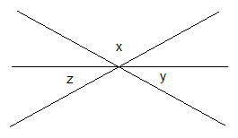

**Exit Ticket Sample Solutions**



***w***

In the diagram to the right, prove that the sum of the labeled angles is .

Label , vertical to

*Vertical angles are equal in measure.*

*Angles on a line sum to*

*Substitution property of equality*

**Problem Set Sample Solutions**

1. In the figure to the right, prove that .

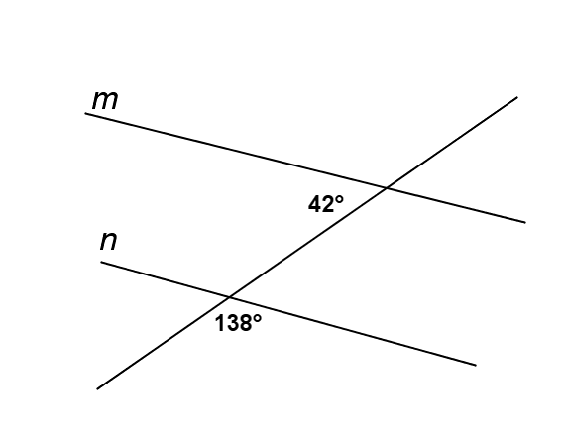

***a***

***b***

*Linear pairs form supplementary angles.*

*Vertical angles are equal in measure.*

*Subtraction property of equality*

*Substitution property of equality*

*If two lines are cut by a transversal such that a pair of alternate interior angles are equal in meaure, then the lines are parallel*

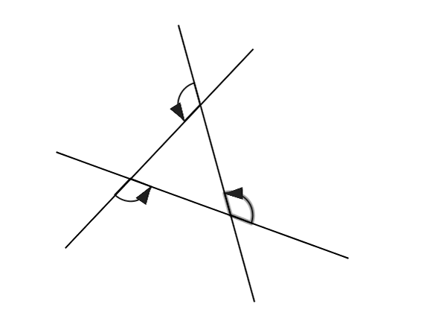

***a°***

***b°***Type equation here.

***c°***

***d°***

***e°***

***f°***

1. In the diagram to the right, prove that the sum of the angles marked by arrows is .

Linear pairs form supplementary angles

Linear pairs form supplementary angles

Linear pairs form supplementary angles

Addition property of equality

Sum of the angle measures in a triangle equals

Subtraction property of equality

1. In the diagram at the right, prove that °.

*If parallel lines are cut by a transversal, then alternate interior angles are equal in measure*

*If parallel lines are cut by a transversal, then interior angles on the same side are supplementary*

*Addition of zero/additive identity property*

*Substitution property of equality*

Basic Properties Reference Chart

|  |  |  |
| --- | --- | --- |
| **Property** | **Meaning** | **Geometry Example** |
| Reflexive Property | A quantity is equal to itself. |  |
| Transitive Property | If two quantities are equal to the same quantity, then they are equal to each other. | If and , then  . |
| Symmetric Property | If a quantity is equal to a second quantity, then the second quantity is equal to the first. | If then . |
| Addition Property of Equality | If equal quantities are added to equal quantities, then the sums are equal. | If and , then  . |
| Subtraction Property of Equality | If equal quantities are subtracted from equal quantities, the differences are equal. | If and , then . |
| Multiplication Property of Equality | If equal quantities are multiplied by equal quantities, then the products are equal. | If then . |
| Division Property of Equality | If equal quantities are divided by equal quantities, then the quotients are equal. | If then . |
| Substitution Property of Equality | A quantity may be substituted for its equal. | If and ,  then . |
| Partition Property (includes “Angle Addition Postulate,” “Segments add,” “Betweenness of Points,” etc.) | A whole is equal to the sum of its parts. | If point is on , then  . |