Lesson 8: Solve for Unknown Angles—Angles in a Triangle

Classwork
Opening Exercise
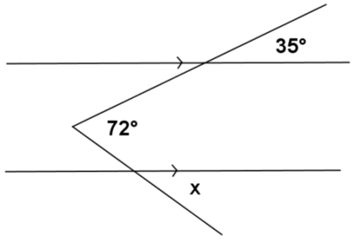
Find the measure of angle $x$ in the figure to the right. Explain your calculations. (Hint: Draw an auxiliary line segment.)

Discussion
The sum of the $3$ angle measures of any triangle is __________.
Interior of a Triangle: A point lies in the interior of a triangle if it lies in the interior of each of the angles of the triangle.
In any triangle, the measure of the exterior angle is equal to the sum of the measures of the angles. These are sometimes also known as angles.
Base angles of an triangle are equal in measure.
Each angle of an triangle has a measure equal to $60°$.

Relevant Vocabulary
Isosceles Triangle: An isosceles triangle is a triangle with at least two sides of equal length.
Angles of a Triangle: Every triangle $△ABC$ determines three angles, namely, $∠BAC$, $∠ABC$, and $∠ACB$. These are called the angles of $△ABC$.
Exterior Angle of a Triangle: Let $∠ABC$ be an interior angle of a triangle $△ABC$, and let $D$ be a point on $\overset{⃡}{AB}$ such that $B$ is between $A$ and $D$. Then $∠CBD$ is an exterior angle of the triangle $△ABC$.

Exercises
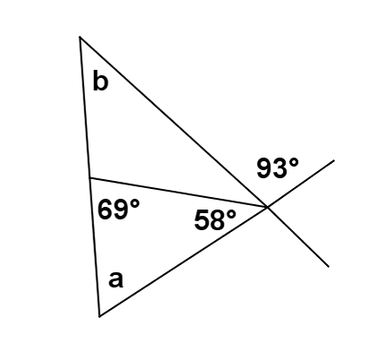
- Find the measures of $a$ and $b$ in the figure to the right. Justify your results.

In each figure, determine the measures of the unknown (labeled) angles. Give reasons for your calculations.
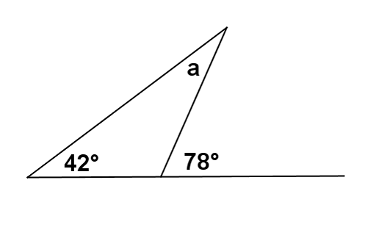 | $m∠a$ =
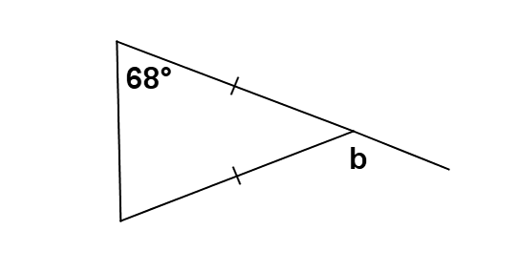 | $m∠b$ =
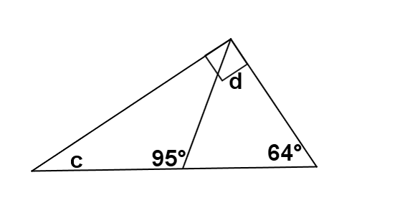 | $m∠c$ =  $m∠d$ =
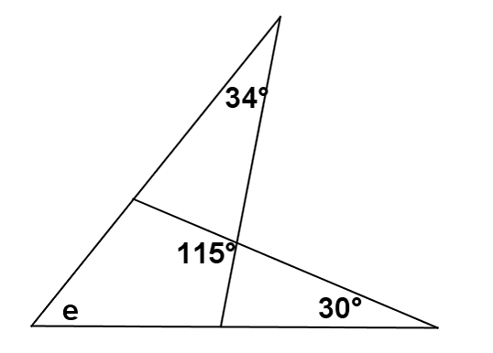 | $m∠e$ =
 | $m∠f$=
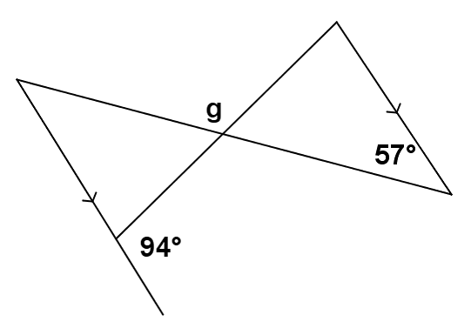 | $m∠g$ =
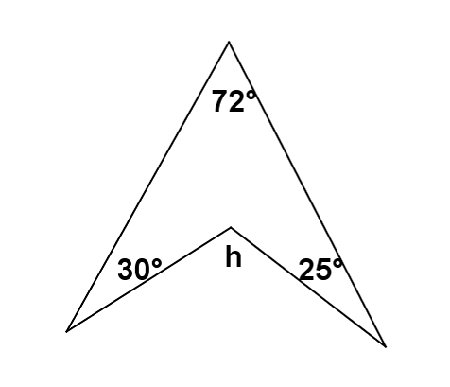 | $m∠h$ =
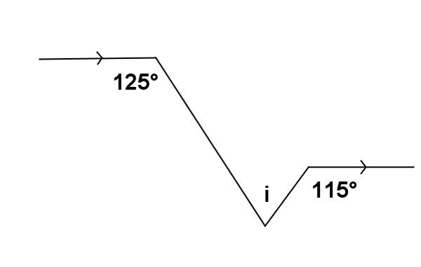 | $m∠i$ =
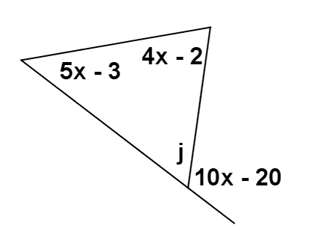 | $m∠j$ =
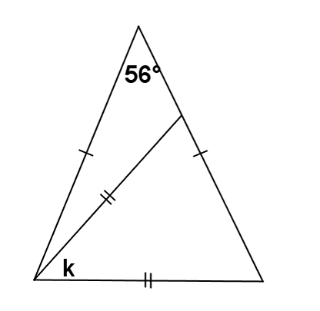 | $m∠k$ =

Problem Set

Find the unknown (labeled) angle in each figure. Justify your calculations.
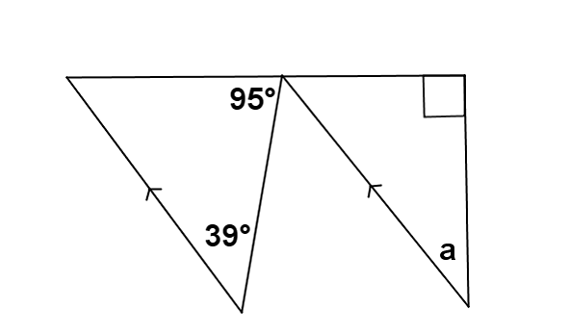 | $m∠k$ =
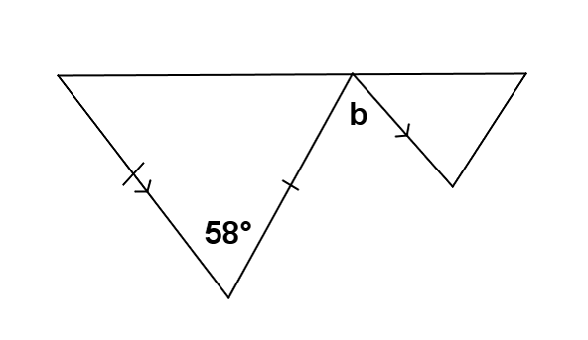 | $m∠k$ =
 | $m∠k$ =

