Lesson 8: Solve for Unknown Angles—Angles in a Triangle

Student Outcome
- Students review formerly learned geometry facts and practice citing the geometric justifications regarding angles in a triangle in anticipation of unknown angle proofs.

Lesson Notes
In Lesson 8, the unknown angle problems expand to include angles in triangles. Knowing how to solve for unknown angles involving lines and angles at a point, angles involving transversals, and angles in triangles, students are prepared to solve unknown angles in a variety of diagrams.
Check the justifications students provide in their answers. The next three lessons on unknown angle proofs depend even more on these justifications.

Classwork
Opening Exercise (5 minutes)
Review the Problem Set from Lesson 7; students will also attempt a review question from Lesson 7 below.
Opening Exercise
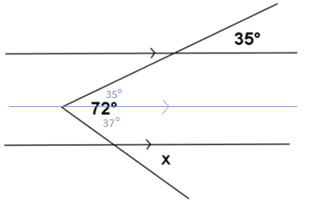
Find the measure of angle $x$ in the figure to the right. Explain your calculations. (Hint: Draw an auxiliary line segment.)
$$m∠x=37°$$
MP.7

Discussion (5 minutes)
Review facts about angles in a triangle.
Discussion
The sum of the $3$ angle measures of any triangle is $180°$.
Interior of a Triangle: A point lies in the interior of a triangle if it lies in the interior of each of the angles of the triangle.
In any triangle, the measure of the exterior angle is equal to the sum of the measures of the opposite interior angles. These are sometimes also known as remote interior angles.
Base angles of an isosceles triangle are equal in measure.
Each angle of an equilateral triangle has a measure equal to $60°$.
Relevant Vocabulary (2 minutes)
Relevant Vocabulary
Isosceles Triangle: An isosceles triangle is a triangle with at least two sides of equal length.
Angles of a Triangle: Every triangle $△ABC$ determines three angles, namely, $∠BAC$, $∠ABC$, and $∠ACB$. These are called the angles of $△ABC$.
Exterior Angle of a Triangle: Let $∠ABC$ be an interior angle of a triangle $△ABC$, and let $D$ be a point on $\overset{⃡}{AB}$ such that $B$ is between $A$ and $D$. Then $∠CBD$ is an exterior angle of the triangle $△ABC$.

Use a diagram to remind students that an exterior angle of a triangle forms a linear pair with an adjacent interior angle of the triangle.

Exercises (30 minutes)
Students try an example based on the Discussion, and review as a whole class.
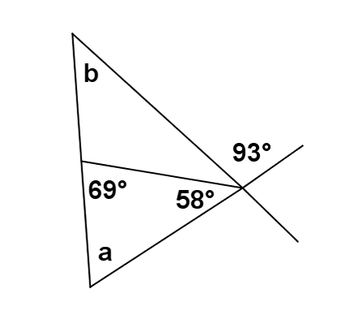
Exercises
- Find the measures of angles $a$ and $b$ in the figure to the right. Justify your results.
$$m∠a=53°$$
$$m∠b=40°$$

In each figure, determine the measures of the unknown (labeled) angles. Give reasons for your calculations.
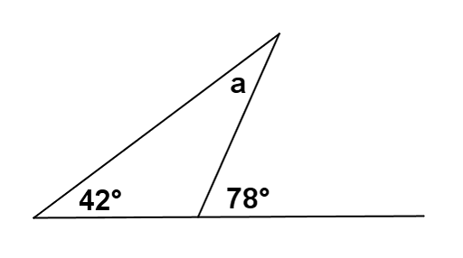 | $m∠a=36°$  Exterior angle of a triangle equals the sum of the two interior opposite angles
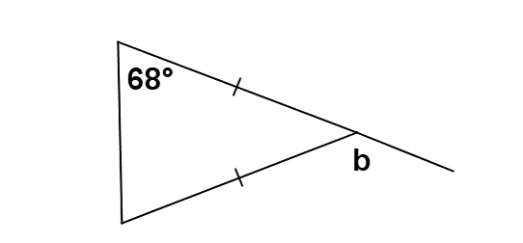 | $mb=136°$  The base angles of an isosceles triangle are equal in measure;  The sum of the angle measures in a triangle is $180°$;  Linear pairs form supplementary angles
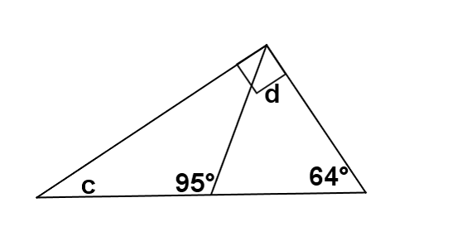 | $m∠c=26°$  The sum of the angle measures in a triangle is $180°$  $$m∠d=31°$$  Linear pairs form supplementary angles;  The sum of the angle measures in a triangle is $180°$

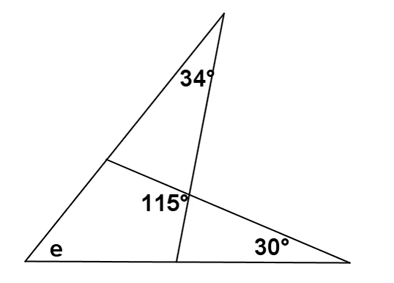 | $m∠e=51°$  Linear pairs form supplementary angles;  The sum of the angle measures in a triangle is $180°$
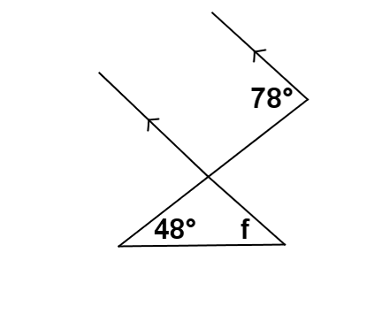 | $m∠f=30°$  If parallel lines are cut by a transversal, then corresponding angles are equal in measure;  Linear pairs form supplementary angles;  The sum of the angle measures in a triangle is $180°$
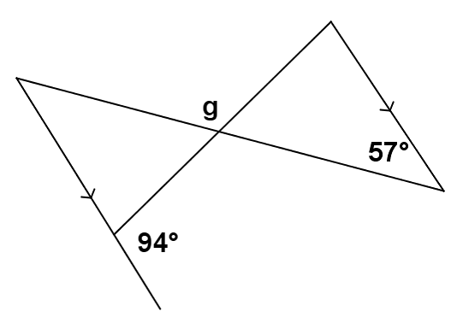 | $m∠g= 143°$  If parallel lines are cut by a transversal, then alternate interior angles are equal in measure;  Linear pairs form supplementary angles;  The sum of the angle measures in a triangle is $180°$
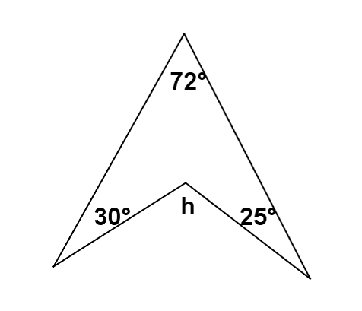 | $m∠h=127°$  Draw an auxiliary line, then use the facts that linear pairs form supplementary angles and the sum of the angle measures in a triangle is $180°$
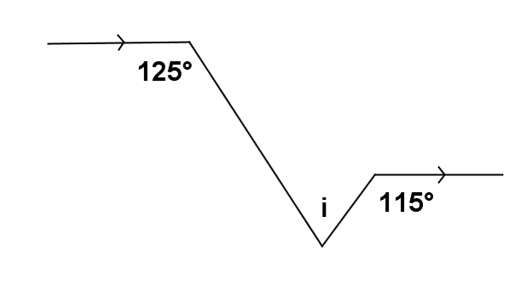 | $m∠i=60°$  If parallel lines are cut by a transversal, then alternate interior angles are equal in measure;  Linear pairs form supplementary angles (twice);  Sum of the angle measures in a triangle is $180˚$

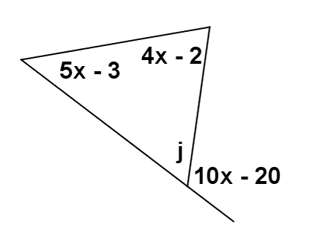 | $$m∠j=50°$$  If parallel lines are cut by a transversal, the alternate interior angles are equal in measure;  Linear pairs form supplementary angles
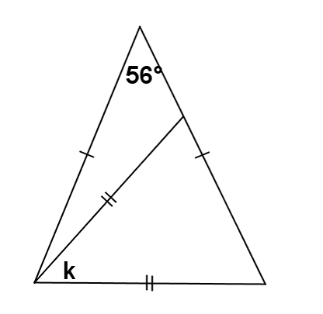 | $$m∠k=56°$$

Exit Ticket (3 minutes)

Name ___________________________________________________ Date____________________
Lesson 8: Solve for Unknown Angles—Angles in a Triangle

Exit Ticket

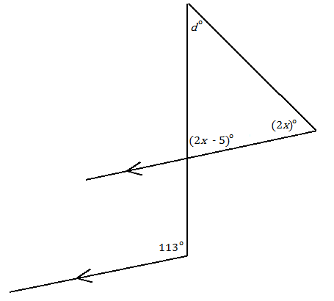
Find the value of $d$ and $x$.

$d=$ ________

$x=$ ________

Exit Ticket Sample Solutions
Find the value of $d$ and $x$.

$$d=41$$
$$x=36$$

Problem Set Sample Solutions

Find the unknown (labeled) angle in each figure. Justify your calculations.
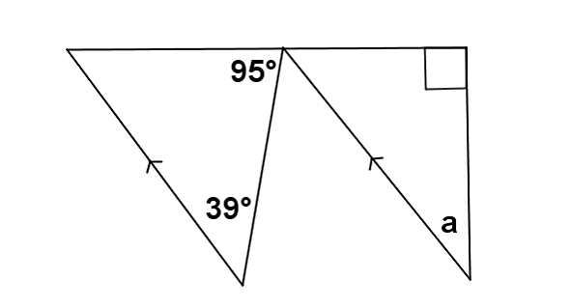 | $m∠a=44°$  If parallel lines are cut by a transversal, then alternate interior angles are equal in measure;  Linear pairs form supplementary angles;  Sum of the angle measures in a triangle equals $180°$
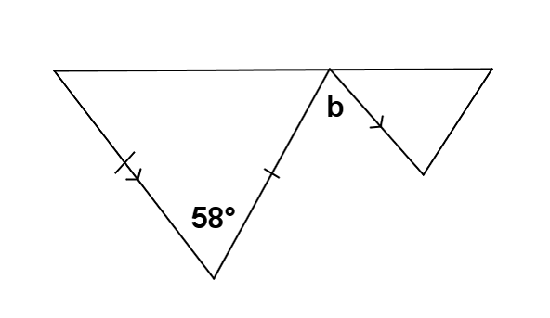 | $m∠b=58°$  If parallel lines are cut by a transversal, then alternate interior angles are equal in measure
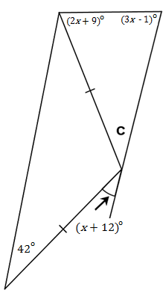 | $m∠c=47°$  The base angles of an isosceles triangle are equal in measure;  Sum of the angle measures in a triangle is $180°$;  Exterior angle of a triangle equals the sum of the two interior opposite angles;  Sum of the angle measures in a triangle is $180°$

