Lesson 7: Solve for Unknown Angles—Transversals

Student Outcomes
- Students review formerly learned geometry facts and practice citing the geometric justifications in anticipation of unknown angle proofs.

Lesson Notes
The focus of the second day of unknown angle problems is problems with parallel lines crossed by a transversal.
This lesson features one of the main theorems (facts) learned in Grade 8:
- If two lines are cut by a transversal and corresponding angles are equal, then the lines are parallel.
- If parallel lines are cut by a transversal, corresponding angles are equal. (This second part is often called the parallel postulate, which tells us a property that parallel lines have that cannot be deduced from the definition of parallel lines.)
Of course, students probably remember these two statements as a single fact: For two lines cut by a transversal, the measures of corresponding angles are equal if and only if the lines are parallel. Decoupling these two statements from the unified statement will be the work of later lessons.
The lesson begins with review material from Lesson 6. In the Discussion and Examples, students review how to identify and apply corresponding angles, alternate interior angles, and same-side interior angles. The key is to make sense of the structure within each diagram.
MP.7
Before moving on to the Exercises, students learn examples of how and when to use auxiliary lines. Again, the use of auxiliary lines is another opportunity for students to make connections between facts they already know and new information. The majority of the lesson involves solving problems. Gauge how often to prompt and review answers as the class progresses; check to see whether facts from Lesson 6 are fluent. Encourage students to draw in all necessary lines and congruent angle markings to help assess each diagram. The Problem Set should be assigned in the last few minutes of class.

Classwork
Opening Exercise (4 minutes)
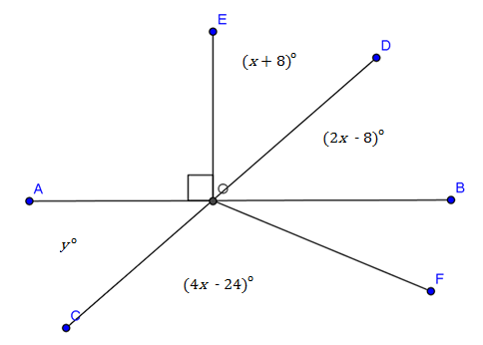
Opening Exercise
Use the diagram at the right to determine $x$ and $y$. $\overset{⃡}{AB}$ and $\overset{⃡}{CD}$ are straight lines.
$$x=30$$
$$y=52$$
Name a pair of vertical angles:
$∠AOC$, $∠DOB$
Find the measure of $∠BOF$. Justify your calculation.
$m∠BOF=32°$, Linear pairs form supplementary angles

Discussion (4 minutes)
Review the angle facts pertaining to parallel lines crossed by a transversal. Ask students to name examples that illustrate each fact:
Discussion
Given line $AB$ and line $CD$ in a plane (see the diagram below), a third line $EF$ is called a transversal if it intersects $\overset{⃡}{AB}$ at a single point and intersects $\overset{⃡}{CD}$ at a single but different point. Line $AB$ and line $CD$ are parallel if and only if the following types of angle pairs are congruent or supplementary:
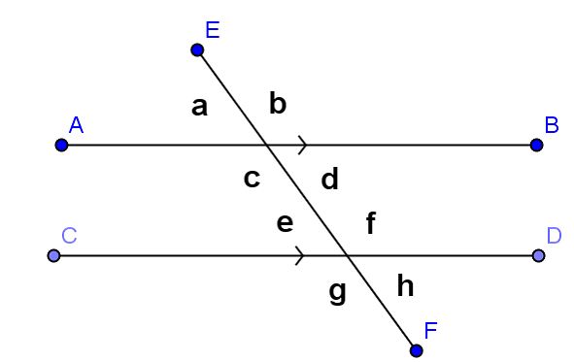
- Corresponding angles are equal in measure
$∠a$ and $∠e$ , $∠d$ and $∠h$, etc.
- Alternate interior angles are equal in measure
$∠c$and $∠f$, $∠d$ and $∠e$

- Same-side interior angles are supplementary
$∠c$ and $∠e$, $∠d$ and $∠f$

Examples (8 minutes)
Students try examples based on the Discussion; review, then discuss auxiliary line.
Examples
MP.7
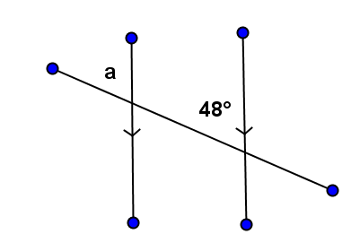 | 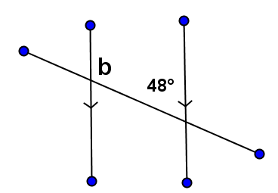
$$m∠a=48°$$ | $$m∠b=132°$$
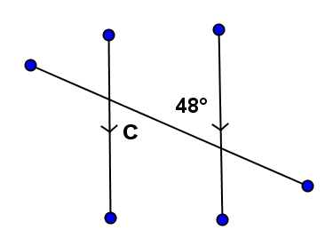 | 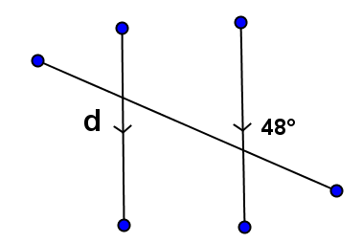
$$m∠c=48°$$ | $$m∠d=48°$$
- An auxiliary line is sometimes useful when solving for unknown angles.
In this figure, we can use the auxiliary line to find the measures of $∠e$ and $∠f$ (how?), then add the two measures together to find the measure of $∠W$.
What is the measure of $∠W$?
$m∠e=41°$,$m∠f=35°$,$m∠W=76°$

Exercises (24 minutes)
Students work on this set of exercises; review periodically.
Exercises
In each exercise below, find the unknown (labeled) angles. Give reasons for your solutions.
MP.7
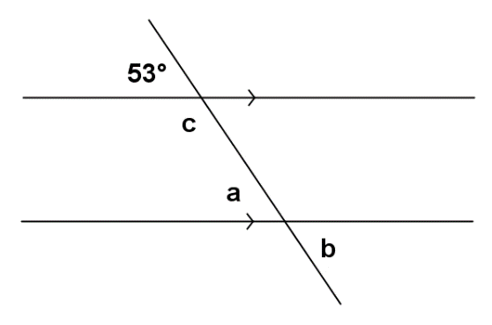 | $m∠a=53°$, If parallel lines are cut by a transversal, then corresponding angles are equal in measure  $m∠b=53°$, Vertical angles are equal in measure  $m∠c=127°$, If parallel lines are cut by a transversal, then interior angles on the same side are supplementary

MP.7
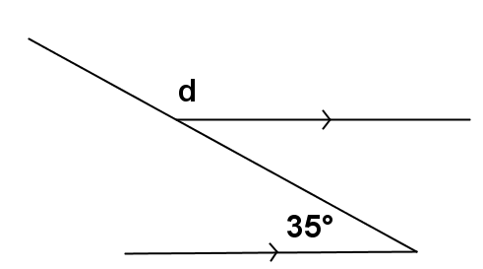 | $m∠d=145°$, Linear pairs form supplementary angles;  If parallel lines are cut by a transversal, then alternate interior angles are equal in measure
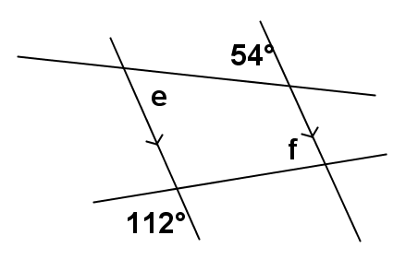 | $m∠e=54°$, If parallel lines are cut by a transversal, then alternate interior angles are equal in measure  $m∠f=68°$, Vertical angles are equal in measure;  If parallel lines are cut by a transversal, then interior angles on the same side are supplementary
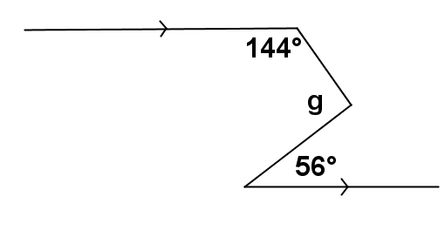 | $m∠g=92°$, Vertical angles are equal in measure;  If parallel lines are cut by a transversal, then interior angles on the same side are supplementary
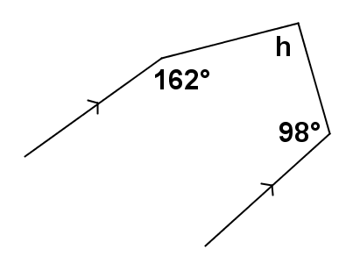 | $m∠h=100°$, If parallel lines are cut by a transversal, then interior angles on the same side are supplementary
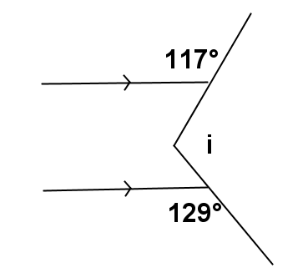 | $m∠i=114°$, Linear pairs form supplementary angles;  If parallel lines are cut by a transversal, then alternate interior angles are equal in measure
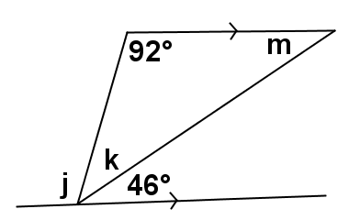 | $m∠j=92°$, If parallel lines are cut by a transversal, then alternate interior angles are equal in measure  $m∠k=42°$, Consecutive adjacent angles on a line sum to $180°$  $m∠m=46°$, If parallel lines are cut by a transversal, then alternate interior angles are equal in measure
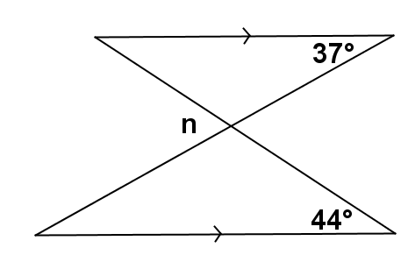 | $m∠n=81°$, If parallel lines are cut by a transversal, then corresponding angles are equal in measure
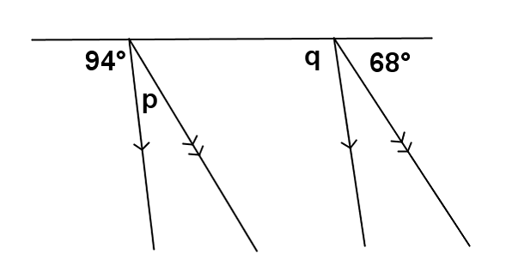  MP.7 | $m∠p=18°$, Consecutive adjacent angles on a line sum to $180°$  $m∠q=94°$, If parallel lines are cut by a transversal, then corresponding angles are equal in measure
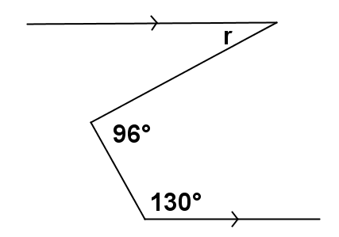 | $m∠r=46°$, If parallel lines are cut by a transversal, then interior angles on the same side are supplementary; If parallel lines are cut by a transversal, then alternate interior angles are equal in measure

Relevant Vocabulary
Relevant Vocabulary
Alternate Interior Angles: Let line $t$be a transversal to lines $l$ and $m$ such that $t$intersects $l$ at point $P$and intersects $m$ at point $Q$. Let $R$ be a point on line $l$ and $S$ be a point on line $m$ such that the points $R$ and $S$ lie in opposite half-planes of $t$. Then $∠RPQ$ and $∠PQS$ are called alternate interior angles of the transversal $t$ with respect to line $m$ and line $l$.
Corresponding Angles: Let line $t$be a transversal to lines $l$ and $m$. If $∠x$ and $∠y$ are alternate interior angles, and $∠y$ and $∠z$ are vertical angles, then $∠x$ and $∠z$ are corresponding angles.

Exit Ticket (5 minutes)

Name ___________________________________________________ Date____________________
Lesson 7: Solving for Unknown Angles—Transversals

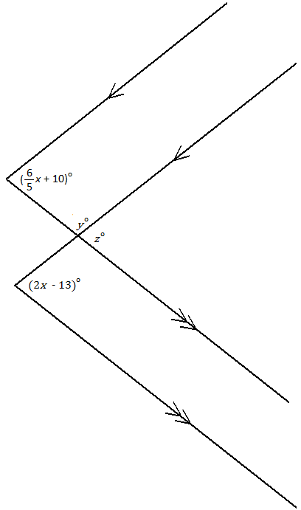
Exit Ticket

Determine the value of each variable.

$x=$
$y=$
$z=$

Exit Ticket Sample Solutions
Determine the value of each variable.

$$x=28.75$$
$$y=135.5$$
$$z=44.5$$

Problem Set Sample Solutions

Find the unknown (labeled) angles. Give reasons for your solutions.
MP.7
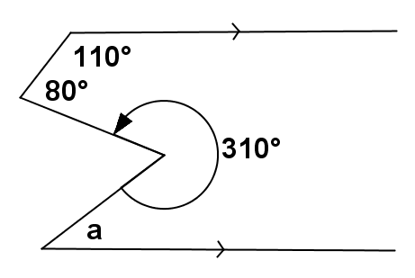 | $m∠a=40°$, If parallel lines are cut by a transversal, then alternate interior angles are equal in measure
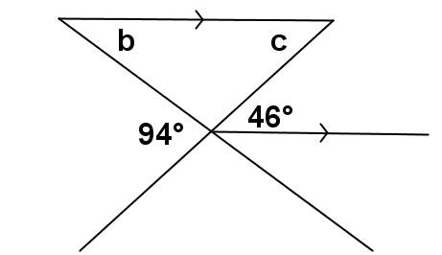 | $m∠b=48°$, If parallel lines are cut by a transversal, then corresponding angles are equal in measure  $m∠c=46°$, Vertical angles are equal in measure;  If parallel lines are cut by a transversal, then corresponding angles are equal in measure

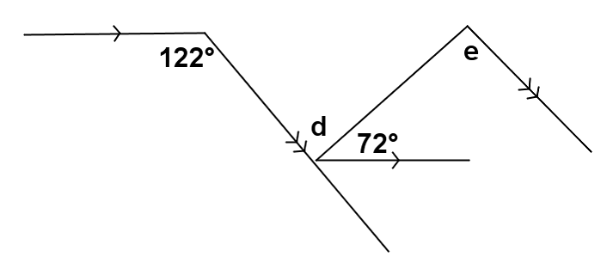 | $m∠d=50°$, If parallel lines are cut by a transversal, then alternate interior angles are equal in measure  $m∠e=50°$, If parallel lines are cut by a transversal, then alternate interior angles are equal in measure
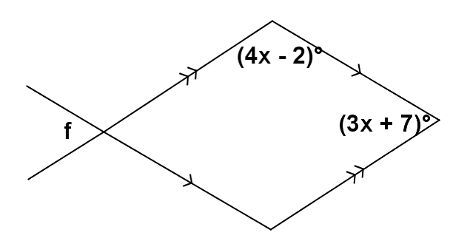 | $m∠f=82°$, If parallel lines are cut by a transversal, then interior angles on the same side are supplementary;  Vertical angles are equal in measure
MP.7

