Lesson 7: Solve for Unknown Angles—Transversals

Classwork
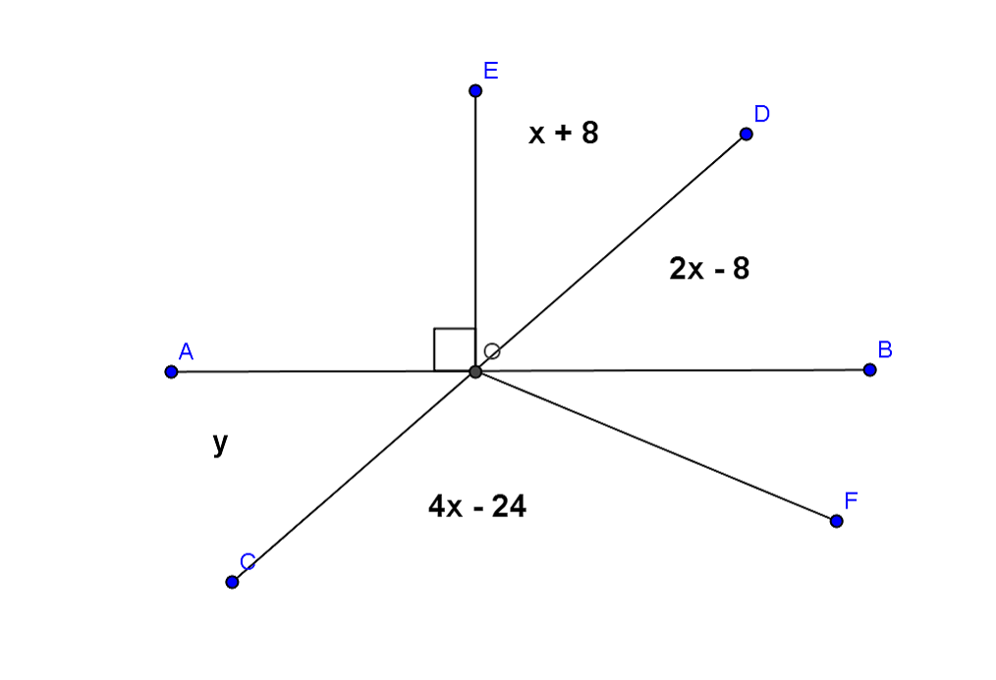
Opening Exercise
Use the diagram at the right to determine $x$ and $y$. $\overset{⃡}{AB}$ and $\overset{⃡}{CD}$ are straight lines.
$x=$
$y=$
Name a pair of vertical angles:

Find the measure of $∠BOF$. Justify your calculation.

Discussion
Given line $AB$ and line $CD$ in a plane (see the diagram below), a third line $EF$ is called a transversal if it intersects $\overset{⃡}{AB}$ at a single point and intersects $\overset{⃡}{CD}$ at a single but different point. Line $AB$ and line $CD$ are parallel if and only if the following types of angle pairs are congruent or supplementary.

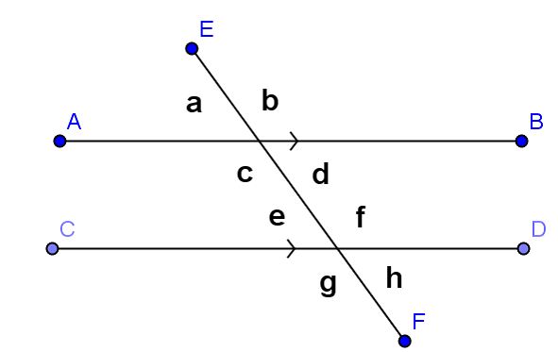
- Corresponding angles are equal in measure

- Alternate interior angles are equal in measure

- Same side interior angles are supplementary

Examples
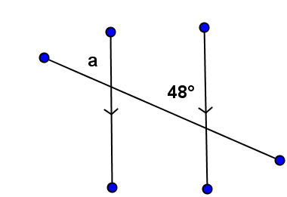 | 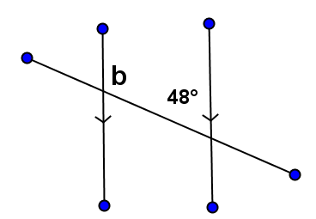
$m∠a$ = | $m∠b$ =
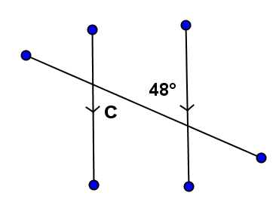 | 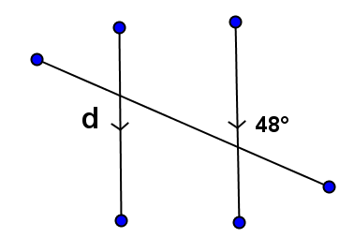
$m∠c$ = | $m∠d$ =

- An _________________________________is sometimes useful when solving for unknown angles.
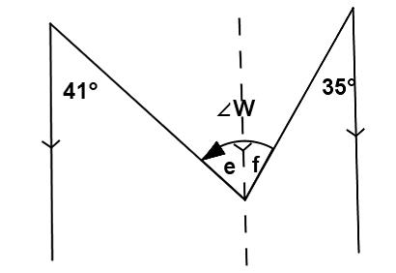
In this figure, we can use the auxiliary line to find the measures of $∠e$ and $∠f$ (how?), then add the two measures together to find the measure of $∠W$.
What is the measure of $∠W$?

Exercises
In each exercise below, find the unknown (labeled) angles. Give reasons for your solutions.
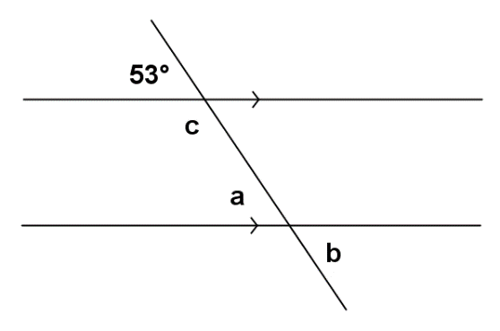 | $m∠a$ =  $m∠b$ =  $m∠c$ =
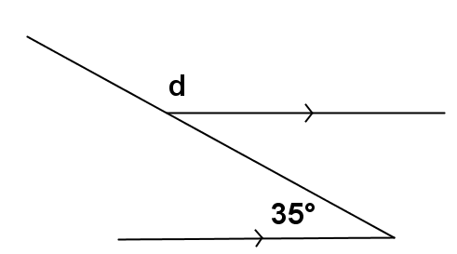 | $m∠d$ =
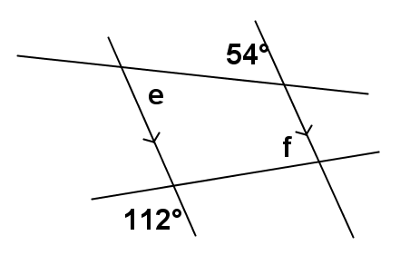 | $m∠e$ =  $m∠f$ =
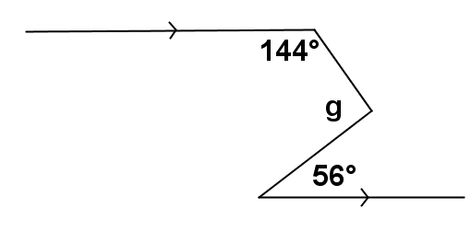 | $m∠g$ =
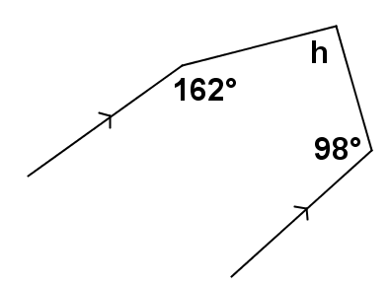 | $m∠h$ =
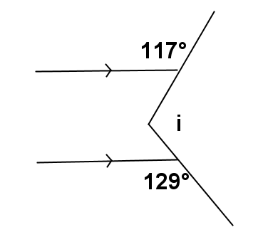 | $m∠i$ =
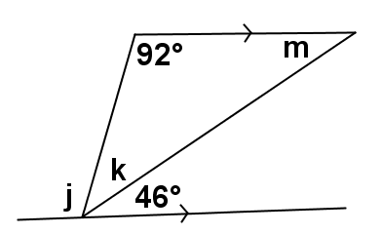 | $m∠j$ =  $m∠k$ =  $m∠m$=
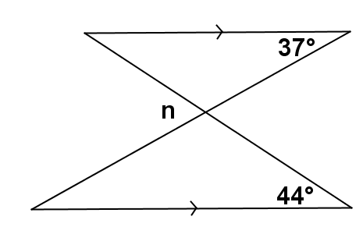  MP.7 | $m∠n$ =
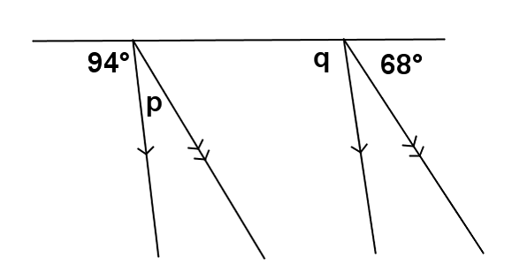 | $m∠p$ =  $m∠q$ =
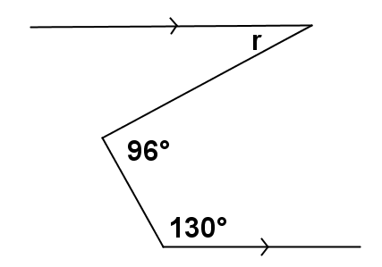 | $m∠r$ =

Relevant Vocabulary
Alternate Interior Angles: Let line $t$be a transversal to lines $l$ and $m$ such that $t$intersects $l$ at point $P$and intersects $m$ at point $Q$. Let $R$ be a point on line $l$ and $S$ be a point on line $m$ such that the points $R$ and $S$ lie in opposite half-planes of $t$. Then $∠RPQ$ and $∠PQS$ are called alternate interior angles of the transversal $t$ with respect to line $m$ and line $l$.
Corresponding Angles: Let line $t$be a transversal to lines $l$ and $m$. If $∠x$ and $∠y$ are alternate interior angles, and $∠y$ and $∠z$ are vertical angles, then $∠x$ and $∠z$ are corresponding angles.

Problem Set

Find the unknown (labeled) angles. Give reasons for your solutions.
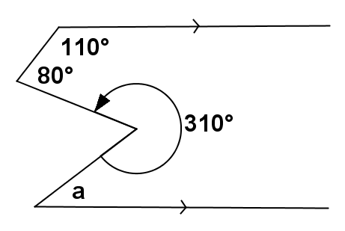 | $m∠a$ =
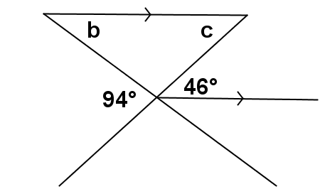 | $m∠b$ =  $m∠c$ =
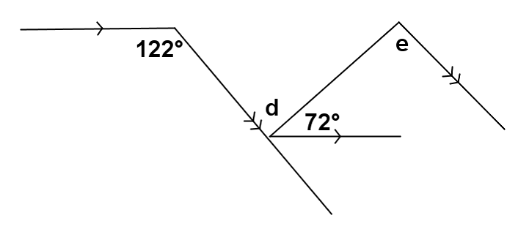 | $m∠d$ =  $m∠e$ =
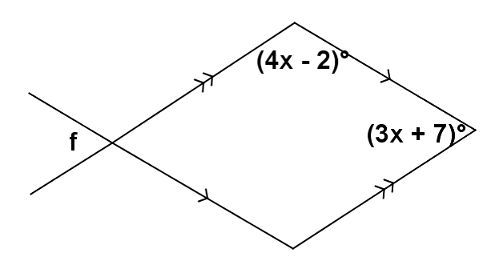 | $m∠f$ =

