Lesson 6: Solve for Unknown Angles—Angles and Lines at a Point

Classwork
Opening Exercise
Determine the measure of the missing angle in each diagram.
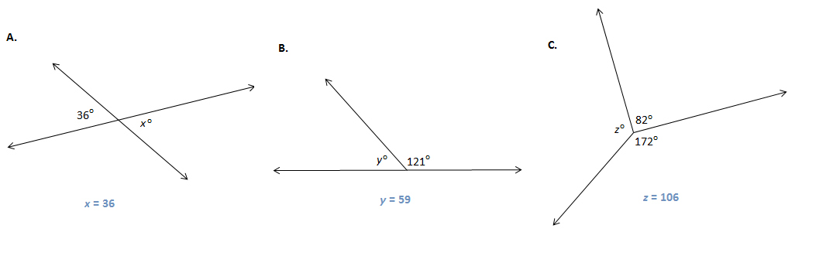

What facts about angles did you use?

Discussion
Two angles $AOC$ and $COB$, with a common side $\vec{OC}$, are if $C$belongs to the interior of $∠AOB$. The sum of angles on a straight line is $180°$ and two such angles are called a linear pair. Two angles are called supplementary if the sum of their measures is , two angles are called complementary if the sum of their measures is . Describing angles as supplementary or complementary refers only to the measures of their angles. The positions of the angles or whether the pair of angles is adjacent to each other is not part of the definition.

In the figure, line segment $AD$ is drawn.
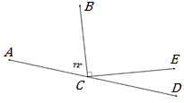
Find $m∠DCE.$

The total measure of adjacent angles around a point is .
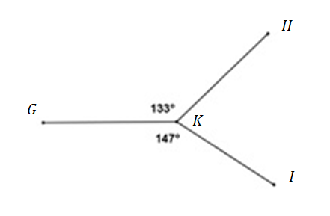
Find the measure of $m∠HKI$.

Vertical angles have measure. Two angles are vertical if their sides form opposite rays.
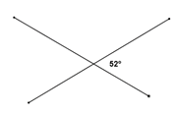
Find $m∠TRV$.
$$V$$
$$T$$
$$R$$
$$S$$
$$U$$

Example 1
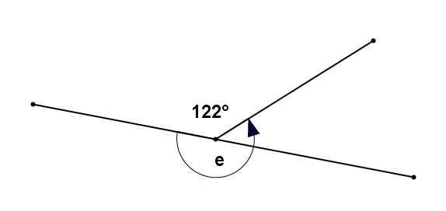
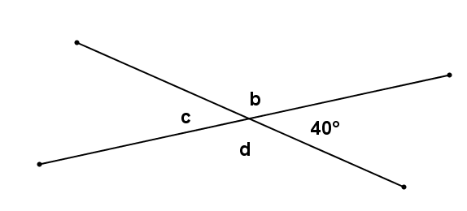
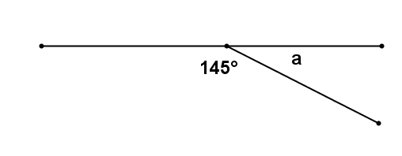
Find the measures of each labeled angle. Give a reason for your solution.

Angle | Angle measure | Reason
$$a$$
$$b$$
$$c$$
$$d$$
$$e$$

Exercises 1–12
In the figures below, $\overline{AB}$, $\overline{CD}$, and $\overline{EF}$ are straight-line segments. Find the measure of each marked angle or find the unknown numbers labeled by the variables in the diagrams. Give reasons for your calculations. Show all the steps to your solutions.
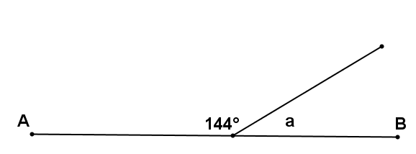
$a=$

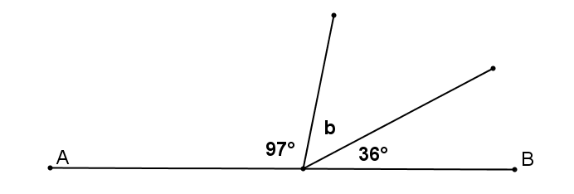

$b=$

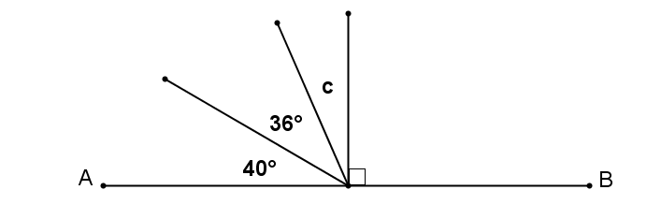

$c=$

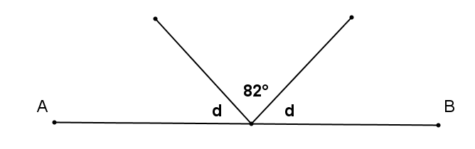

$d=$

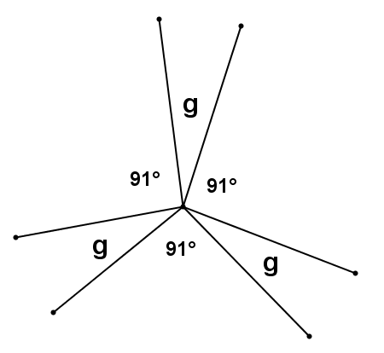

$g=$

For Problems 6–12, find the values of $x$ and $y$. Show all work.
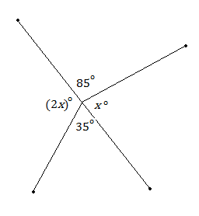
$x=$

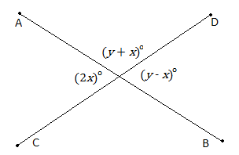

$y$ = $x$ =

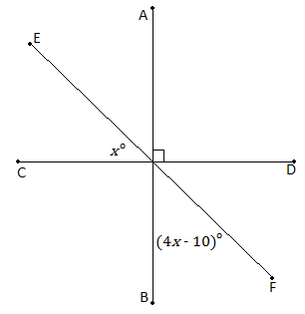
$x$=

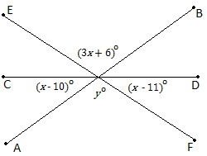
$x$ =

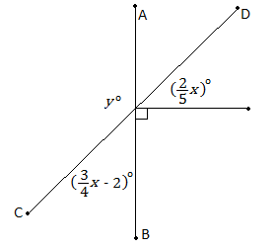

$x$ = $y$ =

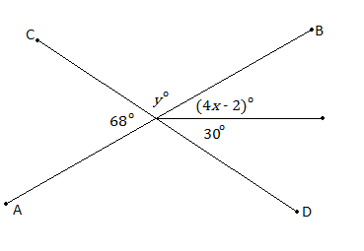

$x$ =

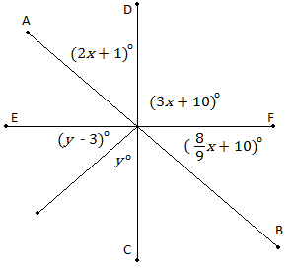

$x$ = $y$ =

Relevant Vocabulary
Straight Angle: If two rays with the same vertex are distinct and collinear, then the rays form a line called a straight angle.
Vertical Angles: Two angles are vertical angles (or vertically opposite angles) if their sides form two pairs of opposite rays.
Problem Set

In the figures below, $\overline{AB}$ and $\overline{CD}$ are straight line segments. Find the value of $x$ and/or $y$ in each diagram below. Show all the steps to your solution and give reasons for your calculations.

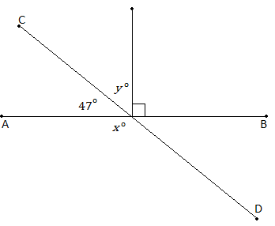
$x$ =

$y$ =

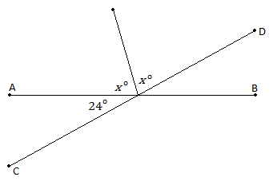

$x$ =

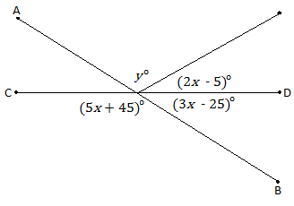
3. $x$ =

$y$ =

