|  |
| --- |
|  |

Lesson 6: Solve for Unknown Angles—Angles and Lines at a Point

**Student Outcomes**

* Students review formerly learned geometry facts and practice citing the geometric justifications in anticipation of unknown angle proofs.

Lesson Notes

Lessons 1–5 serve as a foundation for the main subject of this module, which is congruence. By the end of the unknown angles lessons (Lessons 6–8), students will start to develop fluency in two areas: (1) solving for unknown angles in diagrams and (2) justifying each step or decision in the proof-writing process of unknown angle solutions.

The “missing-angle problems” in this topic occur in many American geometry courses and play a central role in some Asian curricula. A missing-angle problem asks students to use several geometric facts together to find angle measures in a diagram. While the simpler problems require good, purposeful recall and application of geometric facts, some problems are complex and may require ingenuity to solve. Historically, many geometry courses have not expected this level of sophistication. Such courses would not have demanded that students use their knowledge constructively but rather to merely regurgitate information. The missing-angle problems are a step up in problem solving. Why do we include them at this juncture in this course? The main focal points of these opening lessons are to recall or refresh and supplement existing conceptual vocabulary, to emphasize that work in geometry involves reasoned explanations, and to provide situations and settings that support the need for reasoned explanations and that illustrate the satisfaction of building such arguments.

Lesson 6 is problem set based and focuses on solving for unknown angles in diagrams of angles and lines at a point. By the next lesson, students should be comfortable solving for unknown angles numerically or algebraically in diagrams involving supplementary angles, complementary angles, vertical angles, and adjacent angles at a point. As always, vocabulary is critical and students should be able to define the relevant terms themselves. It may be useful to draw or discuss counterexamples of a few terms and ask students to explain why they do not fit a particular definition.

As students work on problems, encourage them to show each step of their work and to list the geometric reason for each step. (e.g., “Vertical angles have equal measure.”) This will prepare students to write a reason for each step of their unknown angle proofs in a few days.

A chart of common facts and discoveries from middle school that may be useful for student review or supplementary instruction is included at the end of this lesson. The chart includes abbreviations students may have previously seen in middle school, as well as more widely recognized ways of stating these ideas in proofs and exercises.

Classwork

Opening Exercise (5 minutes)

Ask students to find the missing angles in these diagrams. The exercise will remind students of the basics of determining missing angles that they learned in middle school. Discuss the facts that student recall and use these as a starting point for the lesson.

Opening Exercise

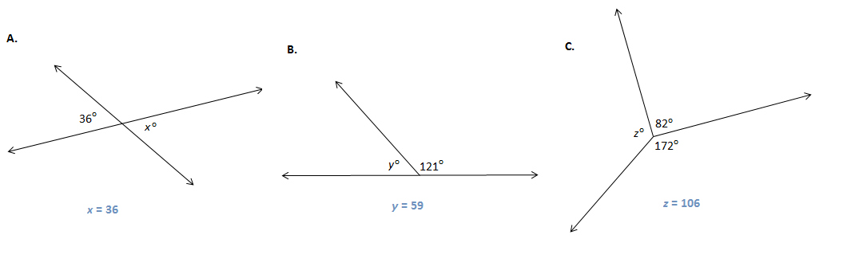Determine the measure of the missing angle in each diagram.

What facts about angles did you use?

Answers may include: vertical angles are equal in measure, linear pairs form supplementary angles, angles at a point sum to .

Discussion (4 minutes)

Discussion

Two angles and , with a common side , are **adjacent angles**  if belongs to the interior of . The sum of angles on a straight line is and two such angles are called a linear pair. Two angles are called supplementary if the sum of their measures is  **;** two angles are called complementary if the sum of their measures is . Describing angles as supplementary or complementary refers only to the measures of their angles. The positions of the angles or whether the pair of angles is adjacent to each other is not part of the definition.

**MP.6**

In the figure, line segment is drawn.

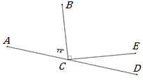

Find

The total measure of adjacent angles around a point is *.*

Find the measure of .

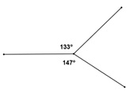

Vertical angles have **equal** measure. Two angles are vertical if their sides form opposite rays.

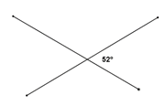Find .

Example 1 (6 minutes)

Example 1

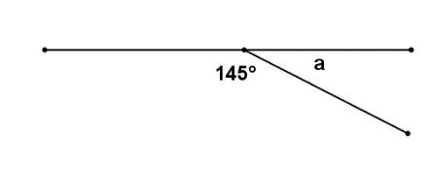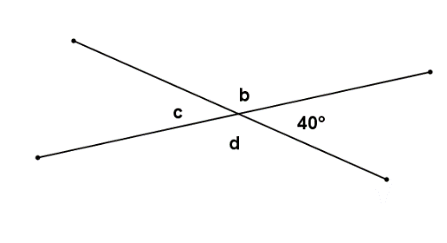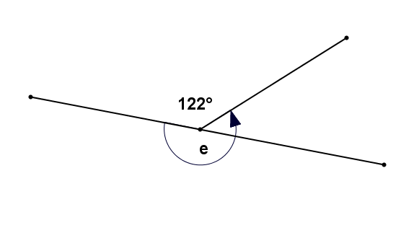

Find the measure of each labeled angle. Give a reason for your solution.

|  |  |  |
| --- | --- | --- |
| Angle | Angle measure | Reason |
| ∠a |  | Linear pairs form supplementary angles. |
| ∠b |  | Linear pairs form supplementary angles. |
| ∠c |  | Vertical angles are equal in measure. |
| ∠d |  | Linear pairs form supplementary angles or vertical angles are  equal in measure. |
| ∠e |  | Angles at a point sum to degrees. |

Exercises (25 minutes)

Exercises

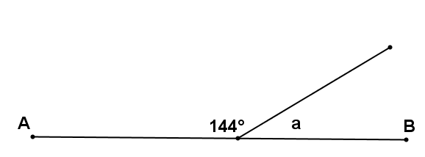In the figures below, , , and are straight-line segments. Find the measure of each marked angle or find the unknown numbers labeled by the variables in the diagrams. Give reasons for your calculations. Show all the steps to your solutions.

**MP.7**

|  |  |
| --- | --- |
|  | *Linear pairs form supplementary angles.* |
|  | *Consecutive adjacent angles on a line sum to .* |
|  | *Consecutive adjacent angles on a line sum to .* |
|  | *Consecutive adjacent angles on a line sum to .* |
|  | *Angles at a point sum to .* |

For Exercises 6–12, find the values of and . Show all work.

**MP.7**

|  |  |  |
| --- | --- | --- |
|  | Angles at a point add up to . | |
|  | ;  Vertical angles are equal in measure. Angles at a point sum to . | |
|  | Vertical angles have equal measures.  Consecutive adjacent angles on a line sum to . | |
|  | ;  Vertical angles are equal in measure. Angles at a point sum to . |
|  | ;  Consecutive adjacent angles on a line sum to . |

|  |  |
| --- | --- |
|  | ;  Consecutive adjacent angles on a line sum to . Vertical angles are equal in measure. |
| 12. | ;  Consecutive adjacent angles on a line sum to . Vertical angles are equal in measure |

**MP.7**

Relevant Vocabulary

Relevant Vocabulary

Straight Angle: If two rays with the same vertex are distinct and collinear, then the rays form a line called a *straight angle*.

Vertical Angles: Two angles are *vertical angles* (or vertically opposite angles) if their sides form two pairs of opposite rays.

Exit Ticket (5 minutes)

Name ___________________________________________________ Date____________________

Lesson 6: Solve for Unknown Angles—Angles and Lines at a Point

Exit Ticket

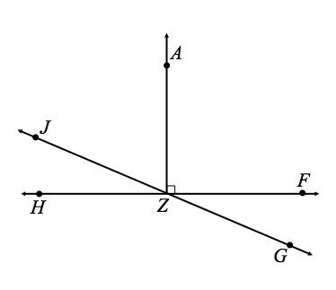Use the following diagram to answer the questions below:

* 1. Name an angle supplementary to and provide the reason for your calculation.
  2. Name an angle complementary to and provide the reason for your calculation.

1. If , what is the measure of each of the following angles? Provide reasons for your calculations.

Exit Ticket Sample Solutions

Use the following diagram to answer the questions below:

* 1. Name an angle supplementary to and provide the reason for your calculation.

or ; Linear pairs form supplementary angles.

* 1. Name an angle complementary to and provide the reason for your calculation.

; The angles sum to .

1. If , what is the measure of each of the following angles? Provide reasons for your calculations.

Problem Set Sample Solutions

In the figures below, and are straight line segments. Find the value of and/or in each diagram below. Show all the steps to your solution and give reasons for your calculations.

|  |  |
| --- | --- |
|  | Angle addition postulate; Linear pairs form supplementary angles |

|  |  |  |
| --- | --- | --- |
|  | Consecutive adjacent angles on a line sum to . | |
|  | Consecutive adjacent angles on a line sum to . Vertical angles are equal in measure |

**Key Facts and Discoveries from Earlier Grades**

|  |  |  |  |  |  |
| --- | --- | --- | --- | --- | --- |
| **Facts (With Abbreviations Used in Grades 4–9)** | | **Diagram/Example** | | **How to State as a Reason in an Exercise or Proof** | |
| Vertical angles are equal in measure.  (vert. ∠s) | |  | | “Vertical angles are equal in measure” | |
| If is a point in the interior of , then .  (∠s add) | |  | | “Angle addition postulate” | |
| Two angles that form a linear pair are supplementary.  (∠s on a line) | |  | | “Linear pairs form supplementary angles” | |
| Given a sequence of consecutive adjacent angles whose interiors are all disjoint such that the angle formed by the first angles and the last angle are a linear pair, then the sum of all of the angle measures is .  ( on a line) | |  | | “Consecutive adjacent angles on a line sum to ” | |
| The sum of the measures of all angles formed by three or more rays with the same vertex and whose interiors do not overlap is .  (∠s at a point) | |  | | “Angles at a point sum to ” | |
| **Facts (With Abbreviations Used in Grades 4–9)** | | **Diagram/Example** | | **How to State as a Reason in an Exercise or Proof** | |
| The sum of the angle measures of any triangle is .  (∠ sum of Δ) | |  | | “Sum of the angle measures in a triangle is ” | |
| When one angle of a triangle is a right angle, the sum of the measures of the other two angles is .  (∠ sum of rt. Δ) | | ; | | “Acute angles in a right triangle sum to ” | |
| The sum of the measures of two angles of a triangle equals the measure of the opposite exterior angle.  (ext. ∠ of Δ) | |  | | “Exterior angle of a triangle equals the sum of the two interior opposite angles” | |
| Base angles of an isosceles triangle are equal in measure.  (base ∠s of isos. Δ) | |  | | “Base angles of an isosceles triangle are equal in measure” | |
| All angles in an equilateral triangle have equal measure.  (equilat. Δ) | |  | | “All angles in an equilateral triangle have equal measure" | |
| **Facts (With Abbreviations Used in Grades 4–9)** | | **Diagram/Example** | | **How to State as a Reason in an Exercise or Proof** | |
| If two parallel lines are intersected by a transversal, then corrsponding angles are equal in measure.  (corr. ∠s, ) | |  | | “If parallel lines are cut by a transversal, then corresponding angles are equal in measure” | |
| If two lines are intersected by a transversal such that a pair of corresponding angles are equal in meaure, then the lines are parallel.  (corr. ∠s converse) | |  | | “If two lines are cut by a transversal such that a pair of corresponding angles are equal in meaure, then the lines are parallel” | |
| If two parallel lines are intersected by a transversal, then interior angles on the same side of the transversal are supplementary.  (int. ∠s, ) | |  | | “If parallel lines are cut by a transversal, then interior angles on the same side are supplementary” | |
| If two lines are intersected by a transversal such that a pair of interior angles on the same side of the transversal are supplementary, then the lines are parallel.  (int. ∠s converse) | |  | | “If two lines are cut by a transversal such that a pair of interior angles on the same side are supplementary, then the lines are parallel” | |
| If two parallel lines are intersected by a transversal, then alternate interior angles are equal in measure.  (alt. ∠s, ) | |  | | “If parallel lines are cut by a transversal, then alternate interior angles are equal in measure” | |
| If two lines are intersected by a transversal such that a pair of alternate interior angles are equal in meaure, then the lines are parallel.  (alt. ∠s converse) | |  | | “If two lines are cut by a transversal such that a pair of alternate interior angles are equal in meaure, then the lines are parallel” | |