Lesson 5: Points of Concurrencies

Classwork

Opening Exercise

You will need a make-shift compass made from string and pencil.

Use these materials to construct the perpendicular bisectors of the three sides of the triangle below (like you did with Lesson 4, Problem Set 2).

How did using this tool differ from using a compass and straightedge? Compare your construction with that of your partner. Did you obtain the same results?

|  |
| --- |
|  |
|  |

Exploratory Challenge

When three or more lines intersect in a single point, they are _____________________, and the point of intersection is the _____________________________.

You saw an example of a point of concurrency in yesterday’s Problem Set (and in the Opening Exercise above) when all three perpendicular bisectors passed through a common point.

The point of concurrency of the three perpendicular bisectors is the _________________________________________.

The circumcenter of is shown below as point .

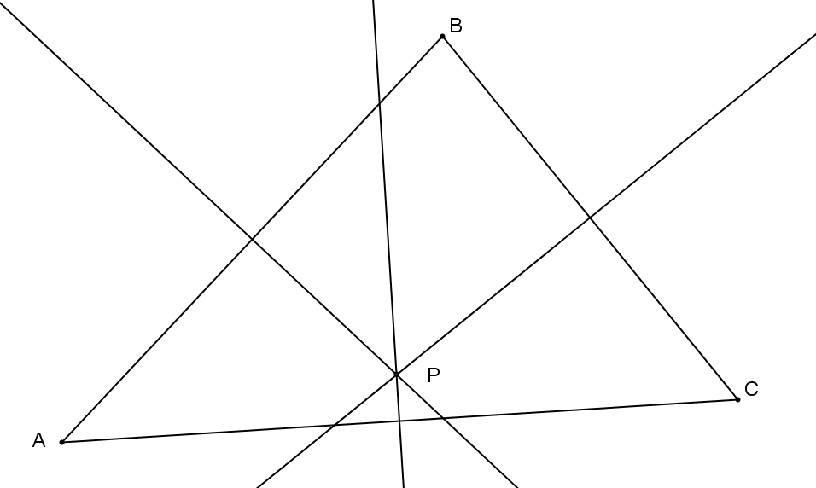

The questions that arise here are WHY are the three perpendicular bisectors concurrent? And WILL these bisectors be concurrent in all triangles? Recall that all points on the perpendicular bisector are equidistant from the endpoints of the segment, which means:

1. is equidistant from and since it lies on the __________________________ of .
2. is also ________________________ from and since it lies on the perpendicular bisector of .
3. Therefore, must also be equidistant from and .

Hence, , which suggests that is the point of _______________________ of all three perpendicular bisectors.

You have also worked with angle bisectors. The construction of the three angle bisectors of a triangle also results in a point of concurrency, which we call the _______________________.

Use the triangle below to construct the angle bisectors of each angle in the triangle to locate the triangle’s incenter.

1. State precisely the steps in your construction above.

|  |
| --- |
|  |
|  |
|  |

1. Earlier in this lesson, we explained why the perpendicular bisectors of the sides of a triangle are always concurrent. Using similar reasoning, explain clearly why the angle bisectors are always concurrent at the incenter of a triangle.

|  |
| --- |
|  |
|  |
|  |
|  |
|  |

1. Observe the constructions below. Point is the __________________________ of (notice that it can fall outside of the triangle). Point is the __________________________ of triangle . The circumcenter of a triangle is the center of the circle that circumscribes that triangle. The incenter of the triangle is the center of the circle that is inscribed in that triangle.

On a separate piece of paper, draw two triangles of your own below and demonstrate how the circumcenter and incenter have these special relationships.

1. How can you use what you have learned in Exercise 3 to find the center of a circle if the center is not shown?

|  |
| --- |
|  |
|  |
|  |
|  |
|  |

Problem Set

1. Given line segment , using a compass and straightedge, construct the set of points that are equidistant from and .

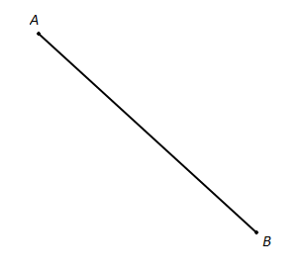

What figure did you end up constructing? Explain.

1. 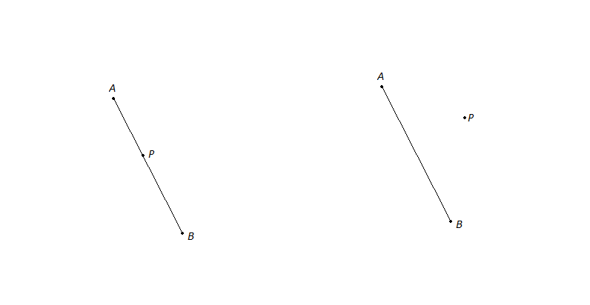For each of the following, construct a line perpendicular to segment that goes through point .
2. 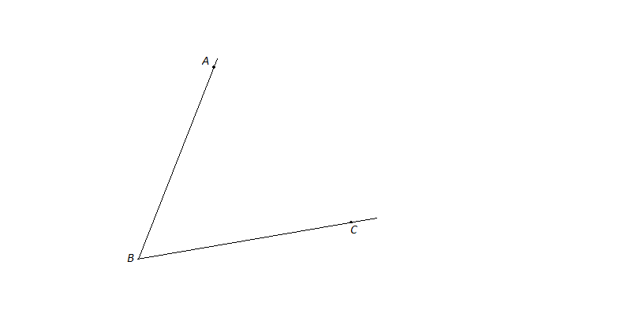Using a compass and straightedge, construct the angle bisector of shown below. What is true about every point that lies on the ray you created?