|  |
| --- |
|  |

Lesson 5: Points of Concurrencies

**Student Outcome**

* Students become familiar with vocabulary regarding two points of concurrencies and understand why the points are concurrent.

Lesson Notes

Lesson 5 is an application lesson of the constructions covered so far.

In the Opening Exercise, students construct three perpendicular bisectors of a triangle but this time use a makeshift compass (i.e., a string and pencil). Encourage students to note the differences between the tools and how the tools would change how the steps are written.

The Discussion addresses vocabulary associated with points of concurrencies. The core of the notes presents why the three perpendicular bisectors are concurrent. Students should then make a similar argument explaining why the three angle bisectors of a triangle are also concurrent.

This topic presents an opportunity to incorporate geometry software if available.

Classwork

Opening Exercise (7 minutes)

Students use an alternate method of construction on Lesson 4, Problem Set 2.

Opening Exercise

You will need a make-shift compass made from string and a pencil.

Use these materials to construct the perpendicular bisectors of the three sides of the triangle below (like you did with Lesson 4, Problem Set 2).

**MP.5**

How did using this tool differ from using a compass and straightedge? Compare your construction with that of your partner. Did you obtain the same results?

Exploratory Challenge (38 minutes)

Exploratory Challenge

When three or more lines intersect in a single point, they are **concurrent** , and the point of intersection is the **point of concurrency** .

You saw an example of a point of concurrency in yesterday’s Problem Set (and in the Opening Exercise above) when all three perpendicular bisectors passed through a common point.

The point of concurrency of the three perpendicular bisectors is the **circumcenter of the triangle** *.*

The circumcenter of is shown below as point .

Have students mark the right angles and congruent segments (defined by midpoints) on the triangle.

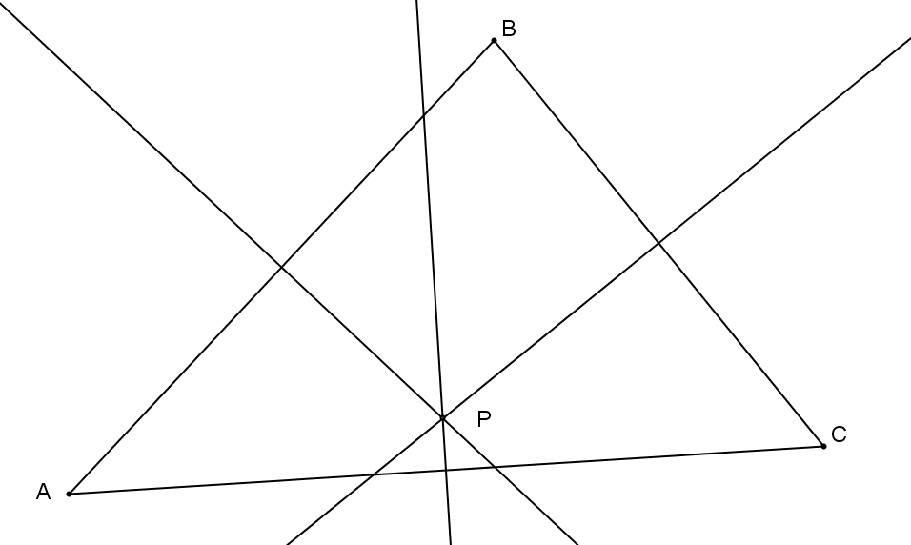

The questions that arise here are WHY are the three perpendicular bisectors concurrent? And WILL these bisectors be concurrent in all triangles? Recall that all points on the perpendicular bisector are equidistant from the endpoints of the segment, which means:

1. is equidistant from and since it lies on the **perpendicular bisector** of .
2. is also **equidistant**  from and since it lies on the perpendicular bisector of .
3. Therefore, must also be equidistant from and .

Hence, , which suggests that is the point of **concurrency**  of all three perpendicular bisectors.

**You have also worked with angle bisectors. The construction of the three angle bisectors of a triangle also results in a point of concurrency, which we call the** **incenter** .

Use the triangle below to construct the angle bisectors of each angle in the triangle to locate the triangle’s incenter.

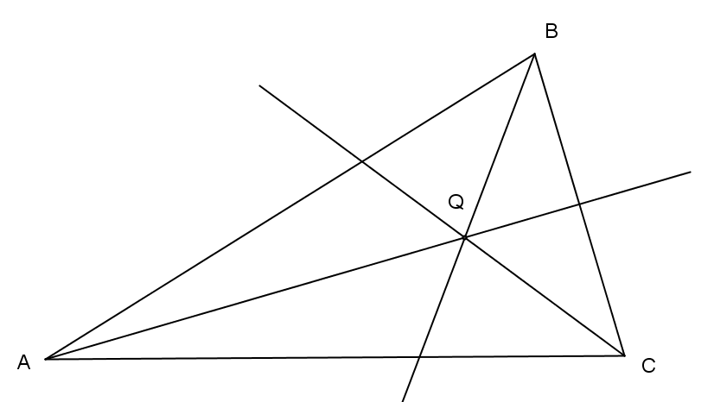

Have students label the congruent angles formed by the angle bisectors.

*Note to Teacher:*

For the first question, students do not need to re-explain constructions they have established prior to the current construction.

1. State precisely the steps in your construction above.
2. Construct the angle bisectors of , , and .
3. Label the point of intersection .
4. Earlier in this lesson, we explained why the perpendicular bisectors of the sides of a triangle are always concurrent. Using similar reasoning, explain clearly why the angle bisectors are always concurrent at the incenter of a triangle.

Any point on the angle bisector is equidistant from the rays forming the angle. Therefore, since point is on the angle bisector of ∠, it is equidistant from and . Similarly, since point is on the angle bisector of , it is equidistant from and . Therefore, must also be equidistant from and , since it lies on the angle bisector of . So is a point of concurrency of all three angle bisectors.

1. Observe the constructions below. Point is the **circumcenter**  of . (Notice that it can fall outside of the triangle.) Point is the **incenter**  of . The circumcenter of a triangle is the center of the circle that circumscribes that triangle. The incenter of the triangle is the center of the circle that is inscribed in that triangle.



On a separate piece of paper, draw two triangles of your own below and demonstrate how the circumcenter and incenter have these special relationships.

Answers will vary.

1. How can you use what you have learned in Exercise 3 to find the center of a circle if the center is not shown?

Inscribe a triangle into the circle and construct the perpendicular bisectors of at least two sides. Where the bisectors intersect is the center of the circle.

Closing

Inform students that the topic shifts to unknown angle problems and proofsfor the next six lessons. The Lesson 5 Problem Set is a preview for Lessons 6–11 but is based on previously taught geometry facts.

Problem Set Sample Solutions

1. Given line segment , using a compass and straightedge, construct the set of points that are equidistant from and .

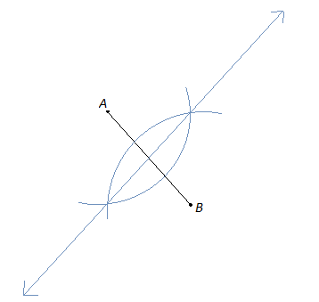

What figure did you end up constructing? Explain.

I ended up drawing the perpendicular bisector of the segment . Every point on this line is equidistant from the points and .

1. For each of the following, construct a line perpendicular to segment that goes through point .

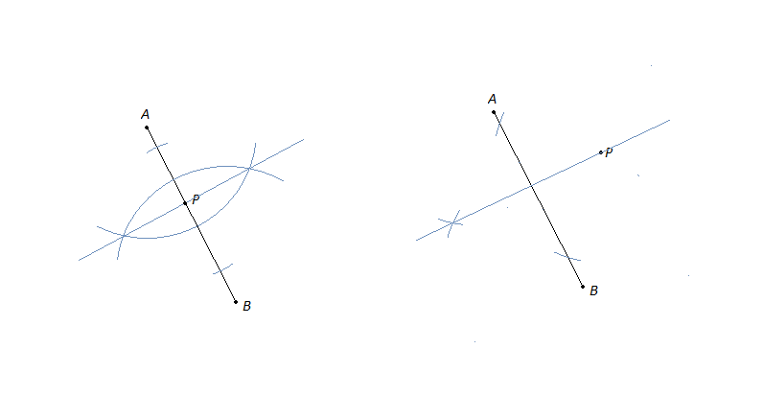

1. Using a compass and straightedge, construct the angle bisector of shown below. What is true about every point that lies on the ray you created?

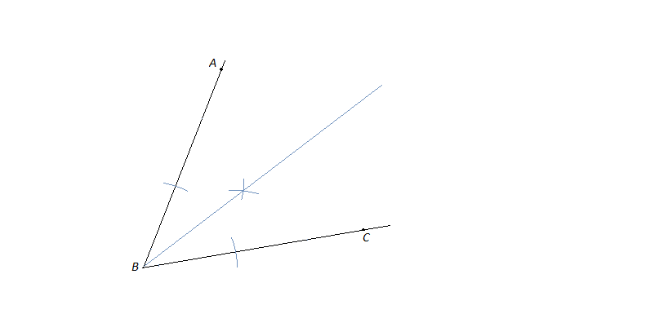

**Every point on the ray is equidistant from ray and ray .**