|  |
| --- |
|  |

Lesson 4: Construct a Perpendicular Bisector

**Student Outcome**

* Students construct a perpendicular bisector and discover the relationship between symmetry with respect to a line and a perpendicular bisector.

Lesson Notes

In Lesson 4, students learn to construct perpendicular bisectors and apply the construction to problems. Students continue to write precise instructions for constructions. The importance of specific language continues throughout the construction lessons. The steps for constructing an angle bisector from the previous lesson flow nicely into the steps for constructing a perpendicular bisector.

The Opening Exercise is another opportunity for students to critique their work. Students use a rubric to assess the Lesson 3 Problem Set on angle bisectors. Determine where students feel they are making errors (i.e., if they score low on the rubric). In the Discussion, students make a connection between Lesson 3 and Lesson 4 as an angle bisector is linked to a perpendicular bisector. Students should understand that two points are symmetric with respect to a line if and only if the line is the perpendicular bisector of the segment that joins the two points. Furthermore, students should be comfortable with the idea that any point on the perpendicular bisector is equidistant from the endpoints of the segment. Lastly, students will extend the idea behind the construction of a perpendicular bisector to construct a perpendicular to a line from a point not on the line.

Classwork

Opening Exercise (5 minutes)

Opening Exercise

Choose one method below to check your Problem Set:

* Trace your copied angles and bisectors onto patty paper; then, fold the paper along the bisector you constructed. Did one ray exactly overlap the other?
* Work with your partner. Hold one partner’s work over another’s. Did your angles and bisectors coincide perfectly?

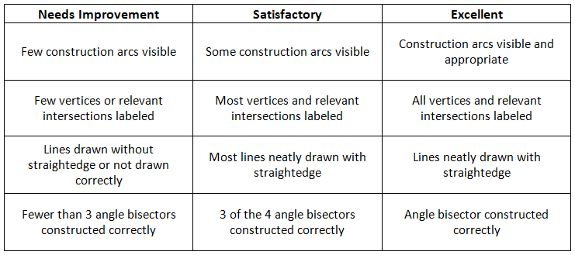Use the following rubric to evaluate your Problem Set:

Mathematical Modeling Exercise (37 minutes)

In addition to the discussion, have students participate in a kinesthetic activity that illustrates the idea of an angle bisector. Ask students to get out of their seats and position themselves at equal distances from two adjacent classroom walls. The students form the bisector of the (likely right) angle formed at the meeting of the adjacent walls.

Discussion

In Lesson 3, we studied how to construct an angle bisector. We know we can verify the construction by folding an angle along the bisector. A correct construction means that one half of the original angle will coincide exactly with the other half so that each point of one ray of the angle maps onto a corresponding point on the other ray of the angle.

We now extend this observation. Imagine a segment that joins any pair of points that map onto each other when the original angle is folded along the bisector. The figure to the right illustrates two such segments.

Let us examine one of the two segments, . When the angle is folded along , coincides with . In fact, folding the angle demonstrates that is the same distance from as is from ; . The point that separates these equal halves of is , which is, in fact, the midpoint of the segment and lies on the bisector . We can make this case for any segment that falls under the conditions above.

By using geometry facts we acquired in earlier school years, we can also show that the angles formed by the segment and the angle bisector are right angles. Again, by folding, we can show that and coincide and must have the same measure. The two angles also lie on a straight line, which means they sum to . Since they are equal in measure and sum to , they each have a measure of .

These arguments lead to a remark about symmetry with respect to a line and the definition of a perpendicular bisector. Two points are symmetric with respect to a line if and only if is the perpendicular bisector of the segment that joins the two points. A perpendicular bisector of a segment passes through the **midpoint** of the segment and forms   
 **right angles** with the segment.

We now investigate how to construct a perpendicular bisector of a line segment using a compass and a straightedge. Using what you know about the construction of an angle bisector, experiment with your construction tools and the following line segment to establish the steps that determine this construction.

Precisely describe the steps you took to bisect the segment.

1. Label the endpoints of the segment and .
2. Draw circle: center , radius and circle : center , radius .
3. Label the points of intersections as and .
4. Draw .

Now that you are familiar with the construction of a perpendicular bisector, we must make one last observation. Using your compass, string, or patty paper, examine the following pairs of segments:

1. ,
2. ,
3. ,

Based on your findings, fill in the observation below.

*Observation:*

Any point on the perpendicular bisector of a line segment is **equidistant** from the endpoints of the line segment.

Mathematical Modeling Exercise

You know how to construct the perpendicular bisector of a segment. Now, you will investigate how to construct a perpendicular to a line from a point not on . Think about how you have used circles in constructions so far and *why* the perpendicular bisector construction works the way it does. The first step of the instructions has been provided for you. Discover the construction and write the remaining steps.



**MP.5**

**&**

**MP.6**

Step 1. Draw circle : center , with radius so that circle intersects line in two points.

Step 2: Label the two points of intersection as and .

Step 3: Draw circle : center , radius .

Step 4: Draw circle : center , radius .

Step 5: Label the unlabeled intersection of circle and circle as .

Step 6: Draw .

**Relevant Vocabulary**

Right Angle: An angle is called a *right angle* if its measure is .

Perpendicular: Two lines are *perpendicular* if they intersect in one point and if any of the angles formed by the intersection of the lines is a (right) angle. Two segments or rays are perpendicular if the lines containing them are perpendicular lines.

Equidistant: A point is said to be *equidistant* from two different points and if . A point is said to be *equidistant* from a point and a line if the distance between and is equal to .

Exit Ticket (3 minutes)

Name ___________________________________________________ Date____________________

Lesson 4: Construct a Perpendicular Bisector

Exit Ticket

Divide the following segment into four segments of equal length.



Exit Ticket Sample Solution

Divide the following segment into four segments of equal length.

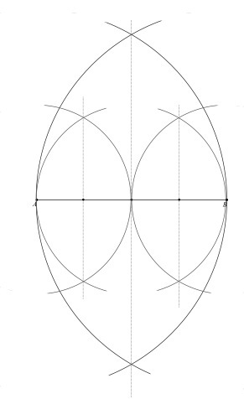

Problem Set Sample Solutions

1. During this lesson, you constructed a perpendicular line to a line from a point not on . We are going to use that construction to construct parallel lines.

To construct parallel lines and :

* + 1. Construct a perpendicular line to a line from a point not on .
    2. Construct a perpendicular line to through point . *Hint:* Consider using the steps behind Problem 4 in the Lesson 3 Problem Set to accomplish this.

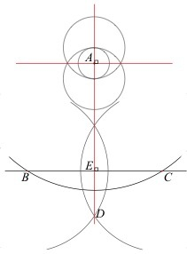

1. Construct the perpendicular bisector of , , and on the triangle below. What do you notice about the segments you have constructed?

Students should say that the three perpendicular bisectors pass through a common point. (Students may additionally conjecture that this common point is equidistant from the vertices of the triangle.)



**MP.5**

1. Two homes are built on a plot of land. Both homeowners have dogs and are interested in putting up as much fencing as possible between their homes on the land but in a way that keeps the fence equidistant from each home. Use your construction tools to determine where the fence should go on the plot of land. How must the fencing be altered with the addition of a third home?

