Lesson 17
Objective: Relate decimal and fraction multiplication.

Suggested Lesson Structure
 Fluency Practice (12 minutes)
 Application Problem (7 minutes)
 Concept Development (31 minutes)
 Student Debrief (10 minutes)
Total Time (60 minutes)
Fluency Practice (12 minutes)
- Multiply Fractions 5.NF.4 (4 minutes)
- Write Fractions as Decimals 5.NF.3 (4 minutes)
- Multiply Whole Numbers by Decimals 5.NBT.7 (4 minutes)
Multiply Fractions (4 minutes)
Materials: (S) Personal white board
Note: This fluency activity reviews Lessons 13–16.
T: (Write $\frac{1}{2}$ $\text{×}$ $\frac{1}{3}$ = ____ .) Say the number sentence with the answer.
S: $\frac{1}{2}$ $\text{×}$ $\frac{1}{3}$ = $\frac{1}{6}$.
Continue the process with the following possible problems: $\frac{1}{2}$ $\text{×}$ $\frac{1}{4}$ and $\frac{1}{2}$ $\text{×}$ $\frac{1}{5}$.
T: (Write $\frac{3}{4}$ $\text{×}$ $\frac{1}{2}$ = ____.) On your personal white board, write the number sentence with the answer.
S: (Write $\frac{3}{4}$ $\text{×}$ $\frac{1}{2}$ = $\frac{3}{8}$.)
T: (Write $\frac{3}{4}$ $\text{×}$ $\frac{1}{3}$ = ____.) Try this problem.
S: (Write $\frac{3}{4}\text{×}\frac{1}{3}$=$\frac{3}{12}$.)
Repeat the process with the following possible problems: $\frac{1}{2}$ $\text{×}$ $\frac{2}{2}$ , $\frac{1}{3}$ $\text{×}$ $\frac{4}{5}$ , and $\frac{2}{3}$ $\text{×}$ $\frac{1}{3}$.
T: (Write $\frac{2}{5}$ $\text{×}$ $\frac{2}{3}$ = ____.) Say the number sentence with the answer.
S: $\frac{2}{5}$ $\text{×}$ $\frac{2}{3}$ = $\frac{4}{15}$.
Continue the process with the following possible problem: $\frac{3}{5}$ $\text{×}$ $\frac{3}{4}$.
T: (Write $\frac{1}{5}$ $\text{×}$ $\frac{2}{3}$ = ____.) On your personal white board, write the equation and solve.
S: (Write $\frac{1}{5}$ $\text{×}$ $\frac{2}{3}$ = $\frac{2}{15}$.)
T: (Write $\frac{2}{3}$ $\text{×}$ $\frac{3}{2}$ = ____.) Try this problem.
S: (Write $\frac{2}{3}$ $\text{×}$ $\frac{3}{2}$ = $\frac{6}{6}$ = 1.)
Continue the process with the following possible problems: $\frac{3}{4}$ $\text{×}$ $\frac{2}{3}$ , $\frac{3}{8}$ $\text{×}$ $\frac{2}{3}$ , and $\frac{2}{5}$ $\text{×}$ $\frac{5}{8}$.
Write Fractions as Decimals (4 minutes)
Materials: (S) Personal white board
Note: This fluency activity prepares students for Lessons 17 and 18.
T: (Write $\frac{1}{10}$.) Say the fraction.
S: 1 tenth.
T: Write it as a decimal.
S: (Write 0.1.)
Continue with the following possible sequence: $\frac{2}{10}$, $\frac{8}{10}$, $\frac{3}{10}$, and $\frac{7}{10}$.
T: (Write $\frac{1}{100}$.) Say the fraction.
S: 1 hundredth.
T: Write it as a decimal.
S: (Write 0.01.)
Continue with the following possible sequence: $\frac{2}{100}$, $\frac{7}{100}$ , $\frac{9}{100}$, $\frac{12}{100}$, $\frac{15}{100}$, $\frac{45}{100}$, and $\frac{93}{100}$.
T: (Write 0.01.) Say it as a fraction.
S: 1 hundredth.
T: Write it as a fraction.
S: (Write $\frac{1}{100}$.)
Continue with the following possible sequence: 0.03, 0.09, 0.11, and 0.87.
Multiply Whole Numbers by Decimals (4 minutes)
Materials: (S) Personal white board
Note: This fluency exercise prepares students for Lessons 17 and 18. In the following dialogue, several possible student responses are represented.
T: (Write 2 × 0.1 = ____.) What is 2 copies of 1 tenth?
S: (Write 2 × 0.1 = 2 tenths.)
T: (Write 0.2 in the number sentence above.)
T: (Erase the product and replace the 2 with a 3.) What is 3 copies of 1 tenth?
S: (Write 3 × 0.1 = 3 tenths.)
T: Write it as a decimal on your personal white board.
S: (Write 0.3.)
T: 4 copies of 1 tenth?
S: (Write 0.4.)
T: 7 × 0.1?
S: (Write 0.7.)
T: (Write 7 × 0.01 = ____.) What is 7 copies of 1 hundredth?
S: (Write 7 hundredths.)
T: Write it as a decimal.
S: (Write 0.07.)
T: What is 5 copies of 1 hundredth? Write it as a decimal.
S: (Write 0.05.)
T: 5 × 0.01?
S: (Write 0.05.)
T: (Write 9 × 0.01 = ____.) On your personal white board, write the number sentence with the answer.
T: (Write 2 × 0.1 = ____.) Say the answer.
T: (Write 20 × 0.1 = ____.) What is 20 copies of 1 tenth?
S: (Write 20 tenths.)
T: Rename it using ones.
S: (Write 2 ones.)
T: (Write 20 × 0.01 = ____.) On your personal white board, write the number sentence with the answer. What are 20 copies of 1 hundredth?
S: (Write 20 × 0.01 = 0.20.) 20 hundredths.
T: Rename the product using tenths.
S: 2 tenths.
Continue this process with the following possible sequence, shifting between choral and personal white board responses: 30 × 0.1, 30 × 0.01, 80 × 0.01, and 80 × 0.1. If students are successful with the previous sequence, continue with the following: 83 × 0.1, 83 × 0.01, 53 × 0.01, 53 × 0.1, 64 × 0.01, and 37 × 0.1.

Application Problem (7 minutes)
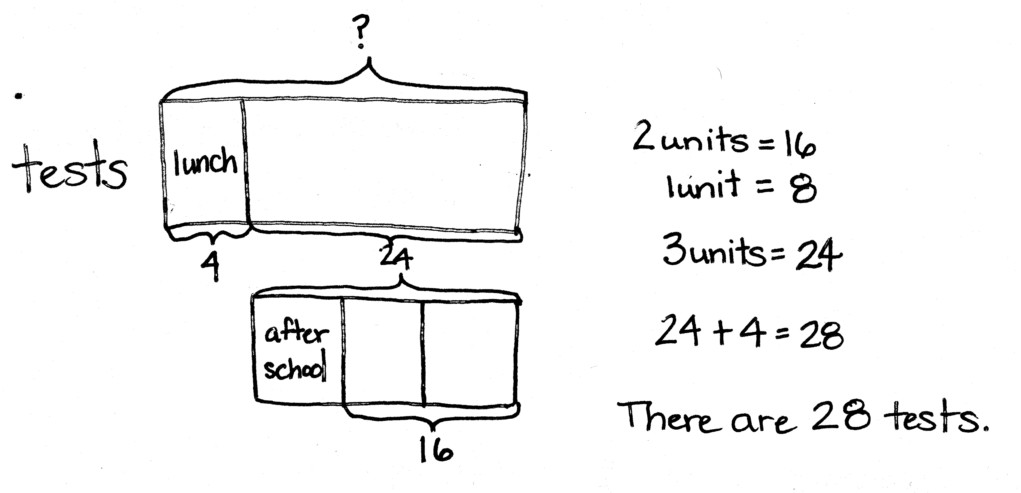
Ms. Casey grades 4 tests during her lunch. She grades $\frac{1}{3}$ of the remainder after school. If she still has 16 tests to grade after school, how many tests are there?
Note: Today’s Application Problem recalls Lesson 16’s work with tape diagrams. This is a challenging problem in that the value of a part is given, and then the value of
2 thirds of the remainder. Possibly remind students to draw without concern initially for proportionality. They can rework the tape diagram if needed.
Concept Development (31 minutes)
Materials: (S) Personal white board, millions through thousandths place value chart (Template)
Problem 1: a. 0.1 $\text{×}$ 4 b. 0.1 $\text{×}$ 2 c. 0.01 $\text{×}$6
T: (Post Problem 1(a) on the board.) Read this multiplication expression using unit form and the word of.
S: 1 tenth of 4.
T: Write this expression as a multiplication sentence using a fraction and solve. Do not simplify your product.
S: (Write $\frac{1}{10} \text{× 4} \text{=} \frac{4}{10}$.)
T: Write this as a decimal on your personal white board.
S: (Write 0.4.)
T: (Write 0.1 $\text{×}$ 4 = 0.4.) Let’s compare the 4 ones that we started with to the product that we found,
4 tenths. Place 4 and 0.4 on a place value chart and talk to your partner about what happened to the digit 4 when we multiplied by 1 tenth. Why did our answer get smaller?
S: This is like 4 copies of 1 tenth. There are 40 tenths in 4 wholes. 1 tenth of 40 is 4. The unit is tenths, so the answer is 4 tenths. The digit 4 stays the same because we are multiplying by 1 of something, but the unit is smaller, so the digit 4 shifted one space to the right. The answer is 4 tenths.
T: What about $\frac{1}{100}$ of 4? Multiply, then show your thinking on the place value chart.
S: (Work to show 4 hundredths or 0.04.)
T: What about $\frac{1}{1,000}$ of 4?
S: 4 thousandths. 0.004.
Repeat the sequence with 0.1 $\text{×}$ 2 and 0.01 $\text{×}$ 6. Ask students to verbalize the patterns they notice.
Problem 2: a. 0.1 $\text{×}$ 0.1 b. 0.2 $\text{×}$0.1 c. 1.2 $\text{×}$ 0.1
$\frac{1}{10}$

1
$\frac{1}{10}$
T: (Post Problem 2(a) on the board.) Write this as a fraction multiplication sentence and solve it with a partner.
S: (Write $\frac{1}{10}\text{×}\frac{1}{10}$ = $\frac{1}{100}$.)
T: Let’s draw an area model to see if this makes sense. What should I draw first? Turn and talk.
S: Draw a rectangle and cut it vertically into 10 units and shade one of them. (Draw and label $\frac{1}{10}$.)
T: What do I do next?
S: Cut each unit horizontally into 10 equal parts, and shade in 1 of those units.
T: (Cut and label $\frac{1}{10}$.) What units does our model show now?
S: Hundredths.
MP.4
T: Look at the double-shaded parts, what is $\frac{1}{10}$of $\frac{1}{10}$? (Save this model for use again in Problem 3(a).)
S: 1 hundredth. $\frac{1}{100}$.
T: Write the answer as a decimal.
S: 0.01.
T: Let’s show this multiplication on the place value chart. When writing 1 tenth, where do we put the digit 1?
S: In the tenths place.
T: Turn and talk to your partner about what happened to the digit 1 that started in the tenths place, when we took 1 tenth of it.
S: The digit shifted 1 place to the right. We were taking a part of 1 tenth, so the answer is smaller than 1 tenth. It makes sense that the digit shifted to the right one place again because the answer got smaller.
T: (Post Problem 2(b) on the board.) Show me 2 tenths on your place value chart.
S: (Show the digit 2 in the tenths place.)
T: Explain to a partner what will happen to the digit 2 when you multiply it by 1 tenth.
S: Again, it will shift one place to the right. Every time you multiply by a tenth, no matter what the digit, the value of the digit gets smaller. The 2 shifts one place over to the hundredths place.
T: Show this problem using fraction multiplication and solve.
S: (Work and show $\frac{2}{10}\text{×}\frac{1}{10}$ = $\frac{2}{100}$.)
T: (Post Problem 2(c) on the board.) If we were to show this multiplication on the place value chart, visualize what would happen. Tell your partner what you see.
S: The 1 is in the ones place and the 2 is in the tenths place. Both digits would shift one place to the right, so the 1 would be in the tenths place and the 2 would be in the hundredths place. The answer would be 0.12. Each digit shifts one place each. The answer is 12 hundredths.
T: How can we express 1.2 as a fraction greater than 1? Turn and talk.
S: 1 and 2 tenths is the same as 12 tenths. 12 tenths as a fraction is just 12 over 10.
T: Show the solution to this problem using fraction multiplication.
S: (Work and show $\frac{12}{10}\text{×}\frac{1}{10}$ = $\frac{12}{100}$.)
Problem 3: a. 0.1 $\text{×}$ 0.01 b. 0.5 $\text{×}$0.01 c. 1.5 $\text{×}$ 0.01
T: (Post Problem 3(a) on the board.) Work with a partner to show this as fraction multiplication.
S: (Work and show $\frac{1}{10} \text{×}\frac{1}{100}.$)
T: What is $\frac{1}{10}\text{×}\frac{1}{100}$?
S: $\frac{1}{1,000}$.
T: (Retrieve the model drawn in Problem 2(a).) Remember this model showed 1 tenth of 1 tenth, which is 1 hundredth. We just solved 1 tenth of 1 hundredth, which is 1 thousandth. Turn and talk with your partner about how that would look as a model.
S: If I had to draw it, I’d have to cut the whole vertically into 100 equal parts and just shade 1. Then, I’d have to cut just one of those tiny parts horizontally into 10 equal parts. If I did that to the rest of the parts, I’d end up with 1,000 equal parts and only 1 of them would be double shaded! It would be like taking that 1 tiny hundredth and dividing it into 10 parts to make thousandths. I’d need a really fine pencil point!
T: (Point to the tenths on place value chart.) Put 1 tenth on the place value chart. I’m here in the tenths place, and I have to find $\text{1 }\text{hundredth}$ of this number. The digit 1 will shift in which direction and why?
S: It will shift to the right, because the product is smaller than what we started with.
T: How many places will it shift?
S: Two places.
T: Why two places? Turn and talk.
S: We shifted one place to the right when multiplying by a tenth, so it should be two places to the right when multiplying by a hundredth. Similarly when we multiply by 10, the numbers shift one place to the left, and two places to the left when we multiply by 100. Our model showed us that finding a hundredth of something is like finding a tenth of a tenth, so we have to shift one place two times.
T: Yes. (Move finger two places to the right to the thousandths place.) So, $\frac{1}{10}\text{×}\frac{1}{100}$ is equal to $\frac{1}{1,000}$.
T: (Post Problem 3(b) on the board.) Visualize a place value chart. When writing 0.5, where will the digit 5 be?
S: In the tenths place.
T: What will happen as we multiply by 1 hundredth?
S: The 5 will shift two places to the right to the thousandths place.
T: Say the answer.
S: 5 thousandths.
T: Show the solution to this problem using fraction multiplication.
S: (Write and solve $\frac{5}{10}\text{×}\frac{1}{100}$ = $\frac{5}{1,000}$.)
T: Show the answer as a decimal.
NOTES ON
MULTIPLE MEANS
OF REPRESENTATION:
It may be too taxing to ask some students to visualize a place value chart. As in previous problems, a place value chart can be displayed or provided. To provide further support for specific students, teachers can also provide place value disks.
S: 0.005.
T: (Post Problem 3(c) on the board.) Express 1.5 as a fraction greater than 1.
S: $\frac{15}{10}$.
T: Show the solution to this problem using fraction multiplication.
S: (Write and show $\frac{15}{10} \text{×} \frac{1}{100}$ = $\frac{15}{1,000}$.)
T: Write the answer as a decimal.
S: 0.015.
Problem 4: a. 7 × 0.2 b. 0.7 × 0.2 c. 0.07 × 0.2
T: (Post Problem 4(a) on the board.) I’m going to rewrite this problem expressing the decimal as a fraction. (Write 7 × $\frac{2}{10}$.)
Are these equivalent expressions? Turn and talk.
S: Yes, 0.2 = $\frac{2}{10}$. So they show the same thing.
T: When we multiply, what will the numerator show?
S: 7 × 2.
T: The denominator?
S: 10.
T: (Write $\frac{7 × 2}{10}$.) Write the answer as a fraction.
S: (Write $\frac{14}{10}.$)
T: Write 14 tenths as a decimal.
S: (Write 1.4.)
T: Think about what we know about the place value chart and multiplying by tenths. Does our product make sense? Turn and talk.
S: Sure! 7 times 2 is 14. So, 7 times 2 tenths is like 7 times 2 times 1 tenth. The answer should be one-tenth the size of 14. It does make sense. It’s like 7 times 2 equals 14, and then the digits in 14 both shift one place to the right because we took only 1 tenth of it. I know it’s like 2 tenths copied 7 times. Five copies of 2 tenths is 1, and then I added 2 more copies of 2 tenths.
T: (Post Problem 4(b) on the board.) Work with a partner and show the solution using fraction multiplication.
S: (Write and solve $\frac{7}{10}\text{×}\frac{2}{10}$ = $\frac{14}{100}$.)
T: What’s 14 hundredths as a decimal?
S: 0.14.
T: (Post Problem 4(c) on the board.) Solve this problem independently. Compare your answer with a partner when you’re done. (Allow students time to work and compare answers.)
T: Say the problem using fractions.
S: $\frac{7}{100}\text{×}\frac{2}{10}\text{=}\frac{14}{1,000}.$
T: What’s 14 thousandths as a decimal?
NOTES ON
MULTIPLE MEANS
OF ACTION AND EXPRESSION:
Teachers and parents alike may want to express multiplying by one-tenth as moving the decimal point one place to the left. Notice the instruction focuses on the movement of the digits in a number. Just like the ones place, the tens place, and all places on the place value chart, the decimal point does not move. It is in a fixed location separating the ones from the tenths.
S: 0.014.

Problem Set (10 minutes)
Students should do their personal best to complete the Problem Set within the allotted 10 minutes. For some classes, it may be appropriate to modify the assignment by specifying which problems they work on first. Some problems do not specify a method for solving. Students should solve these problems using the RDW approach used for Application Problems.

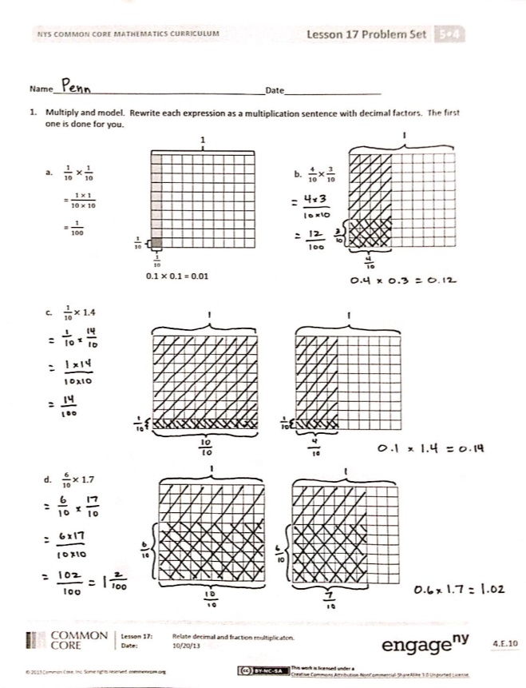
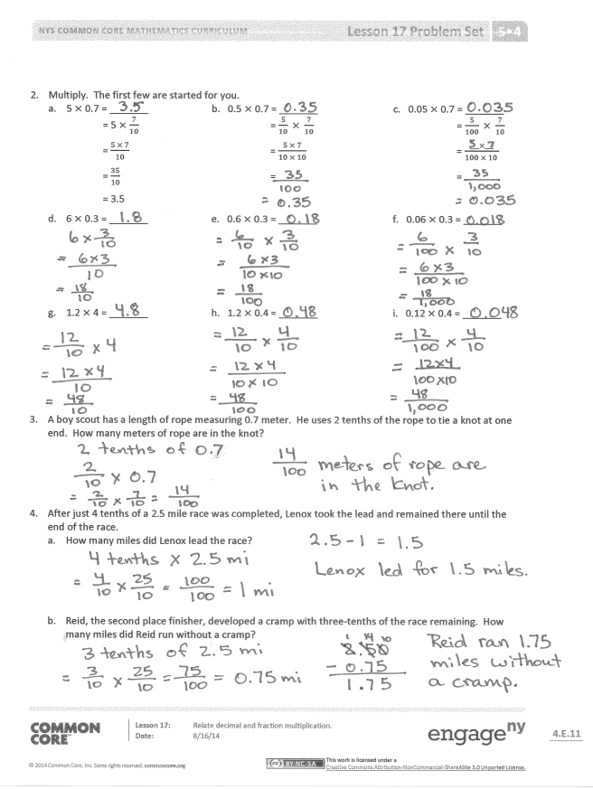
Student Debrief (10 minutes)
Lesson Objective: Relate decimal and fraction multiplication.
The Student Debrief is intended to invite reflection and active processing of the total lesson experience.
Invite students to review their solutions for the Problem Set. They should check work by comparing answers with a partner before going over answers as a class. Look for misconceptions or misunderstandings that can be addressed in the Debrief. Guide students in a conversation to debrief the Problem Set and process the lesson.
You may choose to use any combination of the questions below to lead the discussion.
- In Problem 2, what pattern did you notice between (a), (b), and (c); (d), (e), and (f); and (g), (h), and (i)? (The product is to the tenths, hundredths, and thousandths.)
- Share and explain your solution to Problem 3 with a partner.
- Share your strategy for solving Problem 4 with a partner.
- Explain to your partner why $\frac{1}{10}\text{×}\frac{1}{10}\text{=}\frac{1}{100}$ and $\frac{1}{10}\text{×}\frac{1}{100}\text{=}\frac{1}{1,000}$.
- We know that when we take one-tenth of 3, this shifts the digit 3 one place to the right on the place value chart, because 3 tenths is 1 tenth of 3. How do the digits shift when we multiply by 1 tenth? By 1 hundredth?
Exit Ticket (3 minutes)
After the Student Debrief, instruct students to complete the Exit Ticket. A review of their work will help you assess the students’ understanding of the concepts that were presented in the lesson today and plan more effectively for future lessons. You may read the questions aloud to the students.
Name Date
- Multiply and model. Rewrite each expression as a multiplication sentence with decimal factors. The first one is done for you.
1
$\frac{1}{10}$
$\frac{1}{10}$

- $\frac{1}{10} ×\frac{1}{10}$ b. $\frac{4}{10}×\frac{3}{10}$
= $\frac{1 × 1}{10 × 10}$

= $\frac{1}{100}$

0.1 $×$ 0.1 = 0.01

- $\frac{1}{10}×1.4$

- $\frac{6}{10}×1.7$

- Multiply. The first few are started for you.
- 5 × 0.7 = _______ b. 0.5 × 0.7 = _______ c. 0.05 × 0.7 = _______
= 5 $×$ $\frac{7}{10}$ = $\frac{5}{10} × \frac{7}{10}$ = $\frac{5}{100} × \frac{7}{10}$
= $\frac{5 × 7}{10}$ = $\frac{5 × 7}{10 × 10}$ = $\frac{___×___}{100 × 10 }$
= $\frac{35}{10}$ = =
= 3.5
- 6 × 0.3 = _______ e. 0.6 × 0.3 = _______ f. 0.06 × 0.3 = _______

- 1.2 × 4 = _______ h. 1.2 × 0.4 = _______ i. 0.12 × 0.4 = _______

- A boy scout has a length of rope measuring 0.7 meter. He uses 2 tenths of the rope to tie a knot at one end. How many meters of rope are in the knot?

- After just 4 tenths of a 2.5 mile race was completed, Lenox took the lead and remained there until the end of the race.
  - How many miles did Lenox lead the race?

  - Reid, the second place finisher, developed a cramp with 3 tenths of the race remaining. How many miles did Reid run without a cramp?

Name Date
- Multiply and model. Rewrite each expression as a number sentence with decimal factors.

- $\frac{1}{10}$ × 1.2

- Multiply.

- 1.5 × 3 = _______ b. 1.5 × 0.3 = _______ c. 0.15 × 0.3 = _______

Name Date
- Multiply and model. Rewrite each expression as a number sentence with decimal factors. The first one is done for you.

- $\frac{1}{10} ×\frac{1}{10}$ b. $\frac{6}{10}×\frac{2}{10}$
1
= $\frac{1 × 1}{10 × 10}$
$\frac{1}{10}$

$\frac{1}{10}$
= $\frac{1}{100}$
0.1 × 0.1 = 0.01

- $\frac{1}{10}$ × 1.6

- $\frac{6}{10}$ × 1.9

- Multiply. The first few are started for you.
- 4 × 0.6 = _______ b. 0.4 × 0.6 = _______ c. 0.04 × 0.6 = _______
= 4 × $\frac{6}{10}$ = $\frac{4}{10} × \frac{6}{10}$ = $\frac{4}{100} × \frac{6}{10}$
= $\frac{4 × 6}{10}$ = $\frac{4 × 6}{10 × 10}$ = $\frac{___×___}{100 × 10 }$
= $\frac{24}{10}$ = =
= 2.4
- 7 × 0.3 = _______ e. 0.7 × 0.3 = _______ f. 0.07 × 0.3 = _______

- 1.3 × 5 = _______ h. 1.3 × 0.5 = _______ i. 0.13 × 0.5 = _______

- Jennifer makes 1.7 liters of lemonade. If she pours 3 tenths of the lemonade in the glass, how many liters of lemonade are in the glass?

- Cassius walked 6 tenths of a 3.6 mile trail.
  - How many miles did Cassius have left to hike?

  - Cameron was 1.3 miles ahead of Cassius. How many miles did Cameron hike already?

1,000,000 | 100,000 | 10,000 | 1,000 | 100 | 10 | 1 | . | $\frac{1}{10}$ | $\frac{1}{100}$ | $\frac{1}{1000}$
Millions | Hundred  Thousands | Ten  Thousands | Thousands | Hundreds | Tens | Ones | . | Tenths | Hundredths | Thousandths
 |  |  |  |  |  |  | .
 |  |  |  |  |  |  | .
 |  |  |  |  |  |  | .
 |  |  |  |  |  |  | .
 |  |  |  |  |  |  | .
 |  |  |  |  |  |  | .
 |  |  |  |  |  |  | .
 |  |  |  |  |  |  | .
 |  |  |  |  |  |  | .
 |  |  |  |  |  |  | .

__________________________
millions through thousandths place value chart

