Lesson 16
Objective: Solve word problems using tape diagrams and fraction-by-fraction multiplication.

Suggested Lesson Structure
 Fluency Practice (8 minutes)
 Concept Development (42 minutes)
 Student Debrief (10 minutes)
Total Time (60 minutes)
Fluency Practice (8 minutes)
- Multiply Fractions 5.NF.4 (3 minutes)
- Multiply Whole Numbers by Decimals 5.NBT.7 (5 minutes)
Multiply Fractions (3 minutes)
NOTES ON
MULTIPLE MEANS
OF ENGAGEMENT:
Sixty minutes are allotted for all lessons in Grade 5. All 60 minutes, however, do not need to be consecutive. For example, fluency activities can be completed as students wait in line, or when they are transitioning between subjects.
Materials: (S) Personal white board
Note: This fluency activity reviews Lessons 14 and 15.
T: (Write $\frac{1}{3}$ of $\frac{2}{5}$ is ____.) Write the fraction of a set as a multiplication sentence.
S: $\frac{1}{3}$ × $\frac{2}{5}$.
T: Draw a rectangle and shade in $\frac{2}{5}$.
S: (Draw a rectangle, partition it into 5 equal units, and shade 2 of the units.)
T: To show $\frac{1}{3}$ of $\frac{2}{5}$, how many equal parts do we need?
S: 3.
T: Show 1 third of 2 fifths.
S: (Partition the 2 fifths into thirds, and shade 1 third.)
T: Make the other units the same size as the double-shaded ones.
S: (Extend the horizontal thirds across the remaining units using dotted lines.)
T: What unit do we have now?
S: Fifteenths.
T: How many fifteenths are double-shaded?
S: 2.
T: Write the product and say the sentence.
S: (Write $\frac{1}{3}$ × $\frac{2}{5}$ = $\frac{2}{15}$.) $\frac{1}{3}$ of $\frac{2}{5}$ is 2 fifteenths.
Continue this process with the following possible sequence: $\frac{2}{3}$ × $\frac{2}{5}$ , $\frac{3}{5}$ × $\frac{2}{3}$ , and $\frac{3}{5}$ × $\frac{3}{4}$.
Multiply Whole Numbers by Decimals (5 minutes)
Materials: (S) Personal white board
Note: This fluency exercise prepares students for Lessons 17 and 18.
T: (Write $\frac{1}{10}$ + $\frac{1}{10}$ + $\frac{1}{10}$ ). Say the repeated addition sentence with the answer.
S: $\frac{1}{10}$ + $\frac{1}{10}$ + $\frac{1}{10}$ = $\frac{3}{10}$.
T: (Write 3 × ____ = $\frac{3}{10}$.) On your personal white board, write the number sentence, filling in the missing number.
S: (Write 3 × $\frac{1}{10}$ = $\frac{3}{10}$.)
T: (Write 3 × $\frac{1}{10}$ = 3 × 0.____.) Fill in the missing digit.
S: (Write 3 × $\frac{1}{10}$ = 3 × 0.1.)
T: (Write 3 × 0.1 = 0.____.) Say the missing digit.
S: 3.
Continue with the following expression: $\frac{1}{10}$ + $\frac{1}{10}$ + $\frac{1}{10}$ + $\frac{1}{10}$ + $\frac{1}{10}$.
T: (Write 7 × 0.1 = ____.) On your personal white board, write the number sentence with the answer.
S: (Write 7 × 0.1 = 0.7.)
T: (Write 7 × 0.01 = ____.) Try this problem.
S: (Write 7 × 0.01 = 0.07.)
Continue this process with the following possible sequence: 9 × 0.1 and 9 × 0.01.
T: (Write 20 × $\frac{1}{10}$ = ____.) On your personal white board, write the number sentence with the answer.
S: (Write 20 × $\frac{1}{10}$ = $\frac{20}{10}$ = 2.)
T: (Write 20 × 0.1 = ____.) Try this problem.
S: (Write 20 × 0.1 = 2.)
T: (Write 20 × 0.01 = ____.) Try this problem.
S: (Write 20 × 0.01 = 0.2.)
Continue this process with the following possible sequence: 80 × 0.1 and 80 × 0.01.
T: (Write 15 × $\frac{1}{10}$ = ____.) On your personal white board, write the number sentence with the answer.
S: (Write 15 × $\frac{1}{10}$ = $\frac{15}{10}$.)
T: (Write 15 × 0.1 = ____.) Write the number sentence and answer as a decimal.
S: (Write 15 × 0.1 = 1.5.)
T: (Write 15 × 0.01 = ____.) Try this problem.
S: (Write 15 × 0.01 = 0.15.)
Continue with the following possible sequence: 37 × 0.1 and 37 × 0.01.
Concept Development (42 minutes)
Materials: (S) Problem Set, personal white board
Note: Because today’s lesson involves students in learning a new type of tape diagram, the time normally allotted to the Application Problem has been used in the Concept Development to allow students ample time to draw and solve the story problems.
Note: There are multiple approaches to solving these problems. Modeling for a few strategies is included here, but teachers should not discourage students from using other mathematically sound procedures for solving. The dialogues for the modeled problems are detailed as a scaffold for teachers unfamiliar with fraction tape diagrams.
Problem 2 from the Problem Set opens the lesson and is worked using two different fractions (first 1 fifth, then 2 fifths), so that diagramming of two different whole–part situations may be modeled.
Problem 2
Joakim is icing 30 cupcakes. He spreads mint icing on $\frac{1}{5}$ of the cupcakes and chocolate on $\frac{1}{2}$ of the remaining cupcakes. The rest will get vanilla frosting. How many cupcakes have vanilla frosting?
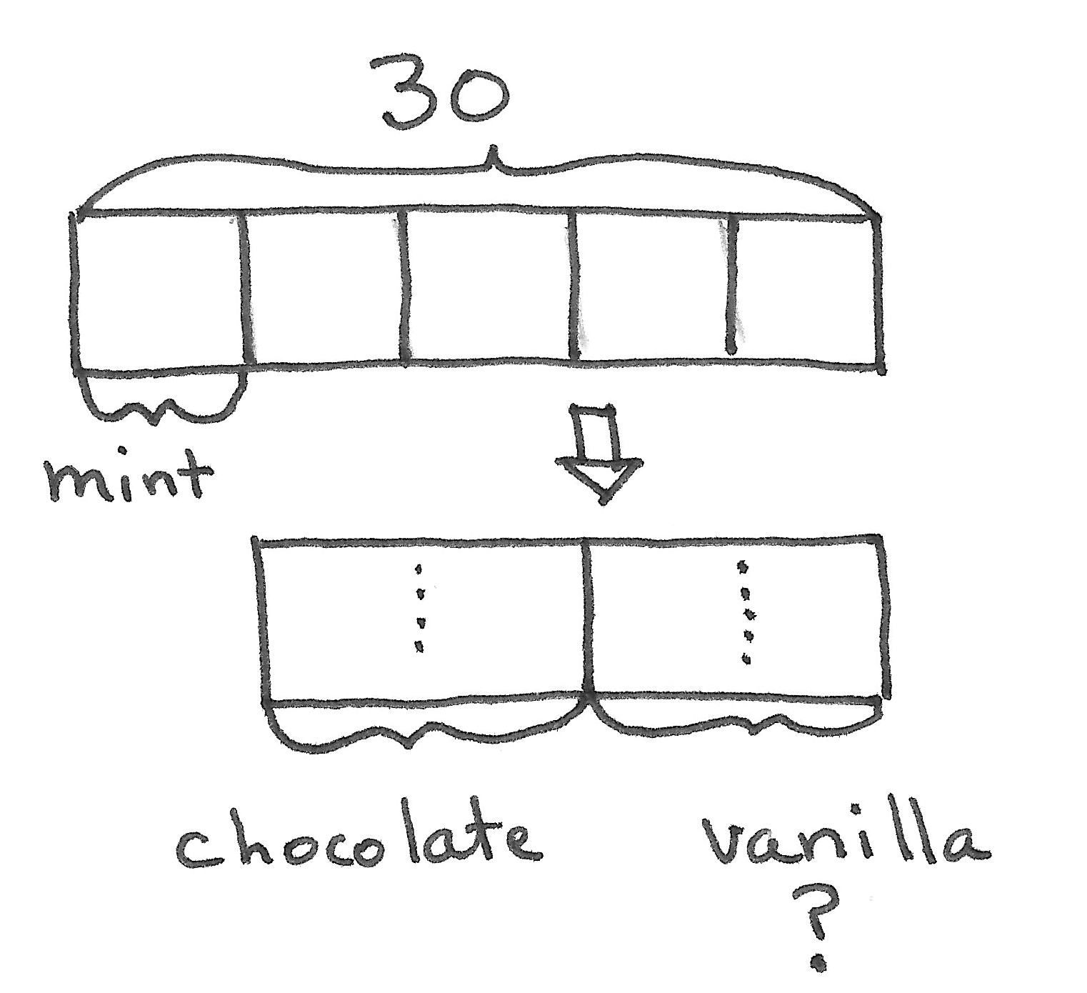
T: (Display Problem 2, and read it aloud with the students.) Let’s use a tape diagram to model this problem.
T: This problem is about Joakim’s cupcakes. What does the first sentence tell us?
S: Joakim has 30 cupcakes.
T: (Draw a tape diagram and label the whole as 30.) Joakim is icing the cupcakes. What fraction of the cupcakes receives mint icing?
S: $\frac{1}{5}$of the cupcakes.
T: How can I show fifths in my tape diagram?
S: Partition the whole into 5 equal units.
T: How many of those units have mint icing?
S: 1.
T: Let’s show that now. (Partition the tape diagram into fifths and label 1 unit mint.)
T: Read the next sentence.
S: (Read.)
T: Where are the remaining cupcakes in our tape diagram?
S: The unlabeled units.
T: Let’s drop that part down and draw a new tape diagram to represent the remaining cupcakes. (Draw a new tape diagram underneath the original whole.)
T: What do we know about these remaining cupcakes?
S: Half of them get chocolate icing.
T: How can we represent that in our new tape diagram?
S: Cut it into 2 equal parts, and label 1 of them chocolate.
T: Let’s do that now. (Partition the lower diagram into 2 units and label 1 unit chocolate.) What about the rest of the remaining cupcakes?
S: They are vanilla.
T: Let’s label the other half vanilla. (Model.) What is the question asking us?
S: How many are vanilla?
T: Place a question mark below the portion showing vanilla. (Put a question mark beneath vanilla.)
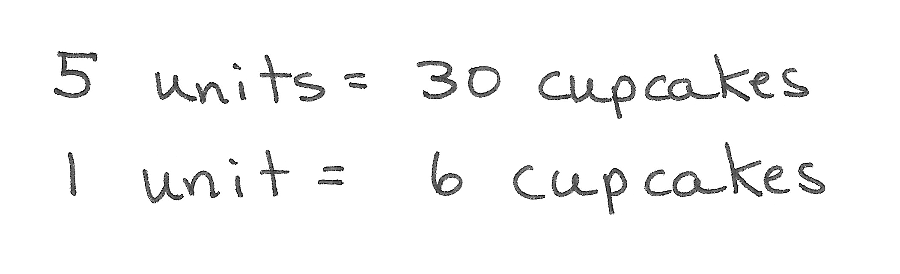
T: Let’s look at our tape diagram to see if we can find how many cupcakes get vanilla icing. How many units does the model show? (Point to the original tape diagram.)
S: 5 units.
T: (Write 5 units.) How many cupcakes does Joakim have in all?
S: 30 cupcakes.
T: (Write = 30 cupcakes.) If 5 units equal 30 cupcakes, how can we find the value of 1 unit? Turn and talk.
S: It’s like 5 times what equals 30. 5 × 6 = 30, so 1 unit equals 6 cupcakes. We can divide.
30 cupcakes ÷ 5 = 6 cupcakes.
T: What is 1 unit equal to? (Write 1 unit = ____.)
S: 6 cupcakes.
T: Let’s write 6 in each unit to show its value. (Write 6 in each unit of original diagram.) That means that 6 cupcakes get mint icing. How many cupcakes remain? (Point to 4 remaining units.) Turn and talk.
S: 30 – 6 = 24. 6 + 6 + 6 + 6 = 24. 4 units of 6 is 24. 4 × 6 = 24.
T: Let’s label that on the diagram showing the remaining cupcakes. (Label 24 above the second tape diagram.) How can we find the number of cupcakes that get vanilla icing? Turn and talk.
S: Half of the 24 cupcakes get chocolate and half get vanilla. Half of 24 is 12.
24 ÷ 2 = 12.
T: What is half of 24?
S: 12.
T: (Write $\frac{24}{2}$ = 12 and label 12 in each half of the second tape diagram.) Write a statement to answer the question.
S: 12 cupcakes have vanilla icing.
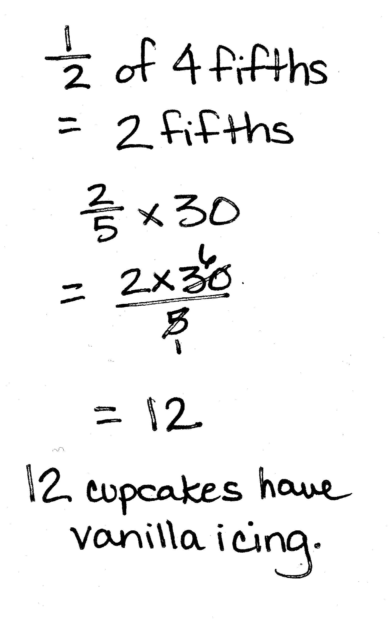
T: Let’s think of this another way. When we labeled the 1 fifth for the mint icing, what fraction of the cupcakes were remaining?
S: $\frac{4}{5}$.
S: What does Joakim do with the remaining cupcakes?
S: $\frac{1}{2}$ of the remaining cupcakes get chocolate icing.
T: (Write $\frac{1}{2}$ of _____.) $\frac{1}{2}$of what fraction?
S: 1 half of 4 fifths.
T: (Write 4 fifths.) What is $\frac{1}{2}$ of 4 fifths?
S: 2 fifths.
T: So, 2 fifths of all the cupcakes got chocolate, and 2 fifths of all the cupcakes got vanilla. The question asked us how many cupcakes got vanilla icing. Let’s find 2 fifths of all the cupcakes which is 2 fifths of 30. Work with your partner to solve.
S: 1 fifth of 30 is 6, so 2 fifths of 30 is 12. $\frac{\text{2}}{\text{5} }\text{×} \text{30}\text{ =}\frac{\text{2 × 30}}{\text{5}}\text{=}\frac{\text{60}}{\text{5}}\text{= }\text{12}\text{.}$ $\frac{2}{5} \text{×} \text{30}\text{ = }\text{2} \text{×}\frac{ 30}{5}\text{= }\text{2 × 6}\text{ = }\text{12}$.
T: So, using fraction multiplication, we got the same answer, 12 cupcakes.
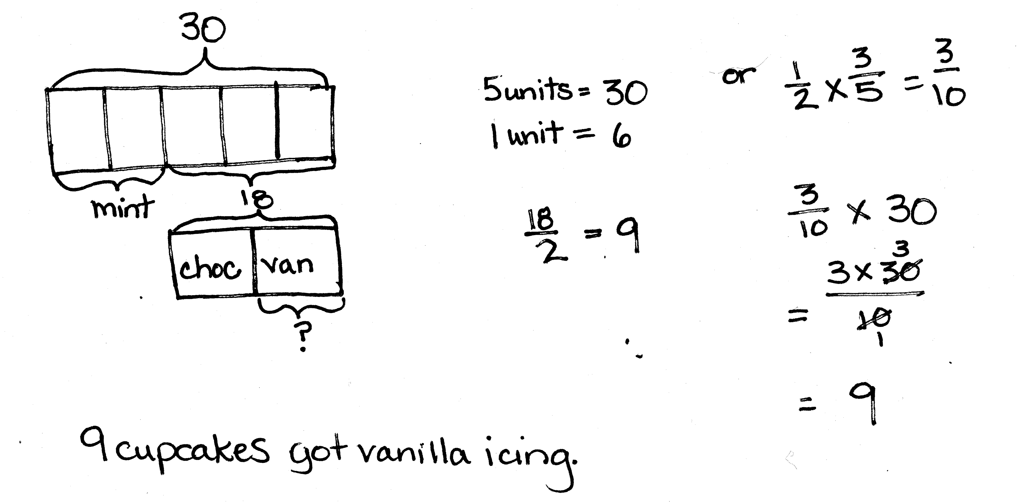
T: This time, let’s imagine that Joakim put mint icing on 2 fifths of the cupcakes. Draw another diagram to show that situation.
S: (Draw.)
T: What fraction of the cupcakes is remaining this time?
MP.4
S: 3 fifths.
T: Let’s draw a second tape diagram that is the same length as the remaining part of our whole. (Draw the second tape diagram below the first.) Has the value of one unit changed in our model? Why or why not?
S: The unit is still 6 because the whole is still 30 and we still have fifths. Each unit is still 6 because we still divided 30 into 5 equal parts.
T: So, how many remaining cupcakes are there this time?
S: 18.
T: Imagine that Joakim still put chocolate icing on half the remaining cupcakes, and the rest were still vanilla. How many cupcakes got vanilla icing this time? Work with a partner to model it in your tape diagram and answer the question with a complete sentence.
S: (Work.)
T: Let’s confirm that there were 9 cupcakes that got vanilla icing by using fraction multiplication. How might we do this? Turn and talk.
MP.4
S: We could just multiply $\frac{1}{2}\text{×}\frac{3}{5}$ and get $\frac{3}{10}$. Then, we can find $\frac{3}{10}$ of 30. That’s 9. We can find $\frac{1}{2}$of 3 fifths. That gives us the fraction of all the cupcakes that got vanilla icing. We need the number of cupcakes, not just the fraction, so we need to multiply $\frac{3}{10}$ and 30 to get 9 cupcakes. Nine cupcakes got vanilla frosting.
T: Complete Problems 1 and 3 on the Problem Set. Check your work with a neighbor when you’re finished. You may use either method to solve.
Solutions for Problem 1 and Problem 3

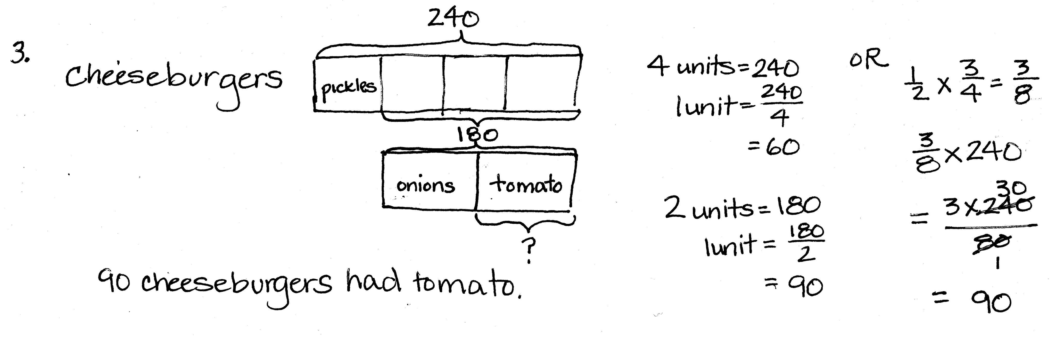

Problem 5
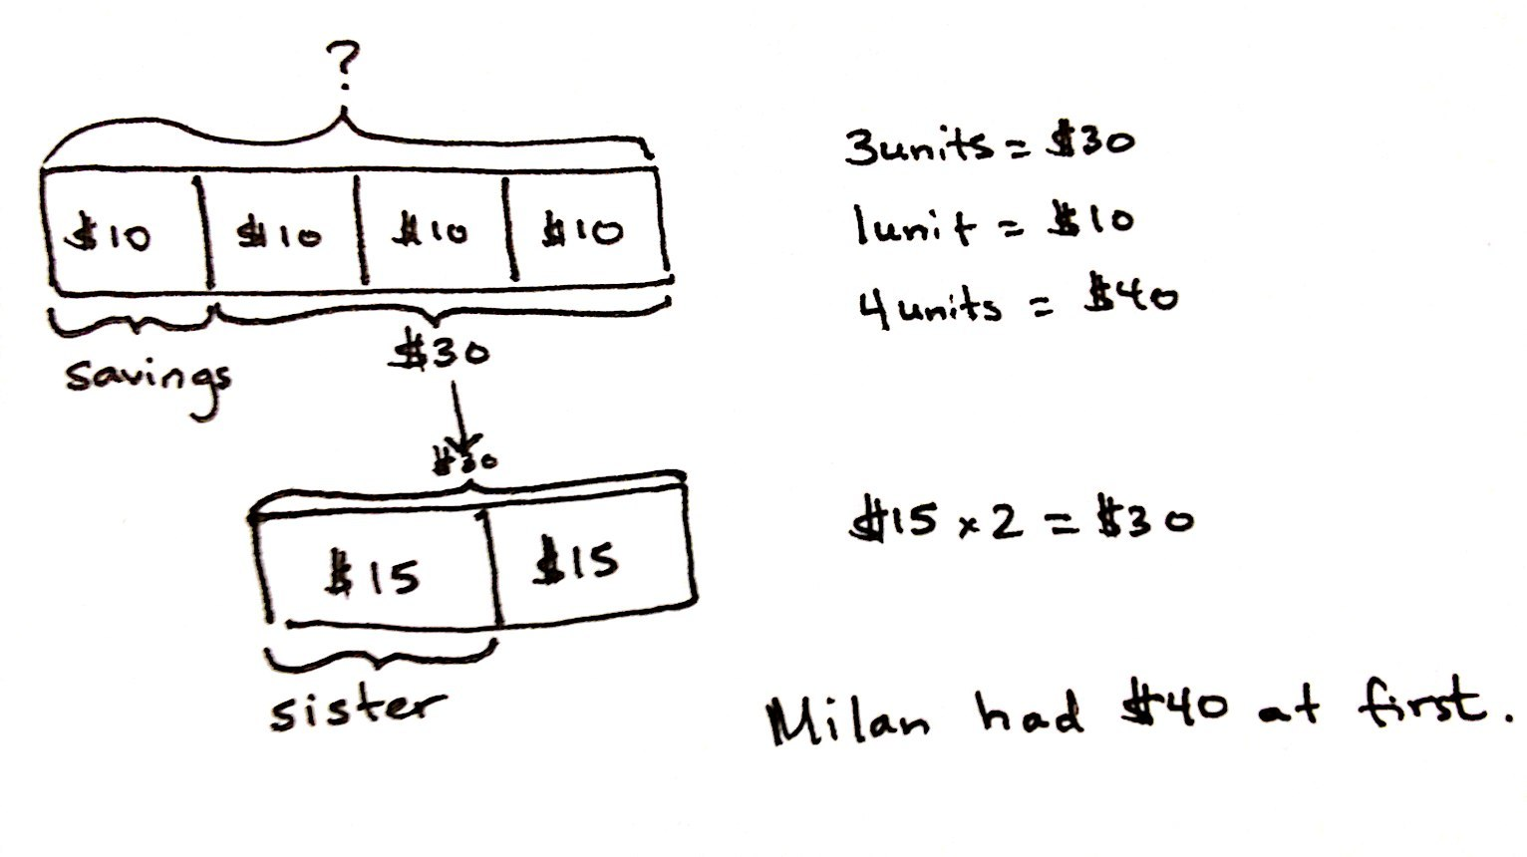
Milan puts $\frac{1}{4}$ of her lawn-mowing money in savings and uses $\frac{1}{2}$ of the remaining money to pay back her sister. If she has $15 left, how much did she have at first?
T: (Post Problem 5 on the board, and read it aloud with the students.) How is this problem different from the ones we’ve just solved? Turn and discuss with your partner.
S: In the others, we knew what the whole was; this time, we don’t. We know how much money she has left, but we have to figure out what she had at the beginning. It seems like we might have to work backwards. The other problems were whole-to-part problems. This one is part-to-whole.
T: Let’s draw a tape diagram. (Draw a blank tape diagram.) What is the whole in this problem?
S: We don’t know yet; we have to find it.
T: I’ll put a question mark above our tape diagram to show that this is unknown. (Label diagram with a question mark.) What fraction of her money does Milan put in savings?
S: $\frac{1}{4}$.
T: How can we show that on our tape diagram?
S: Cut the whole into 4 equal parts and bracket one of them. Cut it into fourths and label 1 unit savings.
T: (Record on the tape diagram.) What part of our tape diagram shows the remaining money?
S: The other parts.
T: Let’s draw another tape diagram to represent the remaining money. Notice that I will draw it exactly the same length as those last 3 parts. (Model.) What do we know about this remaining part?
S: Milan gives half of it to her sister.
T: How can we model that?
S: Cut the tape diagram into two equal parts and label one of them. (Partition the second tape diagram in halves, and label one of them sister.)
T: What about the other half of the remaining money?
S: That’s how much she has left. It’s $15.
T: Let’s label that. (Write $15 in the second equal part.) If this half is $15, (point to labeled half) what do we know about the amount she gave her sister, and what does that tell us about how much was remaining in all? Turn and talk.
S: If one half is $15, then the other half is $15 too. That makes $30. $15 + $15 = $30. $15 × 2 = $30.
T: If the lower tape diagram is worth $30, what do we know about these 3 units in the whole? (Point to the original tape diagram.) Turn and discuss.
S: The remaining money is the same as 3 units, so 3 units is equal to $30. They represent the same money in two different parts of the tape diagram. 3 units is equal to $30.
T: (Label 3 units $30.) If 3 units = $30, what is the value of 1 unit?
S: (Work and show 1 unit = $10.)
T: Label $10 inside each of the 3 units. (Model on the diagram.) If these 3 units are equal to $10 each, what is the value of this last unit? (Point to the unit that was labeled savings.)
S: $10.
T: (Label $10 inside the savings’ unit.) Look at our tape diagram. We have 4 units of $10 each. What is the value of the whole?
S: (Work and show 4 units = $40.)
T: Make a statement to answer the question.
S: Milan had $40 at first.
T: Let’s check our work using a fraction of a set. What multiplication sentence tells us what fraction of all her money Milan gave to her sister? What fraction did she give to her sister?
S: $\frac{1}{2}\text{×}\frac{3}{4}\text{=}\frac{3}{8}$.
T: So, $15 should be 3 eighths of $40. Is that true? Let’s see. Find $\frac{3}{8}$ of $40 with your partner.
S: (Work and show $\frac{3}{8}$of $40 = $15.)
T: Does this confirm our answer of $40 as Milan’s money at first?
S: Yes!
T: Complete Problems 4 and 6 on the Problem Set. Check your work with a neighbor when you’ve finished. You may use either method to solve.
Solutions for Problem 4 and Problem 6

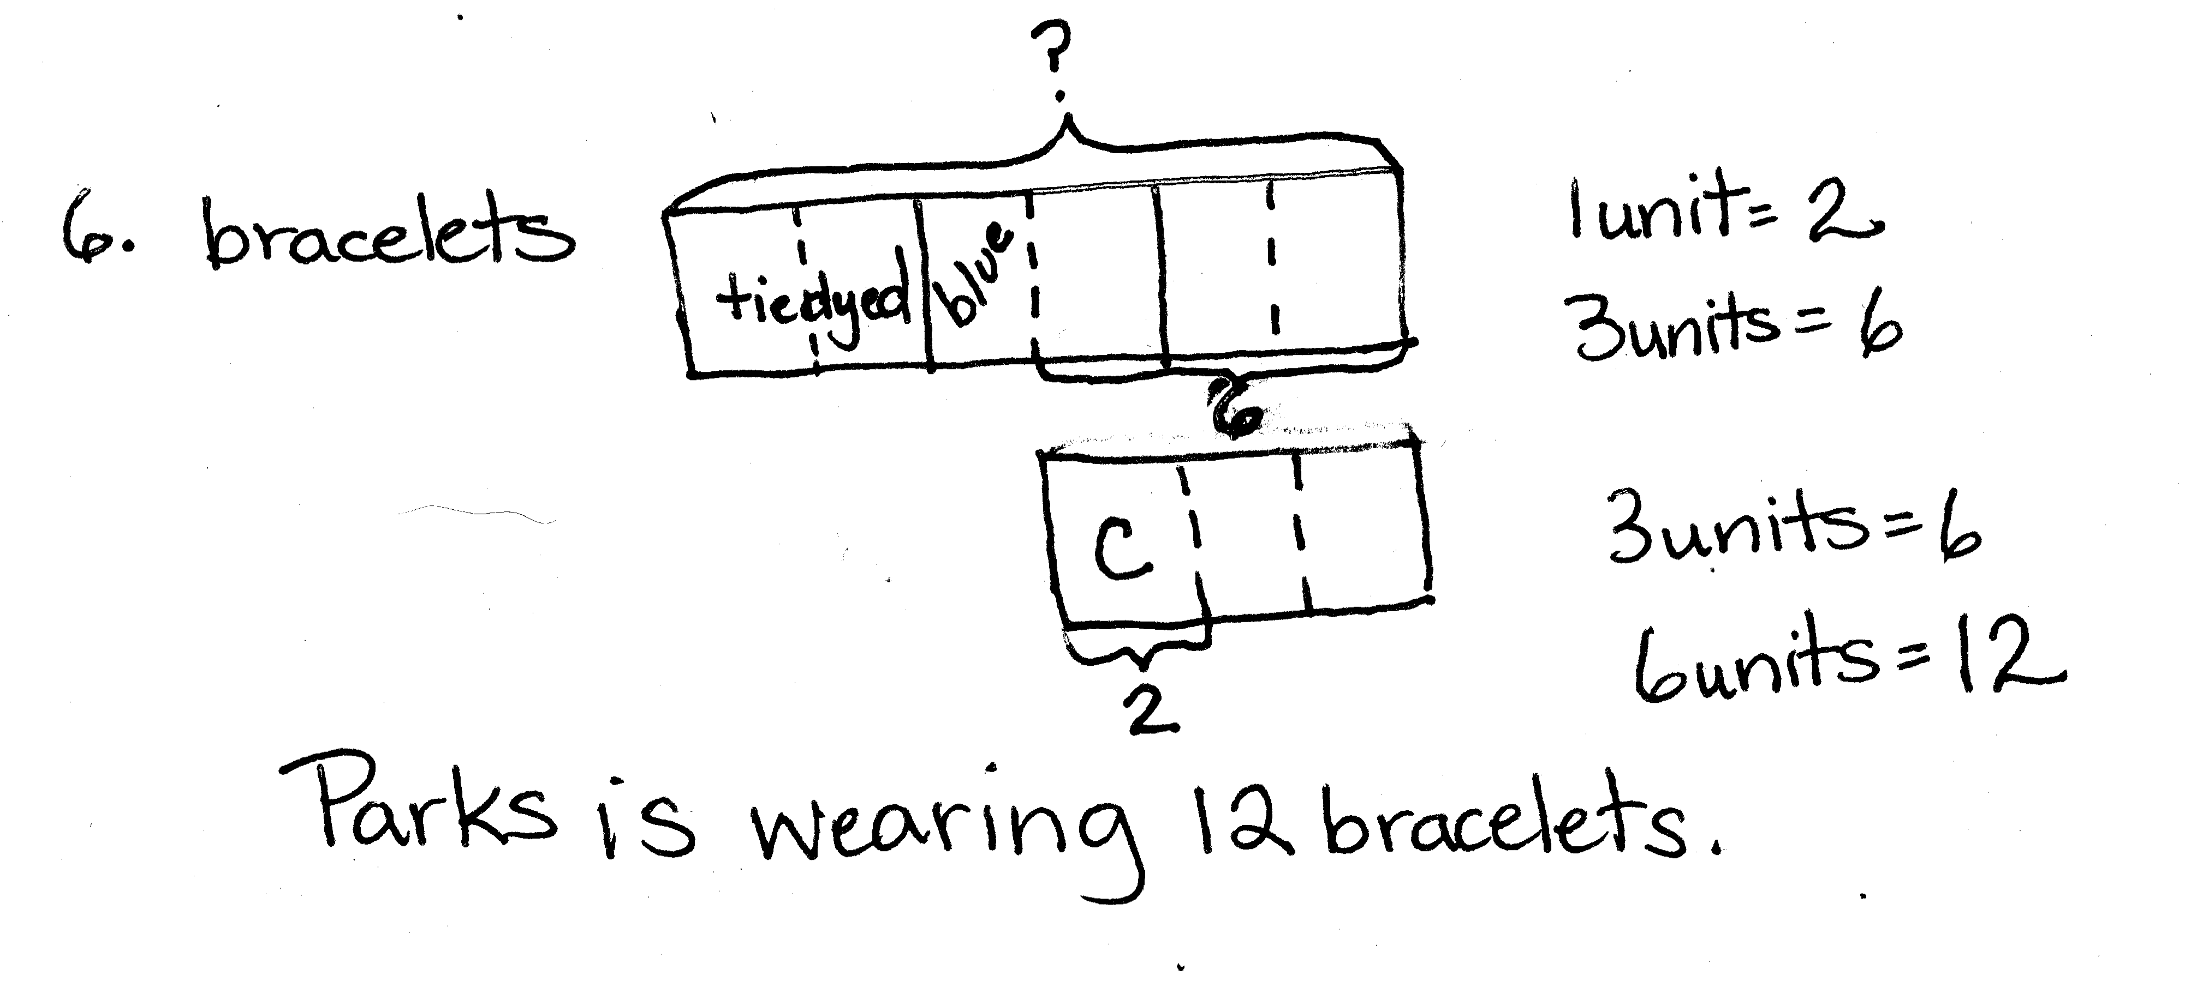
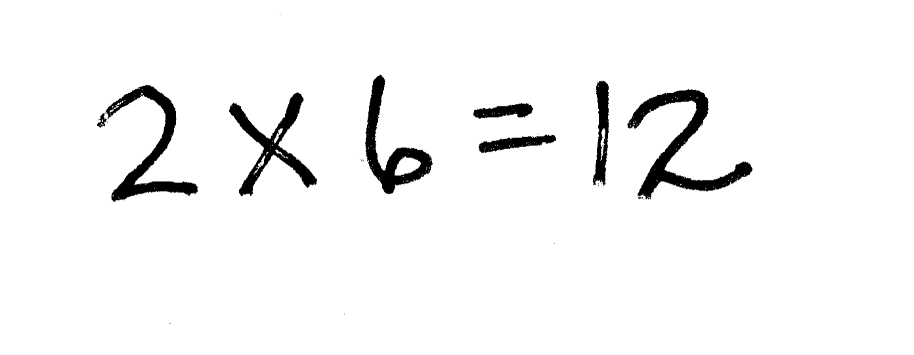
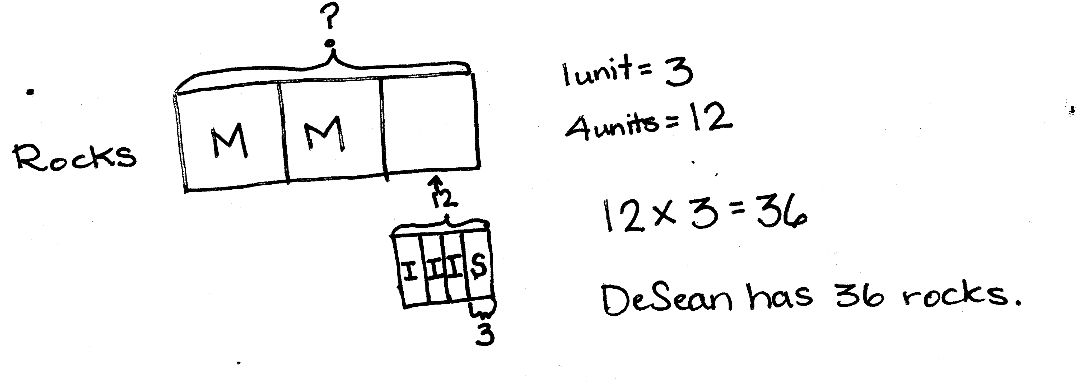
Note: Problem 7 may be used as an extension for early finishers.
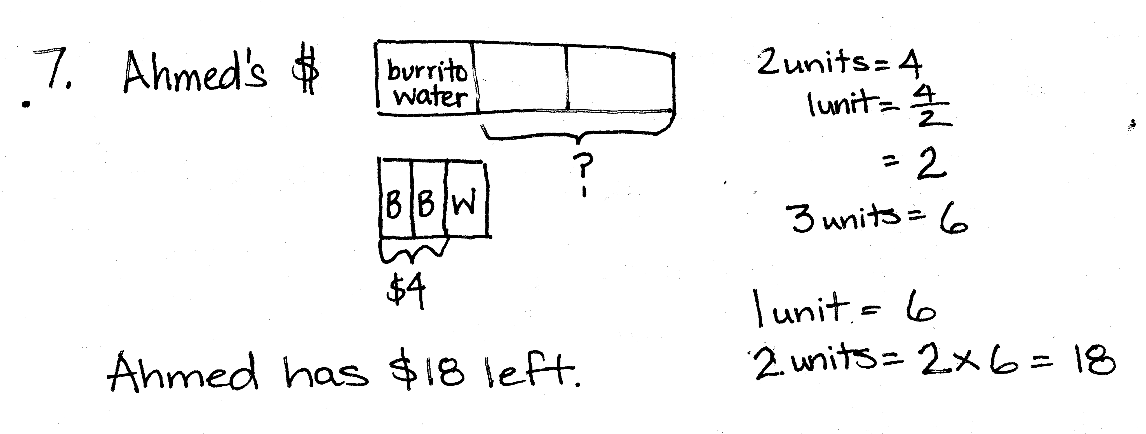

Problem Set (10 minutes)
NOTES ON
MULTIPLE MEANS
OF ENGAGEMENT:
Anticipate that some students may struggle with a homework assignment, and provide support in one of the following ways:
- Complete one of the problems or a portion of a problem as an example before the pages are duplicated for students.
- Staple the Problem Set to the homework as a reference.
- Provide a copy of completed homework as a reference.
- Differentiate homework by using some of these strategies for specific students or specifying that only certain problems be completed.
The Problem Set forms the basis for today’s lesson. Please see the Concept Development for modeling suggestions.
Student Debrief (10 minutes)
Lesson Objective: Solve word problems using tape diagrams and fraction-by-fraction multiplication.
The Student Debrief is intended to invite reflection and active processing of the total lesson experience.
Invite students to review their solutions for the Problem Set. They should check work by comparing answers with a partner before going over answers as a class. Look for misconceptions or misunderstandings that can be addressed in the Debrief. Guide students in a conversation to debrief the Problem Set and process the lesson.
You may choose to use any combination of the questions below to lead the discussion.
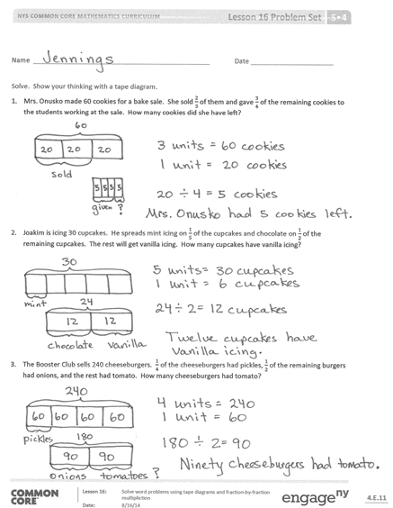
- Did you use the same method for solving Problems 1 and 3? Why or why not?
- Did you use the same method for solving Problems 4 and 6? Why or why not?
- Were any alternate methods used? If so, explain what you did.
- How was setting up Problems 1 and 3 different from the process for solving Problems 4 and 6? What were your thoughts as you worked?
- Talk about how your tape diagrams helped you find the solutions. Give some examples of questions that you could have been able to answer using the information in your tape diagram.
- Questions for further analysis of tape diagrams:
  - Problem 1: Half of the cookies sold were oatmeal raisin. How many oatmeal raisin cookies were sold?
  - Problem 3: What fraction of the burgers had onions? How many burgers had onions?
  - Problem 4: How many more metamorphic rocks does DeSean have than igneous rocks?
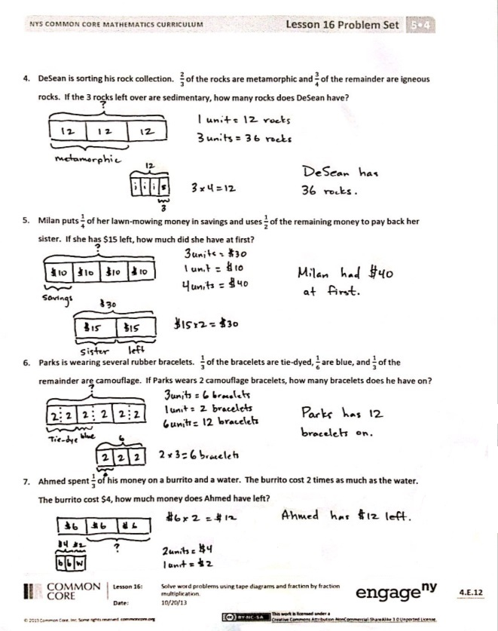
  - Problem 6: If Parks takes off 2 tie-dye bracelets and puts on 2 more camouflage bracelets, what fraction of all the bracelets would be camouflage?
Exit Ticket (3 minutes)
After the Student Debrief, instruct students to complete the Exit Ticket. A review of their work will help you assess the students’ understanding of the concepts that were presented in the lesson today and plan more effectively for future lessons. You may read the questions aloud to the students.

Name Date
Solve and show your thinking with a tape diagram.
- Mrs. Onusko made 60 cookies for a bake sale. She sold $\frac{2}{3}$ of them and gave $\frac{3}{4}$ of the remaining cookies to the students working at the sale. How many cookies did she have left?

- Joakim is icing 30 cupcakes. He spreads mint icing on $\frac{1}{5}$ of the cupcakes and chocolate on $\frac{1}{2}$of the remaining cupcakes. The rest will get vanilla icing. How many cupcakes have vanilla icing?

- The Booster Club sells 240 cheeseburgers. $\frac{1}{4}$ of the cheeseburgers had pickles, $\frac{1}{2}$of the remaining burgers had onions, and the rest had tomato. How many cheeseburgers had tomato?

- DeSean is sorting his rock collection. $\frac{2}{3}$ of the rocks are metamorphic and $\frac{3}{4}$ of the remainder are igneous rocks. If the 3 rocks left over are sedimentary, how many rocks does DeSean have?

- Milan puts $\frac{1}{4}$ of her lawn-mowing money in savings and uses $\frac{1}{2}$ of the remaining money to pay back her sister. If she has $15 left, how much did she have at first?

- Parks is wearing several rubber bracelets. $\frac{1}{3}$ of the bracelets are tie-dye, $\frac{1}{6}$ are blue, and $\frac{1}{3}$ of the remainder are camouflage. If Parks wears 2 camouflage bracelets, how many bracelets does he have on?

- Ahmed spent $\frac{1}{3}$ of his money on a burrito and a water bottle. The burrito cost 2 times as much as the water. The burrito cost $4, how much money does Ahmed have left?

Name Date
Solve and show your thinking with a tape diagram.
- Three-quarters of the boats in the marina are white, $\frac{4}{7}$ of the remaining boats are blue, and the rest are red. If there are 9 red boats, how many boats are in the marina?

Name Date
Solve and show your thinking with a tape diagram.
- Anthony bought an 8-foot board. He cut off$\frac{3}{4}$ of the board to build a shelf, and gave$\frac{1}{3}$ of the rest to his brother for an art project. How many inches long was the piece Anthony gave to his brother?

- Riverside Elementary School is holding a school-wide election to choose a school color. Five-eighths of the votes were for blue, $\frac{5}{9}$ of the remaining votes were for green, and the remaining 48 votes were for red.
  - How many votes were for blue?

  - How many votes were for green?

  - If every student got one vote, but there were 25 students absent on the day of the vote, how many students are there at Riverside Elementary School?

  - Seven-tenths of the votes for blue were made by girls. Did girls who voted for blue make up more than or less than half of all votes? Support your reasoning with a picture.

  - How many girls voted for blue?

