Lesson 8
Objective: Count to 120 in unit form using only tens and ones. Represent numbers to 120 as tens and ones on the place value chart.

Suggested Lesson Structure
 Application Problem (5 minutes)
 Fluency Practice (14 minutes)
 Concept Development (31 minutes)
 Student Debrief (10 minutes)
Total Time (60 minutes)
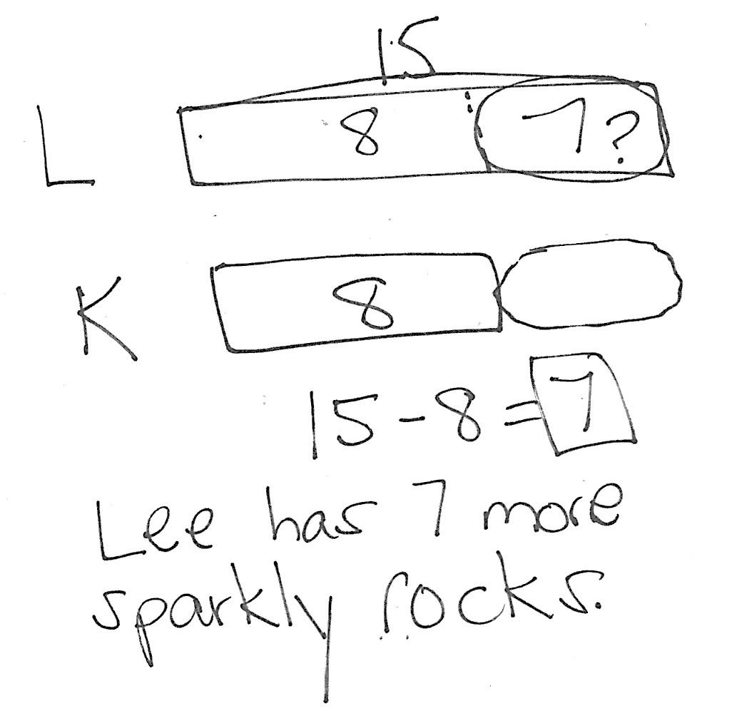
Application Problem (5 minutes)
Lee found 15 sparkly rocks. Kim found 8 sparkly rocks. How many more sparkly rocks did Lee find than Kim?
Note: Today’s Application Problem is a compare with difference unknown problem type. For students who are successful with solving this problem when the term more is used, consider adjusting the question to ask how many fewer sparkly rocks Kim found. You may also ask both questions to help students recognize that the same solution sentence can be used with either question.
Fluency Practice (14 minutes)
- Grade 1 Core Fluency Sprint 1.OA.6 (10 minutes)
- 1 More, 1 Less, 10 More, 10 Less 1.OA.5, 1.NBT.5 (4 minutes)
Grade 1 Core Fluency Sprint (10 minutes)
Materials: (S) Core Fluency Sprint (G1─M5─Lesson 1)
Note: Based on the needs of the class, select a Sprint from yesterday’s materials. There are several possible options available.
- Re-administer the Sprint from the day before.
- Administer the next Sprint in the sequence.
- Differentiate. Administer two different Sprints. Simply have one group do a counting activity on the back of their Sprint while the other Sprint is corrected.
Today, practice Say Ten counting from 88 to 99 and back between Sides A and B of the Sprint.
1 More, 1 Less, 10 More, 10 Less (4 minutes)

NOTES ON
MULTIPLE MEANS OF REPRESENTATION:
Some students may need practice writing the number after they mentally find 1 or 10 more or less. As an alternative for certain students, have them write the numbers instead of saying them.

Materials: (T) Vertical hundreds chart
Note: This fluency activity reviews the grade level standard of mentally finding 10 more or less than a number without having to count.
Display the vertical hundreds chart for reference.
T: Say the number that is 1 more. 5. (Pause, then snap.)
S: 6.
T: 15. (Pause, then snap.)
S: 16.
Continue with the following suggested sequence, as time permits: 55, 75, 105, 115; 67, 97, 107; 9, 49, 99, 109, 119.

Repeat for 10 more:
10, 40, 90, 100
3, 23, 63
56, 86, 96
Repeat for 10 less:
20, 50, 70
45, 65, 95
88, 118, 108
Repeat for 1 less:
4, 14, 84
8, 38, 88
10, 70, 120

Concept Development (31 minutes)
Materials: (T) 100-bead Rekenrek and 20-bead Rekenrek (if available), place value chart, personal white board, document camera (S) Place value chart, personal white boards
Note: If the 20-bead Rekenrek is not available, draw two rows of large dots (5 white and 5 red in each row) on chart paper to represent two more rows of beads. Along with the bead sets, put the place value chart on a board under the document camera or put an image of the place value chart on an interactive board.
Gather students in the meeting area for today’s lesson.
T: You did a great job with the Say Ten counting between the two Sprints today. Let’s count by tens the Say Ten way.
S: (Move the beads on the Rekenrek as students count.) 1 ten, 2 tens, 3 tens, …9 tens, 10 tens.
T: (Write 10 in the tens position on the place value chart.) Since we were only counting tens, there are no additional ones, just 10 tens. (Write 0 in the ones position on the place value chart.)
T: 10 tens is the same as…?
S: 100!
T: What if I add 1 more bead? (Hold up the 20-bead Rekenrek and slide 1 bead over.) Do I still have 10 tens?
S: Yes!
T: But I also have?
S: 1 one.
T: I need a volunteer to change our place value chart to show 10 tens and 1 one. (Select a student and wait as she erases 0 in the ones position and writes 1.)
T: 10 tens 1 one is?
S: 101! (Some students may say one hundred and one. If they do, explain that 100 + 1 describes 100 and 1. To say the number, we say one hundred one. This is similar to naming other numbers, such as 25. Twenty and 5, is written 20 + 5. To say the number, we say twenty-five.)
T: We had 10 tens, then 10 tens 1. Next we would have? (Move another bead on the 20-bead Rekenrek.)
S: 10 tens 2!
T: Let’s change our place value charts to record the tens and ones.

NOTES ON
MULTIPLE MEANS OF REPRESENTATION:
If some students need more support, have them look at the Rekenreks as they are counting. This visual support will help them to identify the number of tens and then the number of additional ones.

T: 10 tens 2 is the same as?
S: 102.
T: Let’s see. 100, 101, 102. Next would be…? (Slide a third bead.)
S: 103!
T: How many tens and ones are in 103? Let’s change our place value charts to record the tens and ones.
T: Let’s count together starting at 98. Listen for when I say to stop.
S/T: (Count together without the Rekenrek.) 98, 99, 100, 101, 102, 103, 104, 105, 106, 107, 108, 109.
T: Stop!
T: How many tens and ones are in 109? Talk with a partner. Let’s show that many on the Rekenrek, and record it on your place value chart. (Circulate and notice students’ recordings.)
T: Let’s look at the Rekenrek. It shows how many tens?
S: 10 tens!
T: It shows how many additional ones?
S: 9 ones!
T: What if we slide over one more bead? How many tens would we have then?
S: 11 tens! (Slide over one more bead, so that the Rekenreks now show 11 tens.)
T: Write this amount on your place value chart. Tell your partner what number has 11 tens. (Wait as students complete the task.)
T: 11 tens is the same as?
S: One hundred ten!
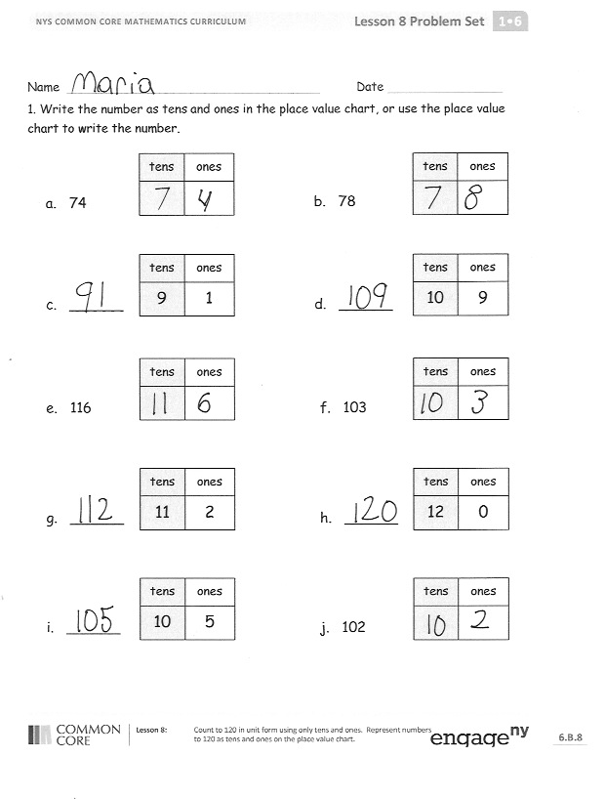
Repeat the process, having students count from a given number and stop at a given number. Students identify the number in both its traditional form and its unit form. A suggested sequence would be 97 to 103, 108 to 112, and 108 to 120. Alternate between saying numbers the regular way and the Say Ten way. If students need more practice, the following partner activity may be used.
- Partner A uses quick tens and ones to draw a number between or including 100 and 120.
- Partner B records the number in the place value chart while Partner A writes the number below their drawing.
- The two partners check that they have matching numbers, and then switch roles to start again.
Problem Set (10 minutes)
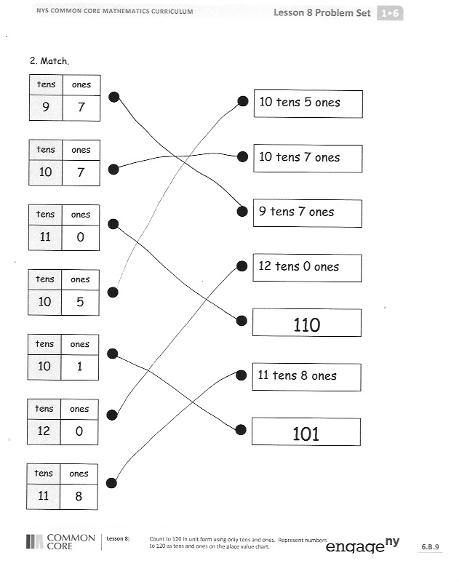
Students should do their personal best to complete the Problem Set within the allotted 10 minutes. For some classes, it may be appropriate to modify the assignment by specifying which problems they work on first. Some problems do not specify a method for solving. Students solve these problems using the RDW approach used for Application Problems.
Student Debrief (10 minutes)
Lesson Objective: Count to 120 in unit form using only tens and ones. Represent numbers to 120 as tens and ones on the place value chart.
The Student Debrief is intended to invite reflection and active processing of the total lesson experience.
Invite students to review their solutions for the Problem Set. They should check work by comparing answers with a partner before going over answers as a class. Look for misconceptions or misunderstandings that can be addressed in the Debrief. Guide students in a conversation to debrief the Problem Set and process the lesson.

You may choose to use any combination of the questions below to lead the discussion.
- Look at Problem 1(d). What similarities and differences do you notice between reading a number and seeing the number in tens and ones?
- Look at Problem 2. Which matches were easy to identify and which were more challenging? Explain why this was so.
- Choose a number from Problem 1. What is another way you could show this number in unit form? (This question is best used if students have been highly successful with today’s lesson.)
- How can Say Ten counting help you with numbers from 100 to 120?
- Look at your Application Problem. Share your strategies for solving the problem.
Exit Ticket (3 minutes)
After the Student Debrief, instruct students to complete the Exit Ticket. A review of their work will help you assess the students’ understanding of the concepts that were presented in the lesson today and plan more effectively for future lessons. You may read the questions aloud to the students.

Name Date
- Write the number as tens and ones in the place value chart, or use the place value chart to write the number.
b. 78
tens
ones

a. 74
tens
ones

c. ______
tens
ones
1
9
d. ______
tens
ones
9
10

f. 103
tens
ones

e. 116
tens
ones

g. ______
tens
ones
2
11
h. ______
tens
ones
0
12

i. ______
tens
ones
5
10
j. 102
tens
ones

- Match.
tens
ones
7
9
10 tens 5 ones

10 tens 7 ones
tens
ones
7
10

tens
ones
8
11
101
11 tens 8 ones
110
12 tens 0 ones
9 tens 7 ones
tens
ones
0
12
tens
ones
1
10
tens
ones
5
10
tens
ones
0
11
Name Date
- Write the number as tens and ones in the place value chart, or use the place value chart to write the number.
b. ______
tens
ones
4
9
a. 83
tens
ones

c. ______
tens
ones
5
11
d. 106
tens
ones

- Write the number.
  - 10 tens 2 ones is the number _________.
  - 11 tens 4 ones is the number _________.

Name Date
    - Write the number as tens and ones in the place value chart, or use the place value chart to write the number.
b. 98
tens
ones

a. 81
tens
ones

c. ______
tens
ones
7
11
d. ______
tens
ones
8
10

f. 111
tens
ones

e. 104
tens
ones

    - Write the number.
a. 9 tens 2 ones is the number _______. | b. 8 tens 4 ones is the number _______.
c. 11 tens 3 ones is the number _______. | d. 10 tens 9 ones is the number ______.
e. 10 tens 1 ones is the number _____. | f. 11 tens 6 ones is the number _____.

    - Match.
tens
ones
2
10
11 tens 4 ones

9 tens 5 ones
tens
ones
5
9

tens
ones
8
11
108
10 tens 0 ones
102
11 tens 0 ones
11 tens 8 ones
tens
ones
0
10
tens
ones
8
10
tens
ones
0
11
tens
ones
4
11

