Lesson 6
Objective: Use the symbols >, =, and < to compare quantities and numerals to 100.

Suggested Lesson Structure
 Application Problem (5 minutes)
 Fluency Practice (13 minutes)
 Concept Development (32 minutes)
 Student Debrief (10 minutes)
Total Time (60 minutes)
Application Problem (5 minutes)
Nikil has 12 toy cars. Willie has 4 toy cars. When Nikil and Willie play, how many toy cars do they have?
Note: Today we return to the very simple put together with result unknown problem type. Please use this to highlight that students might use either a double or single tape to model, as is pictured to the right.
Fluency Practice (13 minutes)
- Core Fluency Differentiated Practice Sets 1.OA.6 (5 minutes)
- Coin Drop 1.NBT.5, 1.MD.3 (3 minutes)
- True or False Number Sentences 1.OA.6, 1.OA.7 (5 minutes)

NOTES ON
MULTIPLE MEANS OF ENGAGEMENT:
For students who are still on Practice Set A, a privately administered oral Practice Set may help them be more successful. The pencil and paper can also hold some students back who may have trouble with their fine motor skills.
Core Fluency Differentiated Practice Sets (5 minutes)
Materials: (S) Core Fluency Practice Sets from G1─M6─Lesson 1
Note: Give the appropriate Practice Set to each student. Help students become aware of their improvement by asking them to quickly stand if they tried a new level or improved their score from the previous day.
Students complete as many problems as they can in 90 seconds.
Assign a counting pattern and start number for early finishers, or have them practice make ten addition or subtraction on the back of their papers. Collect and correct any Practice Sets completed within the allotted time.
Coin Drop (3 minutes)
Materials: (T) 10 dimes, 10 pennies, can
Note: This activity reviews yesterday’s lesson, in which students learned to add and subtract ones and tens within 100.
Today, start with 5 dimes in the can. Drop a penny or a dime into the can, asking them the total after each drop of one coin. Ask them to say, “1 cent more is 51 cents,” or “10 cents more is 60 cents.” For today, perhaps limit it to 1 more and 10 more.
True or False Number Sentences (5 minutes)
Materials: (T/S) Personal white boards
Note: This activity provides practice with Grade 1’s core fluency, while reviewing the inequality symbols that were presented in G1─M4─Topic B.
Review the symbols =, >, and <. Write true and false number sentences using the symbols. On the signal, students say whether the number sentence is true or false. Then, choose a student who answered correctly to prove it.
T (Write 5 = 7.) Is this number sentence true or false? (Pause, then snap.)
S: False.
T: Why? Student A.
S: 5 is less than 7.
T: (Write 8 = 6 + 2.) True or false? (Pause, then snap.)
S: True.
T: Why? Student B.
S: 6 + 2 is 8 and 8 is the same as 8.
T: (Write 8 = 8 underneath 8 = 6 + 2.)
Continue with the following suggested sequence. Be sure to space the number sentences so students can easily see the two expressions and provide time for students to solve on their personal boards, as needed. Before the > and < columns, write the symbols in the middle of the board and review the meanings.

a. 6 = 8 – 2
b. 3 = 8 – 5
c. 5 + 1 = 4 + 1
d. 5 + 1 = 4 + 2

e. 5 > 6
f. 7 > 4
g. 8 > 7
h. 6 > 9

i. 8 < 9
j. 6 < 5
k. 6 < 3 + 3
l. 5 + 2 < 2 + 5

Concept Development (32 minutes)
Materials: (T) Chart paper, comparison cards, tape (S) Place value chart template (from G1─M6─Lesson 2) inserted into personal white boards, comparison cards
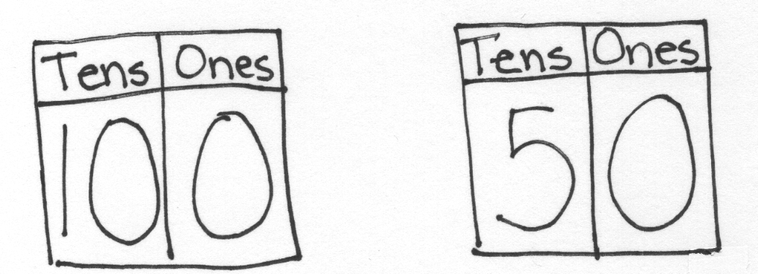
Gather students in the meeting area with their materials.
T: (On chart paper, write 100 and 50 in place value charts with room between them to insert comparison card.) Which number is greater?
S: 100!
T: How do you know?
S: 50 has 5 tens and 100 has 10 tens. When you count up, you say 50 a long time before you say 100. 10 tens is 5 tens more than 5 tens. You need to add more to 50 to make 100.
T: (Show < and > cards.) Which symbol should I use?
S: Greater than! The one on the right.
T: (Tape > symbol between the two place value charts.) What are some of the ways you help yourself remember that this (point to >) is the greater than symbol.
S: Pretend the open side is a hungry alligator’s mouth that eats the bigger number. The side with two endpoints is near the greater number. The side with 1 endpoint is near the smaller one.
T: (Tape the other two symbol cards to the chart paper.) What is the name of this symbol?
S: Less than!
T: This one?
S: Equal to!
T: Choose the symbol you think I should use to compare the two numbers I write. Wait for the snap.
T: (Write 60 and 90. Pause before giving the signal. Add the < symbol between 60 and 90.) Let’s read our math sentence together.
S/T: 60 is less than 90.
Repeat the process from above with the following suggested sequence of numbers: 59 and 52, 80 and 70, 49 and 94, 7 tens and 6 tens 8 ones, 78 ones and 8 tens, 67 ones and 6 tens, 7 tens and 6 tens 10 ones, 10 tens and 90, and 8 tens 2 ones, and 7 tens and 15 ones

NOTES ON
MULTIPLE MEANS OF ENGAGEMENT:
As students are working on the sequence of numbers, be sure they are reading the math sentence out loud once they choose the symbol to compare the numbers. Being able to read the sentence properly demonstrates they have mastered the difference between the symbols.
If students could use more practice, invite them to play Compare It! with a partner.
- Each partner writes a number from 0 to 100 on his board, without showing his partner.
- When both are ready, they show their boards.
- For the first round, Partner A uses the cards to put the symbol between the boards.
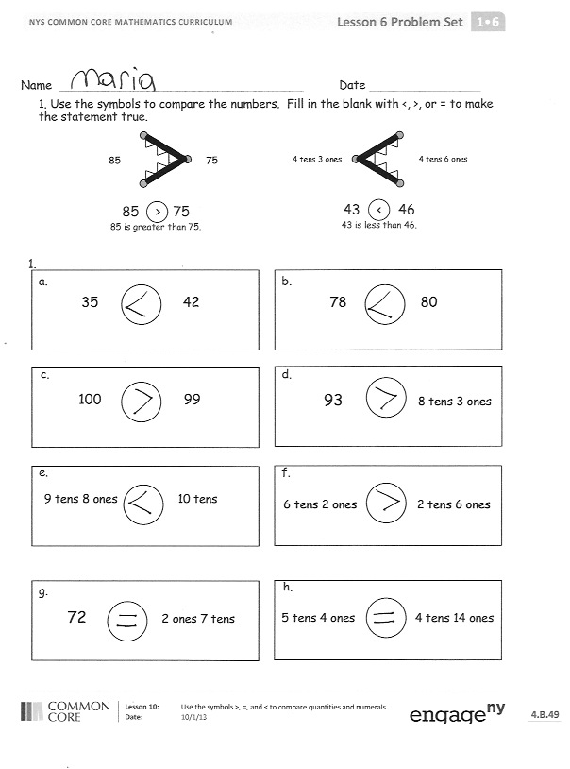
- Partner B reads the true number sentence that you made. (Demonstrate with the number sentence on the board.)
At the end of the first round, have partners use Partner B’s cards. Alternate for each round until the students have played for four minutes. During that time, circulate and notice which students are successful and which students may need more support. Encourage students to make the game more challenging by varying how they represent the number, using quick tens, place value charts, and writing the numbers as tens and ones.
Problem Set (10 minutes)
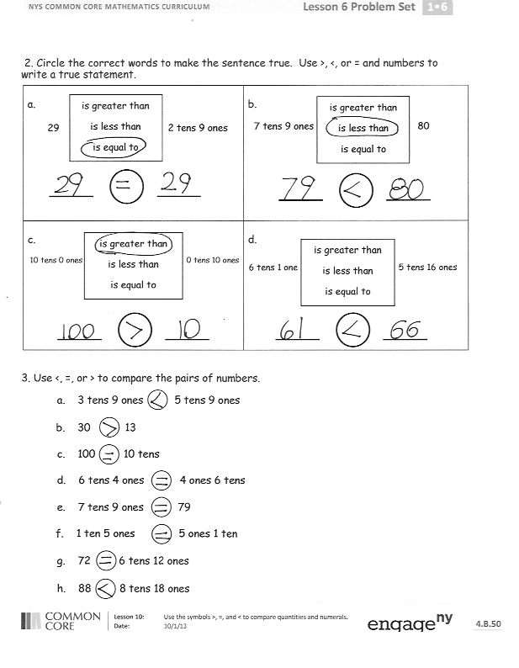
Students should do their personal best to complete the Problem Set within the allotted 10 minutes. For some classes, it may be appropriate to modify the assignment by specifying which problems they work on first. Some problems do not specify a method for solving. Students solve these problems using the RDW approach used for Application Problems.
Student Debrief (10 minutes)
Lesson Objective: Use the symbols >, =, and < to compare quantities and numerals to 100.
The Student Debrief is intended to invite reflection and active processing of the total lesson experience.
Invite students to review their solutions for the Problem Set. They should check work by comparing answers with a partner before going over answers as a class. Look for misconceptions or misunderstandings that can be addressed in the Debrief. Guide students in a conversation to debrief the Problem Set and process the lesson.
You may choose to use any combination of the questions below to lead the discussion.
- Look at Problem 1(g). How did you solve this problem? Explain your thinking.
- Which problem was the trickiest in the Problem Set to compare? What made it tricky and how did you or your partner solve it? If you were going to give a friend advice on how to solve these kinds of tricky comparisons, what would you suggest to him?
- Share a comparison problem that you and your partner created during the Compare It! activity.
- With your partner, share how you remember the meaning of each symbol.
- How did the fluency we practiced today help you with our lesson? Explain your thinking.
- Look at your Application Problem. Share your drawing and your solution. How did your drawing help you solve the problem? How is your drawing similar to or different from your partner’s drawing?
Exit Ticket (3 minutes)
After the Student Debrief, instruct students to complete the Exit Ticket. A review of their work will help you assess the students’ understanding of the concepts that were presented in the lesson today and plan more effectively for future lessons. You may read the questions aloud to the students.

Name Date
- Use the symbols to compare the numbers. Fill in the blank with <, >, or = to make the statement true.
85
75
85 > 75
85 is greater than 75.
4 tens 3 ones
4 tens 6 ones
43 < 46
43 is less than 46.

9 tens 8 ones 10 tens
g.
b.
78 80
a.
35 42

c.
100 99
d.
93 8 tens 3 ones 72 2 ones 7 tens

e.
f.
6 tens 2 ones 2 tens 6 ones

h.
5 tens 4 ones 4 tens 14 ones

- Circle the correct words to make the sentence true. Use >, <, or = and numbers to write a true statement.
a.  29 2 tens 9 ones  is greater than  is less than  is equal to | b.  7 tens 9 ones 80  is greater than  is less than  is equal to
c.  10 tens 0 ones 0 tens 10 ones  is greater than  is less than  is equal to  6 tens 1 one 5 tens 16 ones | d.  is greater than  is less than  is equal to

- Use <, =, or > to compare the pairs of numbers.
a. 3 tens 9 ones 5 tens 9 ones
b. 30 13
c. 100 10 tens
d. 6 tens 4 ones 4 ones 6 tens
e. 7 tens 9 ones 79

g. 72 6 tens 12 ones

f. 1 ten 5 ones 5 ones 1 ten

h. 88 8 tens 18 ones

Name Date
Circle the correct words to make the sentence true. Use >, <, or = and numbers to write a true statement.
a.  36 6 tens 3 ones  is greater than  is less than  is equal to | b.  90 8 tens 9 ones  is greater than  is less than  is equal to
c.  52 5 tens 2 ones  is greater than  is less than  is equal to  4 tens 2 ones 3 tens 14 ones | d.  is greater than  is less than  is equal to

Name Date
- Use the symbols to compare the numbers. Fill in the blank with <, >, or = to make the statement true.
62
57
62 > 57
62 is greater than 57.
5 tens 6 ones
5 tens 9 ones
56 < 59
56 is less than 59.

7 tens 9 ones 9 tens 7 ones
h.
3 tens 5 ones 2 tens 17 ones
3 tens 0 ones 2 tens 10 ones

g.
c.
10 tens 99
b.
60 86
a.
43 35

d.
5 tens 4 ones 54

f.
1 ten 3 ones 31

e.

- Fill in the correct words from the box to make the sentence true. Use >, <, or = and numbers to write a true statement.
is greater than is less than is equal to

a. 37 __________________________ 73

b. 42 __________________________ 1 ten 2 ones

c. 6 tens 7 ones _______________________5 tens 17 ones

d. 2 tens 14 ones _____________________ 4 ones 2 tens

e. 9 ones 5 tens __________________________ 9 tens 5 ones

Comparison cards, page 1. Print double-sided on cardstock. Distribute each of the three cards to students.
> | < | = | <
> | < | = | >
> | < | = | =
> | < | =

Comparison cards, page 2. Print double-sided on cardstock. Distribute each of the three cards to students.
less than | equal to | less than | greater than
greater than | equal to | less than | greater than
equal to | equal to | less than | greater than
 | equal to | less than | greater than

