|  |
| --- |
|  |

Lesson 9: Modeling a Context from a Verbal Description

Student Outcomes

* Students interpret the function and its graph and use them to answer questions related to the model, including calculating the rate of change over an interval and always using an appropriate level of precision when reporting results.
* Students use graphs to interpret the function represented by the equation in terms of the context and answer questions about the model using the appropriate level of precision in reporting results.

**MP.4**

**&**

**MP.6**

This lesson addresses attending to precision when modeling in mathematics. The lesson begins with an explanation of what precision is, and students practice attending to precision with math model practice sets.

Lesson Notes

In this lesson, students use the full modeling cycle to model functions described verbally in a context. Since this is the final lesson of the year, you might want to use the examples and exercises of this lesson for independent work by your students. You might have groups work on the same problem, assign different problems for each group, or offer them a choice. Then, you might have them display their results and/or make a short presentation for the class. Discussion of the work could focus on the most efficient and/or elegant solution paths and the level of precision used in the work and in the reporting. A class discussion around the Opening Exercise should precede the student work in this lesson, and the precision questions in the examples should be used to guide further discussion of this topic.

Throughout this lesson, refer to the modeling cycle depicted below (as seen on page 61 of the CCLS and page 72 of the CCSS).



Classwork

Opening Exercise (3 minutes)

**Opening Exercise**

**What does it mean to attend to precision when modeling in mathematics?**

**Using clear and accurate language when interpreting the meaning and discussing the results of the mathematical model; labeling axes on a graph; specifying the meaning of a variable in a particular function; including units of measure when appropriate; showing mathematical work clearly using correct mathematical symbols and notations; making accurate calculations and checking for the reasonableness of the calculations.**

**Examples 1 and 2 (14 minutes)**

Have students read and plan a strategy for solving the problem below before guiding the class through the problem. It is important to stress the three representations of a function (i.e., tabular, algebraic, symbolic, graphic), in addition to verbal description, and that certain contexts may require one, two, or all three representations.

Example 1

Marymount Township secured the construction of a power plant, which opened in 1990. Once the power plant opened in 1990, the population of Marymount increased by abouteach year for the first ten years and then increased by each year after that.

* 1. If the population was people in 2010, what was the population in 2000?

Sample Response: We can tell that this problem involves a geometric sequence because we are multiplying each term by either or .

This is also a piecewise function since the first ten years the population grows at one rate, and after that it grows at a different rate.

We need to start backwards from 2010 to 2000, since we know the size of the population for 2010.

Geometric sequence:

2000 to 2010

* 1. How should you round your answer? Explain.

The 2010 value appears to be rounded to the nearest thousand . We will use a similar level of precision in our result: .

* 1. What was the population in 1990?

Sample Response: For 1990 to 2000 we know the final population from our answer to part (a), so we can use that to find the initial population in 1990. Note: For this sample response, we rounded off to people.

, so .

If you used the symbolic representation of the piecewise defined function, with , the population estimate is .

* Is it okay that we came out with more people in our model than we should have?
  + *When the total is a number as large as being off by is permissible. In fact, if a population were exactly , most people would likely refer to the population as .*

This is a great opportunity to explain to students why a slight change in geometric sequences can change the answer (sometimes dramatically, if the domain is large enough).

Example 2

If the trend continued, what would the population be in 2009?

Sample response: Since that is one year before the end of our sample, we can divide by to find the value before it.

Exercises (13 minutes)

Have students work in pairs or small groups to solve these problems. If students need more support, you might use these as a guided exercise.

Exercises

1. A tortoise and a hare are having a race. The tortoise moves at miles per hour. The hare travels at miles per hour. Halfway through the race, the hare decides to take a -hour nap and then gets up and continues at miles per hour.
   1. If the race is miles long, who won the race? Support your answer with mathematical evidence.

The time for the tortoise to finish is hours. The time for the hare to finish is hours. So, the hare beat the tortoise by one hour.

* 1. How long (in miles) would the race have to be for there to be a tie between the two creatures, if the same situation (as described in Exercise 1) happened?

Sample solution: Let the tortoise’s time be and hare’s time be .

(racing + napping)

Since both creatures finished the same distance in the same TOTAL time,

Solve for ,

miles.

Check: hours

1. 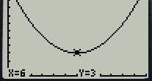The graph on the right represents the value of a popular stock. Its initial value was /share on day .

Note: The calculator uses to represent , and to represent .

* 1. How many days after its initial value at time did the stock price return to per share?

By the symmetry of quadratic equations, the stock must return to its initial value after more days, at .

* 1. Write a quadratic equation representing the value of this stock over time.

Since the quadratic equation reaches a minimum at , use vertex form to write . The initial value at was . So, by substitution, . Therefore, the final equation is .

* 1. Use this quadratic equation to predict the stock’s value after 15 days.

Closing (5 minutes)

Read the bulleted statements to the class. Pause after each item, and ask students to offer examples of how the item was used in the last two lessons of this module. For example, after specifying units, they may mention the units of the radiation half-life problem, or after state the meaning of the symbols they choose, students may say, “In the business problems, we had to identify the expressions for profit, revenue, etc.”

* Mathematically proficient students use clear definitions in discussion with others and in their own reasoning.
* They state the meaning of the symbols/variables they choose, including consistent and appropriate use of the equal sign.
* They are careful about specifying units of measure and labeling axes to clarify the correspondence with quantities in a problem.
* They calculate accurately and efficiently and express numerical answers with a degree of precision appropriate for the problem context.
* When given a verbal description, it is important to remember that functions used to model the relationships may have three representations: a table, an equation, or a graph.

Lesson Summary

**The full modeling cycle is used to interpret the function and its graph, compute for the rate of change over an interval, and attend to precision to solve real-world problems in the context of population growth and decay and other problems in geometric sequences or forms of linear, exponential, and quadratic functions.**

Exit Ticket (10 minutes)

Name Date

Lesson 9: Modeling a Context from a Verbal Description

Exit Ticket

The distance a car travels before coming to a stop once a driver hits the brakes is related to the speed of the car when the brakes were applied. The graph of (shown below) is a model of the stopping distance (in feet) of a car traveling at different speeds (in miles per hour).

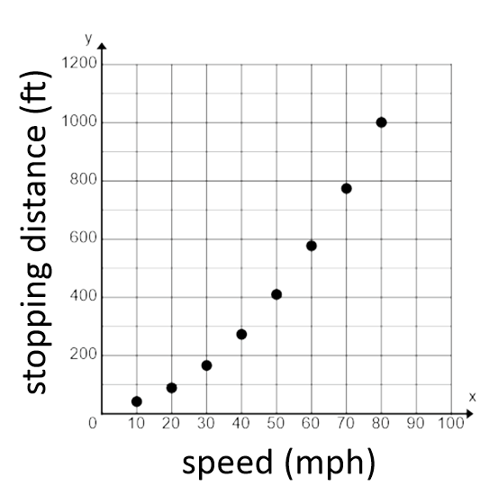

1. One data point on the graph of appears to be . What do you think this point represents in the context of this problem? Explain your reasoning.
2. Estimate the stopping distance of the car if the driver is traveling at when she hits the brakes. Explain how you got your answer.
3. Estimate the average rate of change of between and . What is the meaning of the rate of change in the context of this problem?
4. What information would help you make a better prediction about stopping distance and average rate of change for this situation?

Exit Ticket Sample Solutions

The distance a car travels before coming to a stop once a driver hits the brakes is related to the speed of the car when the brakes were applied. The graph of (shown) is a model of the stopping distance (in feet) of a car traveling at different speeds (in miles per hour).



1. One data point on the graph of appears to be . What do you think this point represents in the context of this problem? Explain your reasoning.

*In this problem, would represent the speed in miles per hour and would represent the stopping distance in feet. It does not make sense for a car to be traveling at , much less only take to come to a stop.*

1. Estimate the stopping distance of the car if the driver is traveling at when she hits the brakes. Explain how you got your answer.

*I can estimate the stopping distance by sketching a curve to connect the data points and locating the -coordinate of a point on this curve when its -coordinate is . My estimate is approximately .*

*Alternately, assume this is a quadratic function in the form , where is the stopping distance, in feet, and is the speed, in miles per hour. Using the point , , so . Using this model, .*

1. Estimate the average rate of change of between and . What is the meaning of the rate of change in the context of this problem?

*and . . This means that between and , the stopping distance is increasing by approximately for each additional*  *increase in speed.*

1. What information would help you make a better prediction about stopping distance and average rate of change for this situation?

A table of data or an algebraic function would help in making better predictions.

Problem Set Sample Solutions

1. According to the Center for Disease Control and Prevention, the breast cancer rate for women has decreased at per year between 2000 and 2009.
   1. If  women were diagnosed with invasive breast cancer in 2009, how many were diagnosed in 2005? For this problem, assume that there is no change in population from 2005 and 2009.

Geometric sequence: Common ratio is .

* 1. According to the American Cancer Society, in 2005 there were people diagnosed with breast cancer. In a written response, communicate how precise and accurate your solution in part (a) is, and explain why.

My solution is precise because my classmates and I followed the same protocols and our values were similar to each other. Since the model we used did not take into account the population increase, our values were off by people, which is. I believe that being off by only is still pretty close to the actual value. My solution was precise and accurate; it could have been more accurate if the population growth was taken into account in the exponential model.

1. The functions and represent the population of two different kinds of bacteria, where is the time (in hours) and and are the number of bacteria (in thousands). and .
   1. Between the third and sixth hour, which bacteria had a faster rate of growth?

***If you graph the functions, you can see that is steeper between those two hours and, therefore, has a faster rate of growth.***

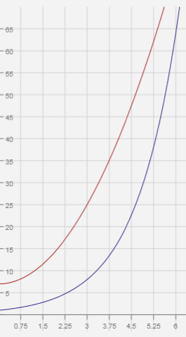

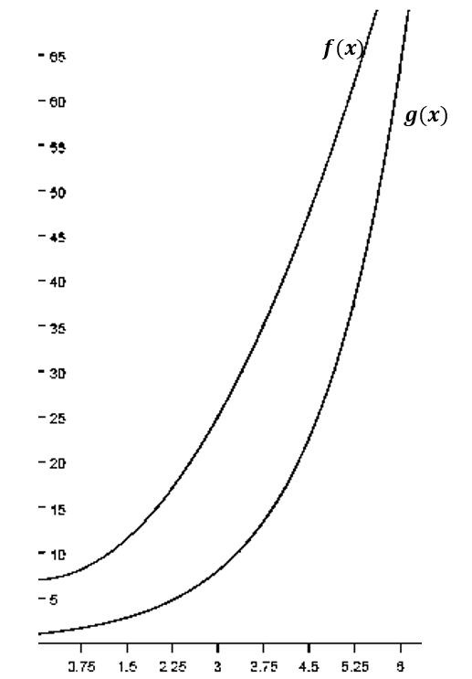

Using the functions to find the average rate of change over the interval , we have

has a slightly higher average rate of change on this interval.



* 1. Will the population of ever exceed the population of ? If so, at what hour?

Since the question asks for the hour (not the exact time), I made a table starting at the 6th hour and compared the two functions. Once exceeded , I stopped. So, sometime in the 7 th hour, exceeds .

|  |  |  |
| --- | --- | --- |
| Hour |  |  |
|  |  |  |
|  |  |  |