Grade 5: Module 4: Unit 3: Lesson 5
Researching about the Red Cross, Continued: How Did the Red Cross Aid Haiti After the 2010 Earthquake?

Long-Term Targets Addressed (Based on NYSP12 ELA CCLS)
I can build knowledge about multiple aspects of a topic by conducting research. (W.5.7)
I can document what I learn about a topic by taking notes. (W.5.8)
I can choose evidence from literary or informational texts to support analysis, reflection, and research. (W.5.9)
After a discussion, I can explain key ideas about the topic being discussed. (SL.5.1)
Supporting Learning Targets | Ongoing Assessment
- I can take notes from an informational text about the Red Cross aid to Haiti.  - I can explain the various ways the Red Cross prioritized aid to Haiti following the 2010 earthquake using evidence from text. | - Three-column note-catcher: What Is a Multinational Aid Organization?  - Vocabulary glossaries in student journals  - Red Cross in Haiti four-square note-catcher

Agenda | Teaching Notes
- Opening  - Homework Review and Engaging the Reader: Four Corners (8 minutes)  - Work Time  - First Read: Jigsaw Expert Groups Read for the Gist (10 minutes)  - Second Read: Jigsaw Expert Groups Take Notes (20 minutes)  - Using Evidence from the Text: Regular Groups Share (17 minutes)  - Closing and Assessment  - Debrief (3 minutes)  - Review Learning Targets (2 minutes)  - Homework  - Read all four sections of the “Haiti Earthquake One-Year Report” independently or to someone at home.  - Add at least one detail to each of the four boxes on your Red Cross in Haiti four-square note-catcher.  - Add and define words from the section you read during class to the glossary in your student journal.  - Continue reading your independent reading book | - Similar to Lessons 1 and 2, students participate in a Jigsaw with their expert groups.  - During Work Time A, each expert group reads a different section of “Haiti Earthquake One-Year Report.” Students work with their groups to determine the gist of their section.  - During Work Time B, students remain in their expert groups to take notes on their Red Cross in Haiti four-square note-catchers, based on the tasks assigned on their “Haiti Earthquake One-Year Report” expert groups task cards.  - During Work Time C, students rejoin their regular small groups and share information from each of the text’s four sections regarding the four areas of Red Cross relief aid. During this share, students record this information onto their Red Cross in Haiti four-square note-catchers.  - Following this, students use a new protocol, “Rank, Talk, Write,” which lets them consider and analyze how aid should be prioritized following a natural disaster.  - The activities in this lesson serve as a scaffold for the mid-unit assessment, which students take in Lesson 6. In preparation for this assessment, make sure the What Do We Know about Natural Disasters? anchor chart (from Unit 1) is posted for review. Also, return any note-catchers you may have collected for students to use during the assessment.  - In advance:  Review: Rank, Talk, Write protocol; Four Corners protocol; and Glass, Bugs, Mud in Checking for Understanding Techniques (see Appendix).  - Post: Four Corners sheets around the room (see supporting materials); expert groups; learning targets.

Lesson Vocabulary | Materials
notes, aid, explain, various, prioritized, evidence  Expert group #1, Transitional and Permanent Homes (4-7): displaced, makeshift, transitional, inclement, assembled, durable, innovative, gabions  Expert group #2, Health, Water, and Sanitation (8-9): cholera, outbreak, launched, campaign, prevent, purification, sanitation, equipping  Expert group #3, Disaster Relief Reduction (10-11): reducing, reinforce, facilitate, skit, preparedness, risk-reduction, persistence, minimize  Expert group #4, Livelihoods and Host Families (12-13): empowering, means, alleviate, priorities, acquire, enabled, host, displaced | - Four Corners sheets (one for each corner/area of the room)  - Three-column note-catcher: What Is a Multinational Aid Organization? (from Lessons 3 and 4)  - Journals  - “Haiti Earthquake One-Year Report” (one section per expert group)  - Red Cross in Haiti four-square note-catcher (one per student)  - “Haiti Earthquake One-Year Report” expert groups task card (one per expert group)  - Red Cross in Haiti four-square note-catcher (answers, for teacher reference)  - Lesson 5 Vocabulary Defined (answers, for teacher reference)  - Share, Rank, Write task card: The Haiti Earthquake of 2010 (to display)

Opening | Meeting Students’ Needs
A. Homework Review and Engaging the Reader: Four Corners (8 minutes)  - Make sure to leave one of the Four Corners sheets in each corner of the room.  - Ask students to take out their three-column note-catcher: What Is a Multinational Aid Organization?  - Review the Four Corners protocol with students and read the Four Corners options aloud.  - Ask students to review the information on their three-column note-catchers. Invite them to choose the Four Corners statement they most agree with and calmly and quietly move to that corner in the room.  - Once all students have moved to one of the four corners, tell them to talk with other students at the same corner about:  - “Why did you choose this statement?”  - “What details from your note-catcher support the statement you chose?”  - After 3 to 4 minutes, invite students from each corner to share the group’s thinking. Encourage students to use specific details from their three-column note-catchers to support their ideas.  - Set a purpose for today’s lesson by saying something like: “During the last several lessons, you read information and took notes about the impact of the Haiti earthquake on the people of Port-au-Prince. You also learned what a multinational aid organization is and how the Red Cross fits this description. In this lesson, you will read chunks of an article about four specific ways the Red Cross helped the people of Haiti affected by the 2010 earthquake. Throughout the lesson, think about which of these four types of aid would be most important to provide immediately following a natural disaster.” | - Display instructions for the Four Corners protocol for students to refer to .  - Display the discussion questions for students to refer to at each corner .  - Tell students that they’ll share their group’s thinking so they have time to prepare what they’ll say when sharing whole group .

Work Time | Meeting Students’ Needs
A. First Read: Jigsaw Expert Groups Read for the Gist (10 minutes)  - Ask students to take their journals and sit with their expert groups from Lessons 1 and 2.  - Distribute one section of “Haiti Earthquake One-Year Report” to each expert group:  Expert group #1: Transitional and Permanent Homes  Expert group #2: Health, Water, and Sanitation  Expert group #3: Disaster Relief Reduction  Expert group #4: Livelihoods and Host Families  - Give expert groups these directions:  - On your own, read your assigned section of the text for the gist.  - As a group, discuss what you think the gist of the section is.  - Note your section’s gist in the margin next to your section of the text.  - Refocus students whole group. Call on each group to share out the gist of their section of text.  - Listen for students to share ideas like:  - “The gist of section 1 is the Red Cross provides people with temporary and permanent homes; they are trying to build thousands of homes for people in Haiti.”  - “The gist of section 2 is the Red Cross helped stop a cholera outbreak in Haiti; they provide water for sanitation; they distributed millions of gallons of water to people in Haiti.”  - “The gist of section 3 is the Red Cross distributes supplies quickly to people after a disaster; they teach children songs, skits, and dances to learn how to prepare for a disaster.”  - “The gist of section 4 is the Red Cross give people money and goods they need to recover; they help people acquire new work skills.” | - Post expert groups for students to smooth the transition back into these groups.  - Strategically assign students who struggle with complex text those chunks that have a lower text complexity  - If expert groups are too large to allow students to concentrate on the read-aloud, divide the group into smaller groups  - Consider creating an anchor chart to record the gist of each chunk of text for students to refer to as they continue to work throughout the lesson .

Work Time (continued) | Meeting Students’ Needs
- Ask students to discuss the following in their expert groups:
  - “What similarities did you hear in the gist statements about each section of text?”
- Invite one member from each group to share. Listen for: “The Red Cross helps people in many ways; they provide people with basic needs like homes, water, medicine, and money.”
B. Second Read: Jigsaw Expert Groups Take Notes (20 minutes)  - Direct students’ attention to the posted learning targets and read the first one aloud:  - “I can take notes from an informational text about Red Cross aid to Haiti.”  - Cold call one to two students to restate the target in their own words. Listen for suggestions like: “Take details, quotes from a text and restate it; paraphrase key details in my note-catcher so I can explain important information from the article.”  - Distribute the Red Cross in Haiti four-square note-catcher to each student and one “Haiti Earthquake One-Year Report” expert groups task card to each expert group.  - Read the directions on the task card aloud and give students 10 minutes to complete their task with their expert groups. For examples of possible details students may record, see Red Cross in Haiti four-square note-catcher (answers, for teacher reference) and Lesson 5 Vocabulary Defined (answers, for teacher reference).  - Focus students’ attention whole group. List the following vocabulary terms where all students can see:  Section #1: displaced  Section #2: prevent  Section #3: reinforce  Section #4: enabled, empowering  - Ask students to write these words in the glossary section of their student journals. Point out that these are terms from different sections of the text, so students may not have seen them all. | - Students who struggle with reading complex text may benefit from a partially filled-in note-catcher .  - Display directions of what to do with the vocabulary words for students to refer to as they work with their group .  - Add the vocabulary words, definitions, and a visual to the anchor chart for the unit.

Work Time (continued) | Meeting Students’ Needs
- Underline the prefix in each word, and ask students to do the same in their glossaries:
dis-, en-, em-, pre-, re-
- Explain that because they will not find all of these words in their group’s section of the text, they must focus on the prefix in each word to help them determine the meaning.
- Invite students to share the meaning of each prefix. Listen for:
dis—separate; away
en-/em—make; provide with
pre—before
re—back; again
- If students don’t know the meaning of a prefix, provide the definition for them.
- Give expert groups these directions:
- Review each of the five vocabulary words by looking at the meaning of the prefix and other parts of the word you know.
- With your expert group, discuss a definition for each term.
- On your own, in your journal glossary, write a synonym or short definition for each word.
- After 3 to 4 minutes, cold call members from each expert group to share their definitions aloud. Listen for:
displaced—away from, separated from ones home or place of residence
prevent—stop something before it happens
reinforce—go back to add support, to strengthen something
enabled—made someone able to do something, made something possible
empowering—making someone more powerful, confident

Work Time (continued) | Meeting Students’ Needs
- Invite students to revise or add to their Red Cross in Haiti four-square note-catchers based on new understandings about vocabulary and common prefixes.
- As time allows, cold call members from each expert group to share out one piece of information they added to their note-catchers based on new understandings about key terms. See Red Cross in Haiti four-square note-catcher (answers, for teacher reference).
C. Using Evidence from the Text: Regular Groups Share (17 minutes)  - Ask students to join their regular small groups. Direct students’ attention to the posted learning targets and read the second one aloud:  - “I can explain the various ways the Red Cross prioritized aid to Haiti following the 2010 earthquake using evidence from text.”  - Point out the words explain, various, prioritized, evidence. Remind students they are familiar with the terms explain and evidence from previous lessons and units. Then, cold call one to two students to share out what they recall about these two terms. Listen for: “Explain means to describe, give details; evidence is facts and information.”  - Next, ask students to discuss with their group what the words various and prioritized mean in the context of this target. After a moment, invite several students to share their thinking whole group. Listen for: “Various means many, several; prioritized means what they thought was most, least important, ranking the importance of different types of aid.”  - Display Part A of the Share, Rank, Write task card: The Haiti Earthquake of 2010 using the document camera. Read the directions for Part A and encourage students to begin. Circulate to listen in and support as needed.  - After 6 to 7 minutes, refocus students whole group. Display Part B of the Share, Rank, Write task card: The Haiti Earthquake of 2010. Read the directions and invite students to begin.  - After 6 to 7 minutes, refocus students’ attention whole group and pose the following questions:  - “Which area of assistance did you prioritize as most important and why?”  - “Which area of assistance did you rank as least important and why?”  - Invite members from each group to share out. Reinforce students’ use of evidence to justify how they prioritized areas of relief. | - Provide a task card for each student to refer to as they work.  - Display the questions for discussion. Chart the answers that students give when they share with the whole group .

Closing and Assessment | Meeting Students’ Needs
A. Debrief (3 minutes)  - Focus students’ attention whole group and ask them to discuss the following with a partner:  - “How did the Red Cross prioritize aid to Haiti after the 2010 earthquake?”  - Invite two or three students to share their thinking with the class. | - Focus students who struggle with complex text on the portions of the text and note-catcher that would help them with the debrief discussion .
B. Review Learning Targets (2 minutes)
- Direct student attention to the posted learning targets and read each of them aloud. Have students use Glass, Bugs, Mud to demonstrate their mastery of each target.
- Tell students they will take the Mid-Unit 3 Assessment during the next lesson.

Homework | Meeting Students’ Needs
- Read all four sections of the “Haiti Earthquake One-Year Report” independently or to someone at home.  - Add at least one detail to each of the four boxes on your Red Cross in Haiti four-square note-catcher.  - Add and define words from the section you read during class to the glossary in your journal.  - Continue reading your independent reading book for this unit at home. | - Provide an audio recording of the article for students who may struggle with reading complex text independently.  - Allow students who struggle with writing to dictate the details to add to their note-catcher to someone at home.  - Consider focusing students who struggle with language on three to four key vocabulary words rather than all of them at once.

Grade 5: Module 4: Unit 3: Lesson 5
Supporting Materials

Four Corner Sheets

The most important thing the Red Cross does is organizing volunteers to provide relief and support to people struck by disaster.

The most important thing the Red Cross does is providing supplies like medicine, food, and water to communities after they are struck by a disaster.
Four Corner Sheets

The most important thing the Red Cross does is providing billions of dollars in relief assistance to areas struck by disaster.

The most important thing the Red Cross does is pre-position supplies in preparation for a natural disaster.
“Haiti Earthquake One-Year Report”
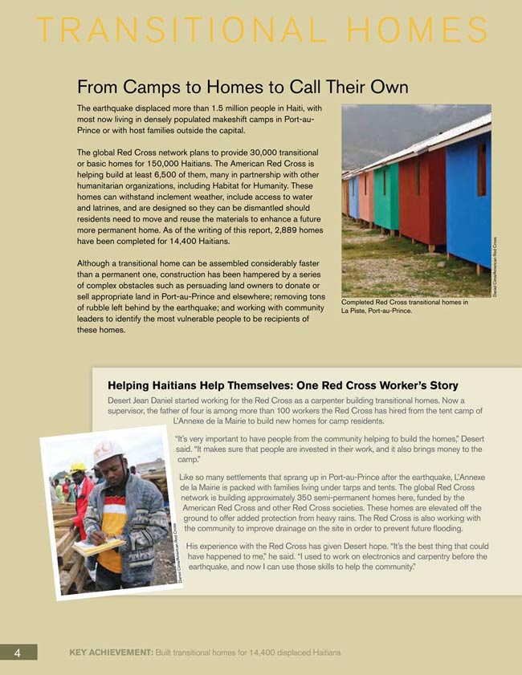
“Haiti Earthquake One-Year Report”
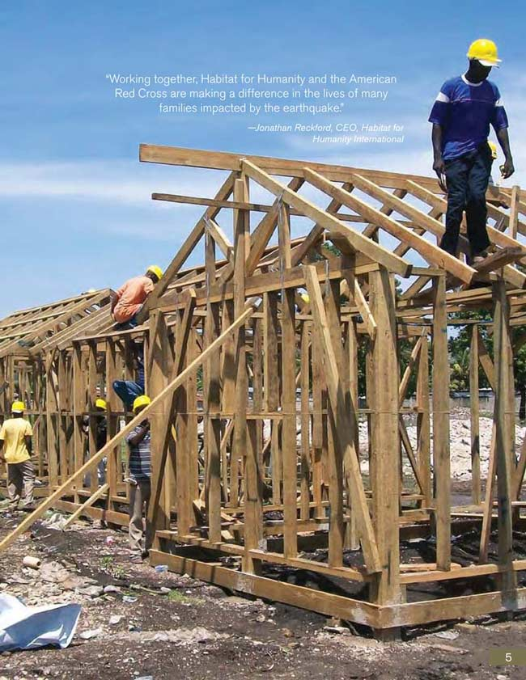

“Haiti Earthquake One-Year Report”

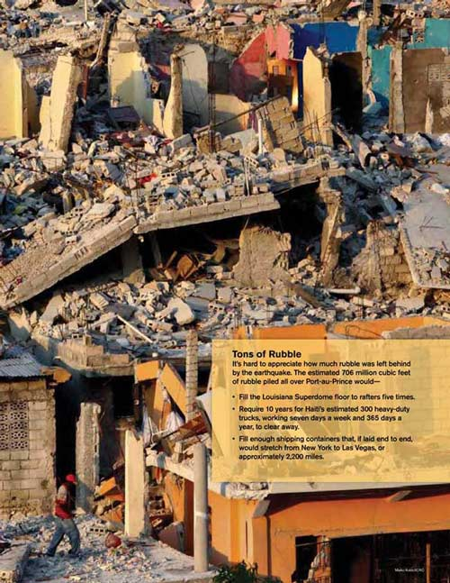
“Haiti Earthquake One-Year Report”

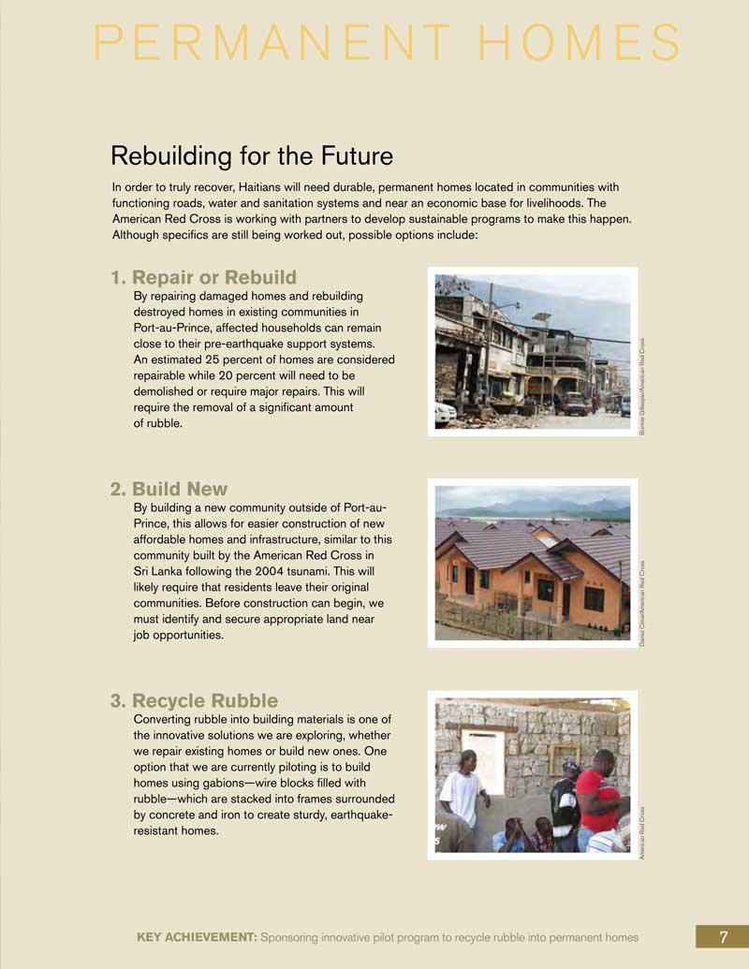
“Haiti Earthquake One-Year Report”

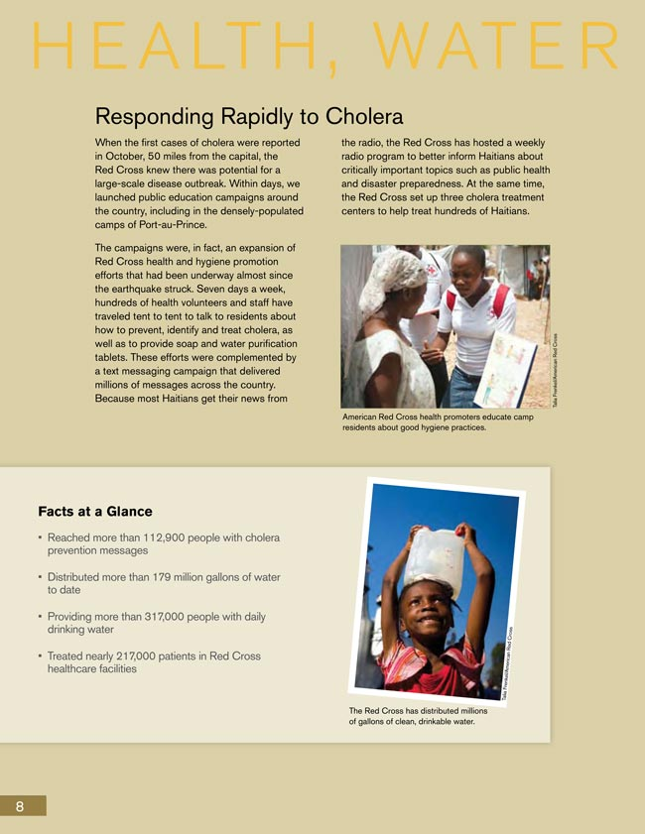
“Haiti Earthquake One-Year Report”
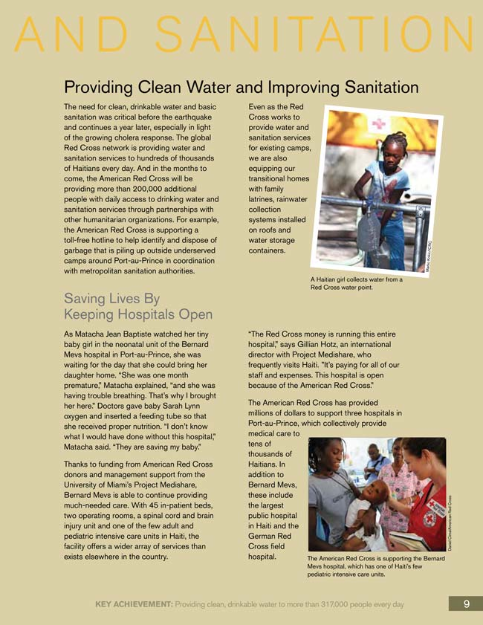
“Haiti Earthquake One-Year Report”
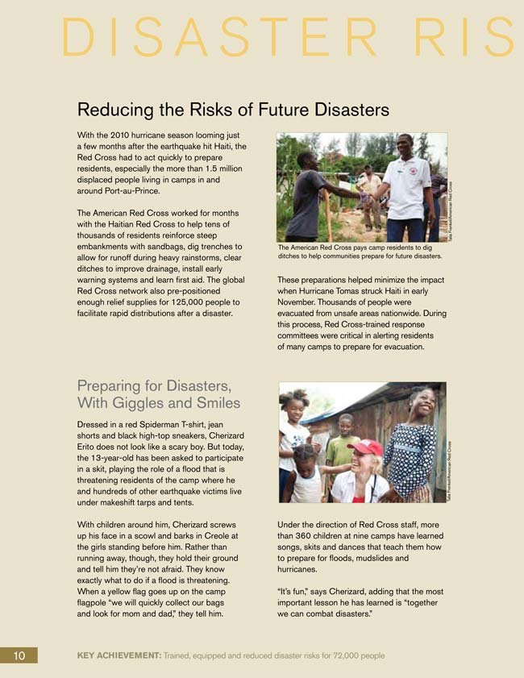
“Haiti Earthquake One-Year Report”
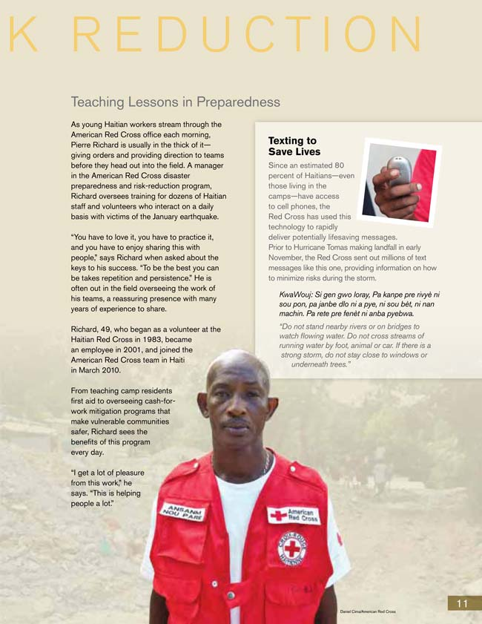

“Haiti Earthquake One-Year Report”
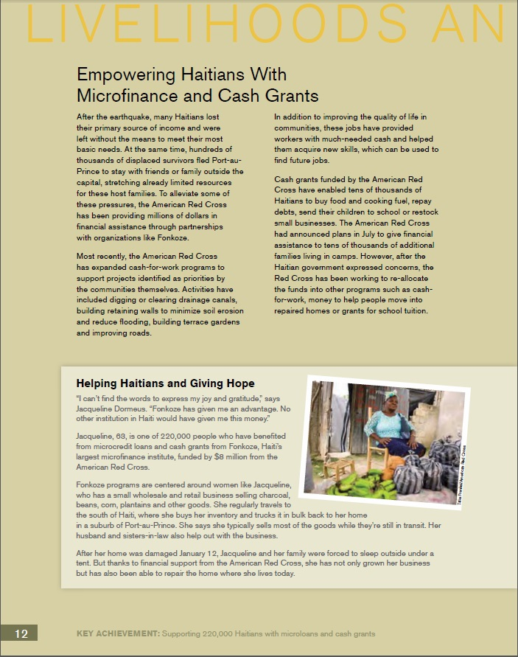
“Haiti Earthquake One-Year Report”
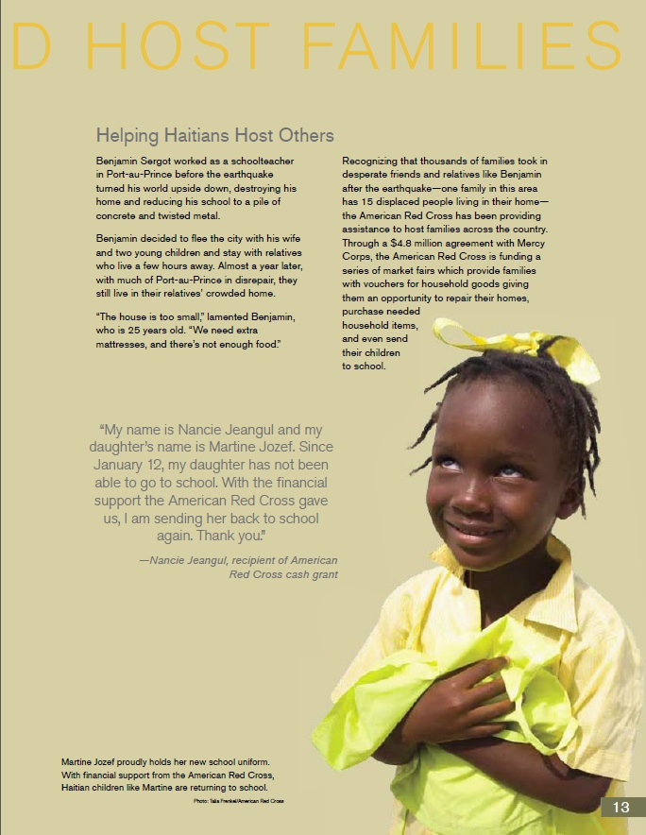
"Haiti Earthquake Relief: One-year Report" by the American National Red Cross, found here: http//www.redcross.org/images/MEDIA_CustomProductCatalog/m3140113_HaitiEarthquake_OneYearReport.pdf. (pages 4-13)
Red Cross in Haiti Four Square Note-catcher

Name:
Date:

Transitional and Permanent Homes | Health, Water, and Sanitation
Disaster Risk Reduction | Livelihood and Host Families

“Haiti Earthquake One-Year Report”
Expert Groups Task Card

Name:
Date:

Expert group #2, Health, Water, and Sanitation (pages 8–9)

Key vocabulary: cholera, outbreak, launched, campaign, prevent, purification, sanitation, equipping

Previous vocabulary: volunteers, coordination

Complete the following with your expert group members:

- On your own, read your section of the text silently.

- As you read, circle key and previous vocabulary and try to determine the meaning of words from context.

- Underline three to five details in the article that explain “Health, Water, and Sanitation” services provided by the Red Cross.

- With your expert group, discuss the details you underlined and why.

- Work with group members to paraphrase evidence and add at least three details to the “Health, Water, and Sanitation” square on your note-catcher.
“Haiti Earthquake One-Year Report”
Expert Groups Task Card

Name:
Date:

Expert group #1, Transitional and Permanent Homes (pages 4–7)

Key vocabulary: displaced, makeshift, transitional, inclement, assembled, durable, innovative, gabions

Previous vocabulary: vulnerable, economic, rubble, secure

Directions: With your expert group members, complete the following:

- On your own, read your section of the text silently.

- As you read, circle key and previous vocabulary and try to determine the meaning of words from context.

- Underline three to five details in the article that explain “Transitional and Permanent Homes” provided by the Red Cross.

- With your expert group, discuss the details you underlined and why.

- Work with group members to paraphrase evidence and add at least three details to the “Transitional and Permanent Homes” square on your note-catcher.
“Haiti Earthquake One-Year Report”
Expert Groups Task Card

Name:
Date:

Expert group #1, Disaster Relief Reduction (pages 10–11)

Key vocabulary: reducing, reinforce, facilitate, skit, preparedness, risk-reduction, persistence, minimize

Previous vocabulary: pre-positioned, distributions, disaster, aid, vulnerable

Complete the following with your expert group members:

- On your own, read your section of the text silently.

- As you read, circle key and previous vocabulary and try to determine the meaning of words from context.

- Underline three to five details in the article that explain “Disaster Relief Reduction” programs provided by the Red Cross.

- With your expert group, discuss the details you underlined and why.

- Work with group members to paraphrase evidence and add at least three details to the “Disaster Relief Reduction” square on your note-catcher.
“Haiti Earthquake One-Year Report”
Expert Groups Task Card

Name:
Date:

Expert group #1, Disaster Relief Reduction (pages 12–13)

Key vocabulary: empowering, means, alleviate, priorities, acquire, enabled, host, displaced

Previous vocabulary: resources, partnerships, gratitude, goods, vouchers

Complete the following with your expert group members:

- On your own, read your section of the text silently.

- As you read, circle key and previous vocabulary and try to determine the meaning of words from context.

- Underline three to five details in the article that explain “Livelihoods and Host Families” support by the Red Cross.

- With your expert group, discuss the details you underlined and why.

- Work with group members to paraphrase evidence and add at least three details to the “Livelihoods and Host Families” square on your note-catcher.
Red Cross in Haiti Four Square Note-catcher
Answers, For Teacher Reference

Transitional and Permanent Homes  Haiti earthquake displaced more than 1.5 million people  People live in makeshift camps in Port-au-Prince  Red Cross plans to provide 30,000 transitional homes  Make homes that can handle inclement weather  Transitional homes can be built and assembled faster  Haitians need durable homes  Use innovative solutions like building homes with gabions | Health, Water, and Sanitation  Red Cross launched a campaign to keep cholera from becoming an outbreak  Volunteers talk to Haitians about how to prevent cholera and provide water purification tablets  Distributed more than 179 million gallons of water to people in Haiti  Red Cross provides water for sanitation needs  Equipping homes with latrines, rainwater collection systems, and water storage containers

Red Cross in Haiti Four Square Note-catcher
Answers, For Teacher Reference

Disaster Risk Reduction  Reducing risks of disaster by helping residents reinforce embankments  Pre-positioned supplies to help facilitate quick distributions after a disaster  Children learn songs, skits, and dances that teach them how to prepare for disasters  Red Cross teaches preparedness and risk-reduction to victims of the Haiti earthquake  Risk-reduction requires persistence  Camp residents in Haiti learn first aid  Red Cross uses technology like text messages to give people information to minimize risks during a storm | Livelihood and Host Families  Empowering Haitians by providing the means to have basic needs met  Red Cross works to alleviate pressures on Haitian families by making money available through its partnerships  Red Cross supports with programs identified as priorities by the communities  Red Cross helps people acquire new skills for work  Red Cross has enabled many Haitians to buy food, fuel, repay debts, send their kids to school, and restock businesses with good to run businesses  Host families provide shelter to displaced people in Haiti  Red Cross provides vouchers for goods people need

Lesson 5 Vocabulary Defined
Answers, For Teacher Reference

Chunk #1, Transitional and Permanent Homes (4–7)
displaced—away from, separated from ones home or place of residence
makeshift—temporary; crude; do-it-yourself
transitional—in-between; process of change
inclement—stormy; rainy; not pleasant
assembled—built; put together
durable—sturdy; strong; long-lasting; resilient
innovative—new; original; modern
gabions—wire blocks filled with rubble (definition from text)

Chunk #2, Health, Water, and Sanitation (8–9)
cholera—a disease caused by bacteria
outbreak—sudden occurrence; epidemic
launched—started; began
campaign—work to achieve a specific goal
prevent—stop something before it happens
purification—cleansing; sanitization; decontamination
sanitation—cleanliness; hygiene
equipping—supplying; providing; stocking

Chunk #3, Disaster Relief Reduction (10–11)
reducing—decrease; lessen; lower
reinforce—go back to add support, to strengthen something
facilitate—make easy; make possible
skit—short play
preparedness—awareness; watchfulness; vigilance
risk-reduction—decrease, lessen, lower the threat, hazard, danger
persistence—perseverance; determination; diligence
minimize—reduce; lessen; decrease
Lesson 5 Vocabulary Defined
Answers, For Teacher Reference

Chunk #4, Livelihoods and Host Families (12–13)
empowering—making someone more powerful, confident
means—income; resources; something that enables someone to do something
alleviate—lessen; ease
priorities—main concerns; most important
acquire—get; obtain; gain
enabled—made someone able to do something, made something possible
host—owner of a house, home that has guests
displaced—away from, separated from ones home or place of residence
Share, Rank, Write Task Card:
The Haiti Earthquake of 2010

Part A: Share

- Share the information you recorded in your note-catcher with other members of your group.
- Group members ask clarifying questions as needed, then record the details onto their own note-catchers to explain each of the other three areas of relief assistance the Red Cross offers.

Part B: Rank, Talk, Write

- Independently write a short summary sentence about each area of assistance in the margin of your note-catcher, next to each box.
- Think about what is the most, second most, third most, and least important type of aid after a natural disaster, then record a number 1–4 to rank the importance of each type of aid (“1” next to most important type of aid, “2,” “3,” “4” next to the second, third, fourth/least important type of aid).
- Discuss how you ranked the four types of aid, most to least important, with your group members. Explain your thinking by using evidence from your note-catcher.
- As a group, determine the one type of aid you think is most important, then write a summary statement on a blank page in your journal to explain what type of aid is most important and why. Be sure to include details and key vocabulary from your notes in your summary.

