Lesson 3
Objective: Use the place value chart to record and name tens and ones within a two-digit number up to 100.

Suggested Lesson Structure
 Application Problem (5 minutes)
 Fluency Practice (15 minutes)
 Concept Development (30 minutes)
 Student Debrief (10 minutes)
Total Time (60 minutes)
Application Problem (5 minutes)
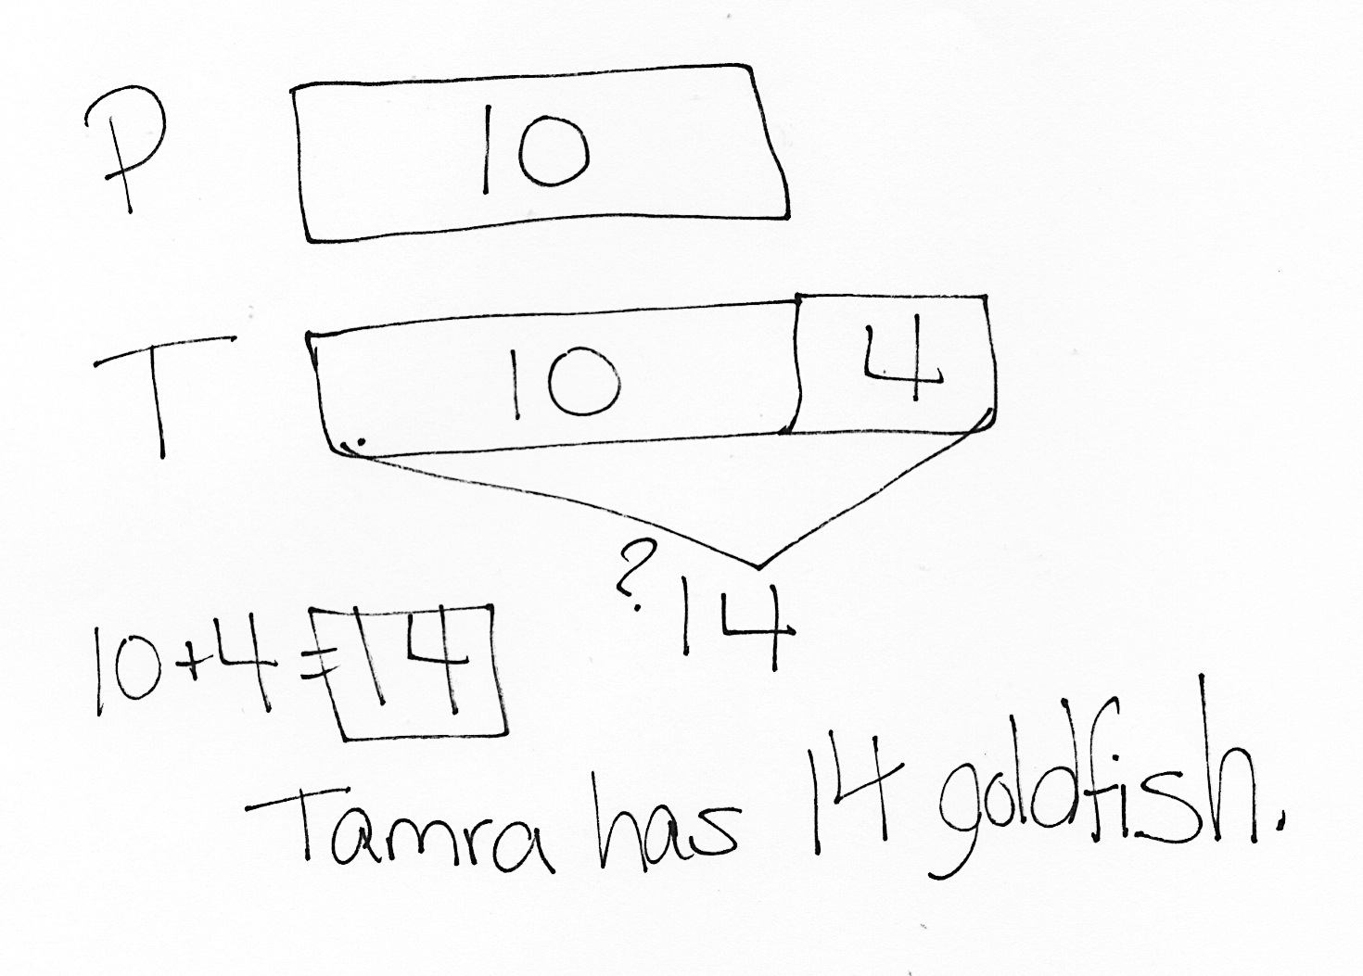
Tamra has 4 more goldfish than Peter. Peter has 10 goldfish. How many goldfish does Tamra have?
Note: Throughout G1–Module 6, the Application Problem will come before the Fluency Practice so that the core fluency can move directly into the operations with two-digit numbers. Today’s Application Problem continues students’ practice with the compare with bigger unknown problem type, which was part of G1–M6–Lesson 2’s objective.
Fluency Practice (15 minutes)
- Grade 1 Core Fluency Sprint 1.OA.6 (10 minutes)
- Subtraction with Cards 1.OA.6 (5 minutes)
Grade 1 Core Fluency Sprint (10 minutes)
Materials: (S) Core Fluency Sprint from G1−M5−Lesson 1
Note: Choose an appropriate Sprint based on the needs of the class. For today’s movement-counting between Sprints A and B, consider practicing Say Ten counting to prepare students for today’s lesson. Suggested counting pattern: Count by ones from 37 to 52 and back, then count by tens from 87 to 107 and back.

Core Fluency Sprint List:
- Core Addition Sprint (targeting core addition and missing addends)

NOTES ON
MULTIPLE MEANS OF REPRESENTATION:
Differentiating Sprints for students helps meet the needs of the class. Adjust them to suit specific learning needs so students feel successful and do not show frustration while completing them.

- Core Addition Sprint 2 (targeting the most challenging addition within 10)
- Core Subtraction Sprint (targeting core subtraction)
- Core Fluency Sprint: Totals of 5, 6, and 7 (developing understanding of the relationship between addition and subtraction)
- Core Fluency Sprint: Totals of 8, 9, and 10 (developing understanding of the relationship between addition and subtraction)
Subtraction with Cards (5 minutes)
Materials: (S) 1 pack of numeral cards 0─10 per set of partners (from G1─M1─Lesson 36)
Note: This review activity strengthens students’ ability to subtract within 10, which supports their work decomposing numbers in future lessons within the module.
- Students combine their digit cards and place them face down between them.
- Each partner flips over two cards and subtracts the smaller number from the larger one.
- The partner with the smallest difference keeps the cards played by both players in that round.
- If the differences are equal, the cards are set aside and the winner of the next round keeps the cards from both rounds.
- The player with the most cards at the end of the game wins.
Concept Development (30 minutes)
Materials: (T) Hide Zero cards (from G1–M1–Lesson 38 and G1–M3–Lesson 2), chart paper (S) 4 ten-sticks from personal math toolkit, personal white board with Place Value Chart Template inserted
Students sit at their desks with their materials.
T: (Show 47 using Hide Zero cards.) What number am I showing?
S: 47.
T: When I pull apart these Hide Zero cards, 47 will be in two parts. What will they be?
S: 40 and 7.
T: (Write 40 and 7 on the board.) You’re right! Explain to your partner why we don’t see 40 but just the digit 4. (Listen as partners explain their thinking to each other.)
S: When you pull apart the cards, you’ll see the 0 hiding behind 7. 4 stands for 40 because it’s in the tens place. 7 stands for just 7 ones.
T: (Pull apart 47 into 40 and 7.) You are right! Show me 47 using quick ten drawings. Count out each ten and add on each of the ones the Say Ten way as you draw them.
S: 1 ten, 2 tens, 3 tens, 4 tens, 4 tens 1, 4 tens 2….
T: How many tens did you draw?

NOTES ON
MULTIPLE MEANS OF ENGAGEMENT:
Provide challenging extensions for students. Give clues with tens and ones and have students guess the number you are thinking of. For example, “What number is made up of…?”
2 tens and 23 ones, 6 tens and 35 ones, 1 ten and 47 ones, 9 tens and 14 ones, etc.
S: 4 tens.
T: How many ones did you draw?
S: 7 ones.
T: Let’s fill in the place value chart. How many tens are in 47?
S: 4 tens.
T: Let’s write 4 in the?
S: Tens place. (Fill in 4.)
T: How many ones are in 47?
S: 7 ones.
T: Let’s write 7 in the?
S: Ones place. (Fill in 7.)
Repeat the process with the following suggested sequence: 57, 67, 86, 68, 95, and 100.
T: (Write 64 on the place value chart.) What does the digit 6 stand for?
S: 6 tens.
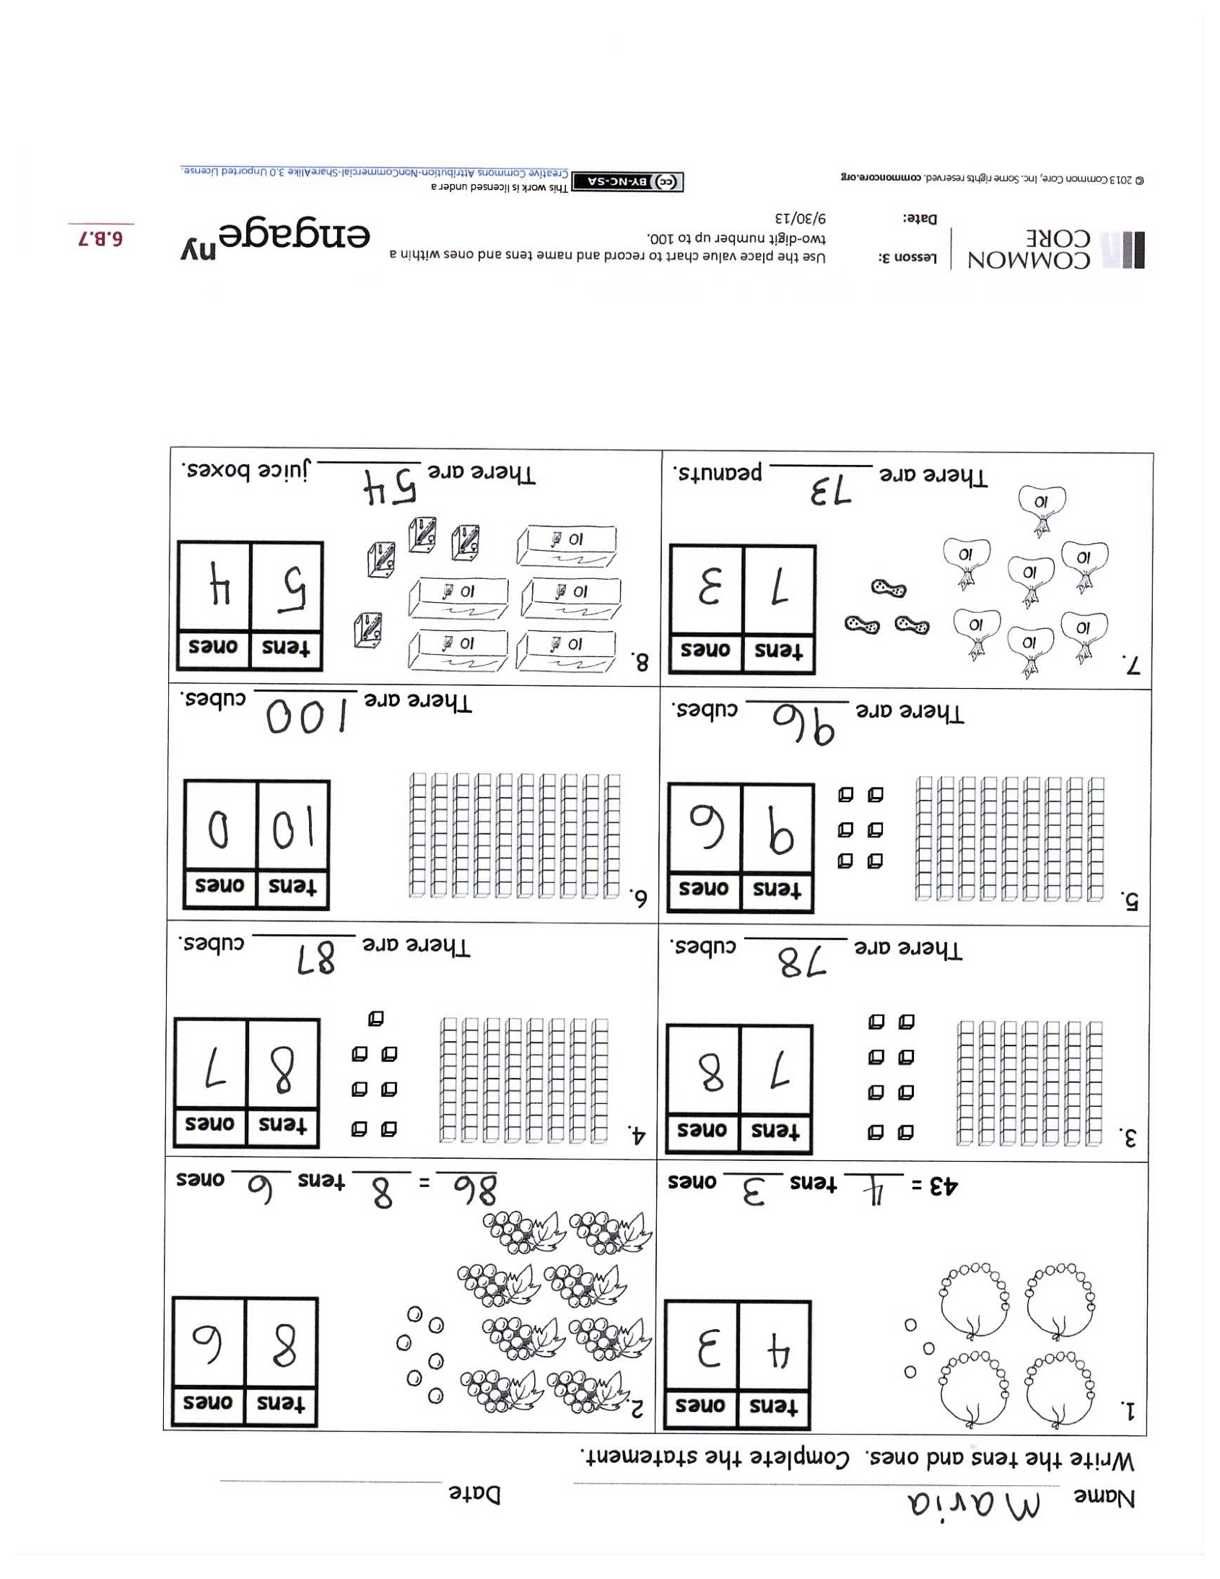
T: 6 tens is the same as?
S: 60.
MP.4
T: What does the digit 4 stand for?
S: 4 ones.
T: What is 6 tens and 4 ones or 60 and 4?
S: 64.
Repeat the process using the following sequence: 74, 84, 93, 73, 65, 56, 79, 97, and 100.
Problem Set (10 minutes)
Students should do their personal best to complete the Problem Set within the allotted 10 minutes. For some classes, it may be appropriate to modify the assignment by specifying which problems they work on first. Some problems do not specify a method for solving. Students solve these problems using the RDW approach used for Application Problems.

Student Debrief (10 minutes)
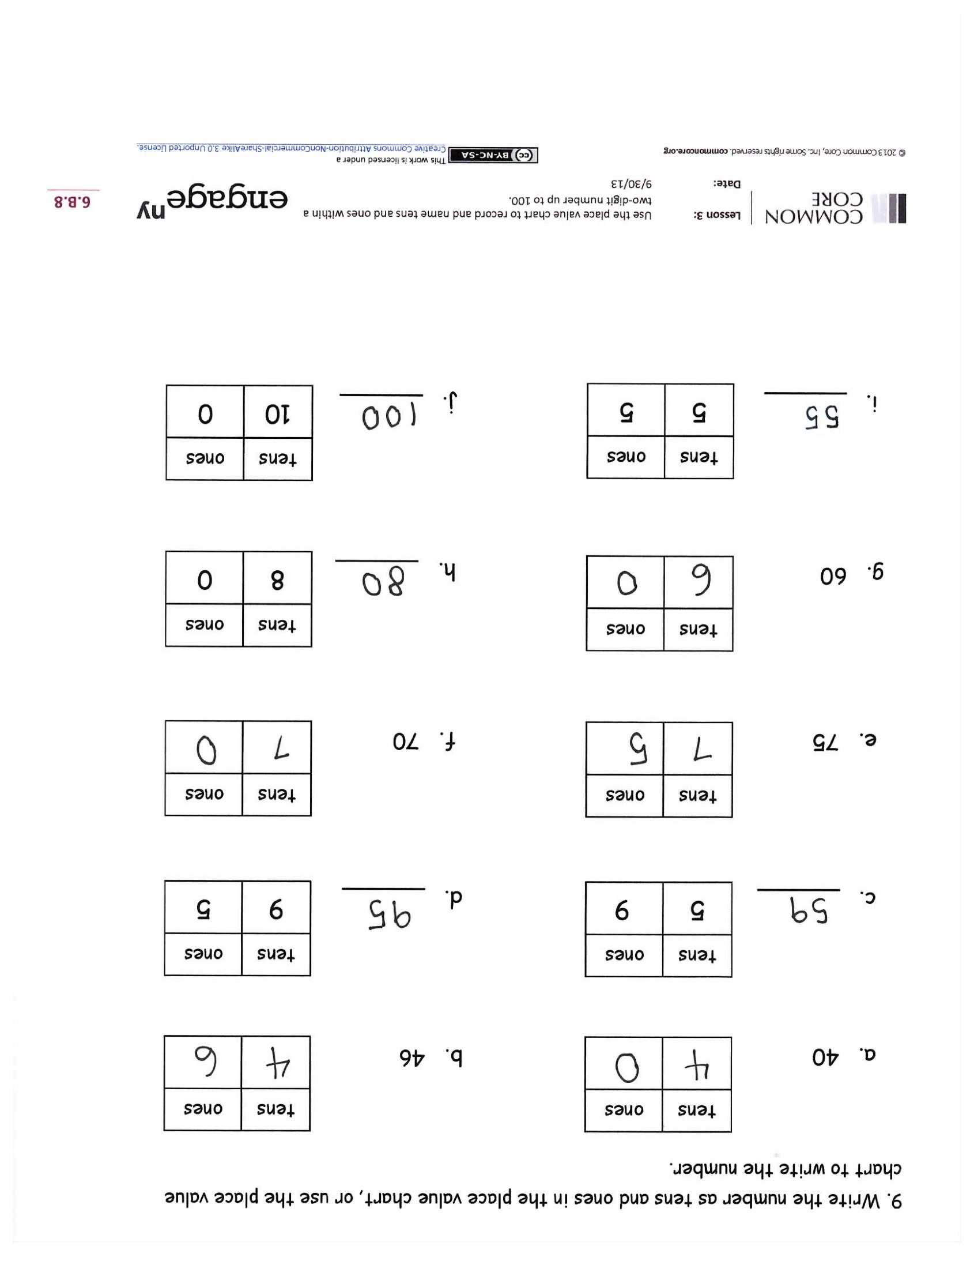
Lesson Objective: Use the place value chart to record and name tens and ones within a two-digit number up to 100.
The Student Debrief is intended to invite reflection and active processing of the total lesson experience.
Invite students to review their solutions for the Problem Set. They should check work by comparing answers with a partner before going over answers as a class. Look for misconceptions or misunderstandings that can be addressed in the Debrief. Guide students in a conversation to debrief the Problem Set and process the lesson.
You may choose to use any combination of the questions below to lead the discussion.
- Look at your answers for Problems 1 and 7. What is the difference between these two numbers? Explain how you know.
- For Problem 3, a student said there are 87 cubes. Is he correct? How can you help this student so he understands place value correctly?
- Using a quick ten drawing or your Hide Zero cards, explain how you solved Problem 9(j).
- Look at Problem 9(b). What must we add to 46 to get 5 tens and 0 ones?
- Think about the fluency exercises we did between our two Sprints today. How can Say Ten counting help you think about the tens and ones in two-digit numbers? Use an example as you share your explanation.
- Look at your Application Problem. How did you solve the problem? Which problem from yesterday is this problem most like?
Exit Ticket (3 minutes)
After the Student Debrief, instruct students to complete the Exit Ticket. A review of their work will help you assess the students’ understanding of the concepts that were presented in the lesson today and plan more effectively for future lessons. You may read the questions aloud to the students.

Name Date

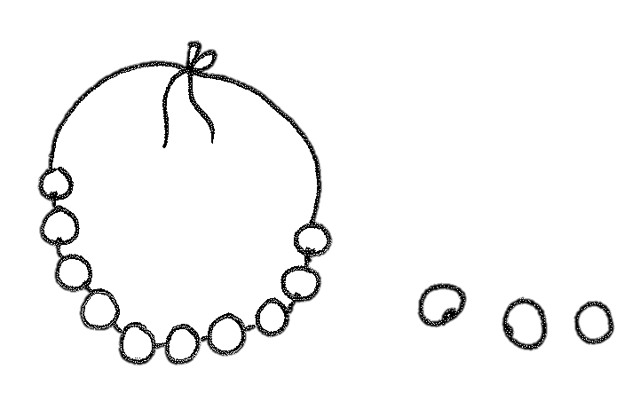
Write the tens and ones. Complete the statement.
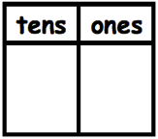  1.  43 = ____ tens ____ ones | 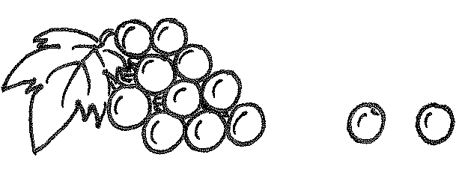  2.  ____ = ____ tens ____ ones
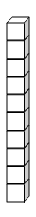  3.  There are _______ cubes. | 4.  There are _______ cubes.
5.  There are _______ cubes. | 6.  There are _______ cubes.
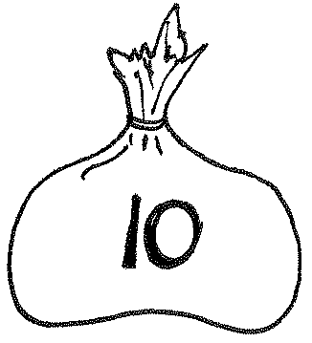  7.  There are _______ peanuts. | 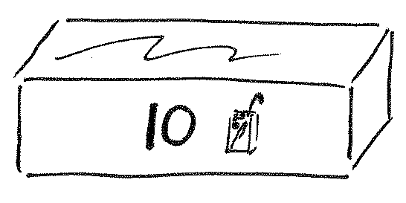  8.  There are _______ juice boxes.

- Write the number as tens and ones in the place value chart, or use the place value chart to write the number.
b. 46
tens
ones

a. 40
tens
ones

c. ______
tens
ones
9
5
d. ______
tens
ones
5
9

f. 70
tens
ones

e. 75
tens
ones

g. 60
tens
ones

h. ______
tens
ones
0
8

j. ______
tens
ones
0
10
i. ______
tens
ones
5
5

Name Date

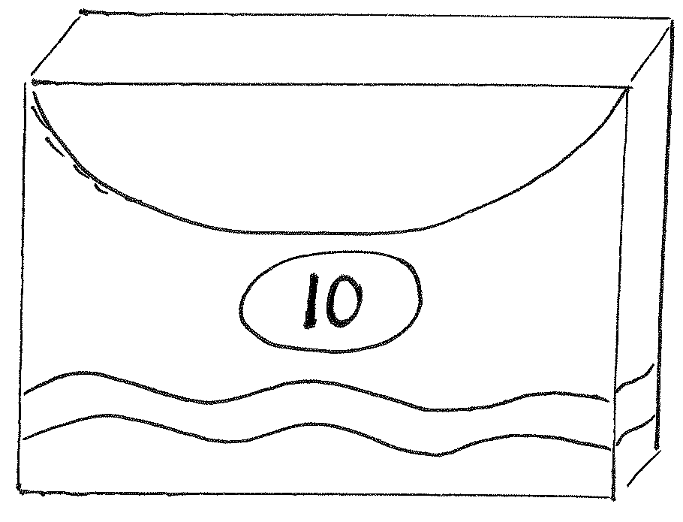
- Write the tens and ones. Complete the statement.

There are _______ markers.

- Write the number as tens and ones in the place value chart, or use the place value chart to write the number.
a. 90
tens
ones

b. ______
tens
ones
7
8

Name Date

Write the tens and ones. Complete the statement.
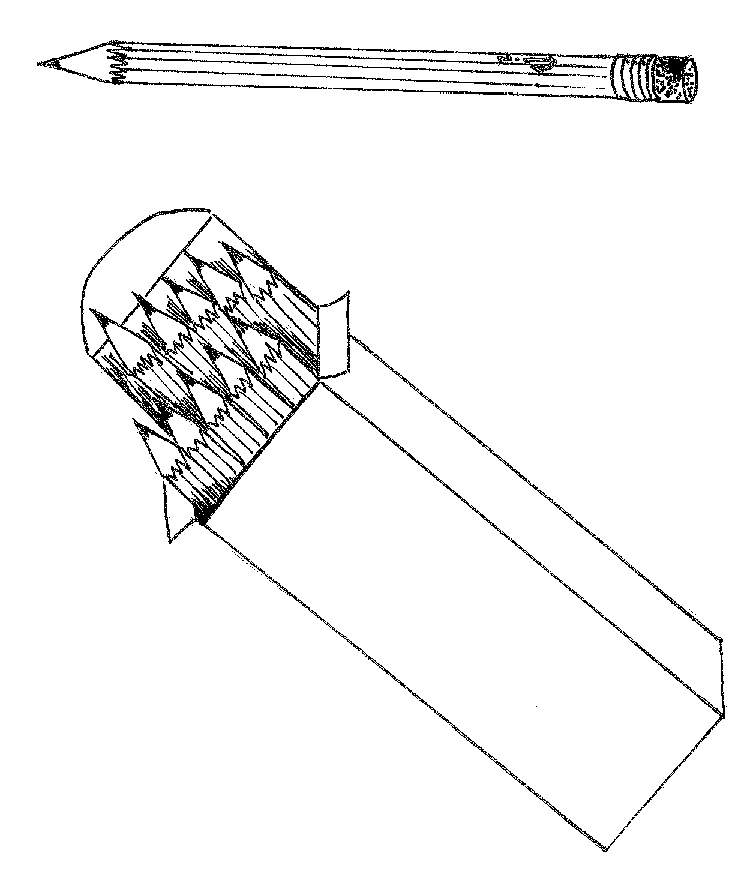  1.  52 = ____ ten ____ ones | 2.  ____ = ____ ten ____ ones
3.  There are _______ cubes. | 4.  There are _______ cubes.
5.  There are _______ cubes. | 6.  There are _______ cubes.
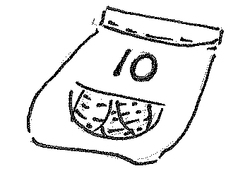  7.  There are _______ carrots. | 8.  There are _______ markers.

- Write the number as tens and ones in the place value chart, or use the place value chart to write the number.
b. 76
tens
ones

a. 70
tens
ones

c. ______
tens
ones
9
4
d. ______
tens
ones
4
9

f. 60
tens
ones

e. 65
tens
ones

g. 90
tens
ones

h. ______
tens
ones
0
10

j. ______
tens
ones
0
8
i. ______
tens
ones
3
8

