Lesson 2
Objective: Solve compare with bigger or smaller unknown problem types.

Suggested Lesson Structure
 Fluency Practice (12 minutes)
 Concept Development (38 minutes)
 Student Debrief (10 minutes)
Total Time (60 minutes)
Fluency Practice (12 minutes)
- Core Fluency Differentiated Practice Sets 1.OA.6 (5 minutes)
- Number Bond Addition and Subtraction 1.OA.6 (5 minutes)
- Happy Counting 1.NBT.1 (2 minutes)
Core Fluency Differentiated Practice Sets (5 minutes)
Materials: (S) Core Fluency Practice Sets from G1–M6–Lesson 1
Note: Give the appropriate Practice Set to each student. Help students become aware of their improvement. After students finish today’s Practice Sets, ask them to raise their hands if they tried a new level today or improved their score from the previous day.
Students complete as many problems as they can in 90 seconds. Assign a counting pattern and start number for early finishers, or have them practice make ten addition or subtraction on the back of their papers. Collect and correct any Practice Sets completed within the allotted time.
Number Bond Addition and Subtraction (5 minutes)
Materials: (S) Personal white boards, die per pair
Note: Practice with missing addends and subtraction will help prepare students to solve comparison problems in today’s Concept Development.
Conduct activity as directed in G1–M6–Lesson 1.
Happy Counting (2 minutes)
Note: In this module, students will be doing addition and subtraction within 100 and extending their counting and number writing skills to 120. Give students practice counting by ones and tens within 100. When Happy Counting by ones, spend more time changing directions where changes in tens occur, which is typically more challenging.
Conduct activity as directed in G1–M6–Lesson 1.
Concept Development (35 minutes)
Materials: (T) Chart with yesterday’s tape diagram and Problem 1, chart with today’s story Problems 2 and 3, 4 ten-sticks (S) Personal math toolkit with 4 ten-sticks, personal white board
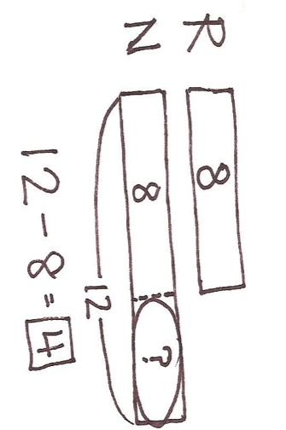
Note: Today’s lesson objective is addressing word problems. Therefore, there is no separate Application Problem.
Gather students in the meeting area with their materials.
Problem 1
T: (Post the tape diagram from yesterday’s Concept Development, Problem 2.)
T: What was the story that went with this tape diagram yesterday?
S: Rose and Nikil both wrote letters. Rose wrote 8 letters and Nikil wrote 12 letters. How many more letters did Nikil write than Rose? We also answered how many fewer letters did Rose write than Nikil? We also figured out how many letters Nikil and Rose wrote in all.
T: Great! I have a new problem for you. (Point to the diagram as you speak.) Rose wrote 8 letters. Nikil wrote 4 more letters than Rose. How many letters did Nikil write? Turn and talk with your partner. (Wait as students discuss.)
T: If Rose wrote 8 letters, and Nikil wrote 4 more letters than Rose, how many letters did Nikil write?

NOTES ON
MULTIPLE MEANS OF ACTION AND EXPRESSION:
If students struggle with word problems, consider using either smaller numbers or encouraging students to include circle representations for the objects and then draw rectangles around the circles to create the tape diagrams.
S: 12 letters!
T: How do you know?
S: You have to add Rose’s 8 letters and then 4 more. You can look at the tape diagram on the chart. Nikil has the same 8 letters as Rose, plus 4 more letters.
T: Yesterday, you subtracted to find the difference between the two sets of letters. Is that what you did this time? Talk with a partner and decide what number sentence you needed to use. (Wait as students discuss.)
S: We needed to add this time. Eight letters plus 4 more letters is 12 letters. 8 + 4 = 12.

Problem 2
T: Let’s try another one. This time, use your linking cubes with a partner. Each of you will show linking cubes for your character.
T/S: Ben solved 6 math problems. Robin solved 4 more problems than Ben. How many problems did Robin solve?
T: Partner A, represent the problems Ben solved. Partner B, represent the problems Robin solved. Then, use your linking cubes to try to solve the problem together. (Circulate as students work to solve the problem. Remind them to read each sentence to recheck their work, making sure that their cubes match every part of the story.)
T: Let’s draw a tape diagram to show what you just did. Who is this story about?
S: Ben and Robin.
T: (Write B and R to start a double tape diagram.) I like that most of you remembered to label your parts.
T: They each solved math problems. (Draw the same size rectangle next to each letter. This will help highlight the parts that are the same as well as the additional part that will be in Robin’s tape.)
T: What do you notice about these two tapes?
S: They are the same size!
T: The same size tape means they solved the same amount of problems. Is this true?
S: No!
T: Who solved more problems?
S: Robin!
T: You are right! I’m going to add an extra part of tape next to Robin’s to show that she solved more problems than Ben. (Draw.) How many more problems did Robin solve?
S: Four more problems.
T: Let’s go back to our story. Read the first sentence.
S: Ben solved 6 math problems.
T: What information can I add to my double tape diagram?
S: Write 6 in Ben’s tape!
T: Where else can I write in the 6? Turn and talk to your partner and explain why.
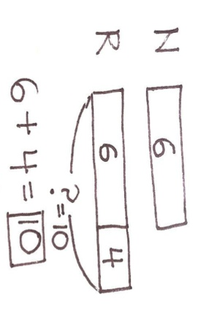
S: Write 6 in the first part of Robin’s tape. It’s the same size as Ben’s tape, so it makes sense to put 6 there, too. It makes sense to put 6 in Robin’s first rectangle because the story says she solved 4 more than Ben. It has to show 4 more than 6 since 6 stands for how many problems Ben solved.
T: Great. (Write 6 in the first part of Robin’s tape.) Does this match the linking cubes on your personal board?
S: Yes!
T: If it doesn’t, this is a good time to fix your model.
T: As I read each part of the story problem again, touch the part of the double tape model on your board that corresponds to what I’m saying.
T/S: (Read each sentence and have students point to the parts of their tape model.)
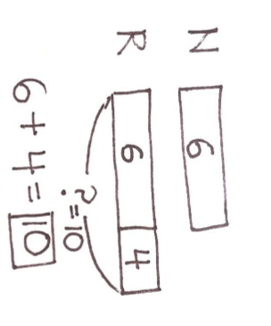
T: Write a number sentence that helped you find how many problems Robin solved.
S: 6 + 4 = 10.
T: How many problems did Robin solve?
S: Ten problems! (As students write 10 on the personal board next to their model, add 10 to the double tape diagram as shown.)
Problem 3
T: Let’s read another story problem together.
T/S: Tamra found 12 ladybugs. Willie found 4 fewer ladybugs than Tamra. How many ladybugs did Willie find?
T: Who are children in this story problem?

NOTES ON
MULTIPLE MEANS OF REPRESENTATION:
Solving problems with the word fewer can be difficult, especially for English language learners. When solving problems of this type, teach students to always focus on “who has more.” For example, after reading the problem, before solving, have students look at who has fewer and who has more. Establishing this before solving will make sure students really understand how to solve this problem type.
S: Tamra and Willie!
T: (Record T and W to begin a double tape diagram and draw two equal size rectangles.)
T: Is it true that they found the same number of ladybugs?
S: No!
T: Who found more ladybugs? Read the story carefully again. Then turn and talk to your partner.
S: Tamra. It didn’t say Tamra found more. But it said Willie found 4 fewer ladybugs. That means Tamra found more.
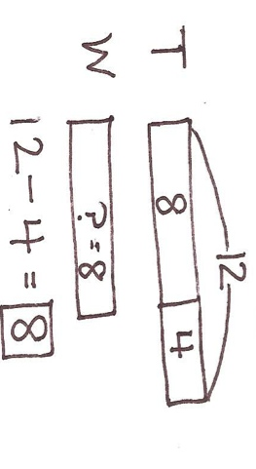
T: Great thinking! I need to add an extra tape, the ”more tape,” onto…?
S: Tamra’s tape!
T: (Add an extra box.) How many more ladybugs did Tamra find than Willie?
S: 4 more ladybugs.
T: (Record 4 in the extra tape.) Let’s read the first sentence of the story.
T/S: Tamra found 12 ladybugs.
T: Take a look at Tamra’s tape. Turn and talk to your partner about where the 12 should go.
S: It should go inside the first part of the tape. No, it should go outside, like we did yesterday for Nikil’s 12 ladybugs. Twelve is the total number of ladybugs, so we need to put the arms around the entire tape for Tamra.
T: Hmm, let’s try the first idea and see. (Write 12 in the first tape.) According to Tamra’s tape now, did she find 12 ladybugs?
S: No. It looks like she found 16 ladybugs.
T: You are right. Is 12 the total amount of ladybugs Tamra found or just a part?
S: The total.
T: Let’s try the other suggestion.
T: (Make a bracket with 12 for Tamra’s tape.) Does this show that Tamra found a total of 12 ladybugs?
S: Yes!
T: Read the next sentence.
S: Willie found 4 fewer ladybugs than Tamra.
T: Did we show that in our double tape diagram?
S: Yes!
T: Read the last part of our story problem.
S: How many ladybugs did Willie find?
T: (Record a question mark in Willie’s tape.) Look at Willie’s tape. What do you notice about the size of the tape?
S: It’s the same as the first part of Tamra’s tape.
T: If we find out what the missing part for Tamra’s tape is, then we are also finding out?
S: Willie’s tape.
T: How can we find this missing part of Tamra’s tape? Turn and talk to your partner.
S: I did 4 + ___ = 12. The answer is 8. I used subtraction to find the missing part. 12 – 4 = 8. The missing part is 8.
T: Great. If this part is 8 (fill in the 8 to complete Tamra’s tape), then what else is 8?
S: Willie’s tape!
T: So, how many ladybugs did Willie find?
S: 8 ladybugs!
Repeat the process by using the following story problems. For each problem, guide students through drawing the double tape diagram.
- Shanika used 11 blocks to build a house. Julio used 5 more blocks than Shanika. How many blocks did Julio use?
- Darnel caught 10 fewer fish than Fran. Fran caught 16 fish. How many fish did Darnel catch?
- Maria found 9 flowers in the garden. Kiana found 12 flowers. How many more flowers did Kiana find than Maria?
Problem Set (10 minutes)
Students should do their personal best to complete the Problem Set within the allotted 10 minutes. For some classes, it may be appropriate to modify the assignment by specifying which problems they work on first. Some problems do not specify a method for solving. Students solve these problems using the RDW approach used for Application Problems.
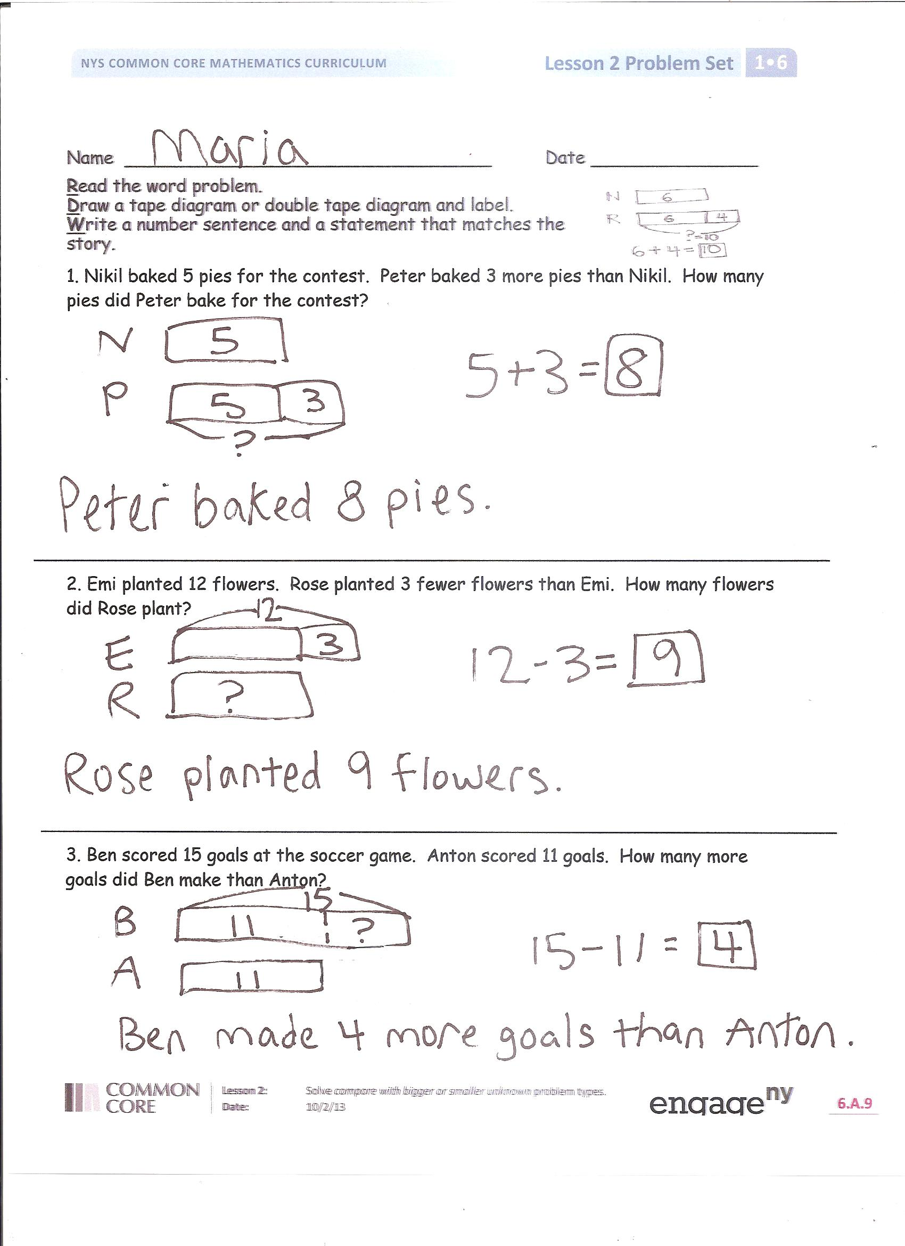
Student Debrief (10 minutes)
Lesson Objective: Solve compare with bigger or smaller unknown problem types.
The Student Debrief is intended to invite reflection and active processing of the total lesson experience.
Invite students to review their solutions for the Problem Set. They should check work by comparing answers with a partner before going over answers as a class. Look for misconceptions or misunderstandings that can be addressed in the Debrief. Guide students in a conversation to debrief the Problem Set and process the lesson.
You may choose to use any combination of the questions below to lead the discussion.
- Look at Problems 1 and 2. How was drawing Nikil’s tape and Emi’s tape different? Explain why this is so.
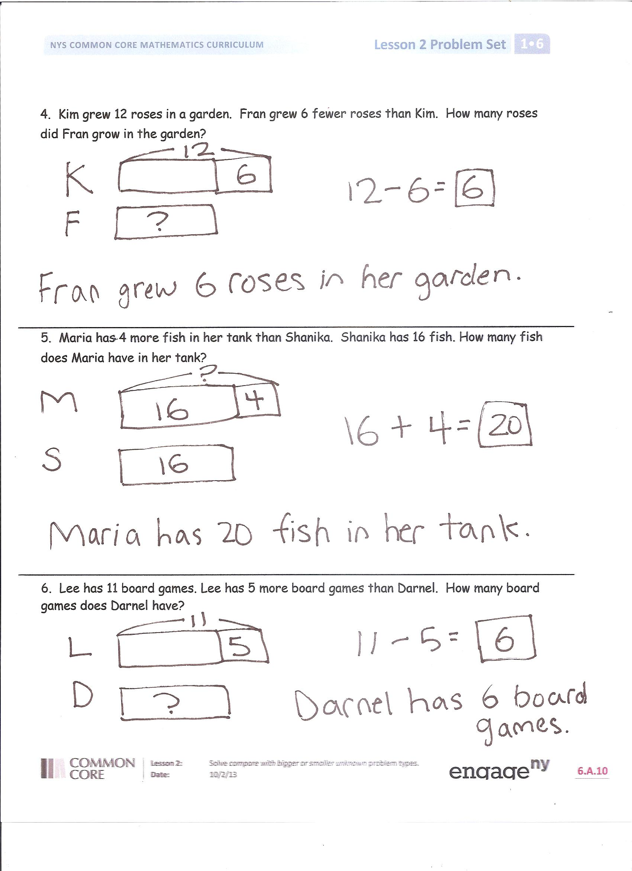
- How was setting up the tape diagram from Problem 3 different from Problem 1?
- Explain to your partner how you solved Problem 6.
- In which problem were you able to use your doubles or doubles plus 1 facts to solve?
- How did working on number bond addition and subtraction in today’s fluency activity help you with solving today’s story problems?
Exit Ticket (3 minutes)
After the Student Debrief, instruct students to complete the Exit Ticket. A review of their work will help you assess the students’ understanding of the concepts that were presented in the lesson today and plan more effectively for future lessons. You may read the questions aloud to the students.

Name Date

Read the word problem.
Draw a tape diagram or double tape diagram and label.
Write a number sentence and a statement that matches the story.

- Nikil baked 5 pies for the contest. Peter baked 3 more pies than Nikil. How many pies did Peter bake for the contest?

- Emi planted 12 flowers. Rose planted 3 fewer flowers than Emi. How many flowers did Rose plant?

- Ben scored 15 goals in the soccer game. Anton scored 11 goals. How many more goals did Ben make than Anton?

- Kim grew 12 roses in a garden. Fran grew 6 fewer roses than Kim. How many roses did Fran grow in the garden?

- Maria has 4 more fish in her tank than Shanika. Shanika has 16 fish. How many fish does Maria have in her tank?

- Lee has 11 board games. Lee has 5 more board games than Darnel. How many board games does Darnel have?

Name Date

Read the word problem.
Draw a tape diagram or double tape diagram and label.
Write a number sentence and a statement that matches the story.

- Tamra decorated 13 cookies. Kiana decorated 5 fewer cookies than Tamra. How many cookies did Kiana decorate?

Name Date

Read the word problem.
Draw a tape diagram or double tape diagram and label.
Write a number sentence and a statement that matches the story.

- Kim went to 15 baseball games this summer. Julio went to 10 baseball games. How many more games did Kim go to than Julio?

- Kiana picked 14 strawberries at the farm. Tamra picked 5 fewer strawberries than Kiana. How many strawberries did Tamra pick?

- Willie saw 7 reptiles at the zoo. Emi saw 4 more reptiles at the zoo than Willie. How many reptiles did Emi see at the zoo?

- Peter jumped into the swimming pool 6 times more than Darnel. Darnel jumped in 9 times. How many times did Peter jump into the swimming pool?

- Rose found 16 seashells on the beach. Lee found 6 fewer seashells than Rose. How many seashells did Lee find on the beach?

- Shanika got 12 cards in the mail. Nikil got 5 more cards than Shanika. How many cards did Nikil get?

