Lesson 1
Objective: Solve compare with difference unknown problem types.

Suggested Lesson Structure
 Fluency Practice (12 minutes)
 Concept Development (38 minutes)
 Student Debrief (10 minutes)
Total Time (60 minutes)
Fluency Practice (12 minutes)
- Core Fluency Differentiated Practice Sets 1.OA.6 (5 minutes)
- Number Bond Addition and Subtraction 1.OA.6 (5 minutes)
- Happy Counting 1.NBT.1 (2 minutes)
Core Fluency Differentiated Practice Sets (5 minutes)
Materials: (S) Core Fluency Practice Sets
Note: Give the appropriate Practice Set to each student. Students who completed all questions correctly on their most recent Practice Set should be given the next level of difficulty. All other students should try to improve their scores on their current levels.
Students complete as many problems as they can in 90 seconds. Assign a counting pattern and start number for early finishers, or have them practice make ten addition or subtraction on the back of their papers. Collect and correct any Practice Sets completed within the allotted time.
Number Bond Addition and Subtraction (5 minutes)
Materials: (S) Personal white boards, die per pair
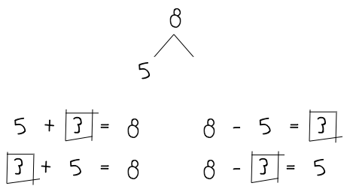
Note: Practice with missing addends and subtraction will help prepare students to solve comparison problems in today’s Concept Development.
- Assign partners of equal ability.
- Allow partners to choose a number for their whole and roll the die to determine one of the parts.
- Both students write two addition and two subtraction sentences with a box representing the unknown number in each equation and solve for the missing number.
- They then exchange boards and check each other’s work.
Happy Counting (2 minutes)
Note: In this module, students will be adding and subtracting within 100 and extending their counting and number writing skills to 120. Give students practice counting by ones and tens within 100. When Happy Counting by ones, spend more time changing directions where changes in tens occur, which is typically more challenging.
Happy Count by ones the regular way and Say Ten way between 60 and 100. Then Happy Count by tens, starting at a number with some ones (e.g., 78).
T:
T/S: 97 96 (pause) 97 98 (pause) 99 100 99 100 (etc.)
Concept Development (38 minutes)
Materials: (T) 4 ten-sticks, 2 charts with today’s story problems (S) Personal math toolkit with 4 ten-sticks, personal white board
Note: Prepare two charts, one with the first story problem about Rose and Nikil, and another with the second. Save the second chart with the solution for tomorrow’s lesson. Today’s lesson objective is addressing word problems. Therefore, there is no separate Application Problem.

NOTES ON
MULTIPLE MEANS OF REPRESENTATION:
Some students may find it helpful to use linking cubes to represent the problems. Students can use different color linking cubes for each part being represented, and then draw the tape diagrams to match their concrete representations.

Gather students in the meeting area with their materials.
Problem 1: Model a change unknown problem with numerals within the tape rather than dots.
T: (Post chart with the story problem.) Let’s read this story problem together.
T/S: Rose wrote 8 letters to her friends. Her goal is to write 12 letters. How many more letters does she need to write to meet her goal?
T: Use a tape diagram to solve how many more letters Rose needs to write. You may also use your linking cubes to help draw and solve.
S: (Solve as the teacher circulates and notices various strategies.)
T: (Choose a student who used a tape diagram to solve. As the student shares, draw the tape diagram on the chart paper.)
S: I drew a rectangle around 8 circles to show how many letters Rose already wrote. Then I drew a rectangle with a question mark because we need to find out how many more letters she needs to write. Then I put arms from the first part to the end of the second part because I knew that she wants to write 12 letters. 8 + __ = 12, so the answer is 4 letters.
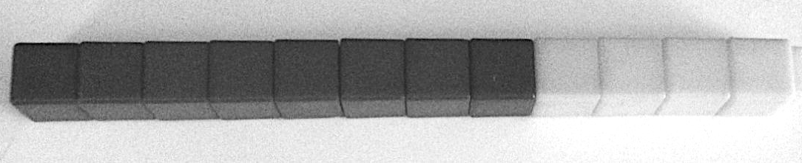
T: Great. (Show a 12-stick of linking cubes made of 8 red and 4 yellow cubes.) I made a model of this story using linking cubes. Watch me as I draw my tape diagram only using numbers. Read the first sentence of the story problem.
S: Rose wrote 8 letters to her friend.
T: (Draw a tape and label it R.) This represents the letters Rose wrote. What number should I write inside? (Point to the linking cubes.)
S: 8.
T: (Write 8 inside the tape.) Read the next sentence.
S: Her goal is to write 12 letters.
T: Is that a part of how many letters she wants to write or is it the total of letters she wants to write?
S: The total.
T: So that means there are some more letters Rose needs to write. We just don’t know how many more yet. (Draw another part and write in a question mark and label it M as shown to the right. Point to the additional part of the linking cubes.)
T: These two parts (point to each), make up the total of how many letters?

NOTES ON
MULTIPLE MEANS OF REPRESENTATION:
To connect students’ use of linking cubes to model the problem with the tape diagram, write the numbers for each part on stickers and adhere the stickers to each part as you draw the tape diagram. A sticker with a question mark can be used to represent the unknown number.

S: 12 letters.
T: (Draw the arms with 12, then hold the linking cube stick at both ends, mimicking the arms drawn in the diagram.) What addition sentence help find the missing part?
S: 8 + ___ = 12.
T: What is the subtraction number sentence to find the missing part?
S: 12 – 8 = 4.
T: How many more letters does Rose need to write?
S: 4 letters.
Problem 2: Model a compare with difference unknown problem.
T: (Post the second chart with the next story problem.) Let’s read another story problem together.
T/S: Rose wrote 8 letters. Nikil wrote 12 letters. How many more letters did Nikil write than Rose?
T: Partner A, using one color, make a stick of how many letters Rose wrote. Partner B, using a different color, make a stick to show the number of letters Nikil wrote. (Allow students time to make their sticks.)
T: Lay the two sticks down on the personal board so we can compare them easily.
T: I see that many of you put your sticks side by side so that they are easier to compare. Let’s all turn our sticks the same way, so we can talk about them together. (Demonstrate by laying down the sticks horizontally on a personal board, as shown on the right.) (Point to the 8-stick.) This stick represents whose letters?
S: Rose.
T: (Label R on the personal board as shown.) (Point to the 12-stick.) This stick represents?
S: Nikil’s letters.
T: (Label with N as shown.) Watch me as I use these cubes to help me draw my tape diagram to compare the number of letters Rose and Nikil wrote. (Write R.) How many letters did Rose write?
S: 8 letters.
T: (Draw a rectangle and write 8 inside.)
T: (Write N in the next line.) How many letters did Nikil write?
S: 12 letters.
T: Will his tape, his part, be longer or shorter than Rose’s tape, her part?
S: Longer!
T: Tell me when to stop when you think the length of the tape represents 12. (Begin drawing the tape.)
S: Stop!
T: (Stop at an appropriate length to represent 12 and complete the rectangle.) What number goes with this tape?
S: 12.
T: The question says, “How many more letters did Nikil write than Rose?” This tape (point to Rose’s tape) represents 8, so this much of Nikil’s tape is also 8. (Partition Nikil’s tape with a dotted line and write 8.) This part of Nikil’s tape represents how many more letters he wrote. (Circle that part of Nikil’s tape and write a question mark as shown to the right.)
T: What is the total number of letters Nikil wrote?
S: 12 letters.
T: What is the part of Nikil’s letters that are the same number as Rose’s letters?
S: The 8 letters.
T: (Point to the question mark.) How many more letters did Nikil write than Rose? What can we do to figure out the unknown part? Turn and talk to your partner.
S: I compared the linking cubes we made and counted the extra cubes. I counted on. There were 8 and I counted on from 4 to get to 12. There were 4 more cubes. I thought 8 + ___ = 12. It’s 4. I used subtraction. I took away 8 from 12 and got 4.
T: If we count on 4 more from 8, we are adding 8 + 4 to get 12. If we cover up the 8 to see how many more letters he wrote, that’s the same as taking away 8 from…?
S: 12!
T: What is 12 – 8?
S: 4.
T: How many more letters did Nikil write?
S: 4 letters.
T: I want you to see that we can use subtraction to compare the number of letters Rose and Nikil’s wrote.
T: Who wrote fewer letters?
S: Rose.
T: How do you know?
S: The tape diagram is shorter than Nikil’s. We know that Nikil wrote more, so Rose wrote fewer.
T: How many fewer letters did Rose write than Nikil? How do you know?
S: Four fewer letters! Look at Rose’s tape diagram. She needs 4 more to match Nikil’s tape diagram. Eight is 4 less than 12. Nikil wrote 4 more letters, so Rose wrote 4 fewer letters. Take away 8 from 12, and that tells you how many fewer letters Rose wrote.
T: (Draw an invisible circle around the space after Rose’s tape that would be where the additional letters would need to be for Rose to have the same number of letters as Nikil.) This part is the same length as Nikil’s extra 4 letters. (In the image to the right, we have included a dotted line to show where to demonstrate the invisible circle.)
Repeat the process with the following story problems. For each problem, ask students to use the linking cubes with their partners to represent the story and guide them through drawing the double tape diagrams.
Tamra collected 9 seashells on the beach. Julio collected 11 seashells.
- How many more seashells did Julio collect?
- How many fewer seashells did Tamra collect?
- How many seashells did Tamra and Julio collect? (This component provides a good contrast between the comparison problem type and a put together problem type.)
Willie saw 13 leaping lizards at the park. Fran saw 8 lizards.
- How many more lizards did Willie see?
- How many fewer lizards did Fran see?
- How many lizards did Willie and Fran see?
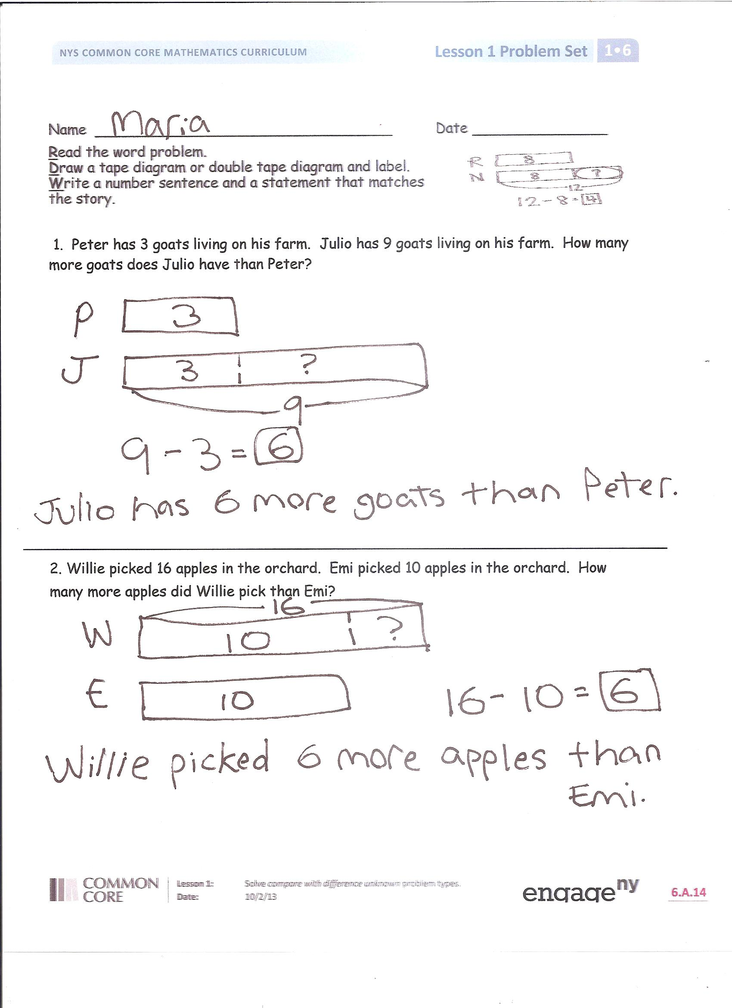
Problem Set (10 minutes)
Students should do their personal best to complete the Problem Set within the allotted 10 minutes. Some problems do not specify a method for solving. This is an intentional reduction of scaffolding that invokes MP.5, Use Appropriate Tools Strategically. Students should solve these problems using the RDW approach used for Application Problems.
For some classes, it may be appropriate to modify the assignment by specifying which problems students should work on first. With this option, let the careful sequencing of the Problem Set guide your selections so that problems continue to be scaffolded. Balance word problems with other problem types to ensure a range of practice. Assign incomplete problems for homework or at another time during the day.
Student Debrief (10 minutes)
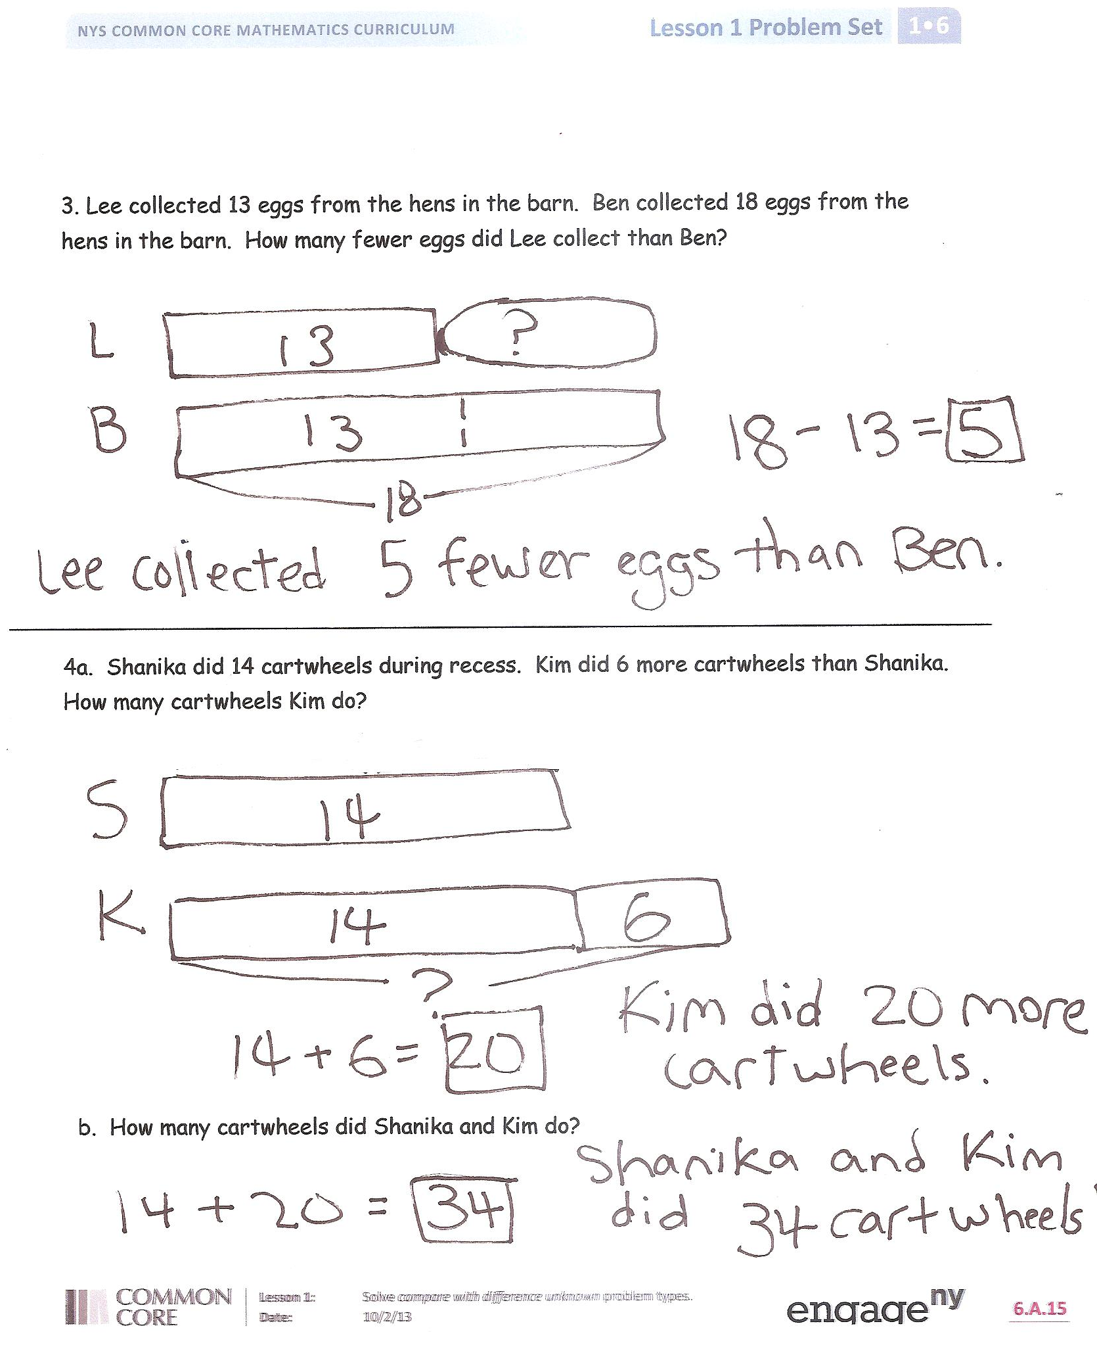
Lesson Objective: Solve compare with difference unknown problem types.
The Student Debrief is intended to invite reflection and active processing of the total lesson experience.
Invite students to review their solutions for the Problem Set. They should check work by comparing answers with a partner before going over answers as a class. Look for misconceptions or misunderstandings that can be addressed in the Debrief. Guide students in a conversation to debrief the Problem Set and process the lesson.
You may choose to use any combination of the questions below to lead the discussion.
- Look at Problem 1. Using the same story, how many fewer goats does Peter have than Julio? What do you notice about the answer to the question in the Problem and this new question? Explain your thinking. How was setting up Problem 3 similar to and different from setting up Problems 1 and 2? What did you need to be sure to do? Why?
- How can your double tape diagram for Problem 4(a) help you solve Problem 4(b)?
- When we know the total and just one of the parts, what strategy did we use to solve for the missing part?
- When two tapes are arranged one above the other like the ones we used today, we call that a double tape diagram. How does setting up our two tapes this way help you compare more easily?
Exit Ticket (3 minutes)
After the Student Debrief, instruct students to complete the Exit Ticket. A review of their work will help you assess the students’ understanding of the concepts that were presented in the lesson today and plan more effectively for future lessons. You may read the questions aloud to the students.
Name Date

My Addition Practice
1. | 6 + 0 = ___ | 11. | 7 + 1 = ___ | 21. | 5 + 3 = ___
2. | 0 + 6 = ___ | 12. | ___ = 1 + 7 | 22. | ___ = 5 + 4
3. | 5 + 1 = ___ | 13. | 3 + 3 = ___ | 23. | 6 + 4 = ___
4. | 1 + 5 = ___ | 14. | 3 + 4 = ___ | 24. | 4 + 6 = ___
5. | 6 + 1 = ___ | 15. | ___ = 3 + 5 | 25. | ___ = 4 + 4
6. | 1 + 6 = ___ | 16. | 6 + 3 = ___ | 26. | 3 + 4 = ___
7. | 6 + 2 = ___ | 17. | 7 + 3 = ___ | 27. | 5 + 5 = ___
8. | 5 + 2 = ___ | 18. | ___ = 7 + 2 | 28. | ___ = 4 + 5
9. | 2 + 5 = ___ | 19. | 2 + 7 = ___ | 29. | 3 + 7 = ___
10. | 2 + 4 = ___ | 20. | 2 + 8 = ___ | 30. | ___ = 3 + 6
Today I finished _____ problems.
I solved _____ problems correctly.

Name Date

My Missing Addend Practice
1. | 6 + ___ = 6 | 11. | 3 + ___ = 6 | 21. | 4 + ___ = 7
2. | 0 + ___ = 6 | 12. | 4 + ___ = 8 | 22. | 7 = 3 + ___
3. | 5 + ___ = 6 | 13. | 10 = 5 + ___ | 23. | 2 + ___ = 7
4. | 4 + ___ = 6 | 14. | 5 + ___ = 9 | 24. | 2 + ___ = 8
5. | 0 + ___ = 7 | 15. | 5 + ___ = 7 | 25. | 9 = 2 + ___
6. | 6 + ___ = 7 | 16. | 8 = 5 + ___ | 26. | 2 + ___ = 10
7. | 1 + ___ = 7 | 17. | 5 + ___ = 9 | 27. | 10 = 3 + ___
8. | 7 + ___ = 8 | 18. | 8 + ___ = 10 | 28. | 3 + ___ = 9
9. | 1 + ___ = 8 | 19. | 7 + ___ = 10 | 29. | 4 + ___ = 9
10. | 6 + ___ = 8 | 20. | 10 = 6 + ___ | 30. | 10 = 4 + ___
Today I finished _____ problems.
I solved _____ problems correctly.

Name Date

My Related Addition and Subtraction Practice
1. | 5 + ___ = 6 | 11. | 7 + ___ = 10 | 21. | 4 + ___ = 8
2. | 1 + ___ = 6 | 12. | 10 – 7 = ___ | 22. | 8 – 4 = ___
3. | 6 - 1 = ___ | 13. | 5 + ___ = 7 | 23. | 4 + ___ = 7
4. | 9 + ___ = 10 | 14. | 7 – 5 = ___ | 24. | 7 – 4 = ___
5. | 1 + ___ = 10 | 15. | 5 + ___ = 8 | 25. | 5 + ___ = 9
6. | 10 – 9 = ___ | 16. | 8 – 5 = ___ | 26. | 9 – 5 = ___
7. | 5 + ___ = 10 | 17. | 4 + ___ = 6 | 27. | 6 + ___ = 9
8. | 10 – 5 = ___ | 18. | 6 – 4 = ___ | 28. | 9 – 6 = ___
9. | 8 + ___ = 10 | 19. | 3 + ___ = 6 | 29. | 4 + ___ = 7
10. | 10 – 8 = ___ | 20. | 6 – 3 = ___ | 30. | 7 – 4 = ___
Today I finished _____ problems.
I solved _____ problems correctly.

Name Date

My Subtraction Practice
1. | 6 - 0 = ___ | 11. | 6 - 3 = ___ | 21. | 8 - 4 = ___
2. | 6 - 1 = ___ | 12. | 7 - 3 = ___ | 22. | 8 - 3 = ___
3. | 7 - 1 = ___ | 13. | 9 – 3 = ___ | 23. | 8 - 5 = ___
4. | 8 - 1 = ___ | 14. | 10 - 8 = ___ | 24. | 9 - 5 = ___
5. | 6 - 2 = ___ | 15. | 10 - 6 = ___ | 25. | 9 - 4 = ___
6. | 7 - 2 = ___ | 16. | 10 – 4 = ___ | 26. | 7 - 3 = ___
7. | 9 - 2 = ___ | 17. | 10 - 5 = ___ | 27. | 10 - 7 = ___
8. | 10 - 10 = ___ | 18. | 7 – 6 = ___ | 28. | 9 - 7 = ___
9. | 10 - 9 = ___ | 19. | 7 - 5 = ___ | 29. | 9 - 6 = ___
10. | 10 - 7 = ___ | 20. | 6 - 4 = ___ | 30. | 8 - 6 = ___
Today I finished _____ problems.
I solved _____ problems correctly.

Name Date

My Mixed Practice
1. | 4 + 2 = ___ | 11. | 2 + ___ = 6 | 21. | 8 - 5 = ___
2. | 2 + ___ = 6 | 12. | 6 - 2 = ___ | 22. | 3 + ___ = 8
3. | 6 = 3 + ___ | 13. | 6 - 4 = ___ | 23. | 8 = ___ + 5
4. | 2 + 5 = ___ | 14. | 5 + ___ = 7 | 24. | ___ + 2 = 9
5. | 7 = 5 + ___ | 15. | 7 - 5 = ___ | 25. | 9 = ___ + 7
6. | 4 + 3 = ___ | 16. | 7 - 4 = ___ | 26. | 9 – 2 = ___
7. | 7 = ___ + 4 | 17. | 7 - 3 = ___ | 27. | 9 - 7 = ___
8. | 8 = ___ + 4 | 18. | 8 = 6 + ___ | 28. | 9 - 6 = ___
9. | 4 + 5 = ___ | 19. | 8 - 2 = ___ | 29. | 9 = ___ + 4
10. | 9 = ___ + 4 | 20. | 8 – 6 = ___ | 30. | 9 - 6 = ___
Today I finished _____ problems.
I solved _____ problems correctly.

Name Date
Read the word problem.
Draw a tape diagram or double tape diagram and label.
Write a number sentence and a statement that matches the story.

  - Peter has 3 goats living on his farm. Julio has 9 goats living on his farm. How many more goats does Julio have than Peter?

- Willie picked 16 apples in the orchard. Emi picked 10 apples in the orchard. How many more apples did Willie pick than Emi?

- Lee collected 13 eggs from the hens in the barn. Ben collected 18 eggs from the hens in the barn. How many fewer eggs did Lee collect than Ben?

- Shanika did 14 cartwheels during recess. Kim did 6 more cartwheels than Shanika. How many cartwheels Kim do?

- How many cartwheels did Shanika and Kim do?
Name Date
Read the word problem.
Draw a tape diagram or double tape diagram and label.
Write a number sentence and a statement that matches the story.

- Anton drove around the racetrack 12 times during the race. Rose drove around the racetrack 5 more times than Anton. How many times did Rose go around the racetrack?
Name Date
Read the word problem.
Draw a tape diagram or double tape diagram and label.
Write a number sentence and a statement that matches the story.

  - Fran donated 11 of her old books to the library. Darnel donated 8 of his old books to the library. How many more books did Fran donate than Darnel?

- During recess 7 students were reading books. There were 17 students playing on the playground. How many fewer students were reading books than playing on the playground?

- Maria is 18 years old. Her brother Nikil is 12 years old. How much older is Maria than her brother Nikil?

    - It rained 15 days in the month of March. It rained 4 more days in April than in March. How many days did it rain in April?

    - How many days did it rain in March and April?

