Lesson 13

Objective: Recognize halves within a circular clock face and tell time to the half hour.

Suggested Lesson Structure

 Fluency Practice (15 minutes)

 Application Problem (5 minutes)

 Concept Development (30 minutes)

 Student Debrief (10 minutes)

**Total Time (60 minutes)**

Fluency Practice (15 minutes)

* Grade 1 Core Fluency Sprint **1.OA.6** (10 minutes)
* Happy Counting **1.NBT.1** (2 minutes)
* Analogous Addition and Subtraction **1.OA.6,** **1.NBT.2** (3 minutes)

Grade 1 Core Fluency Sprint (10 minutes)

Materials: (S) Core Fluency Sprint (Lesson 1 Core Fluency Sprint)

Note: Choose an appropriate Sprint, based on the needs of the class. If the majority of students completed the first three quadrants on the previous Sprint, move to the next Sprint listed in the sequence provided below (Core Fluency Sprint List). If many students are not making it to the third quadrant, consider repeating the same Sprint. As students work, pay attention to their strategies and the number of problems they are answering to consider for future Sprint administration.

Core Fluency Sprint List:

* Core Addition Sprint 1 (Targets core addition and missing addends.)
* Core Addition Sprint 2 (Targets the most challenging addition within 10.)
* Core Subtraction Sprint (Targets core subtraction.)
* Core Fluency Sprint: Totals of 5, 6, and 7 (Develops understanding of the relationship between addition and subtraction.)
* Core Fluency Sprint: Totals of 8, 9, and 10 (Develops understanding of the relationship between addition and subtraction.)

Happy Counting (2 minutes)

Note: This activity prepares students for Module 6 by providing practice counting by ones and tens within 100.

Repeat activity from Lesson 11.

Analogous Addition and Subtraction (3 minutes)

Note: This activity practices Grade 1’s core fluency and reminds students to use their knowledge of sums and differences within 10 (e.g., 5 + 3 = 8) to solve analogous problems within 40 (e.g., 15 + 3 = 18, 25 + 3 = 28, and 35 + 3 = 38).

T: On my signal, say the equation with the answer. 6 + 2 = . (Pause. Signal.)

S: 6 + 2 = 8.

T: 16 + 2 = . (Pause. Signal.)

S: 16 + 2 = 18.

Continue with 26 + 2 and 36 + 2. Then repeat, beginning with other addition or subtraction sentences within 10.

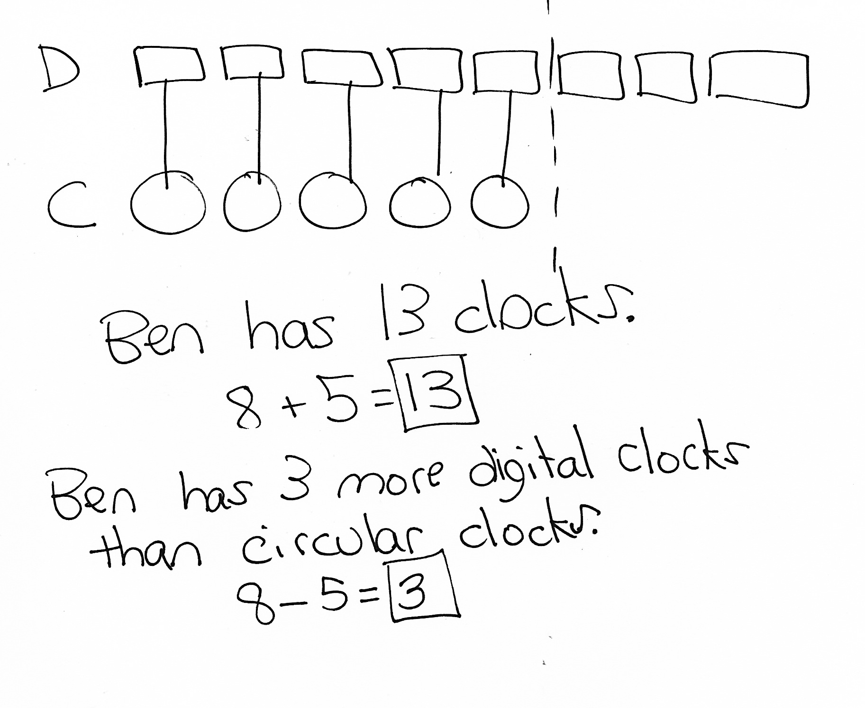Application Problem (5 minutes)

Ben is a clock collector. He has 8 digital clocks and 5 circular clocks. How many clocks does Ben have all together? How many more digital clocks does Ben have than circular clocks?

Note: Today’s Application Problem is very similar to the problem in Lesson 11. Use this opportunity to recognize students who are showing improvement in solving *compare with difference unknown* problem types. Analyze students’ work to pinpoint challenges and then adjust, extend, or modify G1–M6–Lesson 1 to support students’ development with these problem types.

Concept Development (30 minutes)

|  |  |
| --- | --- |
|  | NOTES ON  MULTIPLE MEANS  OF ENGAGEMENT: |

Remember to ask students, “What time is it?” throughout the day to accustom them to looking at a clock and noticing when events happen during their day. Continuing to incorporate clocks into all teaching helps students master telling time to the hour and half hour.

Materials: (T) Clock image 1 (Template 1) (S) Clock images (Template 2), personal white board

Note: Today’s objective extends to clocks students may encounter. If the majority of the class requires more exposure to the traditional analog clock used during Lessons 10─12, substitute the variety of clock faces with the paper clock template in Lesson 11, and have students erase and redraw clock hands for each time they are given.

If using various clock faces, it might be preferable to bring in actual clocks and watches to use during the lesson, or ask families in advance to send in pictures of clocks in their homes.

Have students place the clocks template (Template 2) into their personal white boards and gather in the meeting area.

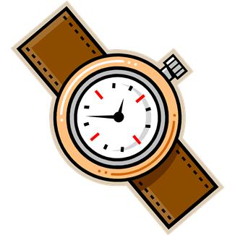

T: (Project clock image 1, a watch.) Many people use something like this to show them what time it is. Do you know what it is called?

S: A watch!

T: Why do people sometimes wear watches? Talk with your partner about it. (Wait as students share thoughts.)

S: It tells them the time. 🡪 It’s like having a clock with you even when you’re outside. 🡪 People have watches because they can’t carry around a big clock.

T: What is the time on this watch?

S: 3:30.

T: This watch looks a lot like the clocks we have been looking at. But sometimes watches and clocks look different from each other. What differences do you notice among the clocks and watches on the clock page in your personal white board (Template 2)?

S: One of them is a square. 🡪 Some of them have no numbers. 🡪 Some of them have a few of the numbers, but not all of the numbers. 🡪 One of them has weird letters where the numbers should be. 🡪 Some of them have pointy arrows on the clock hands.

T: Let’s use what we know about circles and clocks to help us tell the time, even when the clock face looks different.



T: Let’s look at the square clock. What is the time?

S: 9:30.

T: We can also say…?

S: Half past 9.

T: Write the time on the line under the clock. (Wait as students write 9:30.)

T: Let’s all look at the next clock. This clock only has four numbers—3, 6, 9, and 12. Where do you think the missing numbers would go? Use your dry erase marker to put them in. (Wait as students place in the missing numbers.)

|  |  |
| --- | --- |
|  | NOTES ON  MULTIPLE MEANS  OF ENGAGEMENT: |

While teaching, be sure to provide cross-curricular connections for students. Interested students can write a story about their school day and the events that occur at certain times. During other writing activities, encourage students to incorporate time into their stories.

T: What time does the clock show?



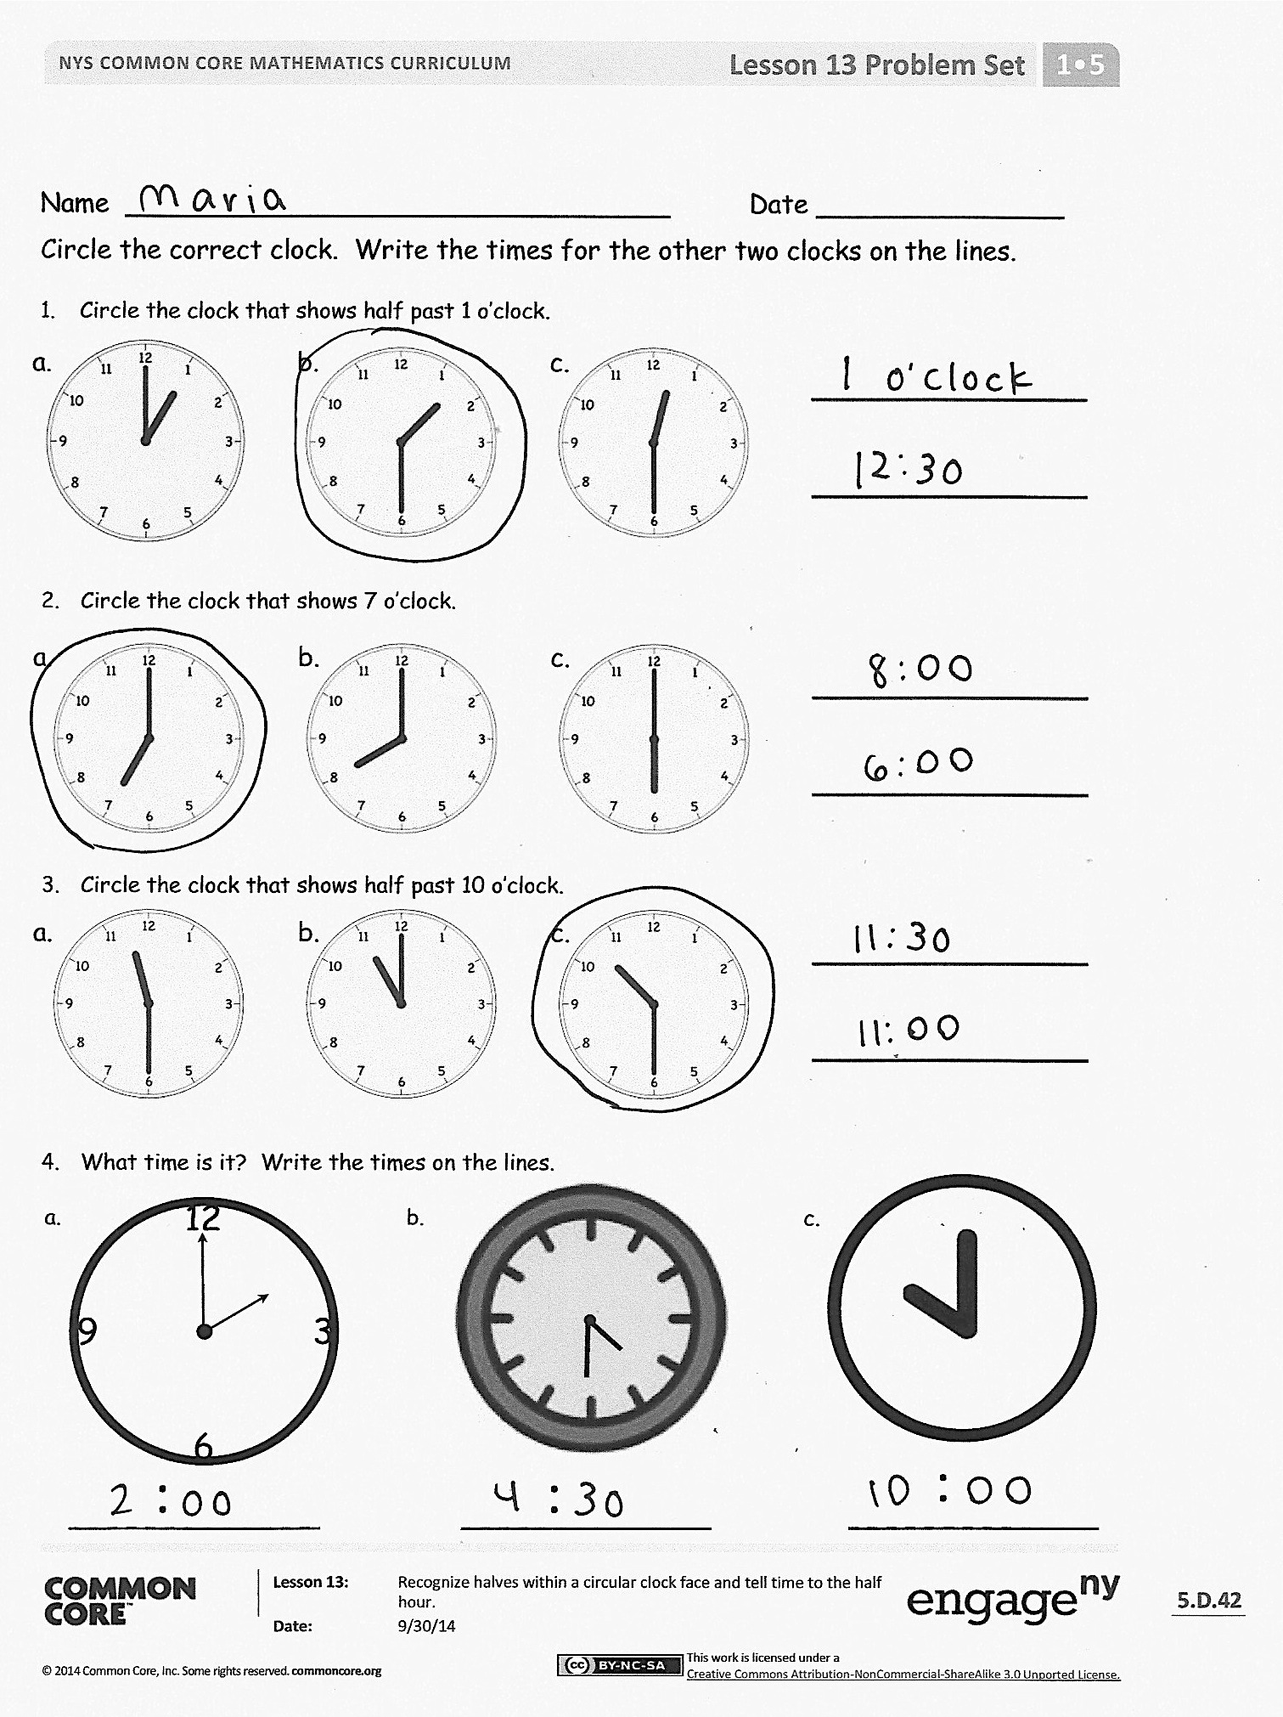S: 4 o’clock!

T: Write the time on the line under the clock.

T: Try the next clock without putting in the missing numbers. *Imagine* the numbers that are missing. (Wait as students write the time on the line.)

T: What time does the clock show?



**MP.7**

S: 11 o’clock!

T: How did you know?

S: The minute hand was on the 12, and the hour hand was just before that, so it had to be the hour that’s before 12, which is 11 o’clock.

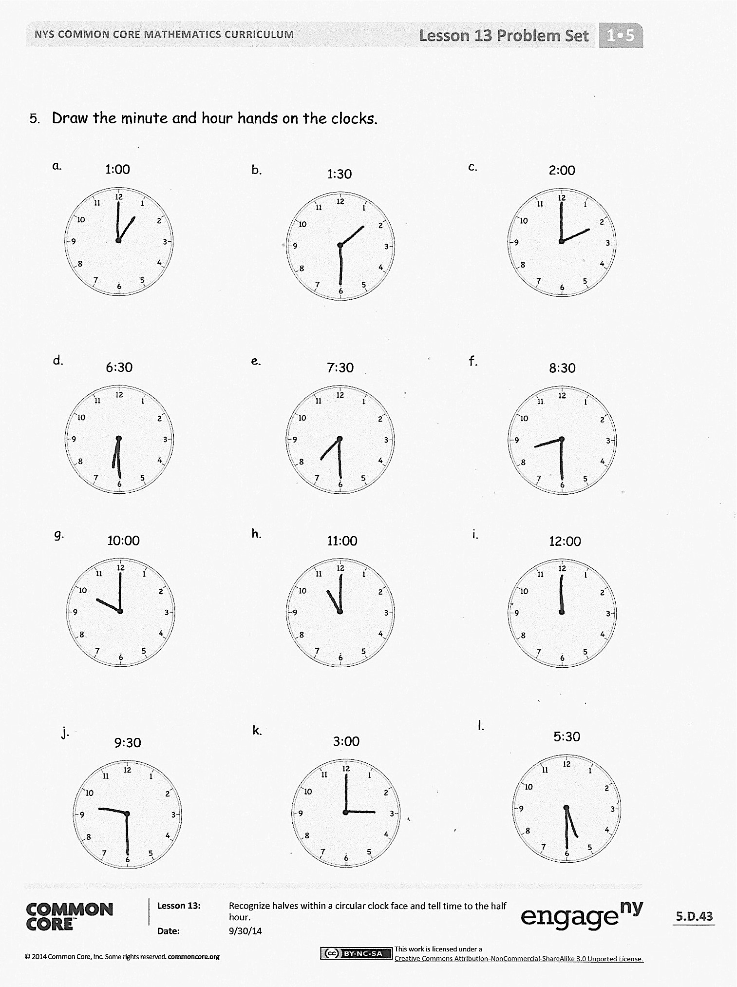Repeat the process for each watch or clock on the page, discussing ways to determine the time based on the position of the hands on the clock face.

Problem Set (10 minutes)

Students should do their personal best to complete the Problem Set within the allotted 10 minutes. For some classes, it may be appropriate to modify the assignment by specifying which problems they work on first.

Student Debrief (10 minutes)

**Lesson Objective:** Recognize halves within a circular clock face and tell time to the half hour.

The Student Debrief is intended to invite reflection and active processing of the total lesson experience.

Invite students to review their solutions for the Problem Set. They should check work by comparing answers with a partner before going over answers as a class. Look for misconceptions or misunderstandings that can be addressed in the Debrief. Guide students in a conversation to debrief the Problem Set and process the lesson.

Any combination of the questions below may be used to lead the discussion.

* Look at your Problem Set. Which clock was the most challenging for you to read and why?
* Look at the clocks on your personal white board. Which clock was the most challenging for you to read and why? Which clock would you like to have in your home and why?
* No matter what a clock looks like, what parts must it include in order for us to tell the time?
* When can it be helpful to know what time it is?
* Look at the Application Problem. Share how you used your drawing to help solve the problem.

Exit Ticket (3 minutes)

After the Student Debrief, instruct students to complete the Exit Ticket. A review of their work will help with assessing students’ understanding of the concepts that were presented in today’s lesson and planning more effectively for future lessons. The questions may be read aloud to the students.

Name Date

Circle the correct clock. Write the times for the other two clocks on the lines.

1. Circle the clock that shows half past 1 o’clock.

a.

c.

b.

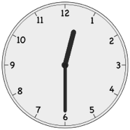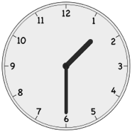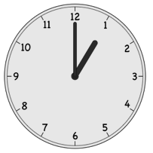

1. Circle the clock that shows 7 o’clock.

a.

b.

c.

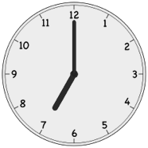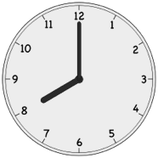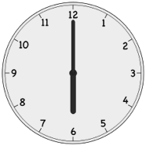

1. Circle the clock that shows half past 10 o’clock.

a.

b.

c.

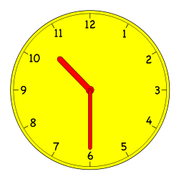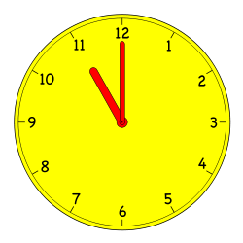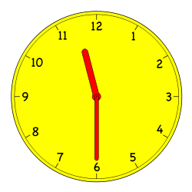

1. What time is it? Write the times on the lines.

b.

a.

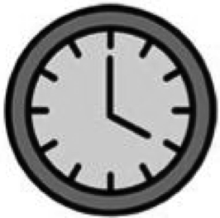

c.

_____________

:

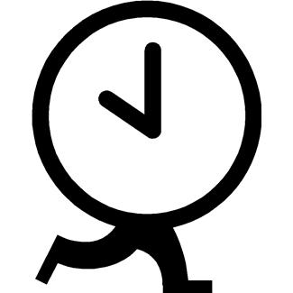

5. Draw the minute and hour hands on the clocks.

_____________

:

_____________

:

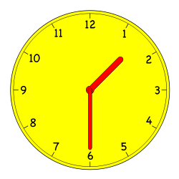

1:30

b.



1:00

a.



2:00

c.



7:30

e.



6:30

d.



8:30

f.



11:00

h.



10:00

g.



12:00

i.



3:00

k.



9:30

j.



5:30

l.

Name Date

1. 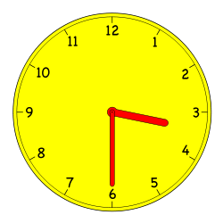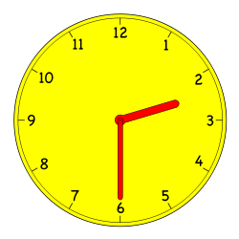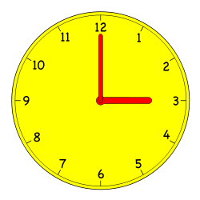Circle the clock(s) that shows half past 3 o’clock.

b.

c.

a.

1. Write the time or draw the hands on the clocks.



4:30

a.

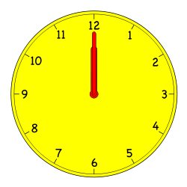

____________________

b.



9 o’clock

c.

Name Date

Fill in the blanks.

A

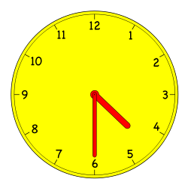

1.

B

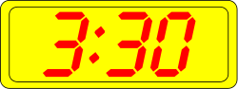

Clock ______ shows half past three.

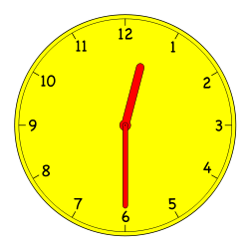

2.

Clock ______ shows half past twelve.

B

A

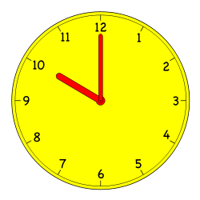

3.

Clock ______ shows eleven o’clock.

B

A

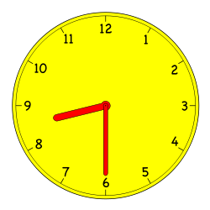

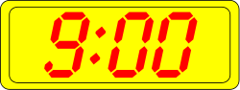4.

Clock ______ shows 8:30.

B

A

B

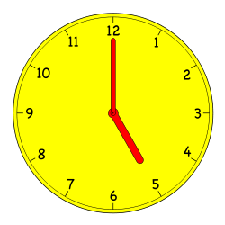

A

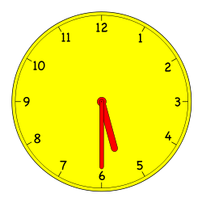

5.

Clock ______ shows 5:00.

1. Write the time on the line under the clock.

|  |  |  |
| --- | --- | --- |
| Macintosh HD:Users:isinger50:Desktop:Screen Shot 2013-08-14 at 11.30.55 AM.pnga.  ___________________ | lock by manio1 - A collection analogue clocks showing every half hour. Suitable for education purposes.b.  ___________________ | lock by manio1 - A collection analogue clocks showing every half hour. Suitable for education purposes.c.  lock by manio1 - A collection analogue clocks showing every half hour. Suitable for education purposes.___________________ |
| d.  igital Clock by manio1 - A collection of digital clocks showing every half hour. Suitable for educational purposes.  lock by manio1 - A collection analogue clocks showing every half hour. Suitable for education purposes.___________________ | lock by manio1 - A collection analogue clocks showing every half hour. Suitable for education purposes.e.  ___________________ | f.  ___________________ |
| g.  ___________________ | h.  igital Clock by manio1 - A collection of digital clocks showing every half hour. Suitable for educational purposes.h  ___________________ | 1. lock by manio1 - A collection analogue clocks showing every half hour. Suitable for education purposes.   ___________________ |

1. Put a check (🗸) next to the clock(s) that show 4 o’clock.

|  |  |  |  |
| --- | --- | --- | --- |
| lock by manio1 - A collection analogue clocks showing every half hour. Suitable for education purposes.a. | lock by manio1 - A collection analogue clocks showing every half hour. Suitable for education purposes.b. | lock by manio1 - A collection analogue clocks showing every half hour. Suitable for education purposes.c. | d.  igital Clock by manio1 - A collection of digital clocks showing every half hour. Suitable for educational purposes. |



[1]



[2] 

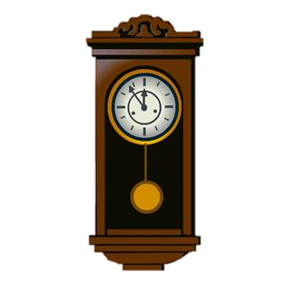

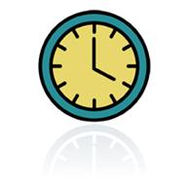

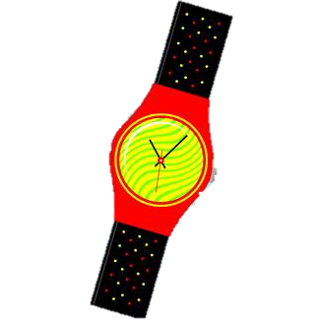

1. clock image 1
2. clock images