Lesson 12
Objective: Recognize halves within a circular clock face and tell time to the half hour.

Suggested Lesson Structure
 Fluency Practice (15 minutes)
 Application Problem (5 minutes)
 Concept Development (30 minutes)
 Student Debrief (10 minutes)
Total Time (60 minutes)
Fluency Practice (15 minutes)
- Core Fluency Differentiated Practice Sets 1.OA.6 (5 minutes)
- Happy Counting 1.NBT.1 (2 minutes)
- Analogous Addition and Subtraction 1.OA.6, 1.NBT.2 (3 minutes)
- Take from Ten Subtraction with Partners 1.OA.6 (5 minutes)
Core Fluency Differentiated Practice Sets (5 minutes)
Materials: (S) Core Fluency Practice Sets (Lesson 3 Core Fluency Practice Sets)
Note: Give the appropriate Practice Set to each student. Help students become aware of their improvement. After students do today’s Practice Sets, ask them to raise their hands if they tried a new level today or improved their score from the previous day.
Students complete as many problems as they can in 90 seconds. Assign a counting pattern and start number for early finishers, or tell them to practice make ten addition or subtraction on the back of their papers. Collect and correct any Practice Set completed within the allotted time.
Happy Counting (2 minutes)
Note: This activity prepares students for Module 6 by providing practice counting by ones and tens within 100.
Repeat activity from Lesson 11.

Analogous Addition and Subtraction (3 minutes)
Note: This activity practices Grade 1’s core fluency and reminds students to use their knowledge of sums and differences within 10 (e.g., 5 + 3 = 8) to solve analogous problems within 40 (e.g., 15 + 3 = 18, 25 + 3 = 28, and 35 + 3 = 38).
T: On my signal, say the equation with the answer. 6 + 2 = . (Pause. Snap.)
S: 6 + 2 = 8.
T: 16 + 2 = . (Pause. Snap.)
S: 16 + 2 = 18.
Continue with 26 + 2 and 36 + 2. Then repeat, beginning with other addition or subtraction sentences within 10.
Suggested sequence:

- 5 + 3, 15 + 3, 25 + 3, 35 + 3
- 5 + 4, 4 + 5, 14 + 5, 24 + 5
- 7 + 2, 2 + 7, 12 + 7, 32 + 7
- 6 – 3, 16 – 3, 26 – 3, 36 – 3
- 8 – 2, 18 – 2, 28 – 2, 38 – 2
- 9 – 3, 19 – 3, 29 – 3, 39 – 3
Take from Ten Subtraction with Partners (5 minutes)
Materials: (S) Personal white board
Note: This fluency activity reviews how to use the Level 3 strategy of taking from ten when subtracting from teen numbers.
Repeat activity from Lesson 11.
Application Problem (5 minutes)
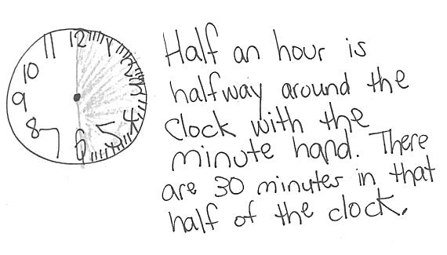
Shade the clock from the start of a new hour through half an hour. Explain why that is the same as 30 minutes.
Note: Before beginning today’s Concept Development, students have the opportunity to demonstrate their understanding using words and pictures. Circulate, and notice the areas where students are using clear, precise language, as well as elements of their explanation that can use stronger or clearer language. Throughout today’s Concept Development, take care to emphasize or extend the lesson around these areas.
MP.6
Concept Development (30 minutes)
Materials: (T) Instructional clock, paper with quarter of page cut out to cover minute hand (see Sequence C figure) (S) Student clock
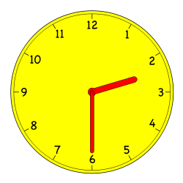
This lesson is designed to support student understanding of telling time to the half hour. Below are four sequences of problems that can be used, from simple to complex:
- Sequence A reinforces time to the hour.
- Sequence B reinforces discriminating between time to the hour and the half hour.
- Sequence C focuses on positioning the hour hand when telling time to the half hour.
- Sequence D challenges students beyond the standard to apply their ability of telling time to the hour and half hour to story problems.
Choose the sequence that is most appropriate for your students. If appropriate, only use part of a sequence.
Sequence A
T: Write the time that matches this clock.
(Hold up a clock showing the following times.)

NOTES ON
MULTIPLE MEANS
OF ENGAGEMENT:
While teaching, be sure to provide cross-curricular connections for students. Visit the school or local library to check out books on time to supplement learning during the last two lessons of the module.

- 11:00
- 2:00
- 6:00
T: On your clock, show the following time. Then, write the time the way it would appear on a digital clock. (Say the following times.)
- 7:00
- 8 o’clock
- 12 o’clock
- 5:00
Sequence B
T: Write the time that matches this clock. (Hold up a clock showing the following times.)
- 7:00
- 12:30 (Ask for both ways to say this time.)
- 1:30 (Ask for both ways to say this time.)
T: On your clock, show the following time. Then, write the time the way it would appear on a digital clock. (Say the following times.)
- Half past 8
- 9:00
- half past 9
- 11:00
- 10:30
- 7 o’clock
- 6:30
Sequence C
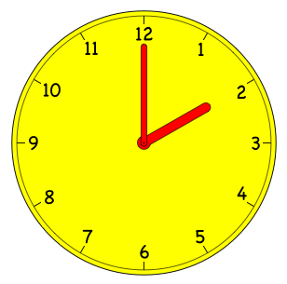
T: I’m going to cover the minute hand on this clock. Look closely at the hour hand to decide what time it is. Show the correct time on your clock, and write the time on your personal white board. (For each time below, cover as much of the clock as possible while showing the hour hand. Place the hour hand directly on the given hour, or halfway between the two numbers, depending on the appropriate position for the given time.)
- 2:00
- 2:30 (Ask for both ways to say this time.)
- 4:00
- 4:30 (Ask for both ways to say this time.)
- 9:30 (Ask for both ways to say this time.)
- 7:30 (Ask for both ways to say this time.)
- 3:00
Sequence D
T: Listen to my story, and see if you can determine the time.
- Kim’s dance class starts at 3 o’clock. The class lasts half an hour. What does the clock look like when the class ends? Show the time by using your paper clock and writing on your personal white board.

NOTES ON
MULTIPLE MEANS
OF ENGAGEMENT:
Remember to provide challenging extensions for students who are above grade level. Giving problems such as those in Sequence D allows students to think about elapsed time. After completing this sequence, advanced students can write their own elapsed time problem to provide another extension to their learning.

- When I left the house to buy groceries, the clock looked like this. (Show clock at 5:00.) It took me 1 hour to buy groceries and come home. What time did the clock show when I arrived home? Use your paper clock and your personal white board to show the time.
- School begins at 8:30. We have lunch after 3 hours. What time do we have lunch? Use your paper clock and your personal white board to show the time.
For each problem situation, invite students to share how they solved the problem and share the position of the hands on their clock and the time displayed on a digital clock.
Problem Set (10 minutes)
Students should do their personal best to complete the Problem Set within the allotted 10 minutes. For some classes, it may be appropriate to modify the assignment by specifying which problems they work on first.
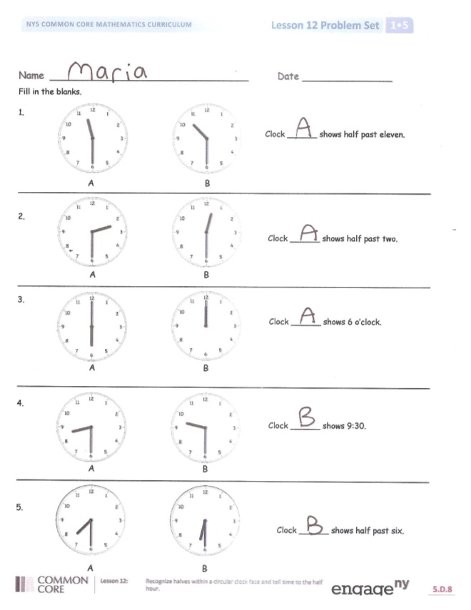
Student Debrief (10 minutes)
Lesson Objective: Recognize halves within a circular clock face and tell time to the half hour.
The Student Debrief is intended to invite reflection and active processing of the total lesson experience.
Invite students to review their solutions for the Problem Set. They should check work by comparing answers with a partner before going over answers as a class. Look for misconceptions or misunderstandings that can be addressed in the Debrief. Guide students in a conversation to debrief the Problem Set and process the lesson.
Any combination of the questions below may be used to lead the discussion.
- Look at Problem 1. How did you choose the correct clock? Demonstrate how you know A is the correct answer.
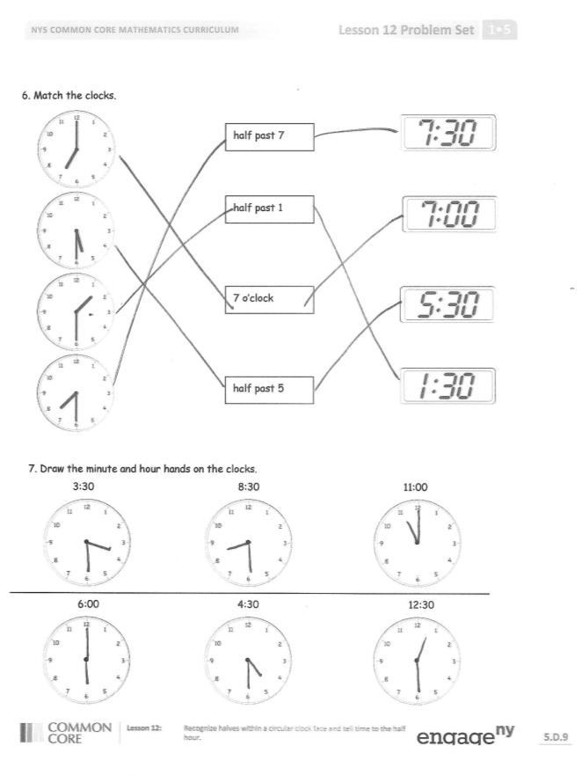
- Look at Problem 4. What is another way to say 9:30? Why is 9:30 also known as half past 9?
- Look at Problem 7. How did you draw the clock hands for 12:30? Explain why you placed the minute hand and the hour hand in each location.
- Look at the clock in our room. Is the time closest to a new hour or closest to half past the hour? What time is it right now?
- How could your fluency activities today help you with your subtraction?
Exit Ticket (3 minutes)
After the Student Debrief, instruct students to complete the Exit Ticket. A review of their work will help with assessing students’ understanding of the concepts that were presented in today’s lesson and planning more effectively for future lessons. The questions may be read aloud to the students.

Name Date
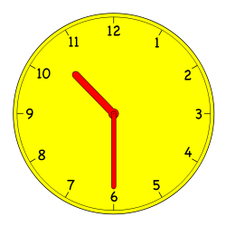
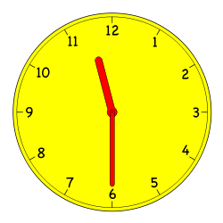
Fill in the blanks.
1.
Clock ______ shows half past eleven.
A
B
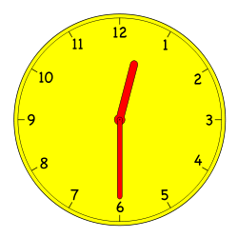

2.
Clock ______ shows half past two.
A
B
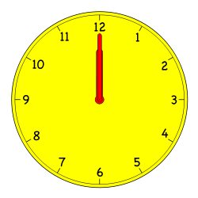
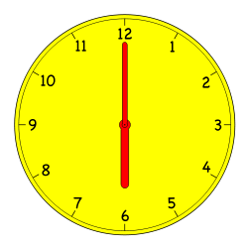

3.
Clock ______ shows 6 o’clock.
B
A
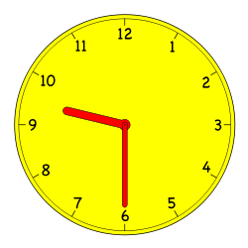
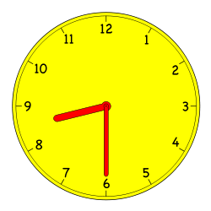
4.
Clock ______ shows 9:30.
B
A
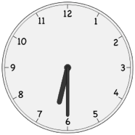
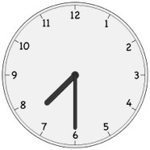
B
A

5.
Clock ______ shows half past six.
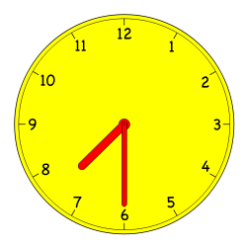
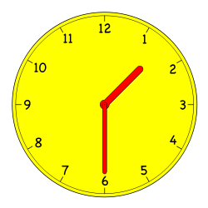
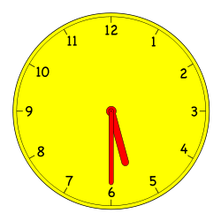
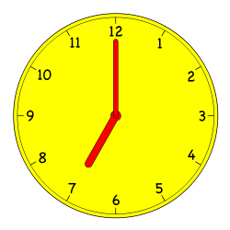
- Match the clocks.
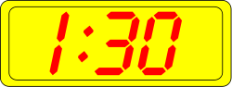
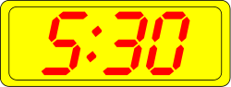
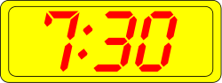
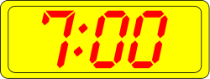
7 o’clock
half past 7
half past 1
half past 5
a.

b.

c.

d.

7. Draw the minute and hour hands on the clocks.
d.
e.
f.
a.
b.
c.
12:30
4:30
6:00
11:00
8:30
3:30
Name Date
Draw the minute and hour hands on the clocks.
10:00
1:30
1. 2.

7:30
5:30
3. 4.
Name Date
Write the time shown on the clock, or draw the missing hand(s) on the clock.
1.  10 o’clock | 2.  half past 10 o’clock
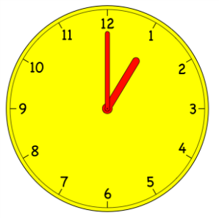  3.  8 o’clock | 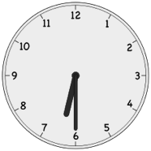  4.  ___________
5.  3 o’clock | 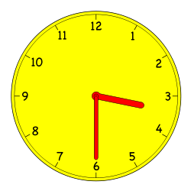  6.  half past 3 o’clock
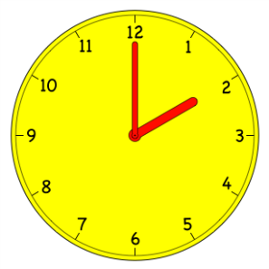  7.  _ ______________ | 8.  half past 6 o’clock
9.  half past 9 o’clock | 10.  4 o’clock

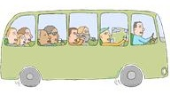
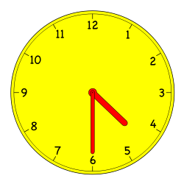
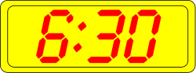
- Match the pictures with the clocks.
f.
e.
Take bus home
4:30
d.
c.
b.
a.
Soccer practice
3:30
Brush teeth
7:30
Homework
half past 6 o’clock
Eat dinner
5:30
Wash dishes
6:00

