Lesson 11

Objective: Recognize halves within a circular clock face and tell time to the half hour.

Suggested Lesson Structure

 Fluency Practice (14 minutes)

 Application Problem (5 minutes)

 Concept Development (31 minutes)

 Student Debrief (10 minutes)

**Total Time (60 minutes)**

Fluency Practice (14 minutes)

* Core Fluency Differentiated Practice Sets **1.OA.6** (5 minutes)
* Happy Counting **1.NBT.1** (2 minutes)
* Think Count **1.OA.5** (2 minutes)
* Take from Ten Subtraction with Partners  **1.OA.6** (5 minutes)

Core Fluency Differentiated Practice Sets (5 minutes)

Materials: (S) Core Fluency Practice Sets (Lesson 3 Core Fluency Practice Sets)

Note: Give the appropriate Practice Set to each student. Students who completed all of the questions correctly on their most recent Practice Set should be given the next level of difficulty. All other students should try to improve their scores on their current levels.

Students complete as many problems as they can in 90 seconds. Assign a counting pattern and start number for early finishers, or tell them to practice make ten addition or subtraction on the back of their papers. Collect and correct any Practice Set completed within the allotted time.

Happy Counting (2 minutes)

Note: In the next module, students learn addition and subtraction within 100 and extend their counting and number writing skills to 120. Give students practice counting by ones and tens within 100 to prepare them for Module 6. When Happy Counting by ones, spend more time changing directions where changes in tens occur, which is typically more challenging. Happy Count by ones the regular way and the Say Ten Way between 40 and 100. Then, Happy Count by tens.

T:         

T/S: 88 89 90 (pause) 89 90 91 90 89 (etc.)

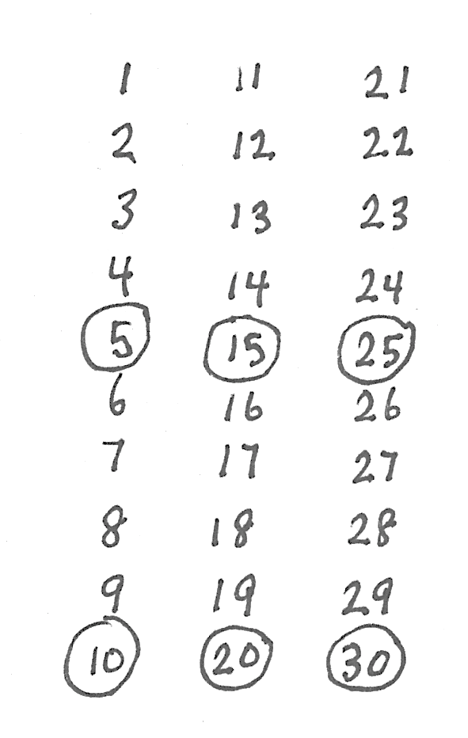Think Count (2 minutes)

Materials: (T) Chart of numbers to 30 with multiples of 5 circled

Note: This activity prepares students for today’s lesson, when they will be adding 5 minutes until they reach 30 minutes to connect half past the hour to 30 minutes past the hour.

Display the chart. Students think-count to 20, saying multiples of 5 aloud. Hide the chart, and let students try to remember the sequence, counting slowly by fives to 20. Repeat think-counting and slowly skip-counting first to 25, and then to 30.

Take from Ten Subtraction with Partners (5 minutes)

Materials: (S) Personal white board

Note: This fluency activity reviews how to use the Level 3 strategy of taking from ten when subtracting from teen numbers.

* 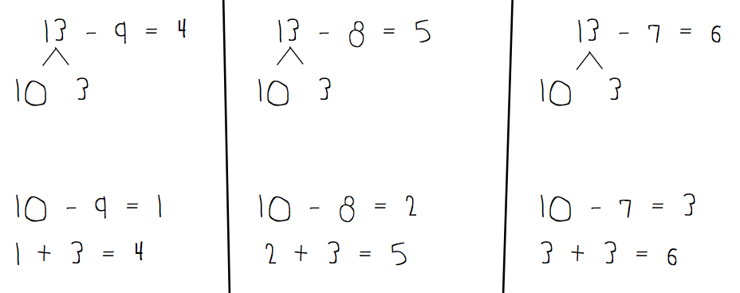Assign partners of equal ability.
* Partners choose a minuend for each other between 10 and 20.
* 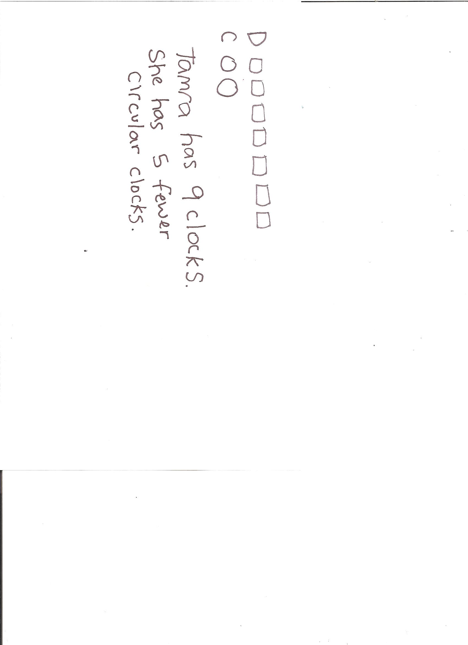On their personal white boards, students subtract 9, 8, and 7 from their number. Remind students to write the two number sentences (e.g., to solve 13 – 8, they write 10 – 8 = 2, 2 + 3 = 5).
* Partners then exchange personal white boards and check each other’s work.

Application Problem (5 minutes)

Tamra has 7 digital clocks in her house and only 2 circular or analog clocks. How many fewer circular clocks does Tamra have than digital clocks? How many clocks does Tamra have all together?

Note: Today’s problem presents both a *put together with result unknown* problem type and a *compare with difference unknown* problem type. Presenting both problems within the same context can support recognizing the differences between the two problem types.

Concept Development (31 minutes)

|  |  |
| --- | --- |
|  | NOTES ON  MULTIPLE MEANS  OF REPRESENTATION: |

Consider your students’ visual needs when determining the appropriate clock for each student. Some students may benefit from large numbers. Other students may find large numbers challenging for identifying the space halfway between the numbers when positioning hands to show the half hour.

Materials: (T) Paper clock created during Lesson 10, document camera, personal white board, dry erase marker, large instructional clock with gears (if available)   
(S) Paper clock created in Lesson 10 or commercial student clocks, personal white board

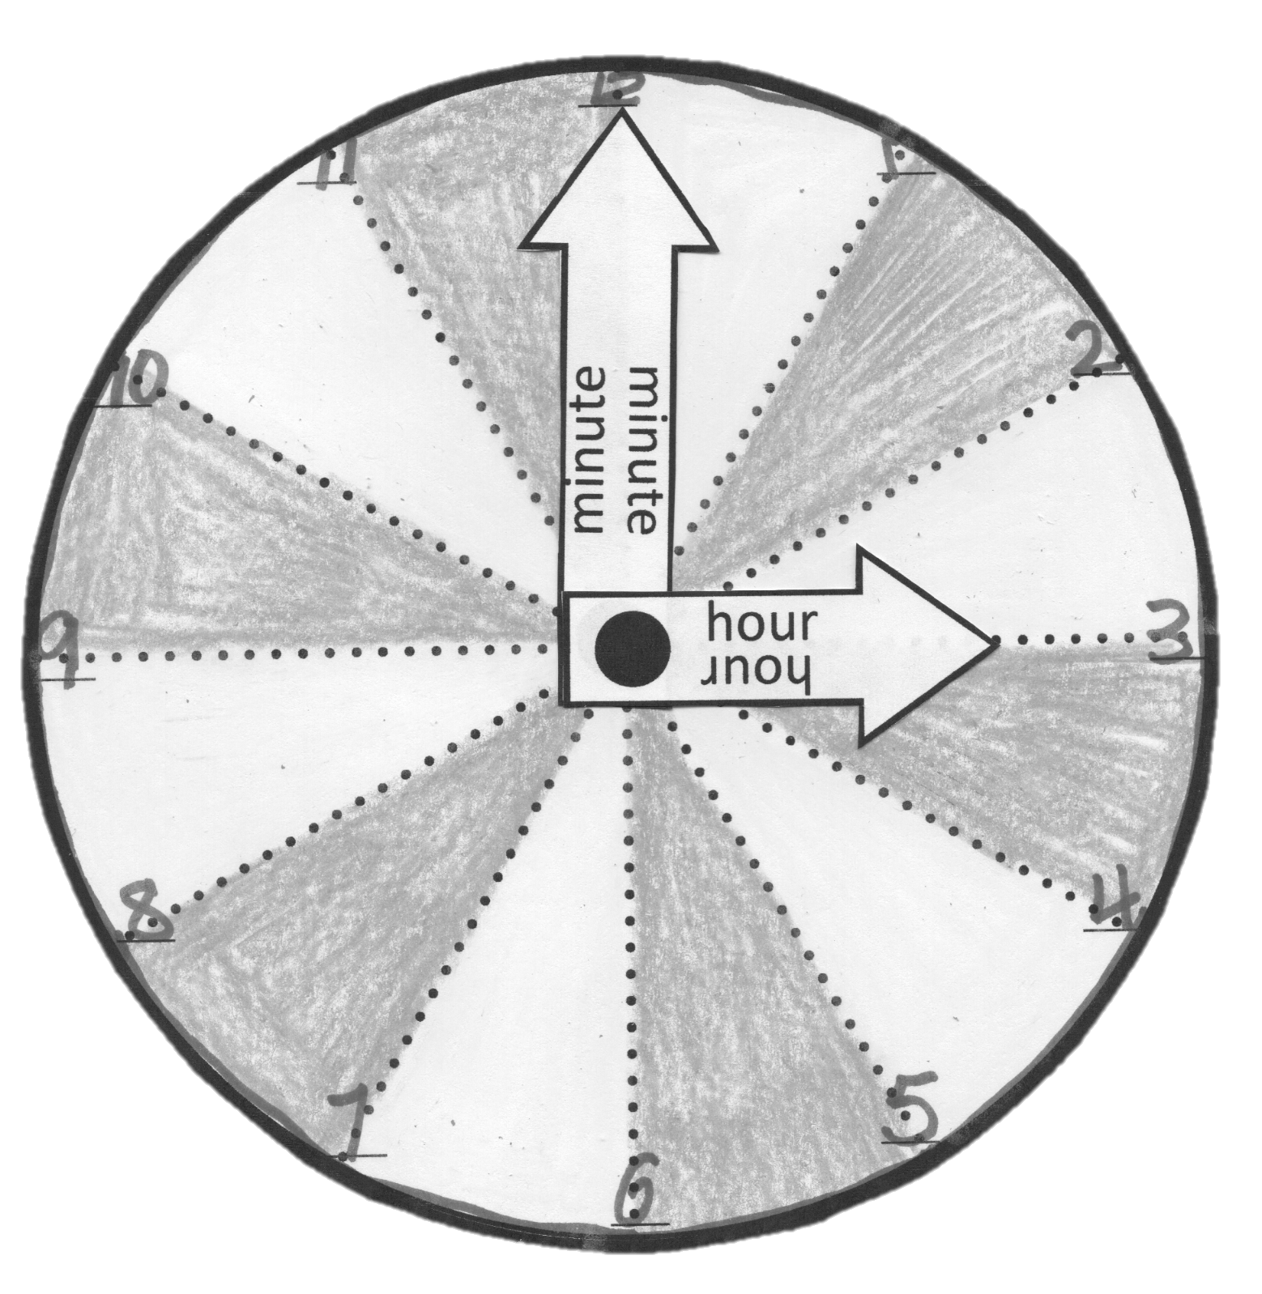Note: For students who need a new paper clock, an additional paper clock with numbers is provided at the end of this lesson (Template).

Distribute materials to students seated at their tables or desks.

T: In the previous lesson, we read the time when we had whole hours with no extra minutes past the hour. Let’s start at 12 o’clock. Where is the minute hand?

S: At the 12.

T: Where is the hour hand?

S: At the 12.

T: (Position the minute hand on the paper clock accordingly.) When the minute hand moves all the way around the clock, it has been 60 minutes, or 1 hour. When 1 hour passes, we will be at…?

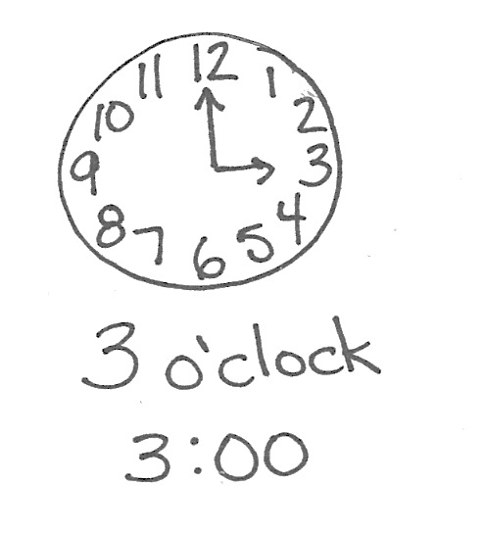S: 1 o’clock!

T: Which clock hand do we move to show 1 o’clock?

S: The hour hand. It’s the short one.

T: (Have students count chorally with you as you move from 1 o’clock, to 2 o’clock, and then 3 o’clock. Move the minute hand all the way around the clock for each hour to show that by moving the minute hand, the hour hand moves to the next hour when the minute hand makes it around the clock once.)

T: (Draw 3 o’clock, as shown to the right.) How would this look on a digital clock? (Have a student volunteer add the digital time, 3:00, as shown.)

T: If we were halfway through the next hour, the hour hand would need to be halfway between 3 and…?

S: 4.

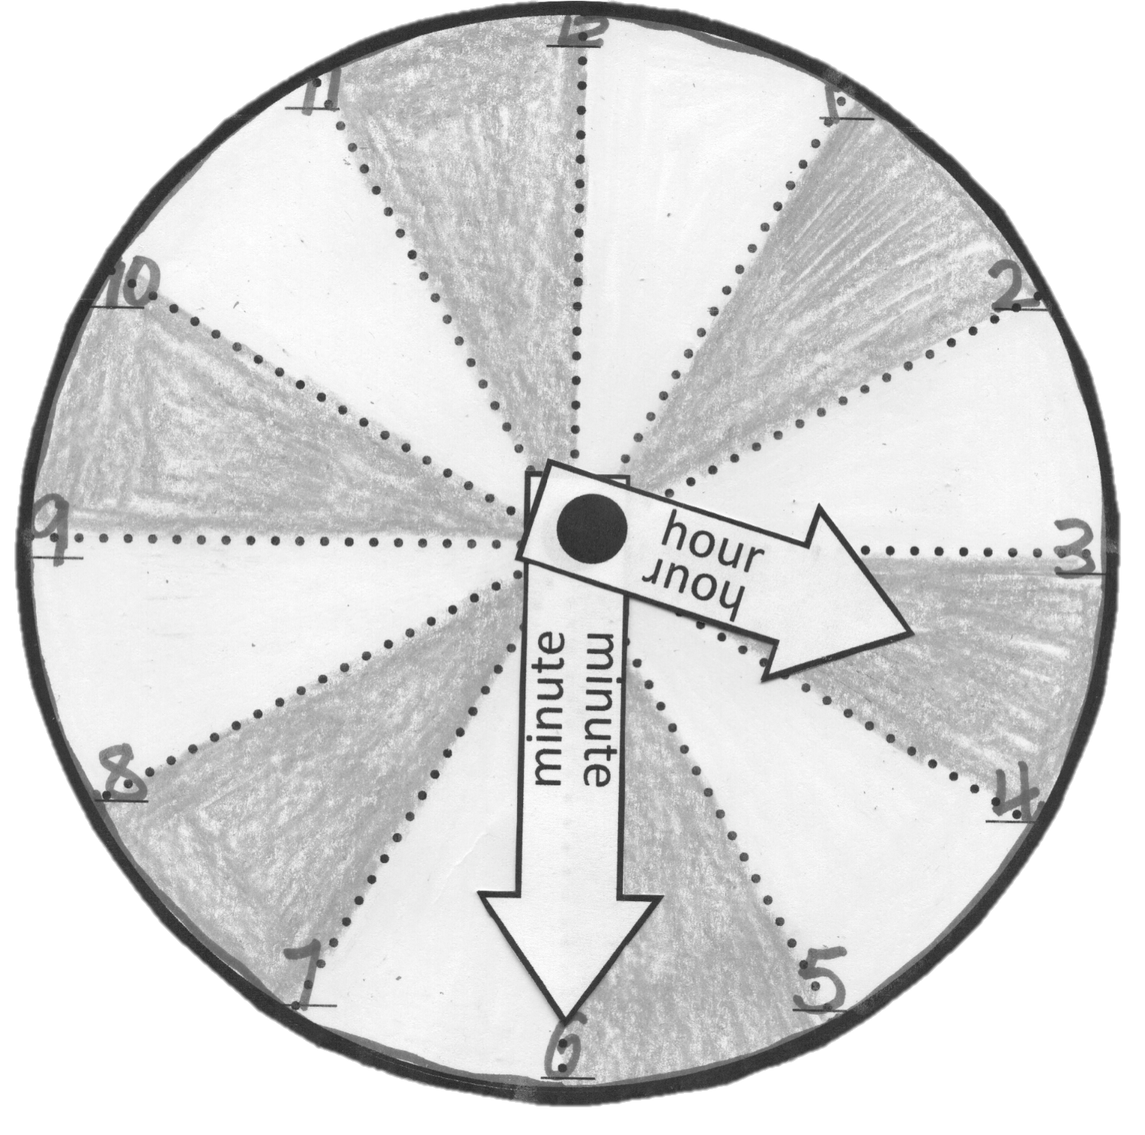

T: (Position the hour hand halfway between 3 and 4.)

T: Now, let’s think about the minute hand. It would go halfway around the circle. Think about our half circles. Where would we need to stop the minute hand so that it would have traveled across the shape of a half of the circle? Talk with a partner. (Provide students time to discuss.)

T: (Insert the clock into the personal white board. Starting at the 12, begin to color over each partition of the clock.) Tell me when I have colored half of the clock. Think about the shape of a half circle.

S: (When the 6 is reached…) STOP!

|  |  |
| --- | --- |
|  | NOTES ON  MULTIPLE MEANS  OF ENGAGEMENT: |

If most of the class has difficulty counting by fives, choose to use the hash marks on a commercial teacher clock or student clock, and count by ones to 30.

T: Which number is halfway around the clock?

S: The 6.

T: (Move the minute hand so that it points at the 6.) Yes, if the minute hand was halfway between one hour and another hour, it would be pointing at the 6. We call this time **half past** 3, because it is half an hour past 3 o’clock.

T: Let’s see how many minutes are in this half of the hour. We can count each minute, using the little marks

on the side of the clock, but it’ll be faster to count by groups of 5 minutes, like we do when we whisper count. There are 5 minutes from one number to the next number. (Point to the number 12 on the clock, and then sweep a finger to the number 1 on the clock.)

T: Think about the whisper counting we practiced during Fluency Practice. Count with me, and use your pencil to write the number of minutes next to each dot as we go. (Move a finger along the edge of the clock while counting.) 5…10…15…20…25…30. When the minute hand gets to halfway around and lands on the 6, it has been…?

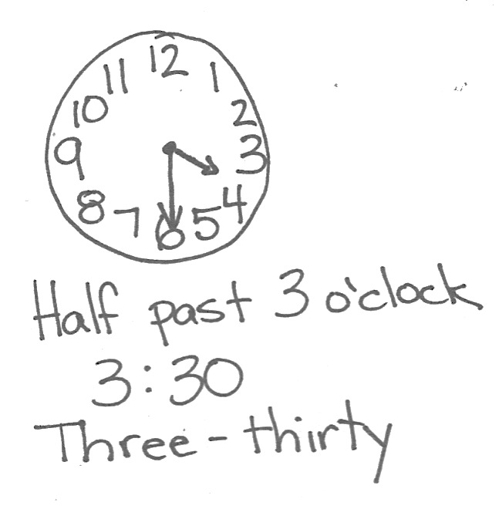S: 30 minutes!

T: Another way to say half past 3 is 3:30, because it’s 3 hours and 30 minutes since 12 o’clock, when we either started a new day, or when we started the afternoon. On a digital clock, half past 3 would look like this. (Write 3:30 on paper. Write *half past 3* next to it.)

T: What time is this? (Point to 3:30.)

S: 3:30.

T: What’s another way we can say that it’s 3:30?

S: Half past 3.

T: Look at our two clocks. One clock shows 3 o’clock. The other clock shows half past 3, or 3:30. Compare them. What do you notice?

S: The clock on 3 o’clock has its minute hand on 12, and the clock at 3:30 has its minute hand at 6. 🡪 The hour hand is pointing directly at 3 on the clock that shows 3 o’clock. The hour hand is pointing between 3 and 4 on the clock that shows 3:30.

Repeat the process of naming a time and having students create the time on their student clocks, and then writing the digital time on their personal white boards. Use the following suggested sequence:

* Half past 4

**MP.7**

* 10:30
* Half past 11
* Half past 12
* 6:30

Problem Set (10 minutes)

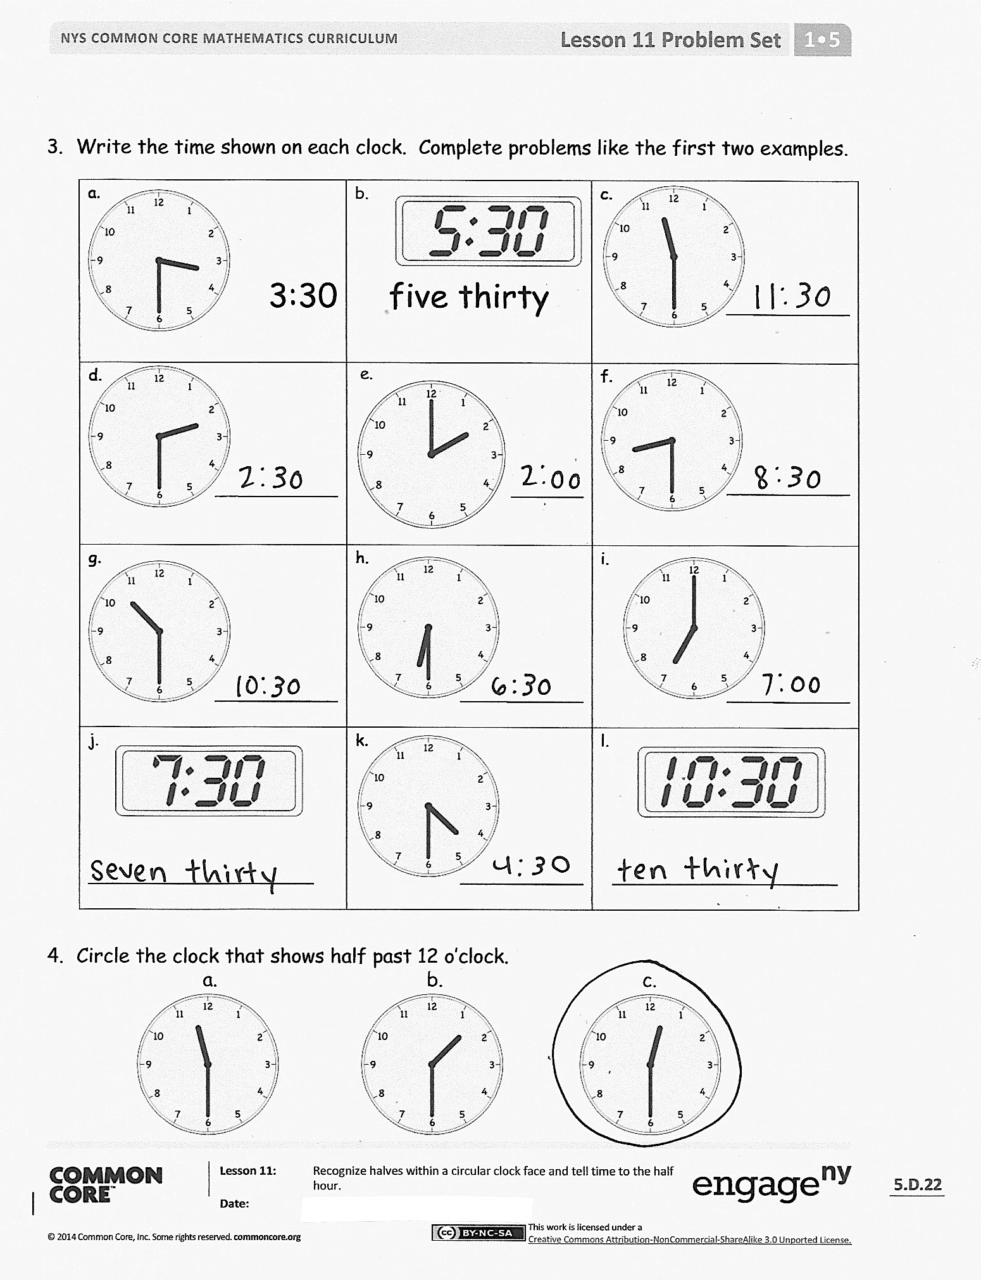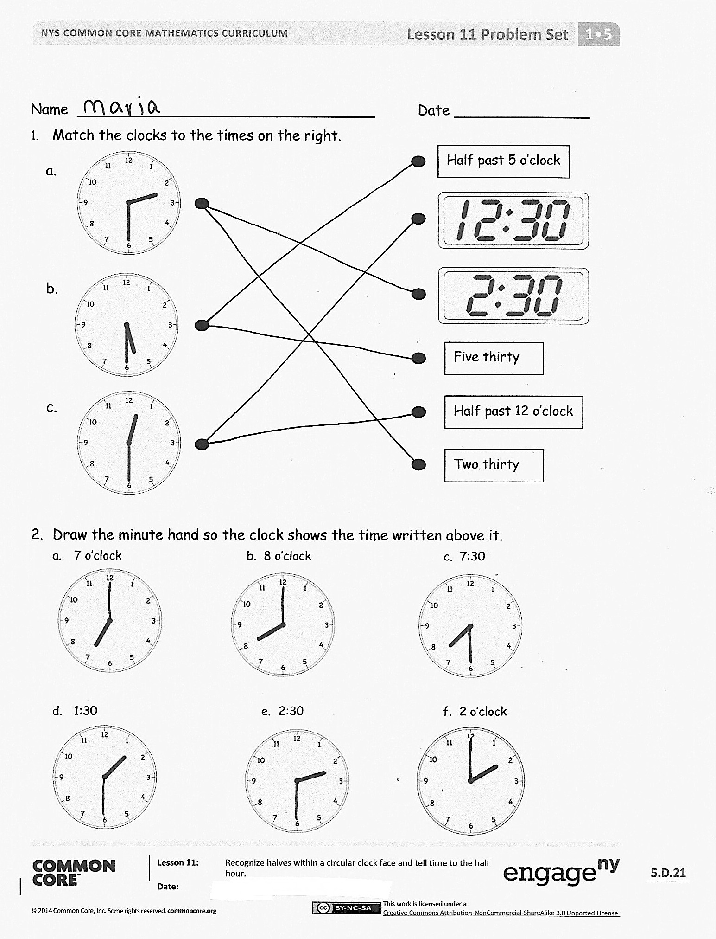

Students should do their personal best to complete the Problem Set within the allotted 10 minutes. For some classes, it may be appropriate to modify the assignment by specifying which problems they work on first.

Student Debrief (10 minutes)

**Lesson Objective:** Recognize halves within a circular clock face and tell time to the half hour.

The Student Debrief is intended to invite reflection and active processing of the total lesson experience.

Invite students to review their solutions for the Problem Set. They should check work by comparing answers with a partner before going over answers as a class. Look for misconceptions or misunderstandings that can be addressed in the Debrief. Guide students in a conversation to debrief the Problem Set and process the lesson.

Any combination of the questions below may be used to lead the discussion.

* Look at Problem 4. Which clock shows half past 12 o’clock? Explain your thinking. Remember to use *hour hand* and *minute hand* in your explanation.
* How many minutes are in half an hour? When it is **half past** seven, how many minutes have there been since 7 o’clock? (Extension: If there are 30 minutes in half an hour, how many minutes are in a whole hour?)
* (Write 7:30 on the board.) What are the two ways to say this time?
* When we go around a circle in this direction (motion in a clockwise path), we say we are going *clockwise.* How can knowing about how clocks work help us understand the direction of *clockwise?*
* Look at the Application Problem. What kinds of clocks do you have in your home? Compare the clocks in your home with Tamra’s clocks. Who has more clocks? How many more clocks does that person have?

Exit Ticket (3 minutes)

After the Student Debrief, instruct students to complete the Exit Ticket. A review of their work will help with assessing students’ understanding of the concepts that were presented in today’s lesson and planning more effectively for future lessons. The questions may be read aloud to the students.

Name Date

1. Match the clocks to the times on the right.

a.

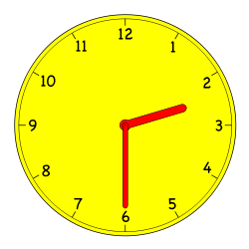

Half past 5 o’clock

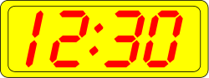

b.

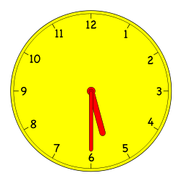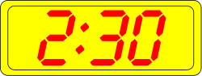

Five thirty

c.

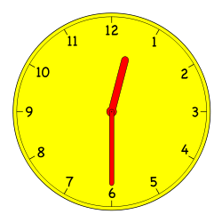

Half past 12 o’clock

Two thirty

1. Draw the minute hand so the clock shows the time written above it.
2. 7 o’clock b. 8 o’clock c. 7:30

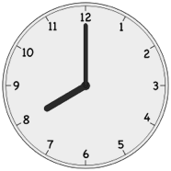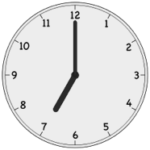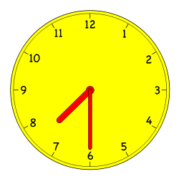

1. 1:30 e. 2:30 f. 2 o’clock

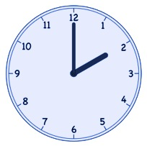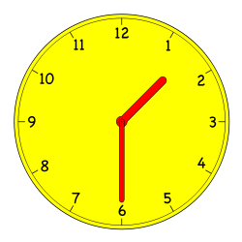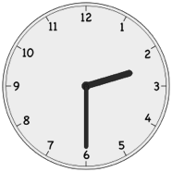

1. Write the time shown on each clock. Complete problems like the first two examples.

|  |  |  |
| --- | --- | --- |
| lock by manio1 - A collection analogue clocks showing every half hour. Suitable for education purposes.a.    3:30 | igital Clock by manio1 - A collection of digital clocks showing every half hour. Suitable for educational purposes.b.    five thirty  e. | lock by manio1 - A collection analogue clocks showing every half hour. Suitable for education purposes.c.    ____________ |
| d.  ____________ | Macintosh HD:Users:isinger50:Desktop:Screen Shot 2013-08-14 at 11.32.41 AM.png  ____________ | lock by manio1 - A collection analogue clocks showing every half hour. Suitable for education purposes.lock by manio1 - A collection analogue clocks showing every half hour. Suitable for education purposes.f.  ____________ |
| lock by manio1 - A collection analogue clocks showing every half hour. Suitable for education purposes.g.  ____________ | lock by manio1 - A collection analogue clocks showing every half hour. Suitable for education purposes.h.  ____________ | lock by manio1 - A collection analogue clocks showing every half hour. Suitable for education purposes.i.  ____________ |
| lock by manio1 - A collection analogue clocks showing every half hour. Suitable for education purposes.igital Clock by manio1 - A collection of digital clocks showing every half hour. Suitable for educational purposes.j.  ______________________ | k.  ____________ | igital Clock by manio1 - A collection of digital clocks showing every half hour. Suitable for educational purposes.l.  ______________________ |

1. 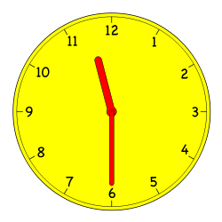Circle the clock that shows half past 12 o’clock.

b.

c.

a.

Name Date

Draw the minute hand so the clock shows the time written above it.

1. 2.

3:30

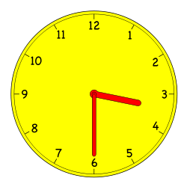

9:30

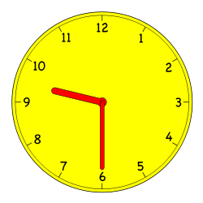

1. Write the correct time on the line.

________________

Name Date

Circle the correct clock.

1. ****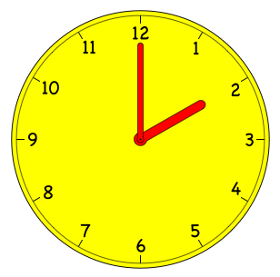Half past 2 o’clock.

b.

b.

b.

c.

a.

1. Half past 10 o’clock.

a.

c.

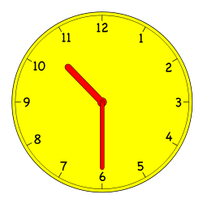

1. 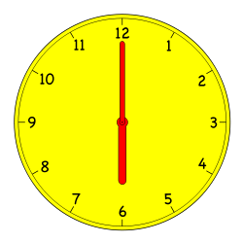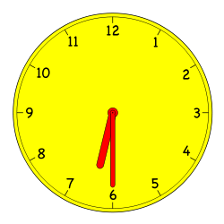6 o’clock.

a.

c.

1. 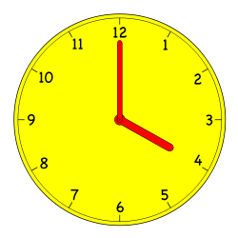Half past 8 o’clock.

c.

b.

a.

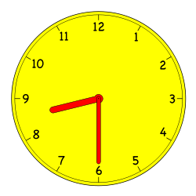

Write the time shown on each clock to tell about Lee’s day.

|  |  |
| --- | --- |
| lock by manio1 - A collection analogue clocks showing every half hour. Suitable for education purposes.5.  Lee wakes up at ___________. | lock by manio1 - A collection analogue clocks showing every half hour. Suitable for education purposes.6.  He takes the bus to school at ________. |
| lock by manio1 - A collection analogue clocks showing every half hour. Suitable for education purposes.7.  He has math at ___________.  lock by manio1 - A collection analogue clocks showing every half hour. Suitable for education purposes. | lock by manio1 - A collection analogue clocks showing every half hour. Suitable for education purposes.8.  lock by manio1 - A collection analogue clocks showing every half hour. Suitable for education purposes.He eats lunch at ___________. |
| 9.  He has basketball practice at ________. | 10.  He does his homework at ___________. |
| lock by manio1 - A collection analogue clocks showing every half hour. Suitable for education purposes.11.  He eats dinner at ___________. | lock by manio1 - A collection analogue clocks showing every half hour. Suitable for education purposes.12.  He goes to bed at ___________. |

hour

hour

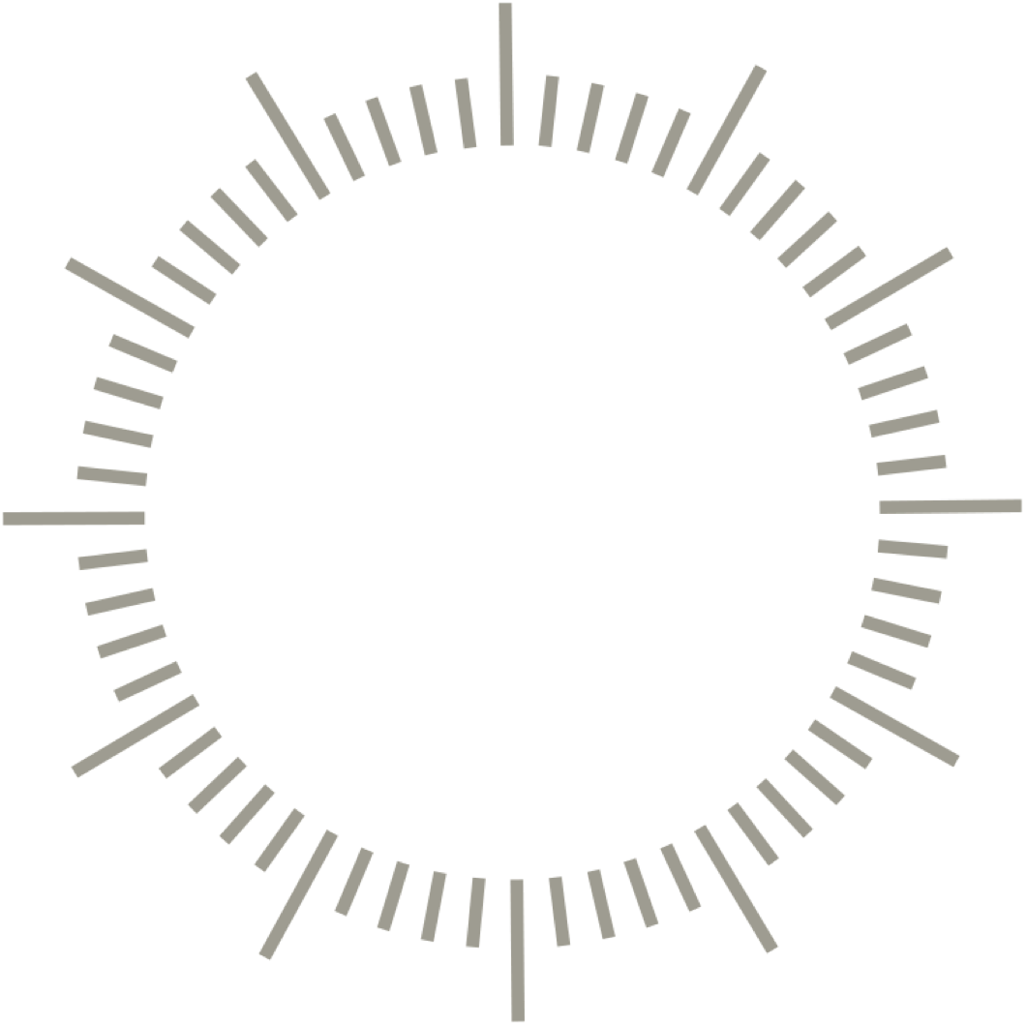

[1]

minute

minute

1. additional paper clock with numbers