Lesson 10
Objective: Construct a paper clock by partitioning a circle and tell time to the hour.

Suggested Lesson Structure
 Fluency Practice (10 minutes)
 Application Problem (5 minutes)
 Concept Development (38 minutes)
 Student Debrief (7 minutes)
Total Time (60 minutes)
Fluency Practice (10 minutes)
- Grade 1 Core Fluency Sprint 1.OA.6 (10 minutes)
Grade 1 Core Fluency Sprint (10 minutes)
Materials: (S) Core Fluency Sprint (Lesson 1 Core Fluency Sprint)
Note: Based on the needs of the class, select a Sprint from Lesson 1. Consider the following options:
- Re-administer the previous lesson’s Sprint.
- Administer the next Sprint in the sequence.
- Differentiate. Administer two different Sprints. Simply have one group do a counting activity on the back of the Sprint, while the other group corrects the second Sprint.
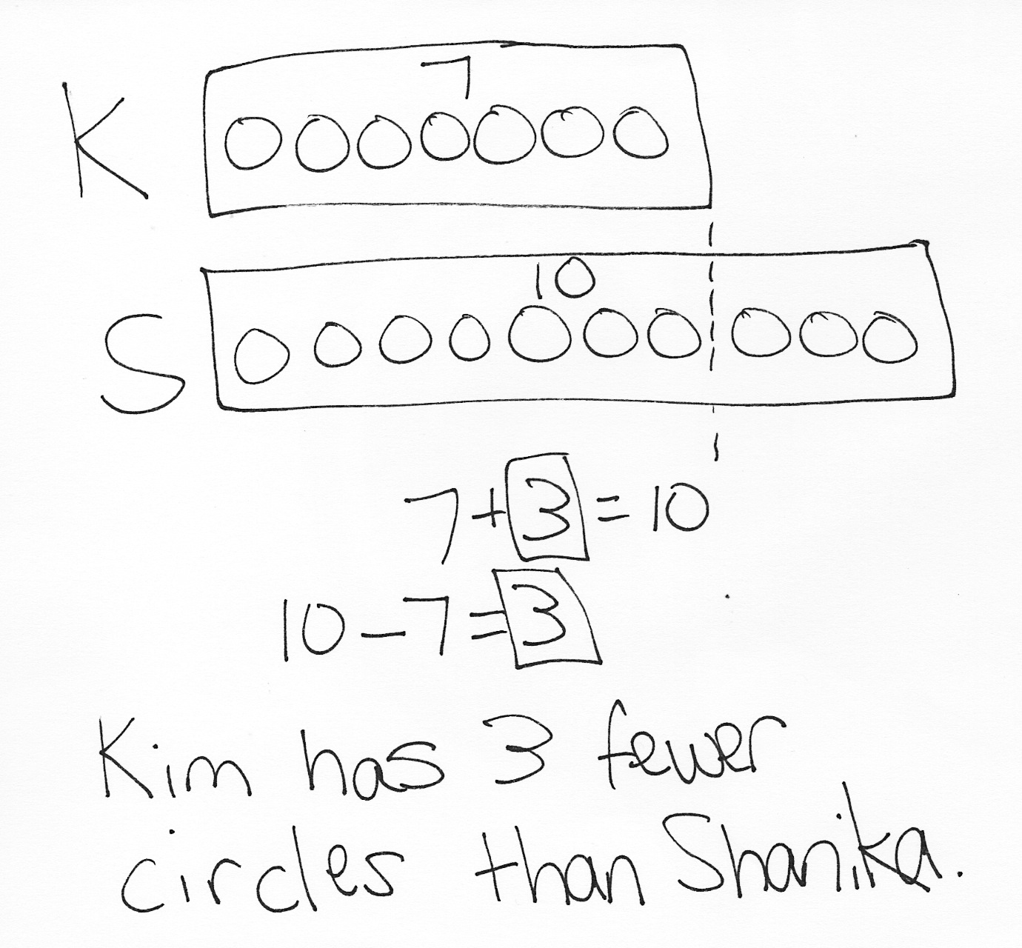
Application Problem (5 minutes)
Kim drew 7 circles. Shanika drew 10 circles. How many fewer circles did Kim draw than Shanika?
Note: Students continue to practice the compare with difference unknown problem type in today’s problem. Children who struggle with this problem type will benefit from seeing and hearing their peers’ solution strategies. After students describe their solutions, let the class know this is a compare problem. Invite students to share why, explaining what is being compared. Module 6 begins with direct instruction on these types of problems. Keep note of which types of problems students are struggling with, as well as which problems they solve successfully. This can assist in targeting instruction at the start of the next module. Circles were chosen as the context for the problem because of their connection to today’s Concept Development.
Concept Development (38 minutes)
Materials: (T) Partitioned circle (Template 1), digital clock (Template 2) (S) Partitioned circle (Template 1) printed on cardstock, scissors, pencil, yellow crayon, orange crayon, brad fastener, personal white board

NOTES ON
MULTIPLE MEANS
OF ENGAGEMENT:
Students who struggle with fine-motor cutting skills would benefit from using a pre-cut circle. Have some ready for these students to use during the lesson.
Note: Before the lesson, cut off the bottom section of the partitioned circle templates so that clock hands can be distributed later in the lesson. (Precut the teacher’s set of clock pieces for ease of use during the lesson.)
Distribute the top section of the partitioned circle template, along with pencils and scissors, to students seated at desks or tables.
T: What shape is on this paper?
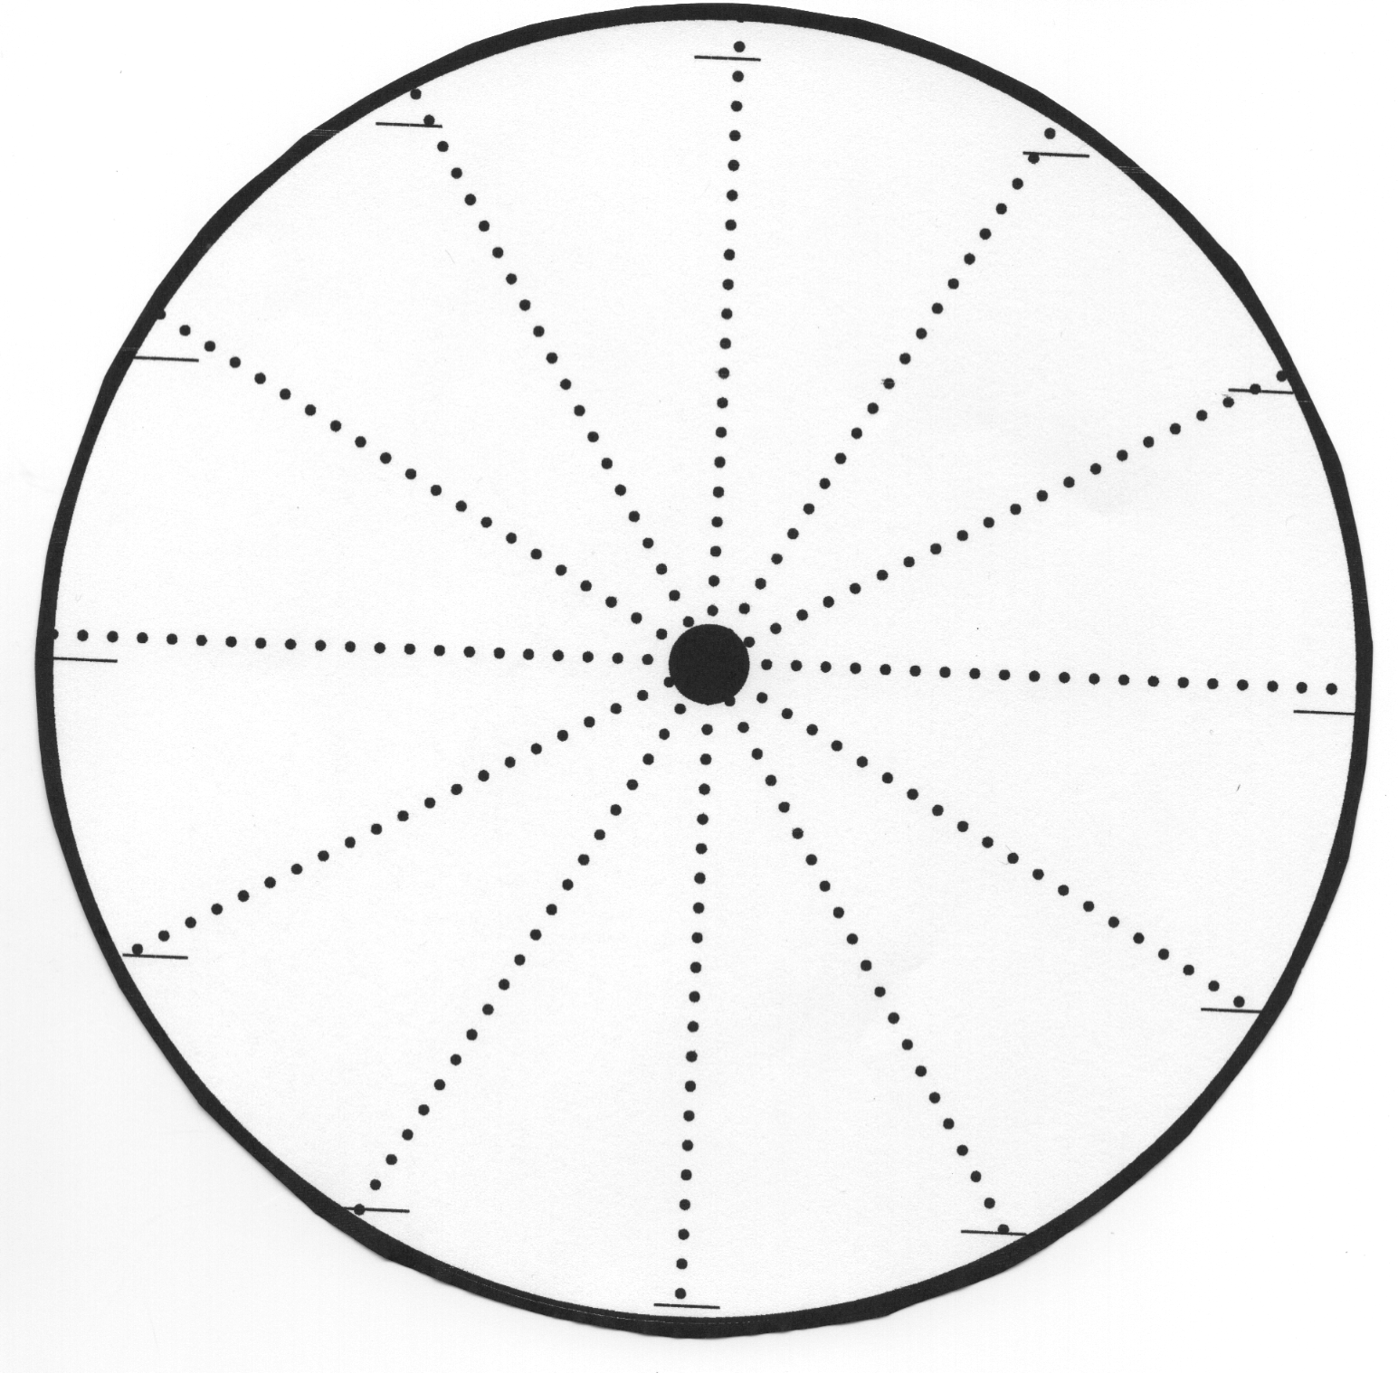
S: A circle!
T: Cut out the circle. Use careful eyes and careful fingers, because we will be using this circle for the next three days. Only cut the dark, bold line that forms the circle. (Hold up circle as a demonstration.)
S: (Cut out the circle.)
T: What do you notice about the dotted lines on the circle?
S: The lines start in the middle and go out to the edge. There are 12 of them. No, there are 6, and they all go through the dot in the middle. They all look equal. The spaces between the lines are about the same size.
Onnnnne!
T: (Put the circle under the document camera.) Let’s look at the spaces between the lines. Are the parts equal, or are all of the parts different sizes?
S: The parts are all equal.
T: Let’s count the parts. Let’s use our finger to trace the edge as we count. We’ll stretch out the counting numbers as we trace the part. When we get to the next piece, we stop and get ready to say the next number. Let me show you.
T: (Trace the edge of the circle under the document camera as the students do the same at their seats, while in unison counting the pieces: Ooooonnnnnne! Twooooooo! Etc.)
S/T: (Repeat together on students’ clocks.)
T: How many equal parts do we have?
S: 12 parts!
T: We’re going to color in each of the parts, but first, let’s use our pencil to trace the edge. We’ll trace the edge with brown, and just as we get to the end of the part, or section, we’ll put in the number. Watch me. (Start at the edge of the circle, at one dotted line, and trace the edge with the brown colored pencil until reaching the next line. Then, write 1 just before the line, as shown in the image down and to the right. While drawing the line, stretch out saying the word one, “Oooooonnnnnne!”) Now, you draw a brown line on the edge of your first section, or part, and when you finish saying, “Ooonnne!,” write 1 just before the next line. (Point to the sample under the document camera.)

NOTES ON
MULTIPLE MEANS
OF ENGAGEMENT:
Students may have some difficulty writing the numbers correctly on their clocks. For students who are likely to turn the circle as they write, tape the circle to their desks.
S: (Trace the edge, and number each line as shown. Then, touch and count the parts once more after the numbers are labeled.)
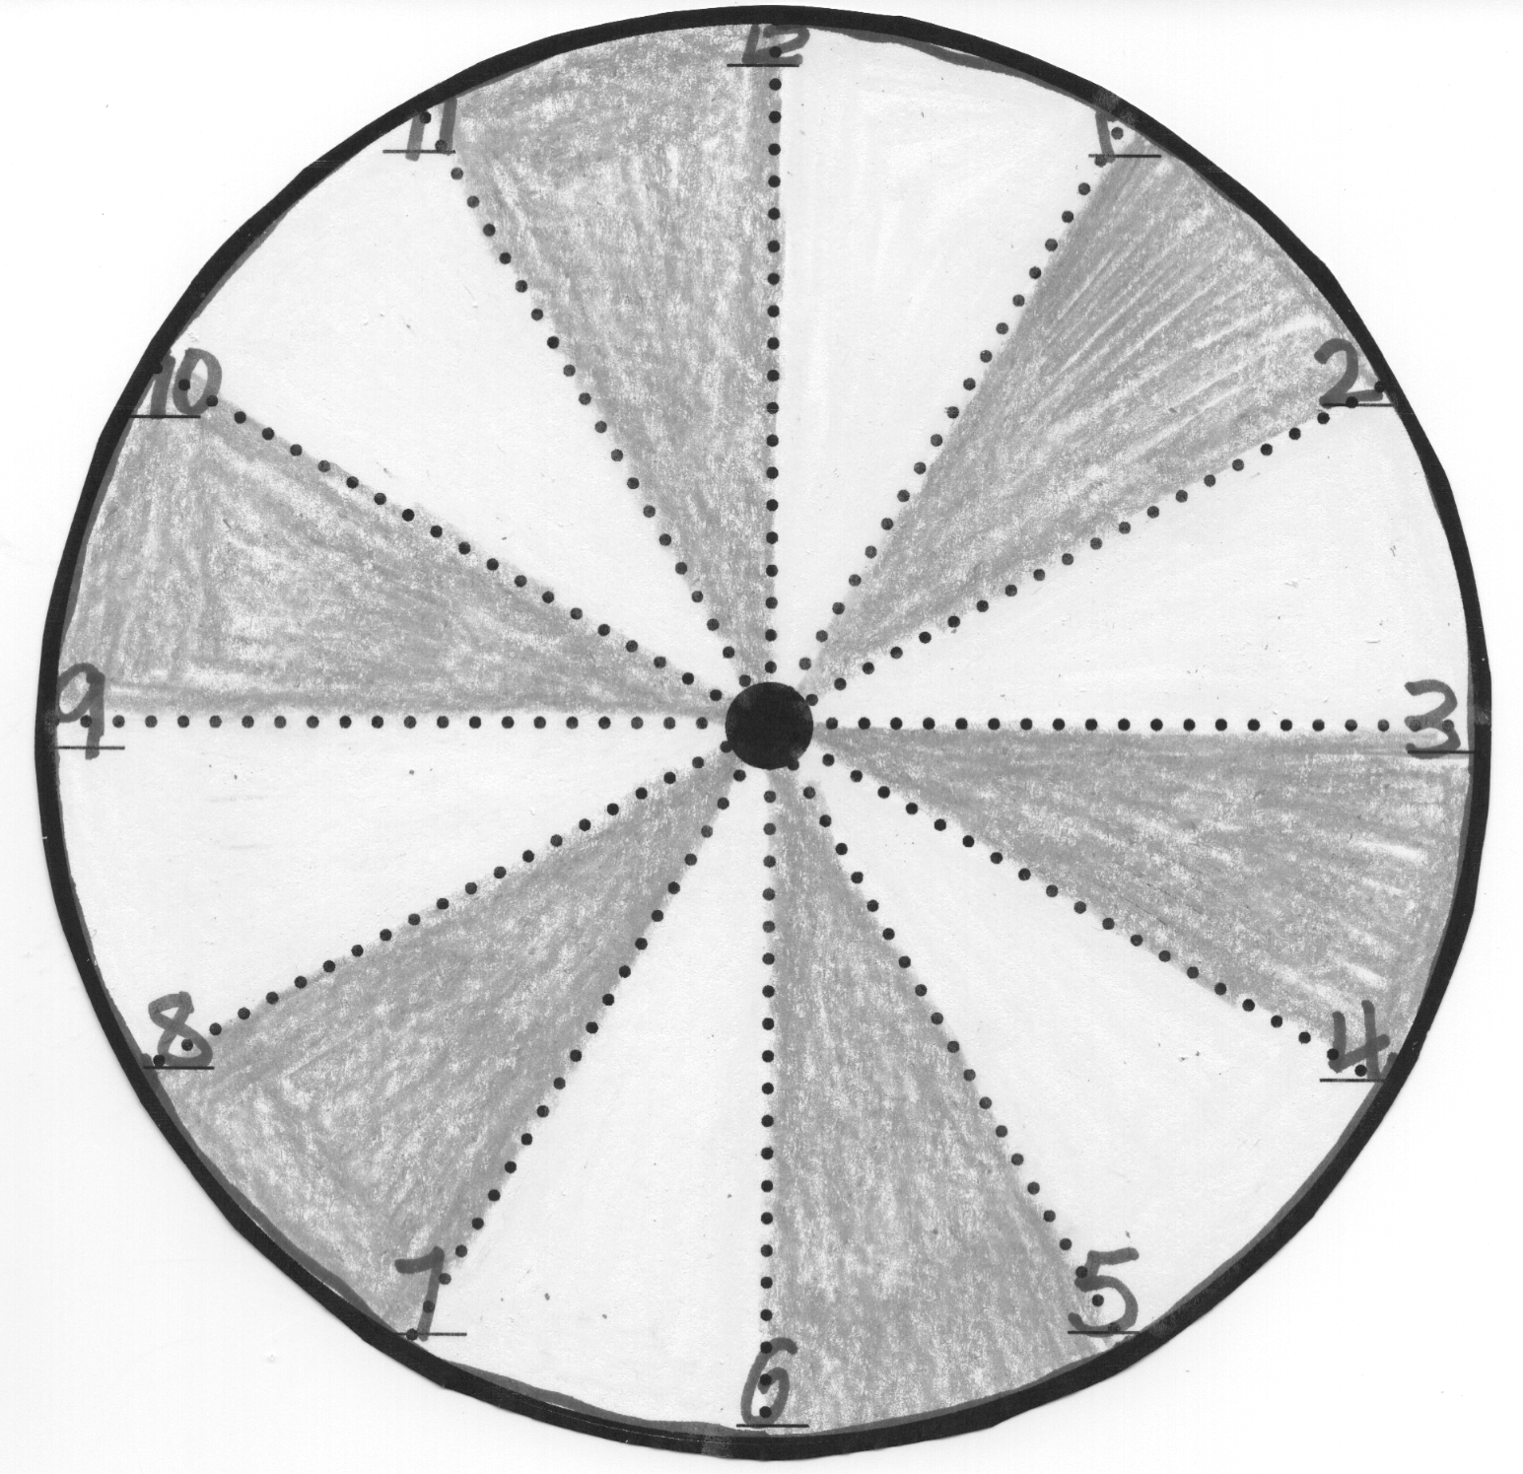
T: Does this look like something you have seen before? Perhaps something we have in our classroom?
S: A clock!
T: Yes, we are making a clock!
T: How many equal parts are labeled on a clock?
S: 12 parts!
T: Let’s color in the 12 parts so we can see them more easily. Alternate between yellow and orange, so each part stands out. Watch as I start the first one. (Color the section between 12 and 1 in yellow, as represented to the right by the lighter shaded section. Then, color the section between 1 and 2 in orange, as represented by the darker shaded section.)
S: (Color sections.)
T: Look at the clock in our classroom. What else does it have that we will need to add to our clocks?
S: Those black things. There’s a red one, too.
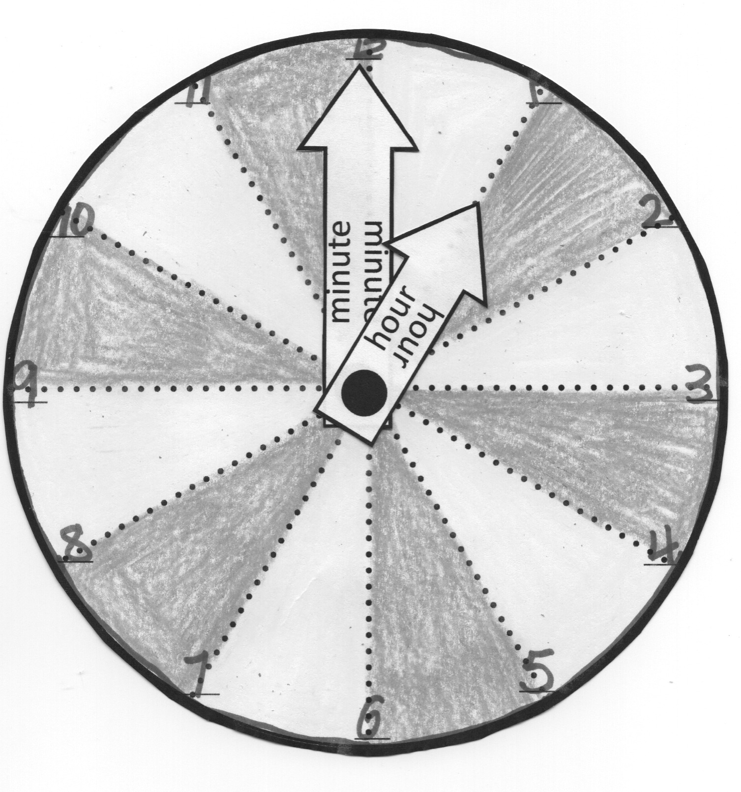
T: Those are called clock hands. The red hand is called a second hand, but we are only going to add the black hands for now. The short one is called the hour hand, and the longer hand is called the minute hand.
T: (Show the paper hands to the class.) You will cut out your hour hand and minute hand, and push a brad fastener through the dots in each of the three pieces, so that the hands are attached to the clock. (Demonstrate, and then distribute the paper clock hands.)
S: (Complete the process of making the paper clocks. Position both clock hands pointing toward the 12.)
T: (Show clock.) This is 12 o’clock. At midnight, or 12 o’clock, every night, we begin a new day.
T: As each minute goes by, both hands of the clock move. When the minute hand gets back to the top, and the hour hand reaches the next number, it means we just completed a full hour. (Position the clock hands so that they are set at 1:00.) We can look at the hour hand to tell us which hour we have completed in the new day. This clock’s hour hand is now at…?
S: 1.
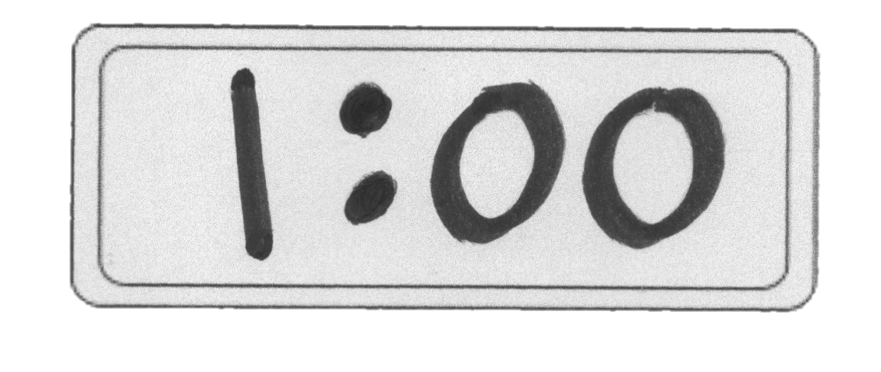
T: When we get through a full hour, but no extra minutes have passed, we say “o’clock” at the end. What time does this clock read?
S: 1 o’clock!
T: (Show 1:00 using the digital clock template under the document camera.) This is how we see 1 o’clock on a digital clock, the kind of electronic clock you see on a microwave, an oven, a cell phone, or a computer. We see the hour first (point to the 1). No extra minutes have passed (point to the zeros).
T: (Position the clock hands so that they are set to 3:00.) What time is this?
S: 3 o’clock!
T: (Show 3:00 using the digital clock template under the document camera.) Three (point to the 3 on the digital clock) o’clock (point to the two zeros).
T: Move the hands of your clock so that it says 11 o’clock. (Wait as students adjust clock hands.)
T: Which hand did you move? The hour hand or the minute hand?
S: The hour hand.
T: To what number is the hour hand pointing?
S: 11.
T: To what number is the minute hand still pointing?
S: 12.
T: Great job! What do you think the digital clock looks like when it reads 11 o’clock?
S: 11, 0, 0.
T: (Show 11:00, using the digital clock template under the document camera.) That’s correct!
T: With your partner, choose a time to make on your paper clock by moving just your hour hand. Then, on your personal white board, write the same time the way you would see it on a digital clock.
As students work with a partner, circulate and support student understanding as needed.
Note: The clocks can be collected and redistributed each day during Topic D lessons. Another clock face with numbers already included will be provided in Lesson 11 for any students who need a new clock for the upcoming lessons. Alternatively, commercially produced student clocks may be used for Lessons 11─13.
Problem Set (10 minutes)
Students should do their personal best to complete the Problem Set within the allotted 10 minutes. For some classes, it may be appropriate to modify the assignment by specifying which problems they work on first.

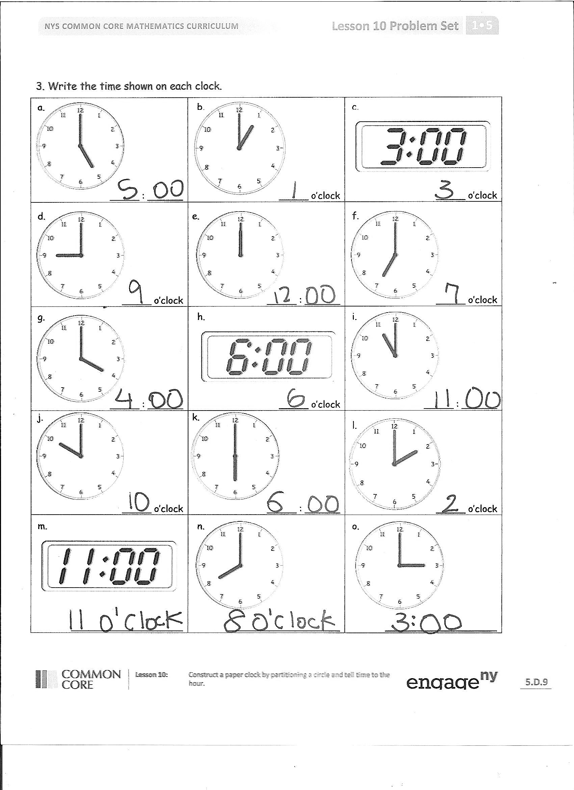
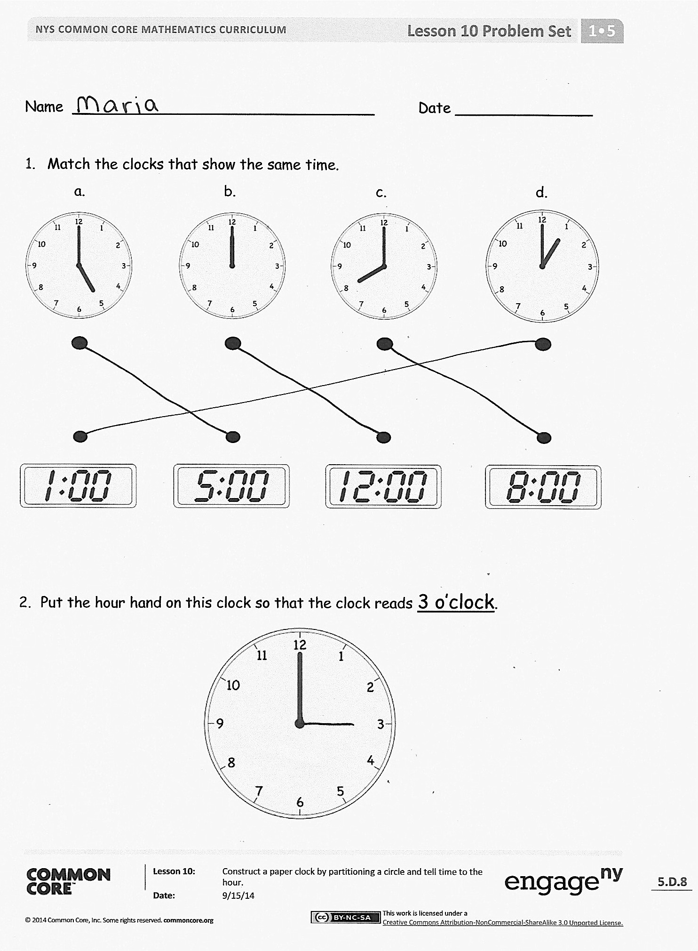
Student Debrief (7 minutes)
Lesson Objective: Construct a paper clock by partitioning a circle and tell time to the hour.
The Student Debrief is intended to invite reflection and active processing of the total lesson experience.
Invite students to review their solutions for the Problem Set. They should check work by comparing answers with a partner before going over answers as a class. Look for misconceptions or misunderstandings that can be addressed in the Debrief. Guide students in a conversation to debrief the Problem Set and process the lesson.
Any combination of the questions below may be used to lead the discussion.
- Look at Problem 2. Where did you put the hour hand to show 3 o’clock? Is the placement of the hour hand just before, just after, or straight toward the 3? How does your hour hand look different from the minute hand?
- Look at Problem 3. Which times were the easiest for you to read? Why? Which time was the trickiest for you to read? What was tricky about it?
- What is the same about all of the times on your Problem Set? When a new hour has started, and no new minutes have passed since the hour started, which number will the minute hand be pointing toward?
- Besides our classroom, where else have you seen a clock, including a digital clock?
- Name the parts of the clock we learned about today. (Hour hand, minute hand.)
- What is your favorite fluency activity and why? How does that activity help you?
Exit Ticket (3 minutes)
After the Student Debrief, instruct students to complete the Exit Ticket. A review of their work will help with assessing students’ understanding of the concepts that were presented in today’s lesson and planning more effectively for future lessons. The questions may be read aloud to the students.
Name Date
- Match the clocks that show the same time.
a.
d.
c.
b.
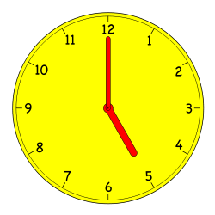
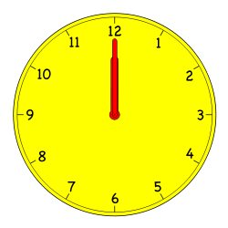
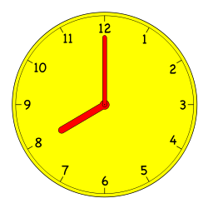
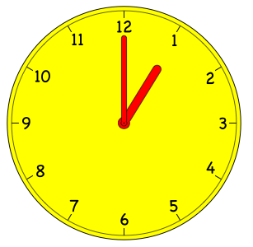

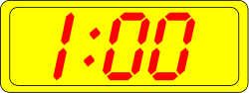
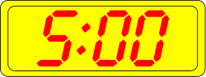
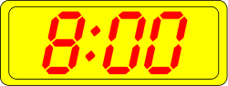
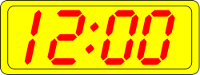
- Put the hour hand on this clock so that the clock reads 3 o’clock.
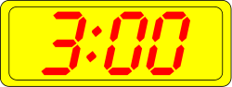
- Write the time shown on each clock.
a.
c.
b.
_____ : ______ | _____ o’clock | _____ o’clock
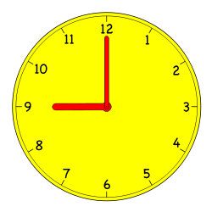  d.  e.  _____ o’clock | _____ : ______ | 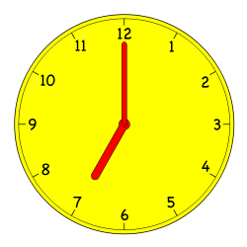  f.  _____ o’clock
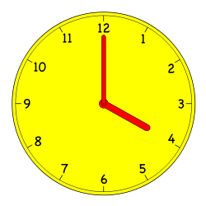  g.  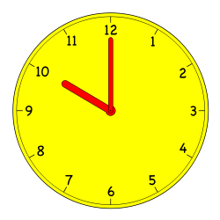  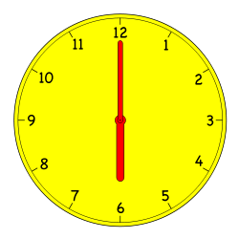  _____ : ______  j.  k. | 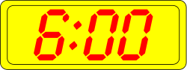  h.  _____ o’clock | 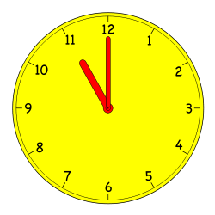  i.  _____ : ______
_____ o’clock | _____ : ______ | 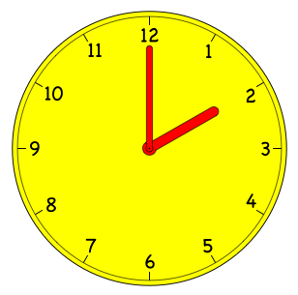  l.  _____ o’clock
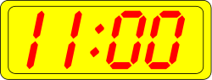  m.  ___________________ | n.  ___________________ | 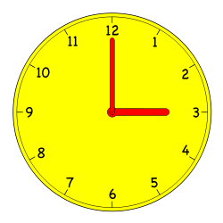  o.  ___________________

Name Date
Write the time shown on each clock.
1.  _________________ | 2.  _________________
3.  _________________ | 4.  ________________

Name Date
- Match each clock to the time it shows.
a.
b.
c.
d.
e.
f.
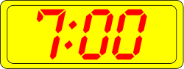
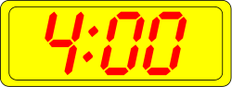
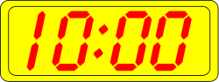
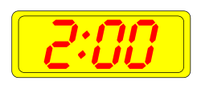
11 o’clock
7 o’clock
4 o’clock
10 o’clock
3 o’clock
2 o’clock

- Put the hour hand on the clock so that the clock matches the time. Then, write the time on the line.
a.
6 o’clock
________________

e.
1 o’clock
d.
7 o’clock
c.
12 o’clock
b.
9 o’clock
________________
________________
________________
________________
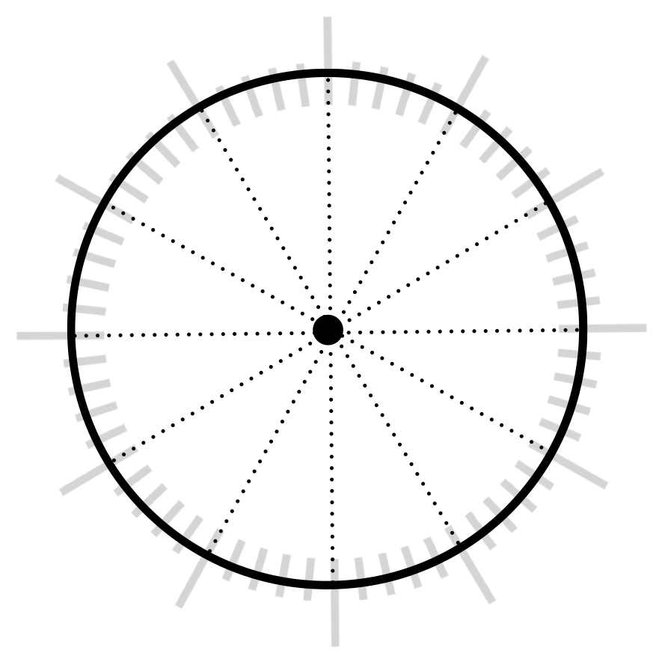
_______
_______
_______
_______
_______
_______
_______
_______
_______
_______
_______
_______

hour
hour
minute
minute

partitioned circle
digital clock

