Lesson 9
Objective: Partition shapes and identify halves and quarters of circles and rectangles.

Suggested Lesson Structure
 Fluency Practice (15 minutes)
 Application Problem (5 minutes)
 Concept Development (30 minutes)
 Student Debrief (10 minutes)
Total Time (60 minutes)
Fluency Practice (15 minutes)
- Grade 1 Core Fluency Sprint 1.OA.6 (10 minutes)
- Make It Equal: Addition Expressions 1.OA.6 (5 minutes)
Grade 1 Core Fluency Sprint (10 minutes)
Materials: (S) Core Fluency Sprint (Lesson 1 Core Fluency Sprint)
Note: When choosing a counting sequence to practice between Sides A and B, consider having students whisper count by fives to 30 and back. Although counting by fives is not a Grade 1 standard, in Lesson 11 students will be adding 5 minutes until they reach 30 minutes to build an understanding of half past the hour.
Choose an appropriate Sprint, based on the needs of the class. If the majority of students completed the first three quadrants on the previous Sprint, move to the next Sprint listed in the sequence provided below (Core Fluency Sprint List). If many students are not making it to the third quadrant, consider repeating the same Sprint. As students work, pay attention to their strategies and the number of problems they answer to consider for future Sprint administration.
Core Fluency Sprint List:
- Core Addition Sprint 1 (Targets core addition and missing addends.)
- Core Addition Sprint 2 (Targets the most challenging addition within 10.)
- Core Subtraction Sprint (Targets core subtraction.)
- Core Fluency Sprint: Totals of 5, 6, and 7 (Develops understanding of the relationship between addition and subtraction.)
- Core Fluency Sprint: Totals of 8, 9, and 10 (Develops understanding of the relationship between addition and subtraction.)
Make It Equal: Addition Expressions (5 minutes)
Materials: (S) Numeral cards (Lesson 1 Fluency Template), one =card, two + cards
Note: This activity builds fluency with Grade 1’s core addition facts and promotes an understanding of equality. The suggested sets move from simple to complex so students can progress through them at their own rate.
Assign students partners of equal ability. Students arrange numeral cards from 0 to 10, including the extra 5. Place the = card between partners. Write or project the suggested sets. Partners take the numeral cards that match the numbers written to make two equivalent expressions (e.g., 10 + 0 = 5 + 5).
Suggested sets: a) 10, 0, 5, 5 b) 9, 8, 2, 1 c) 3, 6, 4, 7 d) 1, 2, 6, 5
e) 1, 2, 5, 4 f) 3, 5, 4, 2 g) 2, 3, 5, 6 h) 3, 4, 5, 6
i) 4, 5, 9, 10 j) 9, 3, 2, 8 k) 8, 5, 9, 4 l) 5, 6, 8, 7
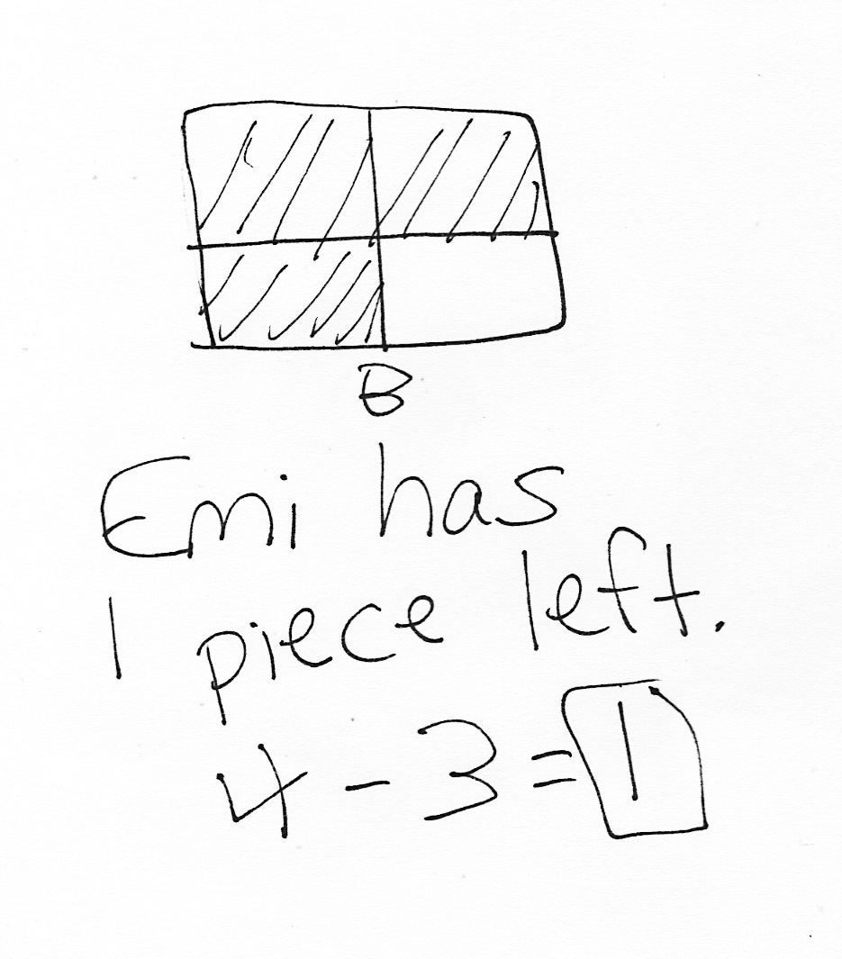
Application Problem (5 minutes)
Emi cut a square brownie into fourths. Draw a picture of the brownie. Emi gave away 3 parts of the brownie. How many pieces does she have left?
Extension: What part, or fraction, of the whole brownie is left?
Note: Today’s Application Problem provides students with the opportunity to apply the terminology of fourths. Students solve the relatively familiar take away with result unknown problem type using fractions as a type of unit.
Concept Development (30 minutes)
Materials: (T) Chart paper, 2 pieces of blank paper of the same size (preferably different colors), document camera (S) Pairs of shapes (Template), personal white board
Gather students in the meeting area with the pairs of shapes template inserted into their personal white boards.

NOTES ON
MULTIPLE MEANS
OF ENGAGEMENT:
For kinesthetic learners, it may be beneficial to provide two pieces of blank paper to student partners and have the students cut one fourth from one paper and one half from another paper along with the teacher.
T: Partner A, draw one line to cut your pizza into halves.
T: Partner B, draw two lines to cut your pizza into quarters.
T: Who has more slices?
S: Partner B has more slices. Partner B has four slices; Partner A only has two slices.
T: Partner A, color one slice of your pizza. Show me your slice.
T: Partner B, color one slice of your pizza. Show me your slice.
T: Partners, put your half and your quarter next to each other.
T: Point to the piece of pizza that is larger. Whose piece is larger?
S: Partner A’s.
T: Now, look at your whole pizza. Who has a larger number of slices?
S: Partner B has more slices. Partner B has four slices of pizza. Partner A only has two slices of pizza.
T: Do you want one half of a yummy pizza or one quarter of a yummy pizza? Discuss this with your partner. Explain your choice. (Listen as students share their thinking, and then repeat the question before having students answer.)
S: I want one half of the pizza because a half is larger than one quarter of the pizza. To get one quarter of the pizza, you have to cut the two halves of the pizza in half again. That’s a lot smaller. I would want one half of the pizza. You need two quarters of the pizza to have the same amount as one half of the pizza.
Draw two circles of equal size on the board. Invite a student volunteer to draw a line to cut the first circle into two halves. Ask the student to color in one half. Label as one half of the circle. Repeat the process with the other circle, coloring in and labeling one fourth of the circle.
T: Let’s try that with the rectangles and see if that’s still true. This time, I’ll use paper to actually cut and compare. Which will be larger, one half of this piece of paper or one fourth of the paper? Talk with your partner, and explain your thinking. (Listen as students share their thinking.)
T: I’m going to fold the paper first to be sure I’m cutting equal parts. (Fold and cut the paper into halves. Ask a student volunteer to hold one half.)
T: How much of the paper is he holding?

NOTES ON
MULTIPLE MEANS
OF REPRESENTATION:
To support students’ vocabulary development, write one fourth of paper on each of the four equal pieces of paper and one half of paper on each of the two equal pieces of paper. These can be posted in the room as a reference, helping students visualize the concept as well as the relationship between concepts.
S: One half of the paper!
T: Let’s cut this same-size piece of paper into four equal parts now, so we can compare one fourth, or one quarter of the paper with one half of the paper. This time, I’m going to fold the paper in half and then in half again to make four equal parts. (Fold and cut paper into fourths.)
T: Are all of my parts equal?
S: Yes!
T: How much of the paper is each piece?
S: One fourth of the paper! (Or, one quarter of the paper.)
T: (Ask a student volunteer to hold one fourth next to the student who is holding one half.) Which piece is larger, or greater, one half of the paper or one fourth of the paper?
S: One half of the paper!
T: How many pieces did we make when we cut the paper into halves?
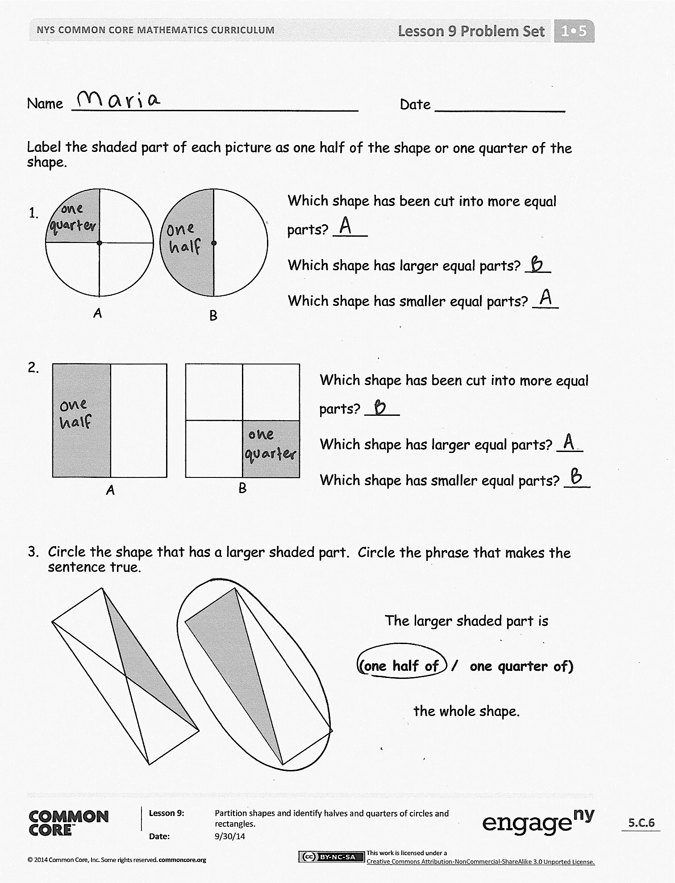
S: Two pieces.
T: How many pieces did we make when we cut the paper into quarters?
S: Four pieces.
T: So, when we cut the paper into two pieces to make halves, our pieces were this size. (Hold up halves.)
T: What happened to the size of our pieces when we cut the same size paper into four pieces to make quarters?
S: The parts became smaller.
T: Why are the pieces smaller now? Talk to your partner.
S: We cut the paper into more pieces. We have more parts, but each part is smaller. The piece of paper is the same size, so if you cut it up into more equal parts, the parts will be smaller.
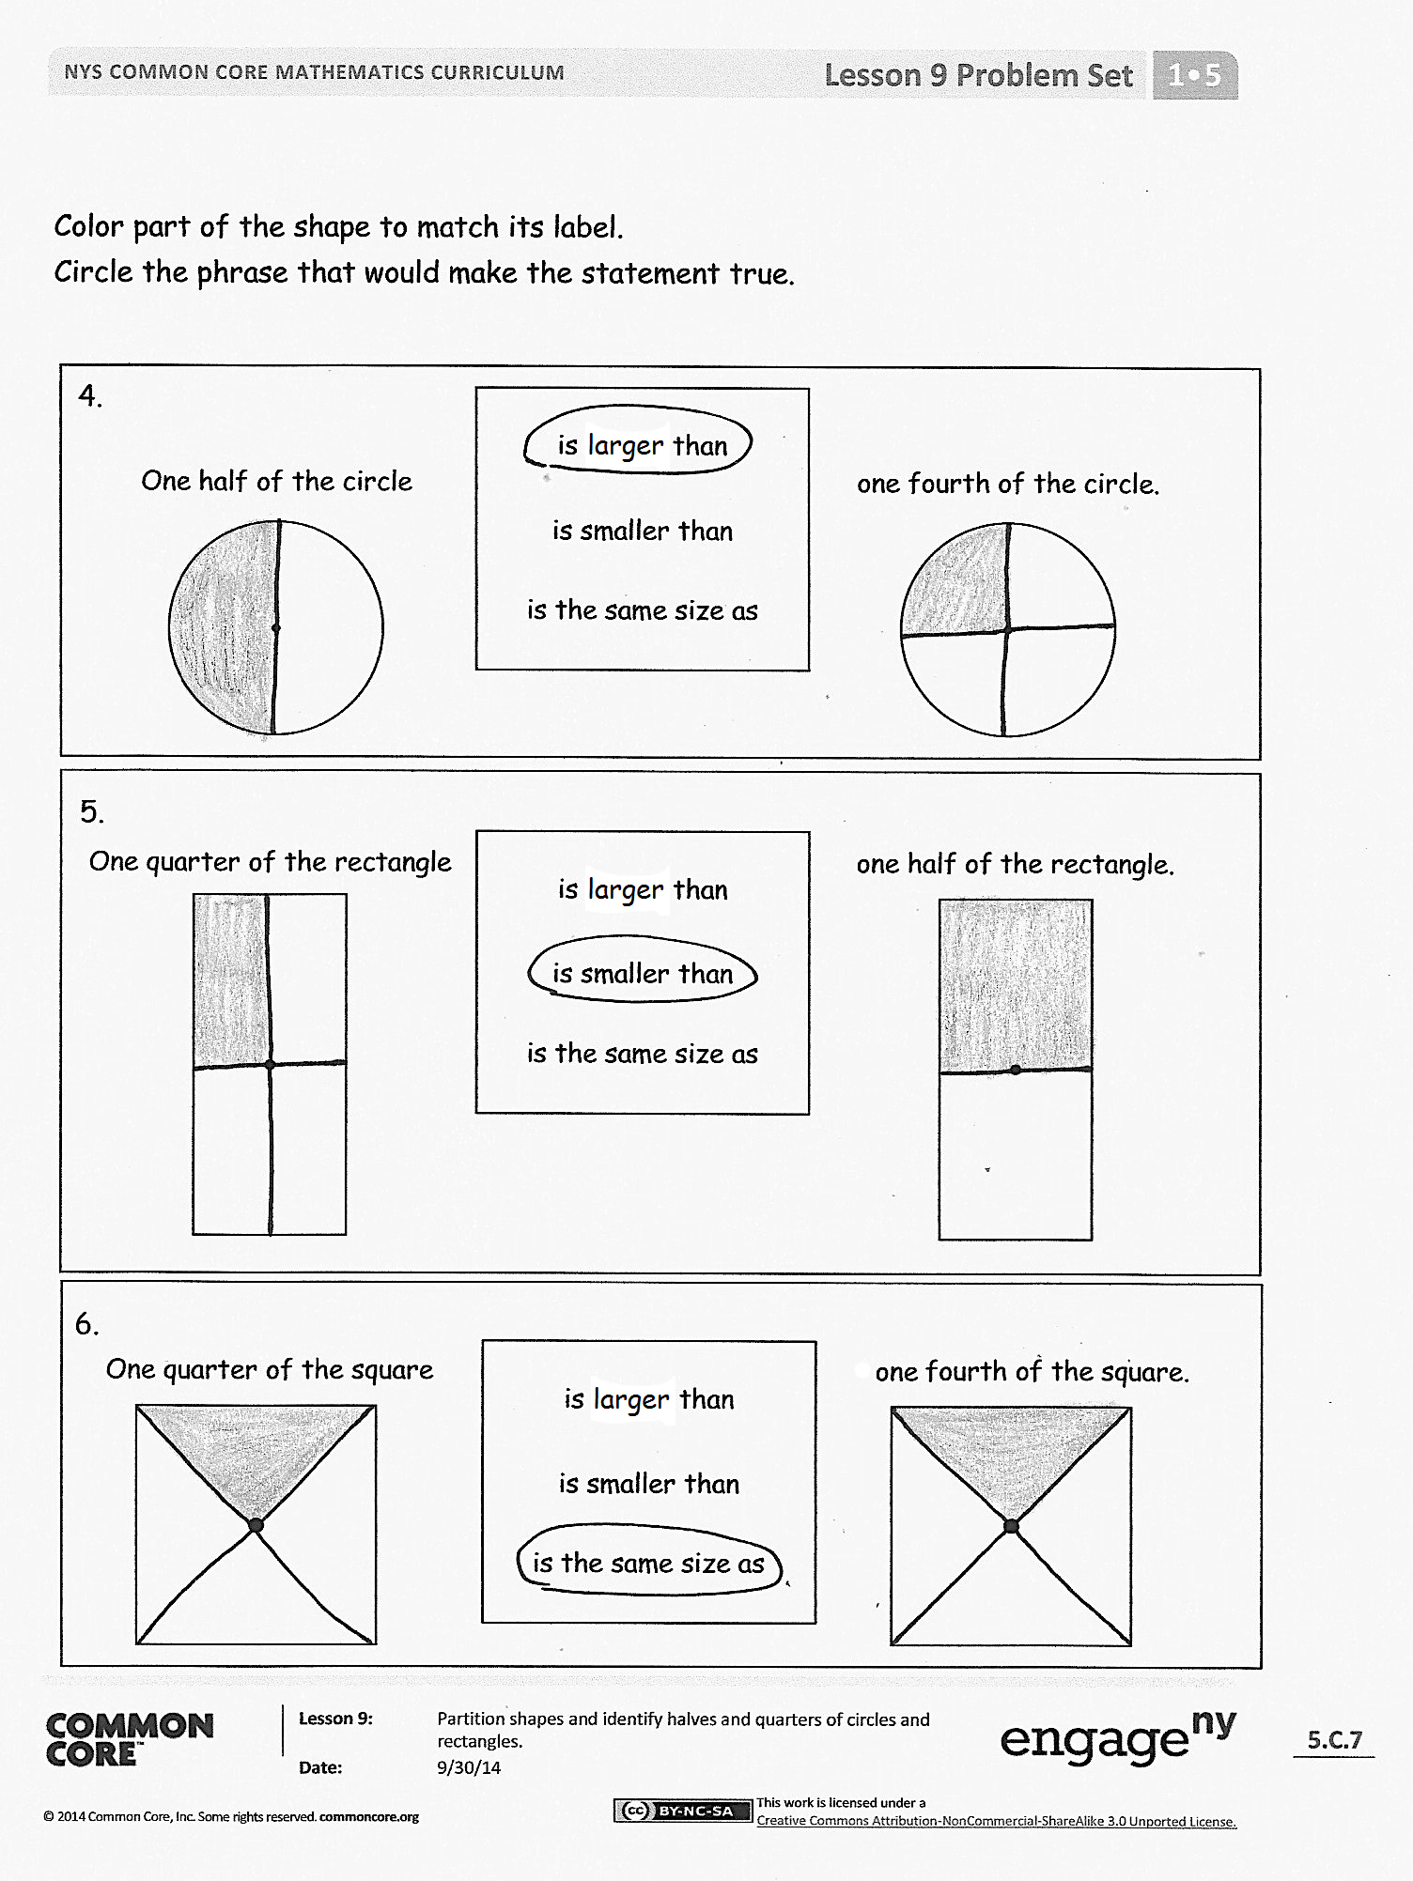
T: On your personal white boards, you have pairs of the same shape. Draw lines and color in one half of the first shape, and then draw lines and color in one quarter, or one fourth, of the other shape. With your partner, see if one fourth is smaller than one half every time, or just sometimes.
When most students have completed the task, have students show their personal white boards under the document camera and explain their findings.
Problem Set (10 minutes)
Students should do their personal best to complete the Problem Set within the allotted 10 minutes. For some classes, it may be appropriate to modify the assignment by specifying which problems they work on first.
Student Debrief (10 minutes)
Lesson Objective: Partition shapes and identify halves and quarters of circles and rectangles.
The Student Debrief is intended to invite reflection and active processing of the total lesson experience.
Invite students to review their solutions for the Problem Set. They should check work by comparing answers with a partner before going over answers as a class. Look for misconceptions or misunderstandings that can be addressed in the Debrief. Guide students in a conversation to debrief the Problem Set and process the lesson.
Any combination of the questions below may be used to lead the discussion.
- Look at Problem 1. Which shaded part is greater, or larger? Is this true for your other problems? Is one half of a shape always larger than one fourth of the same shape?
- If you want more pieces, should you cut your shape into halves or quarters? If you want larger pieces, should you cut your shape into halves or quarters? Explain your thinking.
- Why does cutting something into fourths make the equal parts smaller than cutting it into halves?
- Let’s think about the first question I asked you today. Would you rather have one half of a yummy pizza or one quarter of a yummy pizza? Explain your thinking. (Choose students who may be better able to express accurate reasoning since participating in the lesson.)
- Look at the Application Problem. Share your drawing with your partner. Did you cut your brownie into quarters in the same way or in a different way? How did you make sure you created four equal parts?
Exit Ticket (3 minutes)
After the Student Debrief, instruct students to complete the Exit Ticket. A review of their work will help with assessing students’ understanding of the concepts that were presented in today’s lesson and planning more effectively for future lessons. The questions may be read aloud to the students.

Name Date
Label the shaded part of each picture as one half of the shape or one quarter of the shape.
1.
Which shape has been cut into more equal parts? ____
Which shape has larger equal parts? ___
Which shape has smaller equal parts? ___

B
A

Which shape has been cut into more equal parts? ____
Which shape has larger equal parts? ___
Which shape has smaller equal parts? ___

2.

B
A

- Circle the shape that has a larger shaded part. Circle the phrase that makes the sentence true.
The larger shaded part is
(one half of / one quarter of)
the whole shape.

Color part of the shape to match its label.
Circle the phrase that would make the statement true.
4.
One half of the circle
one fourth of the circle.
is larger than
is smaller than
is the same size as
One quarter of the rectangle
one half of the rectangle.
5.
is larger than
is smaller than
is the same size as
One quarter of the square
one fourth of the square.
6.
is larger than
is smaller than
is the same size as

Name Date
1. Circle T for true or F for false.
a. One fourth of the circle is larger than one half of the circle.
T F
- Cutting the circle into quarters gives you more pieces than cutting the circle into halves. T F

2. Explain your answers using the circles below.

Name Date
- Label the shaded part of each picture as one half of the shape or one quarter of the shape.
A
Which picture has been cut into more equal parts? ____
Which picture has larger equal parts? ___
Which picture has smaller equal parts? ___

A

B

- Write whether the shaded part of each shape is a half or a quarter.
a.  __________ __________ | b.  __________ __________
c.  __________ __________ | d.  __________ __________

- Color part of the shape to match its label. Circle the phrase that would make the statement true.
a.
One quarter of the square
is larger than
is smaller than
is the same size as
one half of the square.

b.

is larger than
is smaller than
is the same size as

One quarter of the rectangle
one fourth of the rectangle.

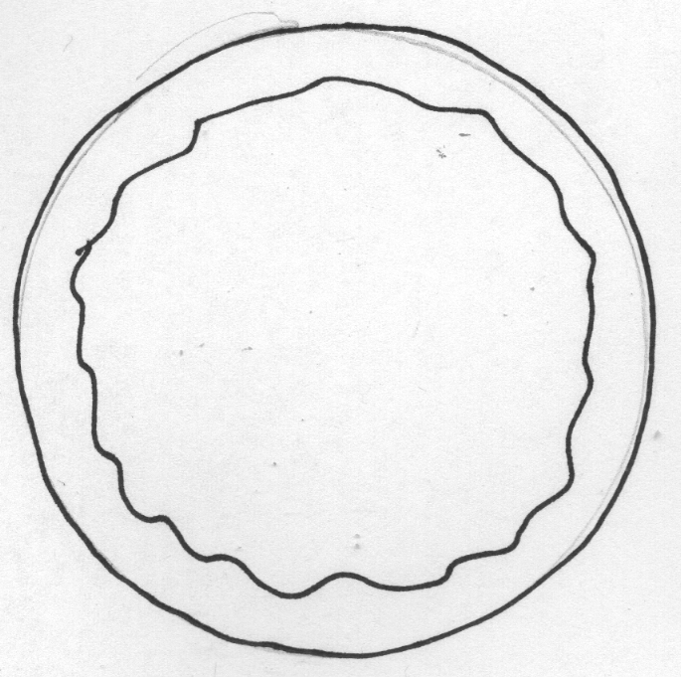

pairs of shapes

