Lesson 8
Objective: Partition shapes and identify halves and quarters of circles and rectangles.

Suggested Lesson Structure
 Fluency Practice (15 minutes)
 Application Problem (5 minutes)
 Concept Development (30 minutes)
 Student Debrief (10 minutes)
Total Time (60 minutes)

Fluency Practice (15 minutes)
- Core Fluency Differentiated Practice Sets 1.OA.6 (5 minutes)
- 5 More 1.NBT.4 (5 minutes)
- Make Ten Addition with Partners 1.OA.6 (5 minutes)

Core Fluency Differentiated Practice Sets (5 minutes)

Materials: (S) Core Fluency Practice Sets (Lesson 3 Core Fluency Practice Sets)
Note: Give the appropriate Practice Set to each student. Help students become aware of their improvement. After students complete today’s Practice Sets, ask them to raise their hands if they tried a new level today or improved their scores from the previous day.
Students complete as many problems as they can in 90 seconds. Assign a counting pattern and start number for early finishers, or tell them to practice make ten addition or subtraction on the back of their papers. Collect and correct any Practice Sets completed within the allotted time.

5 More (5 minutes)
Note: This activity prepares students for Lesson 11, where they add 5 minutes until they reach 30 minutes to connect half past the hour to 30 minutes past the hour. The suggested sequence of this activity enables students to use their experience with analogous addition to add 5. Be sure to provide enough think time for students to mentally add or count on, as needed. If students require more support, consider replacing this activity with Whisper Count from Lesson 7.
T: On my signal, say the number that is 5 more. 0. (Pause. Snap.)
S: 5.
T: 10. (Pause. Snap.)
S: 15.
Continue with the following suggested sequence: 20, 30; 5, 15, 25.

Make Ten Addition with Partners (5 minutes)

Materials: (S) Personal white board
Note: This fluency activity reviews how to use the Level 3 strategy of making ten to add two single-digit numbers.
Repeat the activity from Lesson 7.

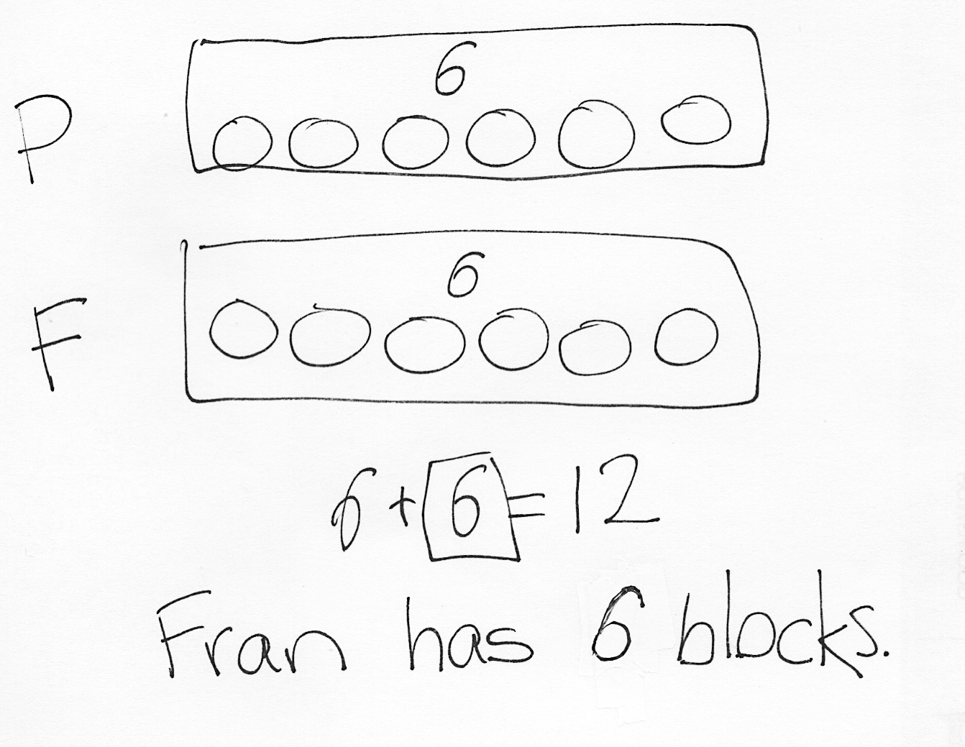
Application Problem (5 minutes)
Peter and Fran each have an equal number of pattern blocks. There are 12 pattern blocks all together. How many pattern blocks does Fran have?
Note: In today’s Application Problem, students explore their understanding of the word equal. Note the various methods students have for solving the problem. Some of these methods may be useful in supporting students’ understanding of equal parts, as applied in today’s Concept Development.

Concept Development (30 minutes)
Materials: (T) Example images (Template 1), circles and rectangles (Template 2), projector (S) Circles and rectangles (Template 2), personal white board
Note: The circles and rectangles template should be cut in half. Distribute the top half—images of pizza—to students at the start of the lesson.
Gather students in the meeting area, with the circles and rectangles template inserted into their personal white boards.
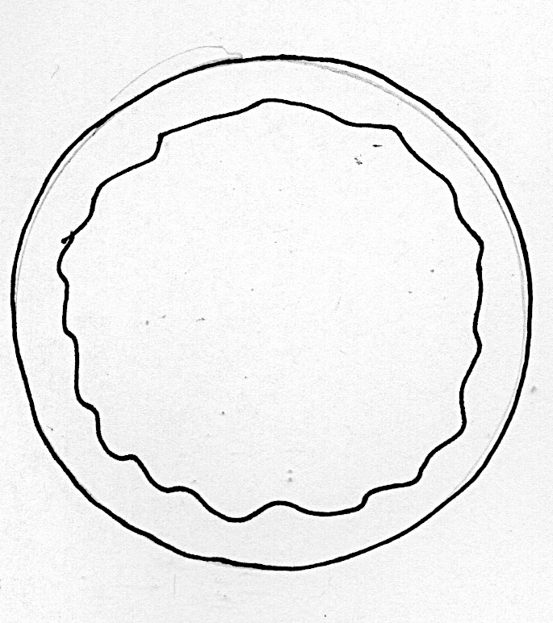
T: Last night, my brother and I bought a small pizza to share. We agreed we would each eat half of the pizza, or one out of two equal parts. My brother cut the pizza for us to share, and it looked like this. (Show Example Image 1.)
T: Why do you think I was mad? What’s wrong with my brother’s version of fair shares?
S: One piece is much bigger than the other piece. They are not cut into equal parts.

T: If my brother and I are going to share this pizza fairly, we need to each have an equal part. To have one half of the pizza, the two parts need to be the same size. On your personal white boards, draw a line to show how the pizza should have been cut.
S: (Partition circle into approximately two equal parts.)
T: (Use student example to share with the class.) Yes! Now, I can get one half of the pizza because each of the two parts is the same size.
T: Sometimes we buy Sicilian pizza, which is shaped like a rectangle. (Project Image 2.) How can we cut this to be in two equal parts, or two halves of the pizza? Draw a line to show how you would cut the rectangular pizza on your personal white boards. (Wait as students draw.)
T: I see more than one idea. Who would like to share how he cut the pizza to be two equal parts, two halves of the pizza?
S: I cut the pizza across (horizontally.) I cut the pizza up and down (vertically.) I cut the pizza across from one corner to the other (diagonally.)
T: Will my brother and I get the exact same amount to eat?
S: Yes!
T: Wow, we found three different ways to cut the pizza into halves! Good job!
T: I need your help, though, because sometimes our mom and dad eat with us. How can we share that rectangle pizza equally among all four of us?
S: You need to cut it into four pieces. The pieces need to be the same size. You can just cut it again the other way. That’s what my mom does with my sandwiches!
T: Draw lines to show how you would cut the rectangle pizza so we would have four equal parts.
S: (Students draw lines on personal white boards over the rectangular pizza.)

NOTES ON
MULTIPLE MEANS
OF REPRESENTATION:
Highlight the critical vocabulary for English language learners throughout the lesson by showing object(s) as a visual or gesturing while saying the words. In this lesson, vocabulary to highlight is half, fourths, quarters, quarter-circle, and half-circle.

T: How did you cut one pizza into four equal parts, or fourths?
S: I drew one line up and down (vertically) and the other line across (horizontally). I drew all my lines in the same way. Everyone would get a strip of pizza that is the same size.
T: Great job! These are all fourths of, or quarters of, the pizza. It is cut into four pieces that are the same size.
S: I drew two lines diagonally through the middle from each corner. That makes four triangles, but they are not all the same shape, so I wonder if the four pieces are equal shares even though they are not the same shape.
T: Interesting observation. I wonder, too! (While the diagonal cuts would create equal shares, the shapes created are not exactly the same. These are the most challenging types of equal parts. You may want to explore cutting shapes diagonally as an extension to the lesson.)

T: Let’s try to make fourths, or quarters, from the circle-shaped pizza. (Observe as students draw lines on their personal white boards. Support students in visually checking that they have four equal parts to their circle.)
T: How did you cut the pizza so that it was cut into four equal parts, which we call fourths or quarters?
S: I cut across (horizontally) and up and down (vertically). I tried to cut it in straight lines, like I did with the rectangle, but the end pieces were too small. I had to cut it through the middle to keep the parts the same size.
T: Good observations. Sometimes it’s easier to make equal parts by cutting them in particular ways. Can the circle AND the rectangle both be cut into fourths?
S: Yes!
T: So, if there are four people sharing a pizza, whichever shape we’re using, we need the whole pizza to be cut into…?
S: Fourths! (Or quarters.)
T: If there are two people sharing, we need the whole pizza to be cut into…?
S: Halves!
T: Look at this shape. (Project Image 3, a quarter-circle.) This shape is called a quarter-circle. How do you think it got its name?
MP.7
S: It comes from a whole circle that got cut into fourths, or quarters. It comes from a circle cut into four equal parts. If you put it together with 3 other pieces that are the same size, you would get a whole circle. Four quarters make one whole.
T: If this shape (point to Image 3, the quarter-circle) is called a quarter-circle, what do you think this shape is called? (Project Image 4, the half-circle.)
S: A half-circle!
T: How did you know?

NOTES ON
MULTIPLE MEANS
OF REPRESENTATION:
Some students may benefit from various aids when modeling halves and fourths. Providing rulers may help students draw straight lines. Other students may need to cut out or fold paper to accurately convey equal partitions.

S: It comes from a whole circle that got cut in half. It comes from a circle cut into two parts. If you put it together with another piece that is the same size, you would get a whole circle. Two halves make one whole.
Distribute the bottom half of the circles and rectangles template to be inserted into the personal white boards. Invite students to partition the shapes in halves. Discuss the various positions of their lines and the importance of having equal parts no matter which way the shape is partitioned. Repeat this process having students partition the shapes into fourths, or quarters.

Problem Set (10 minutes)
Students should do their personal best to complete the Problem Set within the allotted 10 minutes. For some classes, it may be appropriate to modify the assignment by specifying which problems they work on first. Some problems do not specify a method for solving.

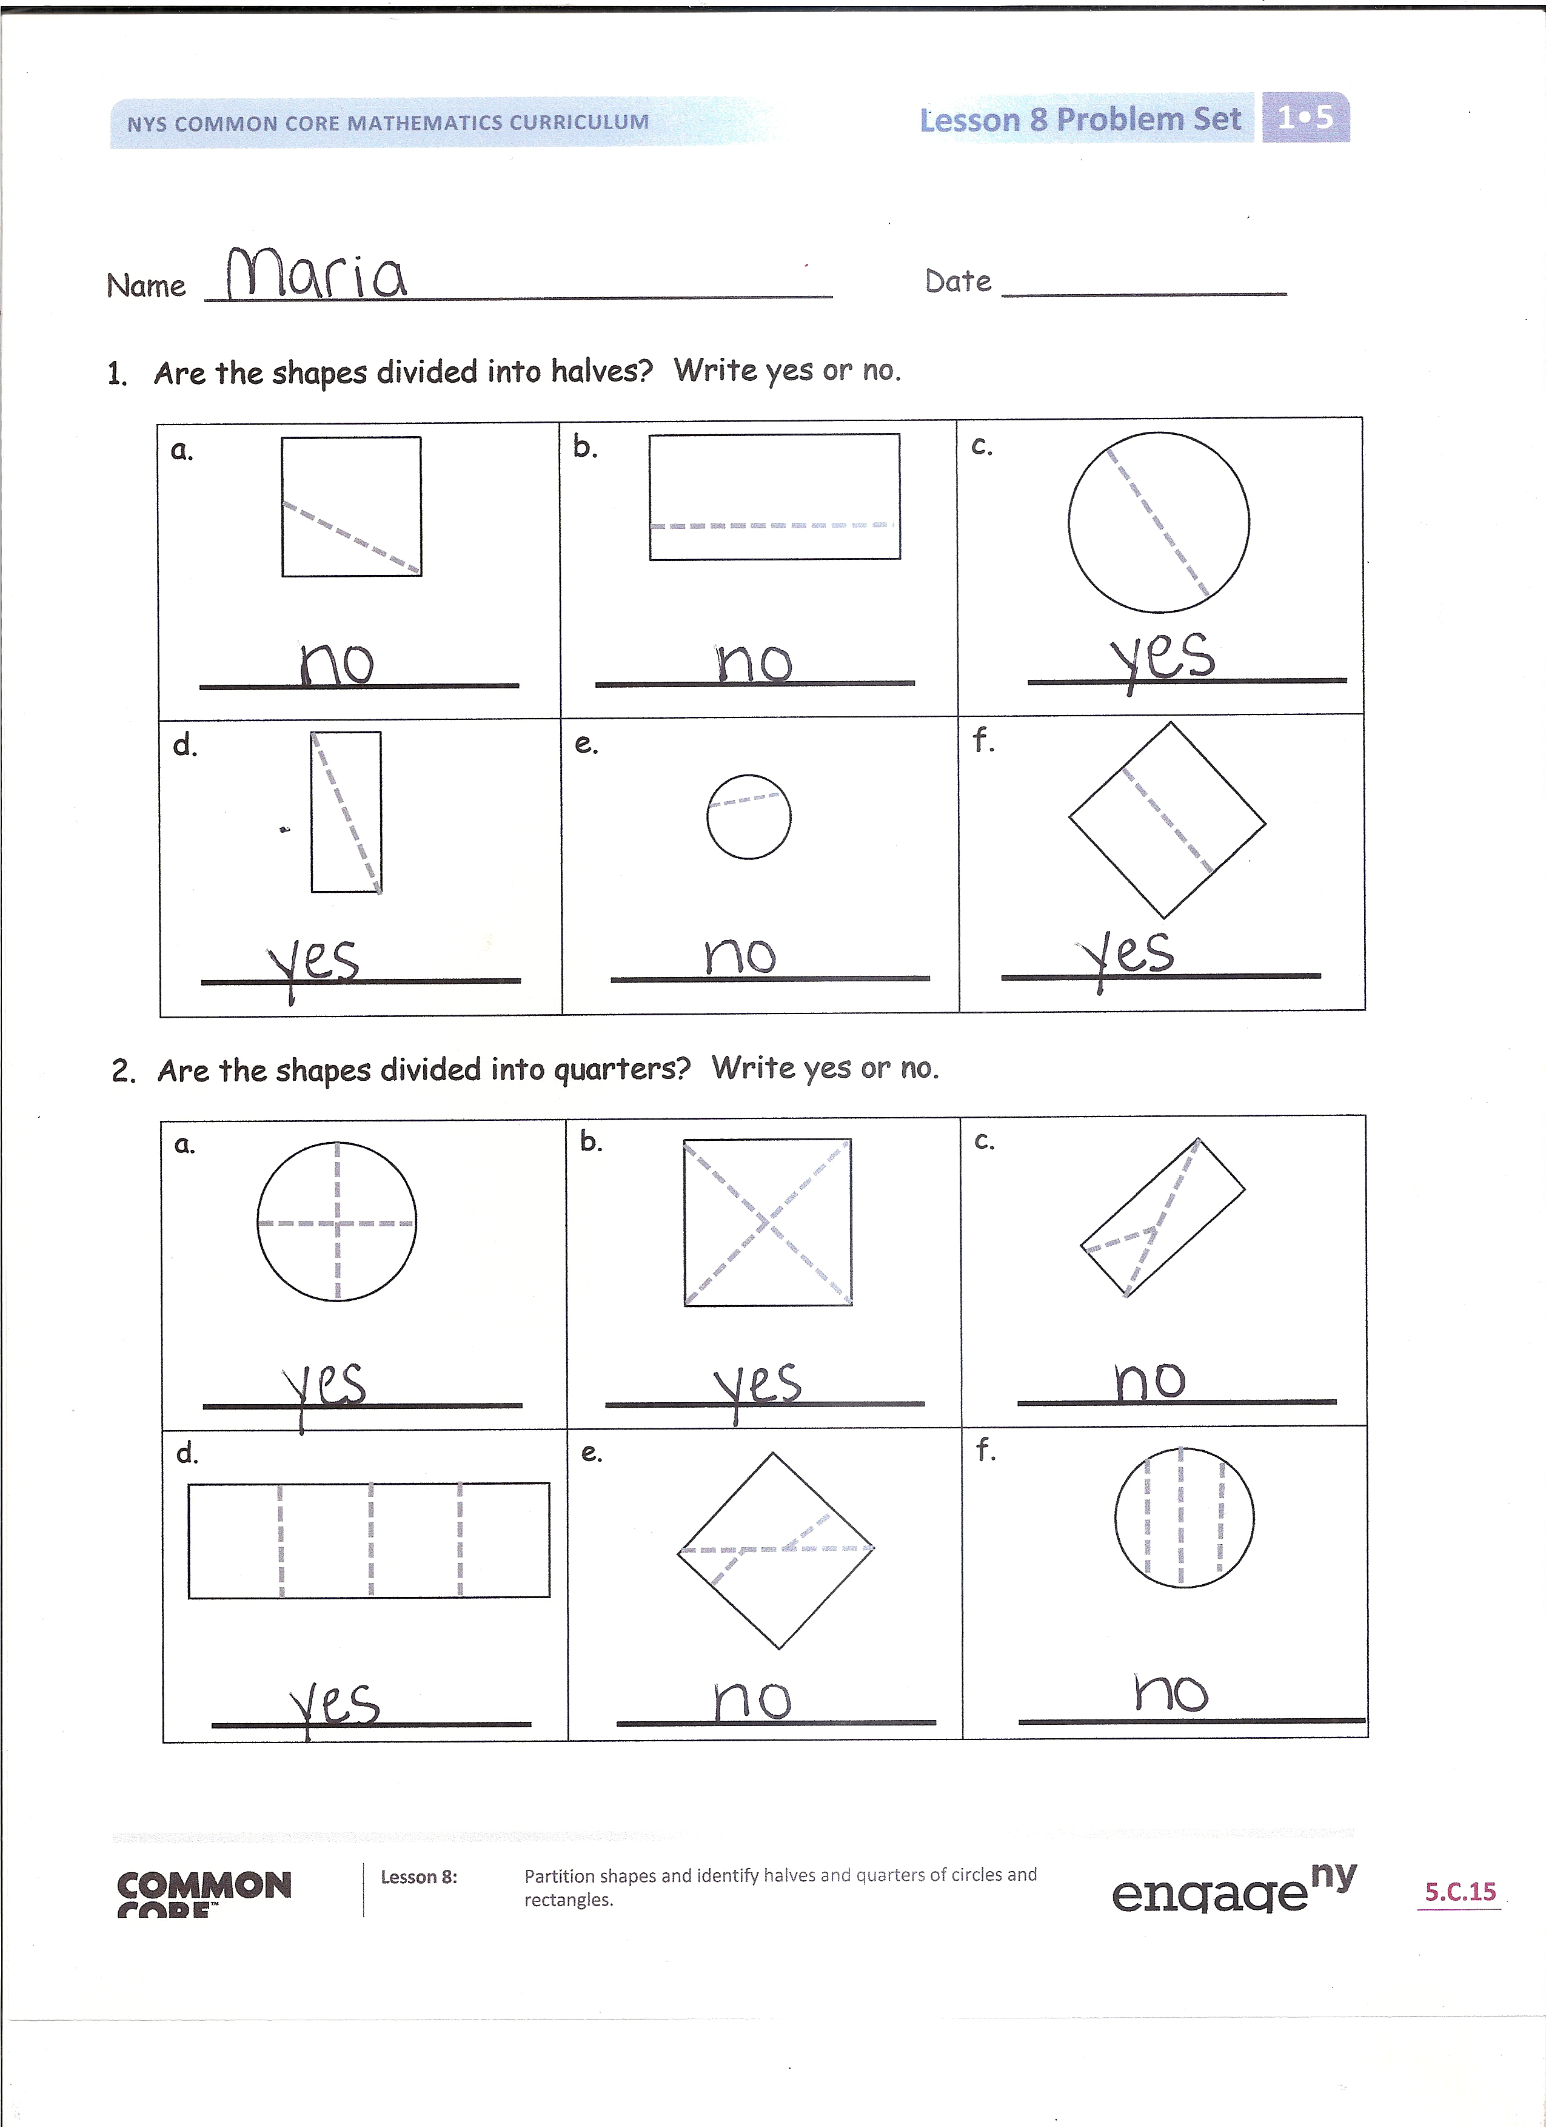
Student Debrief (10 minutes)
Lesson Objective: Partition shapes and identify halves and quarters of circles and rectangles.
The Student Debrief is intended to invite reflection and active processing of the total lesson experience.
Invite students to review their solutions for the Problem Set. They should check work by comparing answers with a partner before going over answers as a class. Look for misconceptions or misunderstandings that can be addressed in the Debrief. Guide students in a conversation to debrief the Problem Set and process the lesson.
Any combination of the questions below may be used to lead the discussion.
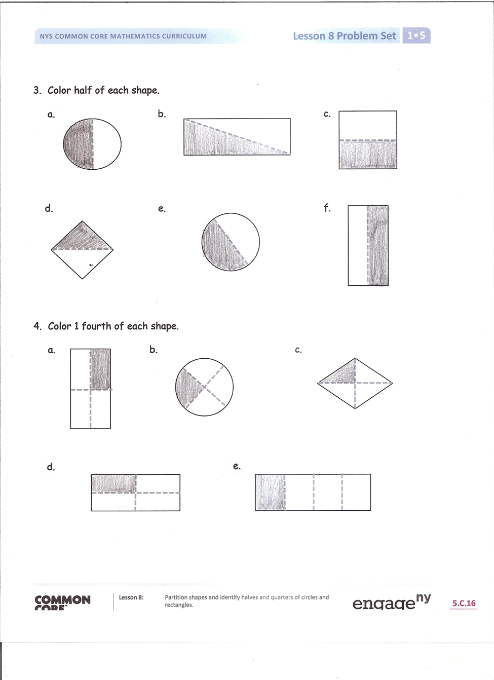
- What word did we learn today to help us name the pieces of a shape cut into two equal parts? (Half or halves.) (Hold up the rectangle pizza image, with a line to divide it in half.) How much of the pizza is one part? (Half of the pizza.)
- What two different ways can we name the parts of a shape that is cut into four equal parts? (Fourths or quarters.) (Hold up the rectangle pizza image, divided into quarters.) How much of the pizza is one part? (A quarter of the pizza, or a fourth of the pizza.) Look at Problem 1. Find an example of a shape that is not divided into halves. How did you decide that the parts were not equal?
- Look at Problem 2. Find an example of a shape that is not divided into quarters. How did you decide it did not have four equal parts?
- (Display the chart created during Lesson 7.) Let’s look at the shapes we made with our tangram pieces during our last lesson. Can we name the size of the equal pieces in each of our shapes?
- Someone told me that when you cut rectangles into quarters, you always get smaller rectangles. Is that true? Look over your Problem Set to support your thinking with examples.

- What is the shape of a half-circle? How does it compare to a quarter-circle?
- How many quarter-circles would you need to make a whole circle? How many quarter-circles would you need to make a half-circle? Explain your thinking.
- Think about today’s fluency activities. Choose one of the activities we completed, and tell your partner how it can help you practice your number work.

Exit Ticket (3 minutes)
After the Student Debrief, instruct students to complete the Exit Ticket. A review of their work will help with assessing students’ understanding of the concepts that were presented in today’s lesson and planning more effectively for future lessons. The questions may be read aloud to the students.

Name Date
- Are the shapes divided into halves? Write yes or no.
a. | b. | c.
d. | e. | f.
- Are the shapes divided into quarters? Write yes or no.
a. | b. | c.
d. | e. | f.

3. Color half of each shape.
a. b. c.

d. e. f.

- Color 1 fourth of each shape.
a. b. c.

d. e.

Name Date
Color 1 fourth of this square. | Color half of this rectangle.
Color half of this square. | Color a quarter of this circle.

Name Date
- Circle the correct word(s) to tell how each shape is divided.
a.  equal parts unequal parts | b.  equal parts unequal parts
c.  halves fourths | d.  halves quarters
e.  halves quarters | f.  fourths halves
g.  quarters halves | h.  halves fourths

- What part of the shape is shaded? Circle the correct answer.

a. b.

1 half 1 quarter
1 half 1 quarter

c. d.

1 half 1 quarter
1 half 1 quarter

- Color 1 quarter of each shape. 4. Color 1 half of each shape.

Image 2
Image 1
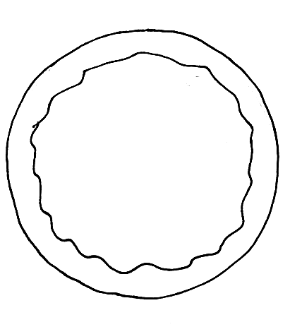

Image 3
Image 4

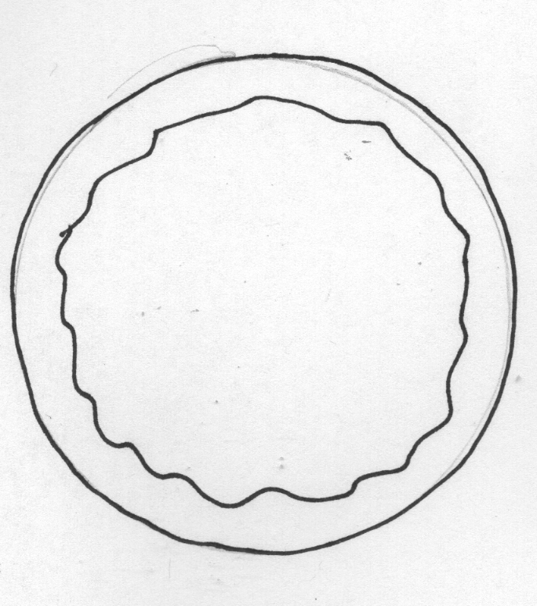

example images
circles and rectangles

