Lesson 7
Objective: Name and count shapes as parts of a whole, recognizing relative sizes of the parts.

Suggested Lesson Structure
 Fluency Practice (12 minutes)
 Application Problem (5 minutes)
 Concept Development (33 minutes)
 Student Debrief (10 minutes)
Total Time (60 minutes)
Fluency Practice (12 minutes)
- Core Fluency Differentiated Practice Sets 1.OA.6 (5 minutes)
- Whisper Count 1.NBT.4 (2 minutes)
- Make Ten Addition with Partners 1.OA.6 (5 minutes)
Core Fluency Differentiated Practice Sets (5 minutes)
Materials: (S) Core Fluency Practice Sets (Lesson 3 Core Fluency Practice Sets)
Note: Give the appropriate Practice Set to each student. Students who completed all of the questions correctly on their most recent Practice Set should be given the next level of difficulty. All other students should try to improve their scores on their current levels.
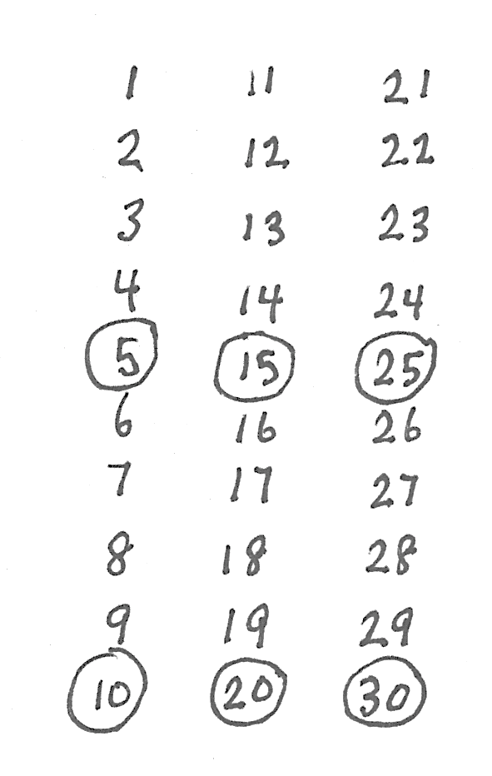
Students complete as many problems as they can in 90 seconds. Assign a counting pattern and start number for early finishers, or tell them to practice make ten addition or subtraction on the back of their papers. Collect and correct any Practice Sets completed within the allotted time.
Whisper Count (2 minutes)
Materials: (T) Chart of numbers to 30 with multiples of 5 circled
Note: This activity prepares students for Lesson 11, where they add 5 minutes until reaching 30 minutes to connect half past the hour to 30 minutes past the hour. If the students are proficient at counting on by fives, consider substituting for the Fluency Practice 5 More (Lesson 8).
Whisper count to 30 with students, saying multiples of 5 out loud.
T: Whisper count with me. Say the circled numbers out loud.
T/S: (Whisper.) 1, 2, 3, 4.
T/S: (Say.) 5.
Continue counting to 30.
Make Ten Addition with Partners (5 minutes)

NOTES ON
MULTIPLE MEANS
OF ACTION AND EXPRESSION:
Some students may find this fluency activity challenging or need more time finishing problems. Scaffold tasks by carefully selecting the number of problems to be completed for certain partners.

Materials: (S) Personal white board
Note: This fluency activity reviews how to use the Level 3 strategy of making ten to add two single-digit numbers.
- Assign partners of equal ability.
- Partners choose an addend for each other from 1 to 10.
- On their personal white boards, students add their number to 9, 8, and 7. Remind students to write the two addition sentences they learned in Module 2, as seen in the examples below.
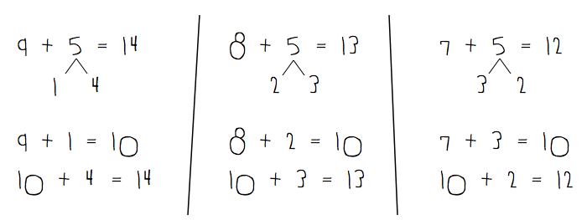
- Partners then exchange personal white boards and check each other’s work.
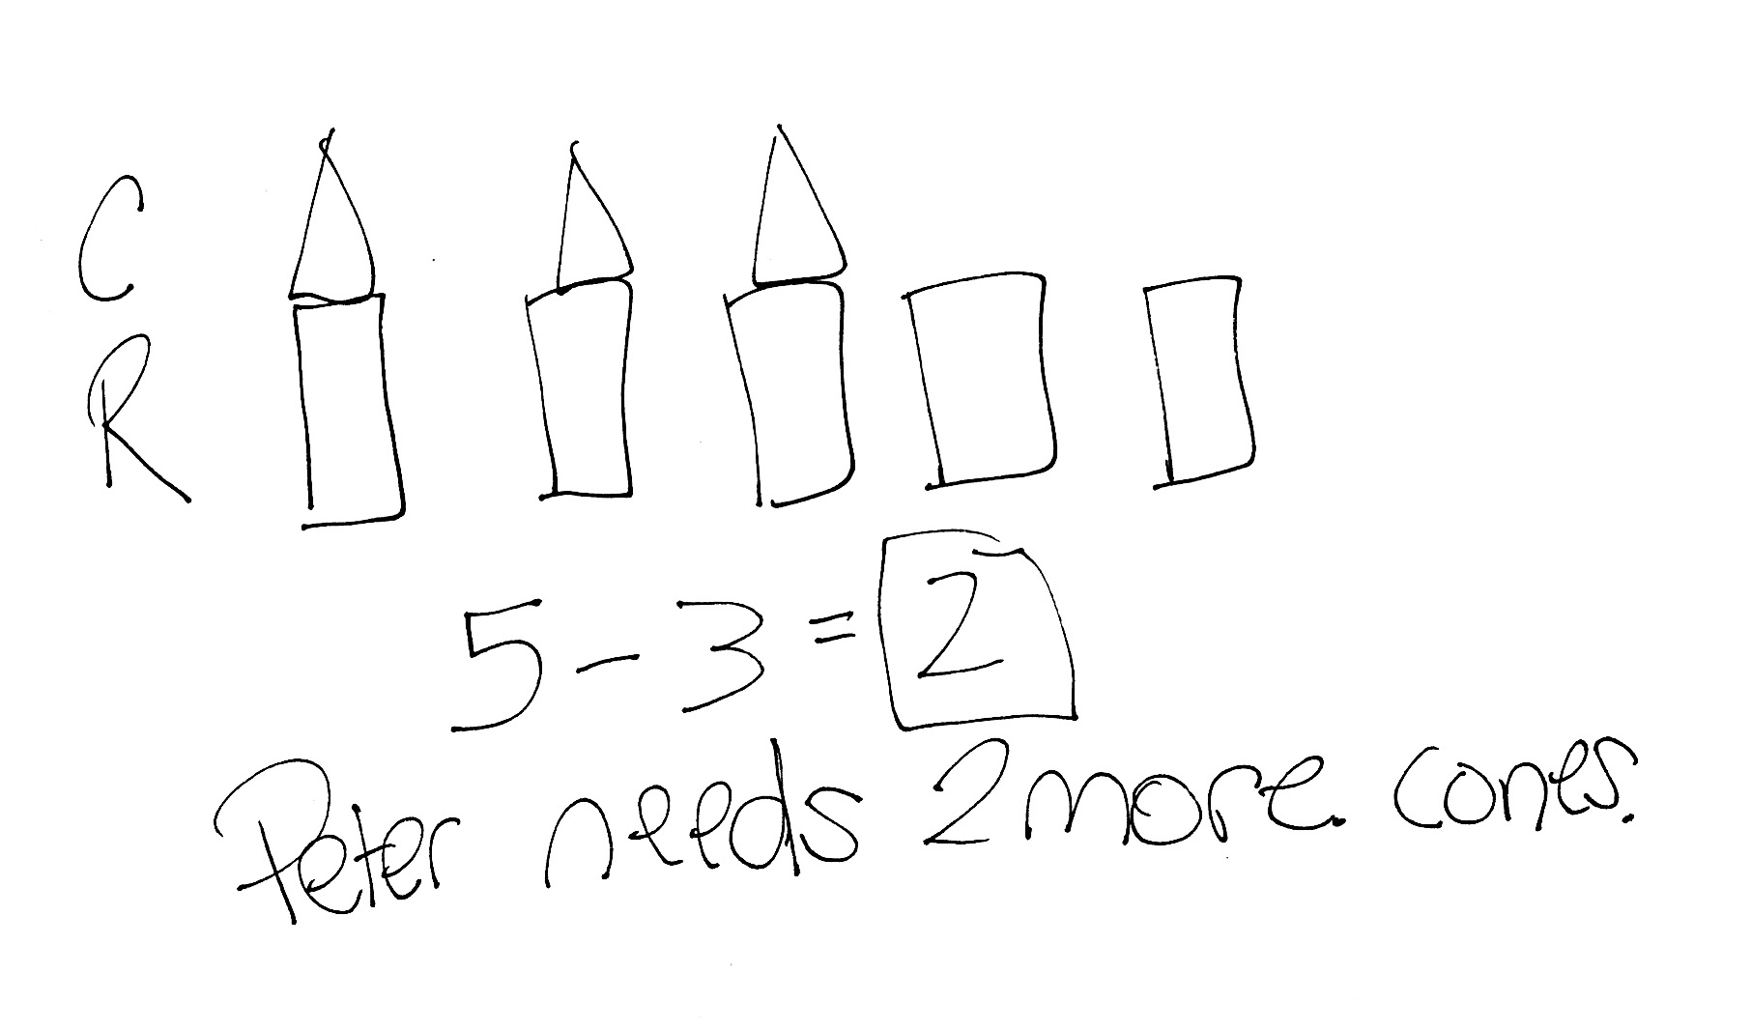
Application Problem (5 minutes)
Peter set up 5 rectangular prisms to make 5 towers. He put a cone on top of 3 of the towers. How many more cones does Peter need to have a cone on every tower?
Note: This Application Problem presents a compare with difference unknown problem type using easy numbers. Before moving to Concept Development, link the Application Problem question with the more challenging comparison question of, How many fewer cones does Peter have than rectangular prisms? In the student sample selected, notice that the student does not yet independently use double-tape diagrams. After the student explains how she solved this problem using her drawing, one rectangle can be drawn around the cones, and one rectangle can be drawn around the prisms, turning the drawing into a double-tape diagram. If there are students in the class who are already effectively using the double-tape diagram, the two models can be compared.
Concept Development (33 minutes)
Materials: (T) Tangram pieces (Lesson 5 Template), document camera, pattern blocks, chart paper, yellow marker (S) Tangram pieces (Lesson 5 Template), pattern blocks in individual plastic bags (set of 1─2 hexagons, 6 squares, 6─10 triangles, 2─4 trapezoids, 2─4 blue rhombuses, 2─4 tan rhombuses)
Seat students at their desks or tables with the tangram pieces ready to use and pattern blocks in individual plastic bags ready for later in the lesson.
T: Two lessons ago, we made many different shapes using two or more of these tangram pieces. Can you think of any shapes we made?
S: We made a big square. We made a smaller square. We made a rectangle. We made trapezoids and parallelograms.

NOTES ON
MULTIPLE MEANS
OF ACTION AND EXPRESSION:
Asking questions for comprehension during this lesson is important for guiding students toward evaluating their thinking. This provides students with an opportunity to evaluate their process and analyze errors.

T: Great! Use two or more of your pieces to make a shape you can name.
S: (Students spend one minute creating shapes. Circulate and ask questions such as the following: What is the name of your overall shape? Can you add another piece to your shape to make another larger shape that you can name?)
T: Let’s look at some of the shapes you created and see what parts, or shapes, they are made of. (Choose a student who created a square using two smaller triangles. Invite the student to place his shape under the document camera.)
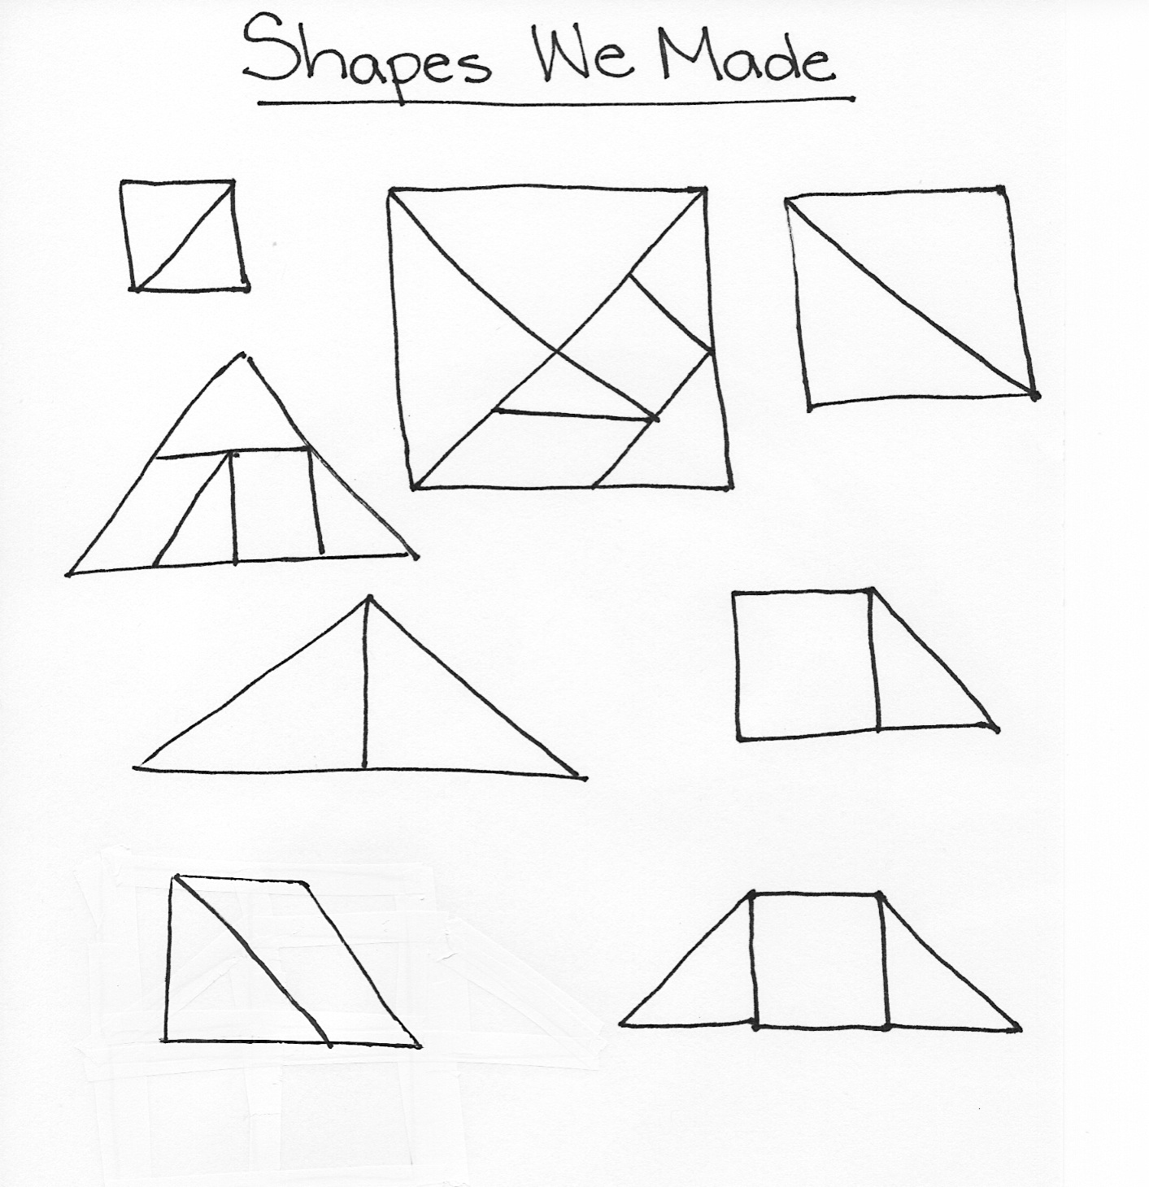
T: What is the shape that he created?
S: A square!
T: What are the parts that he used to make this square, and how many parts are there?
S: He used two triangles to make the square.
T: Great! Let’s record this. (Draw the shape on chart paper, partitioned to show the pieces used.) Student A used two triangles to make a square.
T: I saw someone make a square in a different way. (Under the document camera, position all tangram pieces to make the large square.) What are the parts that are used to make this square, and how many parts are there?
S: There are seven parts. There are two large triangles, one medium triangle, two small triangles, one parallelogram, and one square. (Add shapes to the chart as shown.)
Repeat this process with any other composite shapes that the students created. Some additional examples are shown in the chart.
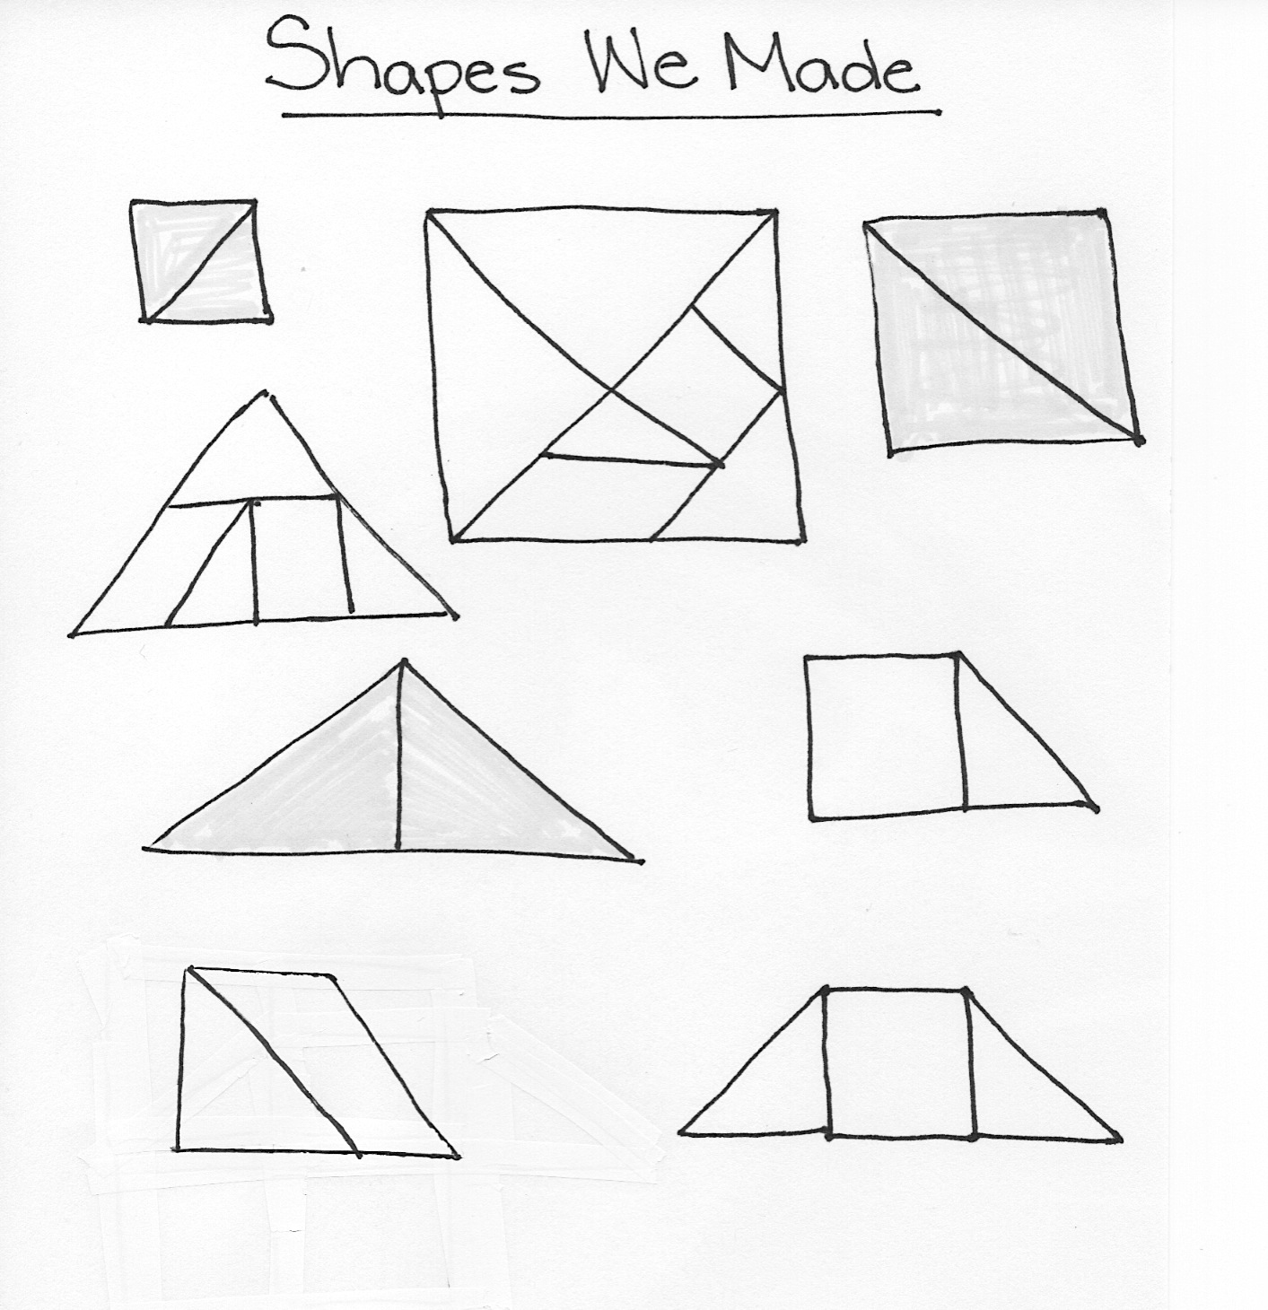
T: Some of the shapes on our chart are made with equal parts, where two same-size parts were used to make the larger shape. Can you find them on the chart?
S: The first square is made of equal parts!
T: (Color both equal parts with a yellow marker so that the equal parts stand out.) Can you find any more shapes made with equal parts?
S: The triangle made with two smaller triangles has equal parts! (Continue as appropriate.)
T: What about the large square that we made using all of the pieces? Is this made of seven equal parts?
S: No. The parts are different sizes. There are big triangles and little triangles.
T: You are correct! Let’s check the rest of our shapes on the chart to make sure we found all the shapes with equal parts. (Repeat the process by having students explain why the rest of the shapes do not have equal parts.)
T: Let’s look at some of the hexagon shapes we made a few days ago. (Place one yellow hexagon pattern block under the document camera.) How can we make a hexagon using smaller pattern block pieces?
S: Use six triangles! (Place six green triangles on top of the yellow hexagon, under the document camera.)
T: Is the hexagon made of equal parts?
equal parts
S: Yes!
T: How many equal parts?
S: Six!
T: What’s another way to make a hexagon?
S: Two trapezoids! (Place two trapezoids on top of the yellow hexagon, under the document camera.)
T: Is the hexagon made of equal parts?
S: Yes!
equal parts
not equal parts
T: How many equal parts?
S: Two!
T: Can we use trapezoids and triangles to make a hexagon?
S: Use one trapezoid and three triangles. (Place pieces on top of the yellow hexagon, under the document camera.)
T: How many parts are used for this hexagon?
S: Four parts!
T: Are they four equal parts?
S: No. The trapezoid is much bigger than the triangles.
T: With a partner, make one hexagon that is created with equal parts and another hexagon that is made with parts that are not equal.
Give students one minute to create composite shapes. Then, have students share their composite hexagon with the class, noting how many parts are used to make the shape and if the shape is made of equal parts. Record these shapes on the chart, coloring the composite shapes made with equal parts in yellow, and labeling 2 equal parts or 3 equal parts as appropriate.

NOTES ON
MULTIPLE MEANS
OF ENGAGEMENT:
While teaching, be sure to provide cross-curricular connections for students. Visit the school or local library to check out books on shapes or equal parts to supplement learning during Topic C.

Extension: If time allows, invite students to use their pattern blocks to create other shapes with equal parts. The composite shapes created do not need to be shape names that students know. If including this portion, during the Student Debrief, ask students what shapes they made with their blocks and what they noticed when they used equal parts for the entire shape.
Problem Set (10 minutes)
Students should do their personal best to complete the Problem Set within the allotted 10 minutes. For some classes, it may be appropriate to modify the assignment by specifying which problems they work on first.
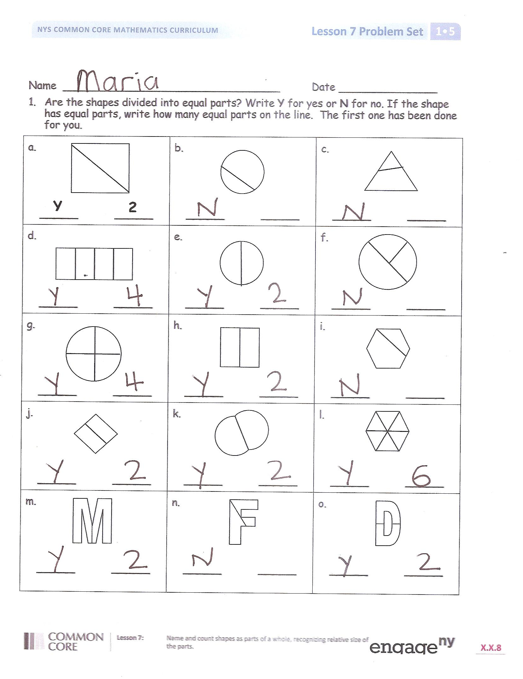
Student Debrief (10 minutes)
Lesson Objective: Name and count shapes as parts of a whole, recognizing relative sizes of the parts.
The Student Debrief is intended to invite reflection and active processing of the total lesson experience.
Invite students to review their solutions for the Problem Set. They should check work by comparing answers with a partner before going over answers as a class. Look for misconceptions or misunderstandings that can be addressed in the Debrief. Guide students in a conversation to debrief the Problem Set and process the lesson.
Any combination of the questions below may be used to lead the discussion.
- Look at Problem 1. Find an example of a shape that is not divided into equal parts. How did you decide that the parts were not equal?
- Look at Problem 4. What are the shapes of your equal parts? Compare with your partner. Did everyone make the same shape?

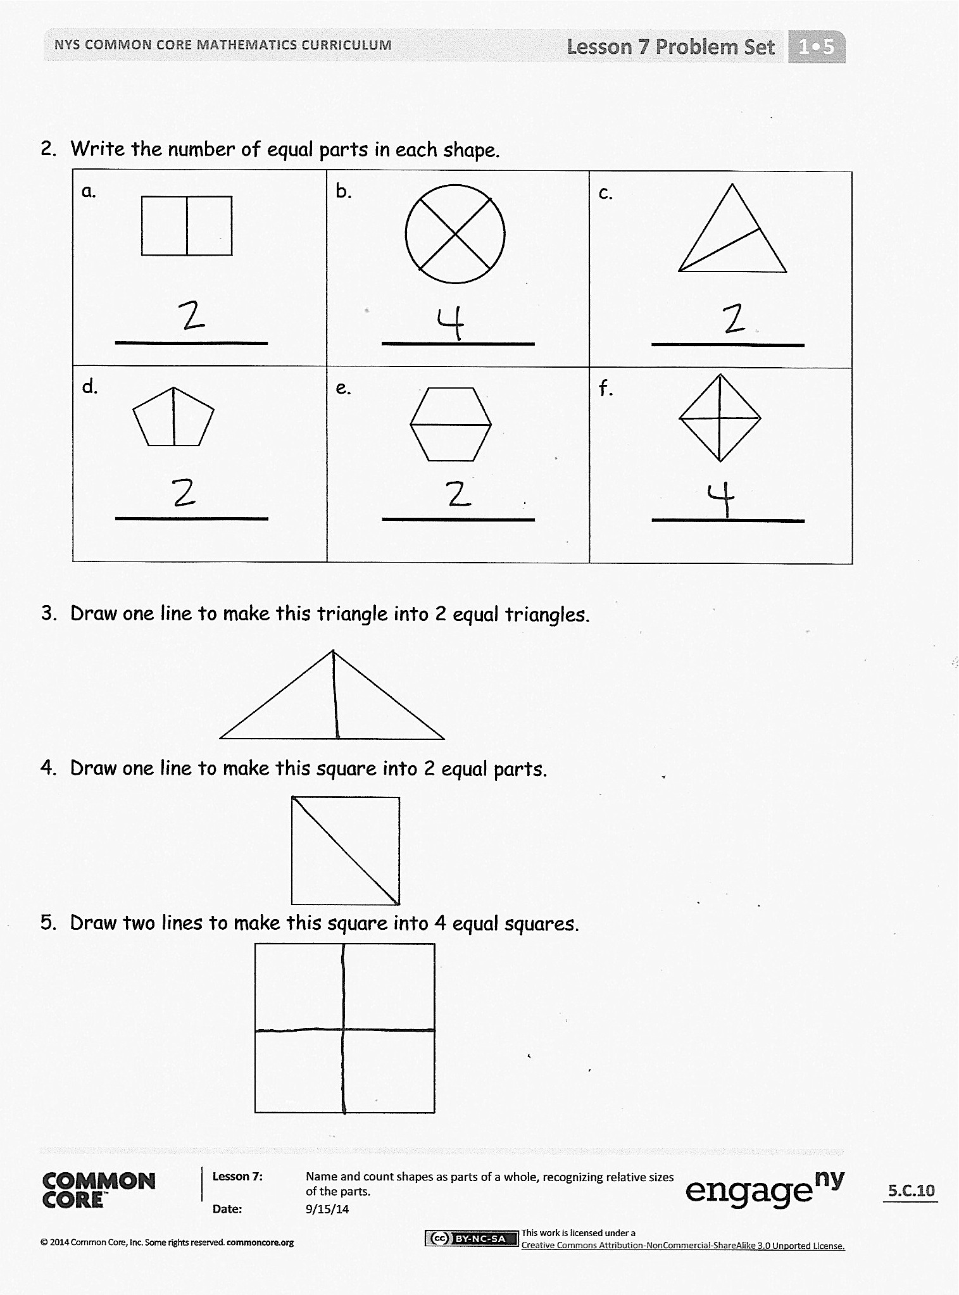
- What does it mean when we say a shape has equal parts? How is this the same as or different from the ways we have used the word equal in the past? Give examples of ways we use the word equal in math class.
- Think about your Fluency Practice today. Which addition or subtraction facts are becoming easier for you to remember?
Exit Ticket (3 minutes)
After the Student Debrief, instruct students to complete the Exit Ticket. A review of their work will help with assessing students’ understanding of the concepts that were presented in today’s lesson and planning more effectively for future lessons. The questions may be read aloud to the students.

Name Date
- Are the shapes divided into equal parts? Write Y for yes or N for no. If the shape has equal parts, write how many equal parts on the line. The first one has been done for you.
a.  2  Y  _____ _____ | b.  _____ _____ | c.  _____ _____
d.  _____ _____ | e.  _____ _____ | f.  _____ _____
g.  _____ _____ | h.  _____ _____ | i.  _____ _____
j.  _____ _____ | k.  _____ _____ | l.  _____ _____
m.  _____ _____ | n.  _____ _____ | o.  _____ _____

- Write the number of equal parts in each shape.
a. | b. | c.
d. | e. | f.

- Draw one line to make this triangle into 2 equal triangles.

- Draw one line to make this square into 2 equal parts.

- Draw two lines to make this square into 4 equal squares.

Name Date
Circle the shape that has equal parts.

How many equal parts does the shape have? _______

Name Date
- Are the shapes divided into equal parts? Write Y for yes or N for no. If the shape has equal parts, write how many equal parts there are on the line. The first one has been done for you.
a.  2  Y  _____ _____ | b.  _____ _____ | c.  _____ _____
d.  _____ _____ | e.  _____ _____ | f.  _____ _____
g.  _____ _____ | h.  _____ _____ | i.  _____ _____
j.  _____ _____ | k.  _____ _____ | l.  _____ _____
m.  _____ _____ | n.  _____ _____ | o.  _____ _____

- Draw 1 line to make 2 equal parts. What smaller shapes did you make?

I made 2 _______________________.

- Draw 2 lines to make 4 equal parts. What smaller shapes did you make?

I made 4 ____________________.

- Draw lines to make 6 equal parts. What smaller shapes did you make?

I made 6 ______________________.

