Lesson 6
Objective: Create a composite shape from three-dimensional shapes and describe the composite shape using shape names and positions.

Suggested Lesson Structure
 Fluency Practice (13 minutes)
 Application Problem (5 minutes)
 Concept Development (32 minutes)
 Student Debrief (10 minutes)
Total Time (60 minutes)
Fluency Practice (13 minutes)

NOTES ON
MULTIPLE MEANS
OF ENGAGEMENT:
Encourage students to set goals for improvement on Sprints and Fluency Practice Sets. Provide scaffolds, strategies, and opportunities for practice to help students reach their personal goals.
- Grade 1 Core Fluency Sprint 1.OA.6 (10 minutes)
- Coin Drop 1.OA.6, 1.NBT.6 (3 minutes)
Grade 1 Core Fluency Sprint (10 minutes)
Materials: (S) Core Fluency Sprint (Lesson 1 Core Fluency Sprint)
Note: Based on the needs of the class, select a Core Fluency Sprint. Consider the options below:
- Re-administer the previous lesson’s Sprint.
- Administer the next Sprint in the sequence.
- Differentiate. Administer two different Sprints. Simply have one group do a counting activity on the back of the first Sprint as the other group corrects the second Sprint.
Coin Drop (3 minutes)

NOTES ON
MULTIPLE MEANS
OF ENGAGEMENT:
After playing Coin Drop with pennies and then dimes, mix pennies and dimes so that students have to add based on the changing value of the coin. This challenges students and keeps them listening for what comes next.
Materials: (T) 4 dimes, 10 pennies, can
Note: In this activity, students practice adding and subtracting ones and tens.
T: (Hold up a penny.) Name my coin.
S: A penny.
T: How much is it worth?
S: 1 cent.
T: Listen carefully as I drop pennies in my can. Count along in your minds.
Drop in some pennies, and ask how much money is in the can. Take out some pennies, and show the class. Ask how much money is still in the can. Continue adding and subtracting pennies for a minute or so. Then, repeat the activity with dimes.
Application Problem (5 minutes)
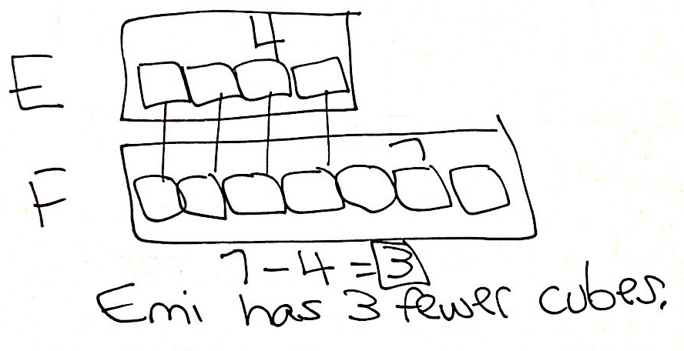
Emi lined up 4 yellow cubes in a row. Fran lined up 7 blue cubes in a row. Who has fewer cubes? How many fewer cubes does she have?
Note: Today’s Application Problem continues to provide the opportunity for students to work with compare with difference unknown problem types. For the past few days, students have looked at questions that asked how many more. Today’s question incorporates the challenging vocabulary word fewer. Consider giving examples of the word fewer prior to having students solve the problem.
Concept Development (32 minutes)
Materials: (T) Three-dimensional solids including cubes, cones, rectangular prisms, spheres, and cylinders,
1 large privacy folder (S) Sets of three-dimensional shapes, large privacy folder (1 per pair)
Note: This lesson works best with ample materials for each set of students. If a set of three-dimensional solids is not readily available, use a collection of reused or recycled materials such as those listed in
Lesson 3.
On a table or desk, behind a privacy folder, gather the teacher’s set of three-dimensional shapes so that students cannot see the shapes as the teacher picks them up to build. Distribute the materials to the students, seated at their desks or tables. Place one additional sample of each shape on the floor or table in front of the class for students who need visual reminders of each shape.

NOTES ON
MULTIPLE MEANS
OF ENGAGEMENT:
While describing the composite structure students are to build, consider giving visual cues for certain words. Otherwise, some students may not be able to keep up with the directions. Some will benefit from directional cues or seeing the shape they are supposed to place on their desks.
T: I am going to build a three-dimensional structure but hide it behind this folder. Listen to my description, and try to build the same shape at your desk.
T: (Slowly describe the structure, providing time for students to build as you explain each shape’s placement.)
T: I am putting…
- A cube on the table.
- A cone on top of the cube so that the circular face is touching the top of the cube.
T: Do you think your structure looks like my structure? Share what you built with your partner.
S: (Discuss choices.)
T: (Remove the privacy folder to reveal the structure.) Were you correct?
S: Yes! (Allow students a moment to adjust their structure if they were not correct.)
Repeat the process, building a structure with three components, such as the following:
T: I am putting…
- A rectangular prism with the longest face touching the table.
- A cube on top of the prism, directly in the middle.
- Two cones on top of the prism, one on each end.
Repeat the process a third time, as described below:
T: (Slowly describe the structure, providing time for students to build while explaining each shape’s placement.)
T: I am putting…
- A rectangular prism with the longest face touching the table.
- A cylinder on top of the prism all the way to the right, with the circular face touching the prism.
- A cylinder on top of the prism all the way to the left, with the circular face touching the prism.
- A rectangular prism on top of these cylinders so that it touches both cylinders.
- A cone right in the center of this rectangular prism, with the circular face touching the prism.
T: Let me repeat my description. As I do, look at your structure and decide if you have everything where you want it. (Repeat the description as students check the structures they have created.)
T: Who is convinced they have the same structure that I have? Explain why you think you are correct.
S: (Use reasoning, along with the description that was provided.)
T: (Remove the privacy folder to reveal the structure.) Were you correct?
S: Yes! (Allow students a moment to adjust their structures if they were not correct.)
T: Do you like my new composite shape?
S: Yes!
T: Do you think you could make and describe your own interesting composite shapes?
S: Yes!
T: With your partner, you are going to get to play the Build My Composite Shape Game that we just played together.
- Partner A will make a structure behind his hiding folder. Partner B should turn his back so that he cannot peek. Partner A will tell Partner B when to turn around.
- As Partner A describes the structure, Partner B tries to make it with her three-dimensional shapes. When she thinks she has the right structure, Partner A removes the folder, and they compare structures.
- The partners switch roles. Continue to take turns until time is up.
As students play, circulate and ensure that students are using precise language to describe the position and location of their three-dimensional shapes. When partners are building different structures, ask Partner A to explain the location and position of the shapes again, and support clear communication between the students.
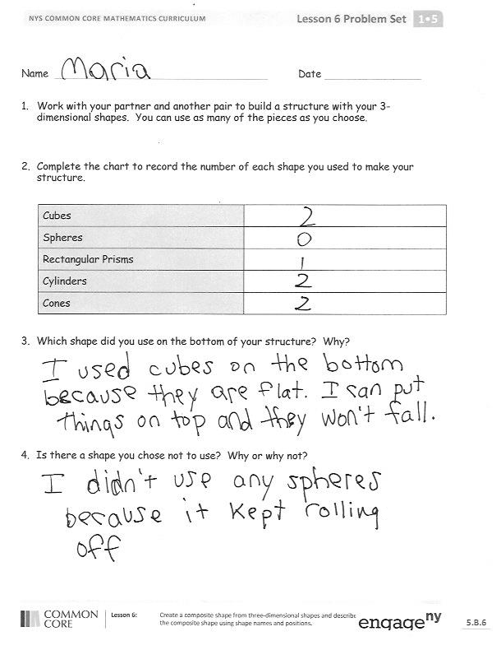
Problem Set (10 minutes)
Students should do their personal best to complete the Problem Set within the allotted 10 minutes. For some classes, it may be appropriate to modify the assignment by specifying which problems they work on first.
Student Debrief (10 minutes)
Lesson Objective: Create a composite shape from three-dimensional shapes and describe the composite shape using shape names and positions.
The Student Debrief is intended to invite reflection and active processing of the total lesson experience.
Invite students to review their solutions for the Problem Set. They should check work by comparing answers with a partner before going over answers as a class. Look for misconceptions or misunderstandings that can be addressed in the Debrief. Guide students in a conversation to debrief the Problem Set and process the lesson.

Any combination of the questions below may be used to lead the discussion.
- Which three-dimensional shapes did you choose to use and why? Why did you choose to leave some shapes out?
- Were more spheres or cubes used in the structures? Why might that be?
- Find two three-dimensional structures that used the same pieces to make different larger shapes. Explain the similarities and differences.
- Look at today’s Sprint. Explain how the answer to the first number sentence helped you easily solve the next number sentence.
Exit Ticket (3 minutes)
After the Student Debrief, instruct students to complete the Exit Ticket. A review of their work will help with assessing students’ understanding of the concepts that were presented in today’s lesson and planning more effectively for future lessons. The questions may be read aloud to the students.

Name Date
- Work with your partner and another pair to build a structure with your
3-dimensional shapes. You can use as many of the pieces as you choose.

- Complete the chart to record the number of each shape you used to make your structure.
Cubes
Spheres
Rectangular Prisms
Cylinders
Cones

- Which shape did you use on the bottom of your structure? Why?

- Is there a shape you chose not to use? Why or why not?

Name Date
Maria made a structure using her 3-dimensional shapes. Use your shapes to try to make the same structure as Maria as your teacher reads the description of Maria’s structure.
Maria’s structure has:
- 1 rectangular prism with the shortest face touching the table.
- 1 cube on top and to the right of the rectangular prism.
- 1 cylinder on top of the cube with the circular face touching the cube.

Name Date
- Use some 3-dimensional shapes to make another structure. The chart below gives you some ideas of objects you could find at home. You can use objects from the chart or other objects you may have at home.
Cube | Rectangular prism | Cylinder | Sphere | 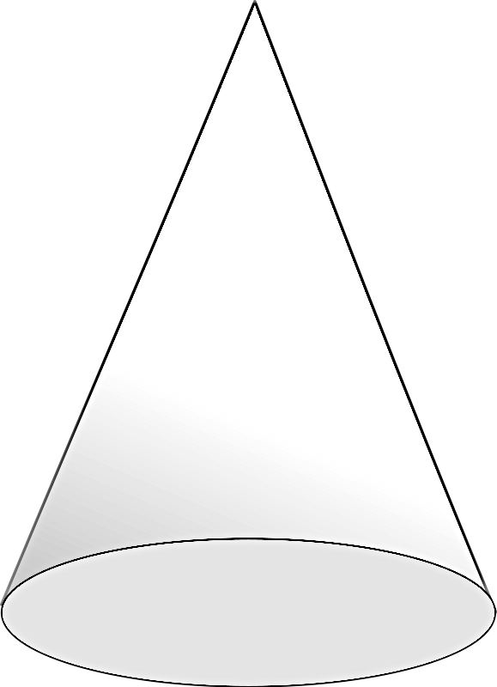  Cone
Block | Food box:  Cereal, macaroni and cheese, spaghetti, cake mix, juice box | Food can:  Soup, vegetables, tuna fish, peanut butter | Tennis ball | Ice cream cone
Dice | Tissue box | Toilet paper or paper towel roll | Rubber band ball | Party hat
 | Hardcover book | Glue stick | Basketball | Funnel
 | DVD or video game box |  | Soccer ball
Ask someone at home to take a picture of your structure. If you are unable to take a picture, try to sketch your structure or write the directions on how to build your structure on the back of the paper.

