Lesson 5
Objective: Compose a new shape from composite shapes.

Suggested Lesson Structure

A NOTE ON
STANDARDS ALIGNMENT:
In this lesson, students use tangram pieces as a context for composing a new shape from composite shapes (1.G.2). The Progression Document on Geometry does not include parallelogram as a shape for Grade 1 students, although this shape is one of the basic shapes within a tangram.

 Fluency Practice (13 minutes)
 Application Problem (5 minutes)
 Concept Development (32 minutes)
 Student Debrief (10 minutes)
Total Time (60 minutes)
Fluency Practice (13 minutes)
- Grade 1 Core Fluency Sprint 1.OA.6 (10 minutes)
- Shape Flash 1.G.1 (3 minutes)
Grade 1 Core Fluency Sprint (10 minutes)
Materials: (S) Core Fluency Sprint (Lesson 1 Core Fluency Sprint)
Note: Choose an appropriate Sprint, based on the needs of the class. Motivate students to monitor and appreciate their own progress. As students work, observe the areas where they slow down or get stuck. Pay attention to the strategies students use.
Core Fluency Sprint List:
- Core Addition Sprint 1 (Targets core addition and missing addends.)
- Core Addition Sprint 2 (Targets the most challenging addition within 10.)
- Core Subtraction Sprint (Targets core subtraction.)
- Core Fluency Sprint: Totals of 5, 6, and 7 (Develops understanding of the relationship between addition and subtraction.)
- Core Fluency Sprint: Totals of 8, 9, and 10 (Develops understanding of the relationship between addition and subtraction.)
Shape Flash (3 minutes)
Materials: (T) Two-dimensional shape flash cards (Lesson 4 Fluency Template), three-dimensional shapes used in Lesson 3
Note: This fluency activity reviews the attributes and names of two-dimensional and three-dimensional shapes. For three-dimensional shapes, consider displaying the shape as students answer the questions. As soon as students are ready to visualize, flash the shape instead. Repeat Shape Flash from Lesson 4.
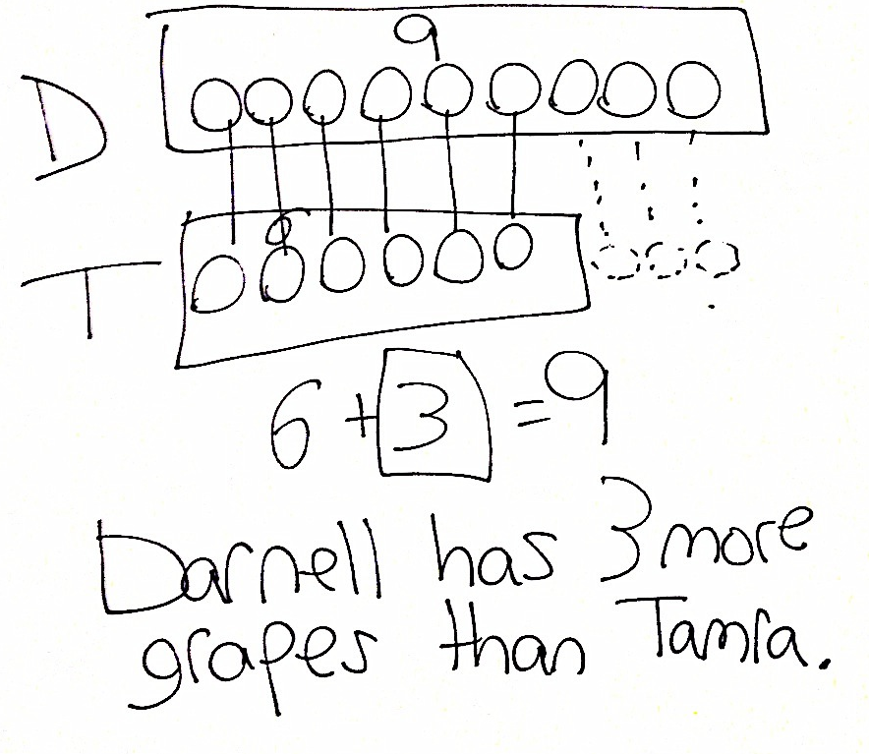
Application Problem (5 minutes)
Darnell and Tamra are comparing their grapes. Darnell’s vine has 9 grapes. Tamra’s vine has 6 grapes. How many more grapes does Darnell have than Tamra?
Note: This compare with difference unknown problem continues to engage students in the same type of problem using different contexts and a larger difference between the numbers. If necessary, remind students that they are comparing Darnell’s grapes and Tamra’s grapes. When comparing two numbers, it is best to use double tape diagrams, which more clearly support visualizing the difference between the two quantities.
Concept Development (32 minutes)
Materials: (T) Tangram (Template), scissors (S) Tangram (Template) (cut off bottom tangram on each sheet to be sent home with homework), scissors
Note: This lesson uses tangrams. If time allows, consider sharing the origin of the tangram or read Grandfather Tang’s Story by Ann Tompert. Of the 7 individual pieces within a tangram, there is one shape that is not part of the Grade 1 Standards for Geometry: parallelogram. For this reason, the attributes of a parallelogram are not discussed in this lesson. Students are introduced to the shape name as a way to discuss the pieces being used as they create composite shapes.

NOTES ON
MULTIPLE MEANS
OF ENGAGEMENT:
Some students may need support cutting their tangram sheets. Precut some of the sheets, or, as the rest of the class is cutting, assist certain students.
Have students store their tangram pieces in their personal toolkits to be used during Lesson 7.
Cut out the large square from the tangram sheet to be used by the teacher. Distribute the materials to the students, seated at their desks or tables.
T: Today, we will be cutting out our shapes from this one large shape. What is this shape? (Hold up the tangram backward, so students do not see all of the lines within the square.)
S: A square.
T: Cut out the large square from your piece of paper. (Wait as students cut.)
T: Look how I folded my paper down the diagonal line that goes through the middle of the square. (Fold paper.) What do you see on one side?
S: A triangle!
T: Cut out this triangle on your paper as I cut out my triangle.
(Cut out triangle as students cut out triangle.)
T: How many pieces do you have now?
S: Two pieces!
T: What is the shape of each piece?
S: They are both triangles!
T: Both of these triangles are made of smaller parts. What parts do you see in this triangle? (Hold up triangle made of two triangles.)
S: That triangle is made of two smaller triangles.
T: What parts do you see in this triangle? (Hold up other triangle.)
S: I see two small triangles and one bigger triangle. I see a square. I see another shape. It kind of looks like a rhombus, but the sides don’t look like they are the same length.
T: You are right. That shape (point to parallelogram) is not quite a rhombus. A rhombus is a special parallelogram that has equal straight sides. When the shape is like this, where all pairs of opposite sides are equal, it is called a parallelogram. Do you see how this pair is not the same length as this pair? One pair is long, and the other is shorter, so it cannot be called a rhombus. We just call it a parallelogram.

NOTES ON
MULTIPLE MEANS
OF ENGAGEMENT:
Arranging shapes to create specific composite shapes and then recomposing the pieces into different shapes can be challenging for some students. Be sure to allow time for students to use models or work with a partner as these students work on coordinating their visual and motor skills.
T: Let’s cut apart the two triangles that make this first large triangle. (Fold the larger triangle in half to show the two smaller triangles, and cut. Students do the same.)
T: Put your two triangles you cut apart to the side. Take the largest triangle on your table, and place it in front of you like mine. (Place the longest side as the base.) Let’s cut off this little triangle at the top. (Students and teacher all cut off top triangle.)
T: What shape do the square, little triangles, and parallelogram make together? Do you see what shape has been hiding inside the larger triangle?
S: A trapezoid!
T: Let’s cut out the parallelogram. (Cut and circulate as students are cutting.)
T: What shape do the two triangles and the square make together?
S: A smaller trapezoid!
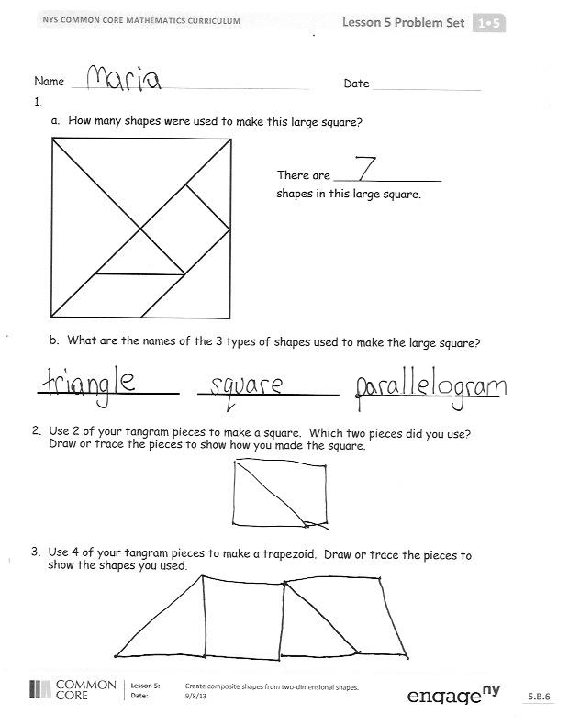
T: Now, let’s cut apart all of the last pieces.
(Cut and circulate as students are cutting.)
T: Put your pieces back to form the large square we started with. (Allow students ample time to position the pieces. Make every effort not to interfere as students work at positioning the shapes during this sequence of the lesson. Encourage students to persevere, providing the least direction possible. For students who finish quickly, have them shuffle their pieces and try to make new shapes.)
MP.1
T: Great job! These seven pieces that form a large square are called a tangram. You can make lots of different and interesting shapes by combining some or all of the parts. Let’s use just the two largest triangles. Put all the other pieces to the side. (Wait as students move pieces.)
T: If I leave these pieces the way they were, what shape do they make when they are together?
S: A large triangle!
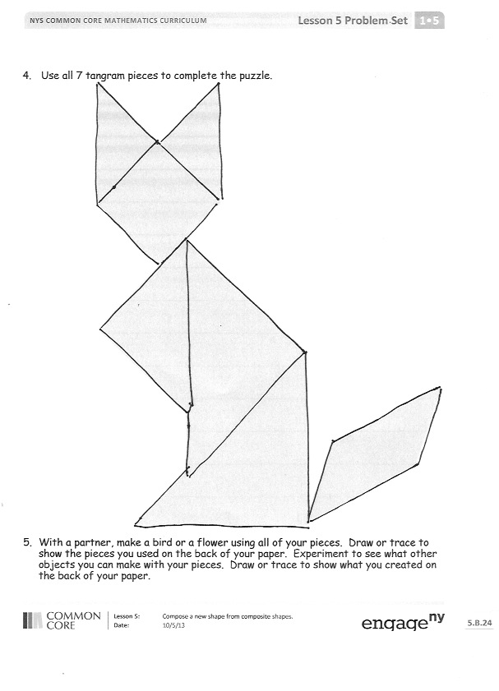
T: Move the shapes around, and see if you can make another shape using the same pieces. (Circulate as students work individually or with a partner.)
T: What shape did you make?
S: I made a square. I made a parallelogram.
T: With your partner, take two or three of the same tangram pieces, and try to each make a different shape using the same pieces. Here’s a hint: You may want to flip over your pieces, turn them, or slide them around to make the new shapes.
After students have worked with their partners for two or three minutes, have pairs share one of the various composite shapes they made.
Problem Set (10 minutes)
Students should do their personal best to complete the Problem Set within the allotted 10 minutes. For some classes, it may be appropriate to modify the assignment by specifying which problems they work on first. Some problems do not specify a method for solving.
Student Debrief (10 minutes)
Lesson Objective: Compose a new shape from composite shapes.
The Student Debrief is intended to invite reflection and active processing of the total lesson experience.
Invite students to review their solutions for the Problem Set. They should check work by comparing answers with a partner before going over answers as a class. Look for misconceptions or misunderstandings that can be addressed in the Debrief. Guide students in a conversation to debrief the Problem Set and process the lesson.
Any combination of the questions below may be used to lead the discussion.
- Which shapes are used to make the large square we call a tangram? Which smaller shapes can be seen inside the tangram square?
- Look at Problem 2. Share how you made a square. Could you have used other tangram pieces to make the square?
- Look at Problem 3. Share how you made a trapezoid with four pieces. Could you have made a trapezoid with fewer pieces? Demonstrate your solution. Compare the similarities and differences.
- How did you cover the picture in Problem 4? Did everyone use the same pieces in the same places? Why or why not?
- Think about today’s Fluency Practice. Did you get better at a slow-me-down problem today? Did you do anything to make that happen?
Exit Ticket (3 minutes)
After the Student Debrief, instruct students to complete the Exit Ticket. A review of their work will help with assessing students’ understanding of the concepts that were presented in today’s lesson and planning more effectively for future lessons. The questions may be read aloud to the students.

Name Date

- How many shapes were used to make this large square?
There are _______________ shapes in this large square.

- What are the names of the 3 types of shapes used to make the large square?

- Use 2 of your tangram pieces to make a square. Which 2 pieces did you use? Draw or trace the pieces to show how you made the square.

- Use 4 of your tangram pieces to make a trapezoid. Draw or trace the pieces to show the shapes you used.

- Use all 7 tangram pieces to complete the puzzle.

- With a partner, make a bird or a flower using all of your pieces. Draw or trace to show the pieces you used on the back of your paper. Experiment to see what other objects you can make with your pieces. Draw or trace to show what you created on the back of your paper.
Name Date
  - Use words or drawings to show how you can make a larger shape with 3 smaller shapes. Remember to use the names of the shapes in your example.

Name Date
- Cut out all of the tangram pieces from the separate piece of paper you brought home from school. It looks like this:

  - Tell a family member the name of each shape.

  - Follow the directions to make each shape below. Draw or trace to show the parts you used to make the shape.
- Use 2 tangram pieces to make 1 triangle.

- Use 1 square and 1 triangle to make 1 trapezoid.

- Use one more piece to change the trapezoid into a rectangle.

- Make an animal with all of your pieces. Draw or trace to show the pieces you used. Label your drawing with the animal’s name.

One tangram is to be used during class.
The other tangram is to be sent home with the homework.

tangram

