|  |
| --- |
|  |

Lesson 6: Modeling a Context from Data

Student Outcomes

* Students write equations to model data from tables, which can be represented with linear, quadratic, or exponential functions, including several from Lessons 4 and 5. They recognize when a set of data can be modeled with a linear, exponential, or quadratic function and create the equation that models the data.
* Students interpret the function in terms of the context in which it is presented, make predictions based on the model, and use an appropriate level of precision for reporting results and solutions.

Lesson Notes

This real-life descriptive modeling lesson is about creating different types of functions based on data, including linear, quadratic, and exponential. This lesson uses the full modeling cycle as explained on page 61 of the CCLS or page 72 of the CCSS.



(Note that this lesson will likely require a calculator and graph paper.)

Classwork

Opening Exercise (5 minutes)

Display the three sets of data below on the board or screen. Divide the class up into three sections. Each section has to analyze one table. Students must complete the following:

Opening Exercise

* 1. Identify the type of function that each table appears to represent (e.g., quadratic, linear, exponential, square root).

**A**

|  |  |
| --- | --- |
|  |  |
|  |  |
|  |  |
|  |  |
|  |  |
|  |  |

**B**

|  |  |
| --- | --- |
|  |  |
|  |  |
|  |  |
|  |  |
|  |  |
|  |  |

**C**

|  |  |
| --- | --- |
|  |  |
|  |  |
|  |  |
|  |  |
|  |  |
|  |  |

* 1. Explain how you were able to identify the function.
  2. Find the symbolic representation of the function.
  3. Plot the graphs of your data.

Have one student from each section share the work of his or her group with the class and explain the group’s approach. Discuss the strategies of each group. Make sure all students are grounded in the three procedures for recognizing the three basic functions (i.e., linear, quadratic, and exponential).

*Scaffolding:*

Have students create a “crib sheet” for the three different functions (i.e., linear, exponential, and quadratic), with information for how to identify them and completed examples. This might be part of their journals or notebooks for this module.

* 1. A: Linear B: Exponential C: Quadratic
  2. I looked at the difference in each output.  
     A is constant so that it is linear (common difference is ),   
     B is a geometric sequence (common ratio is ), and for  
     C the difference of the differences is the same number (), so it is quadratic.
  3. A: B: C:

d.

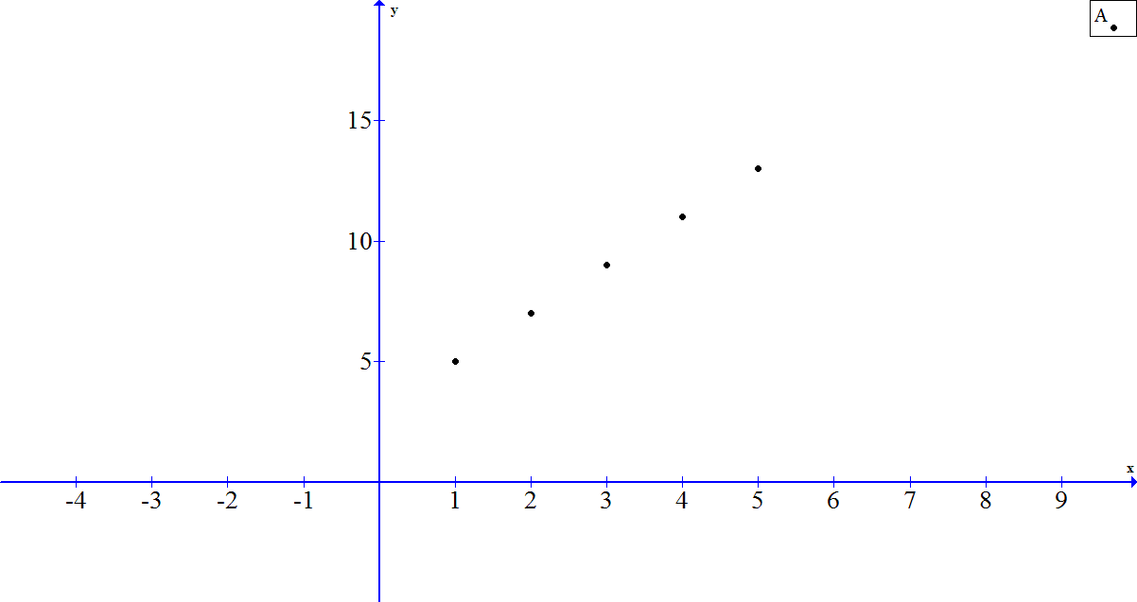

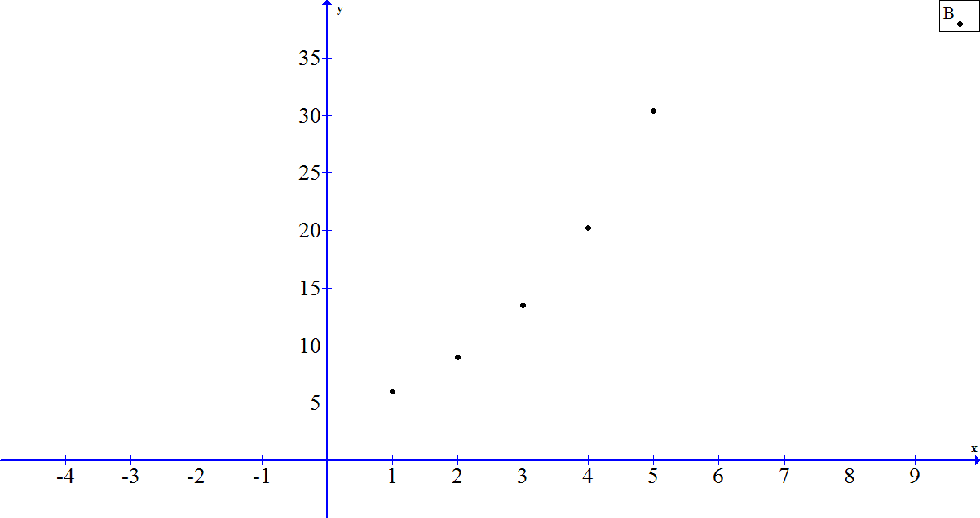

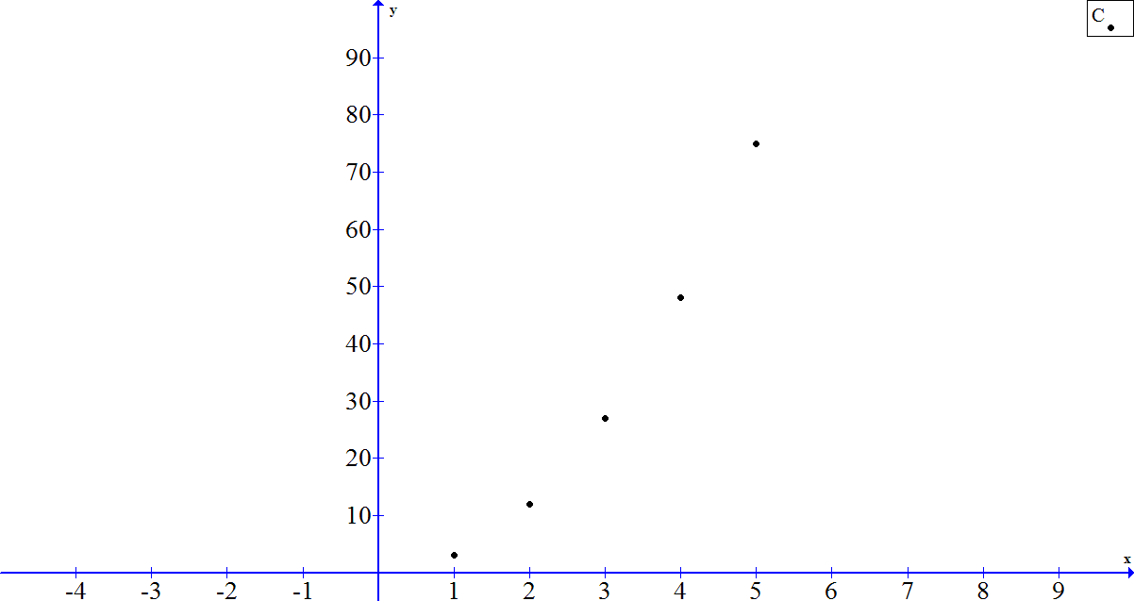

*Scaffolding:*

You might begin with this example as a guided activity to help struggling students get started. Then let them try to create and use student responses to guide the discussion further, if needed.

* Start by plotting the pairs in the table using the values in the second and third columns.
* Let’s look at the graph of this data (see below). (Window – : , : )
* The graph appears to be linear, but it’s important to remember the window we are looking at might be hiding some important features of the graph. Try changing the window to see what is happening in other parts of the coordinate plane.
* This could be a quadratic graph. We will need to investigate further with the data.
* So, let’s look for common differences and key features in the table.

Example 1 (15 minutes)

* The approach we take when examining sequences and tables can be used when we want to model data.

Present the following problem and have students work with a partner or small group to answer the questions related to the data set. Depending on the needs of your students, you might use this example as an independent exercise or a guided group activity. Some scaffolding suggestions are offered in the box on the right that you might use to get the students started on building the model. Note that this example is designed to be a quadratic pattern that appears linear with no accounting for statistical variability in measurement.

Example 1

Enrique is a biologist who has been monitoring the population of a rare fish in Lake Placid. He has tracked the population for years and has come up with the following estimates:

|  |  |  |
| --- | --- | --- |
| Year Tracked | Year Since | Estimated Fish Population |
|  |  |  |
|  |  |  |
|  |  |  |
|  |  |  |
|  |  |  |

Create a graph and a function to model this situation, and use it to predict (assuming the trend continues) when the fish population will be gone from the Lake Placid ecosystem. Verify your results, and explain the limitations of each model.

When we plot this data in a reasonable viewing window, the data appear to be linear. One limitation of using a graph is that it is difficult to get a viewing window that allows us to see all of the key features of the function represented. When we look at the first differences, we can see that this is not a linear relationship. To determine when the fish population will be gone, we need to find the function to model this situation.

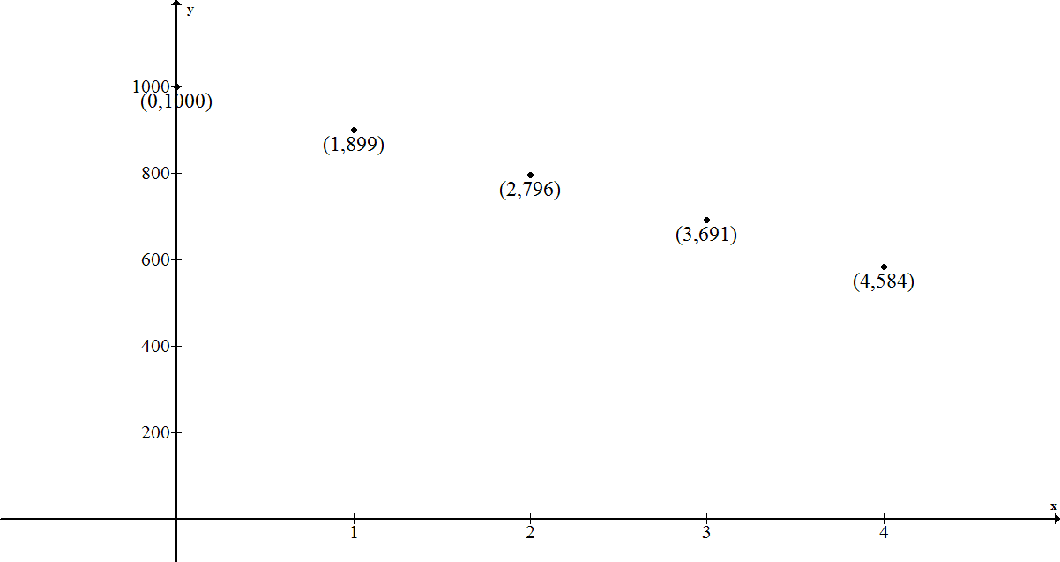

Looking at differences may help us identify the function type. The first differences are ,,,, etc. These are not the same but are at regular intervals. That tells us that there will be a common second difference, in this case . This data can be modeled with a quadratic function.

Creating a symbolic representation:

The standard form for a quadratic function is .

We know that is the-intercept. That tells us . Now we have .

Substitute :

Substitute :

Now solve the linear system:

Now solve for :

The function model is .

So, now we need to determine when the fish population will be .

Solve .

Using the quadratic formula: or

Since only the positive number of years is reasonable in this situation, we will say that years after 2002.

Depending on whether the initial measurement is taken at the beginning of 2002 or at the end, we could say that the fish population will be gone during 2011 or that it will be gone by 2012.

The function model has fewer limitations than the graph, but it provides results that need to be interpreted in the context of the problem.

This problem requires that students make decisions about precision during their problem-solving process but especially at the end when they must answer the question about which year the fish population will actually be gone.

**MP.6**

Students may decide to extend the table. Here is what they will find. Make sure that they also create the function, verify their results, and discuss the limitations of their model.

|  |  |  |  |  |
| --- | --- | --- | --- | --- |
| Year Tracked | Year Since | Estimated Fish Population | 1st Difference | 2nd Difference |
|  |  |  |  |  |
|  |  |  |  |  |
|  |  |  |  |  |
|  |  |  |  |  |
|  |  |  |  |  |
|  |  |  |  |  |
|  |  |  |  |  |
|  |  |  |  |  |
|  |  |  |  |  |
|  |  |  |  |  |
|  |  | Fish are gone |  |  |

Exercises (20 minutes)

Exercises

1. Bella is a BMX bike racer and wants to identify the relationship between her bike’s weight and the height of jumps (a category she gets judged on when racing). On a practice course, she tests out bike models with different weights and comes up with the following data.

|  |  |
| --- | --- |
| Weight (lb.) | Height Of Jump (ft.) |
|  |  |
|  |  |
|  |  |
|  |  |
|  |  |
|  |  |
|  |  |
|  |  |

* 1. Bella is sponsored by Twilight Bikes and must ride a bike. What can she expect her jump height to be?

*By looking at the differences between the terms, we can identify that this is a linear relationship (or an arithmetic sequence) that decreases by for every increase in weight.*

* 1. Bella asks the bike engineers at Twilight to make the lightest bike possible. They tell her the lightest functional bike they could make is . Based on this data, what is the highest she should expect to jump if she only uses Twilight bikes?

* 1. What is the maximum weight of a bike if Bella’s jumps have to be at least high during a race?

1. The concentration of medicine in a patient’s blood as time passes is recorded in the table below.

|  |  |
| --- | --- |
| Time (hours) | Concentration of Medicine (ml) |
|  |  |
|  |  |
|  |  |
|  |  |
|  |  |

* 1. The patient cannot be active while the medicine is in his blood. How long, to the nearest minute, must the patient remain inactive? What are the limitations of your model(s)?

If we plot the points, we can see a general shape for the graph.

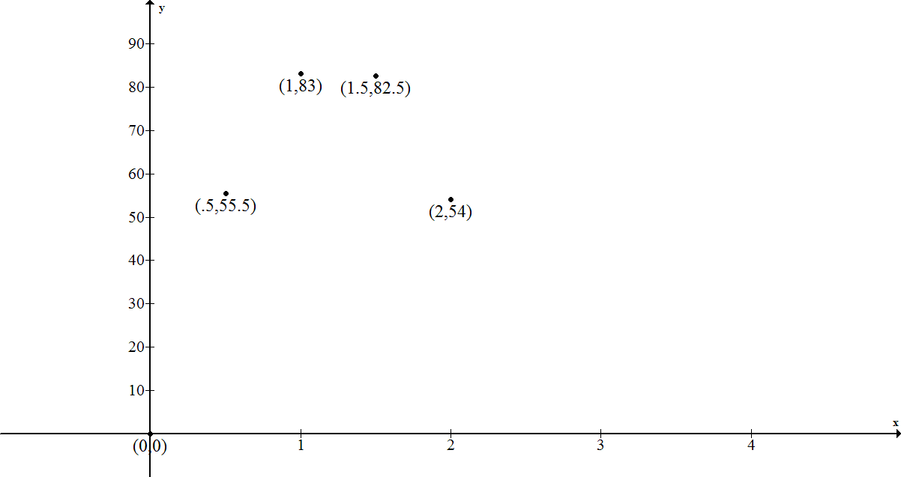

This might be a quadratic relationship, but we cannot be sure based on just the graph. If we look at the differences, we see that the first differences are , ,, and. Then, the second differences are consistently . Yes, this is a quadratic relationship.

Since we know is on the graph, the constant of the quadratic function is . Now we can use a system of two linear equations to find the symbolic representation:

Substituting

(Multiply both sides by to eliminate the decimals.)

Substituting

so,

We set the function equal to zero and find the other zero of the function to be or hours. For this context, hours makes sense. In hours and minutes, the patient must remain inactive forhours and minutes.

The function is a good model to use for answering this question since the graph requires some speculation and estimation.

Alternatively, students may generate a model by estimating the location of the vertex at about , and then using the vertex form of a quadratic equation. Using this method results in an equation of approximately. A useful extension activity could be to compare these two methods and models.

* 1. What is the highest concentration of medicine in the patient’s blood?

*Using the symmetry of the zeros of the function, we find the vertex to be at the midpoint between them or at . So the highest concentration will be* .

1. A student is conducting an experiment, and as time passes, the number of cells in the experiment decreases. How many cells will there be after minutes?

|  |  |
| --- | --- |
| Time (minutes) | Cells |
|  |  |
|  |  |
|  |  |
|  |  |
|  |  |
|  |  |
|  |  |

If we divide each term by the one before it, we see that this is a geometric sequence where the rate is and the initial value is . Therefore, we can represent this sequence symbolically by

cells

Closing (1 minute)

* What are the limitations when modeling from a set of data?
  + *We are working with a finite set of points. We must assume that the same trend or pattern would continue beyond the set of data.*

Lesson Summary

**When given a data set, strategies that could be used to determine the type of function that describes the relationship between the data are**

* **Determine the variables involved and plot the points.**
* **After making sure the -values are given at regular intervals, look for common differences between the data points—first and second.**
* **Determine the type of sequence the data models first, and then use the general form of the function equation to find the parameters for the symbolic representation of the function.**

Exit Ticket (4 minutes)

Name Date

Lesson 6: Modeling a Context from Data

Exit Ticket

Lewis’s dad put in a money market fund with a fixed interest rate when he was . Lewis cannot touch the money until he is , but he gets updates on the balance of his account.

|  |  |
| --- | --- |
| **Years After Lewis Turns** | **Account Balance in Dollars** |
|  |  |
|  |  |
|  |  |
|  |  |
|  |  |

* 1. Develop a model for this situation.
  2. Use your model to determine how much Lewis will have when he turns years old.
  3. Comment on the limitations/validity of your model.

Exit Ticket Sample Solutions

Lewis’s dad put in a money market fund with a fixed interest rate when he was . Lewis cannot touch the money until he is , but he gets updates on the balance of his account.

|  |  |
| --- | --- |
| Years After Lewis Turns 16 | Account Balance in Dollars |
|  |  |
|  |  |
|  |  |
|  |  |
|  |  |

* 1. Develop a model for this situation.

We might try graphing this data. However, in the viewing window that shows our data points (see graph below), it appears that the function might be linear. Let’s try zooming out to see more of the key features of this graph. (See graph below.)

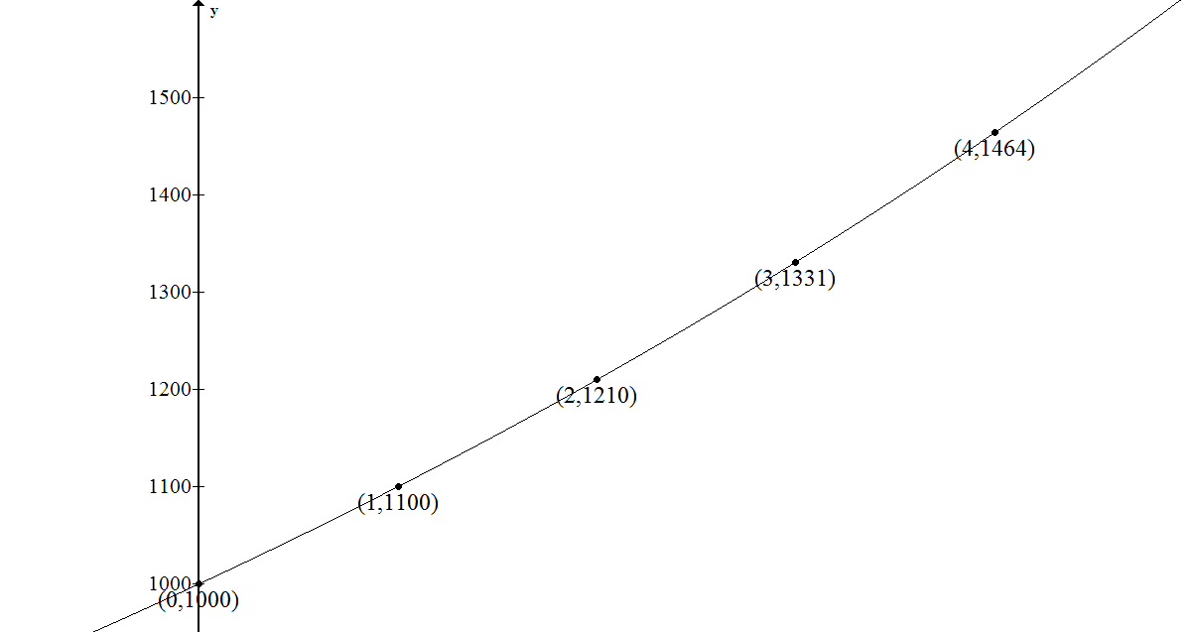

This viewing window gives us a close-up of the data points and their relation to each other. However, we cannot really see the features of the graph that represent the data.

***`***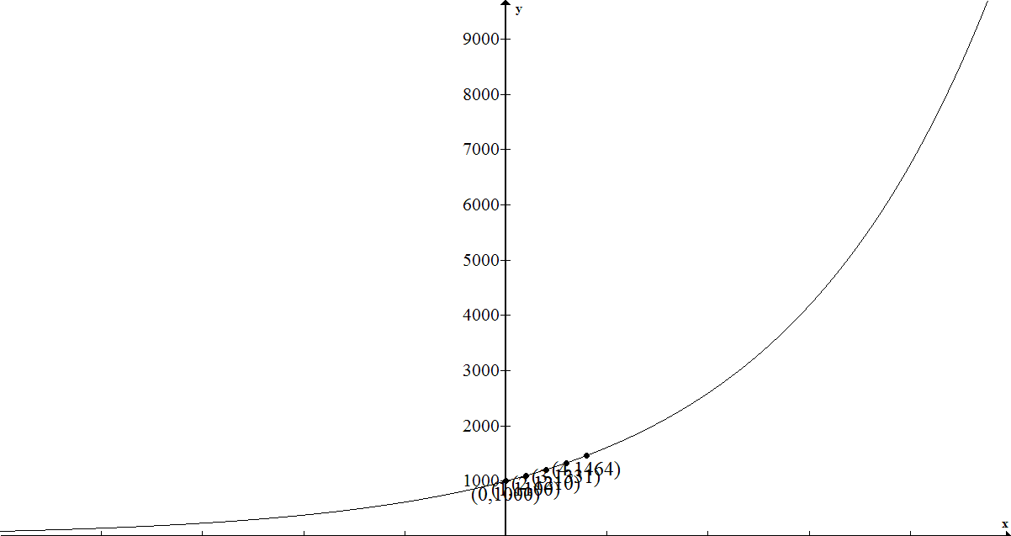

In this version of the graph, you can see how the data from our table is grouped on a very short section of the graph. From this view, we can see the exponential nature of the graph.

Using the data table to find a function model: The first and second differences have no commonalities; therefore, this is not linear or quadratic. Checking to see if there is a common ratio, we see that this is an exponential relationship (or a geometric sequence) where the common ratio is , and the initial value is . Check: Since on this table time starts at , using t as the exponent will yield for the initial balance.

Therefore, we can represent this sequence symbolically by

* 1. Use your model to determine how much Lewis will have when he turns years old.

***Using the function: Since Lewis will be 26 ten years after he turns , we will need to evaluate :***

or .

We might also try extending our data table to verify this result. There are a couple of precision decisions to make: Shall we use as the common ratio? How soon should we begin rounding numbers off? For this table, we decided to use as the common ratio and rounded to the nearest cent.

We might also try to answer this question using our graph. Below is another view of the graph. Can you estimate the balance at ?

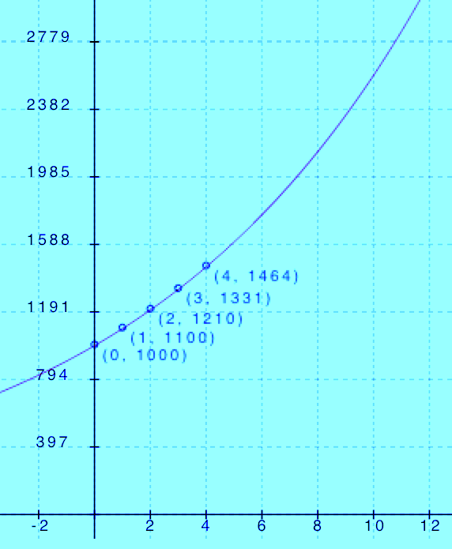

|  |  |  |
| --- | --- | --- |
| Lewis’s Age | Years After Lewis Turns 16 | Account Balance in Dollars |
|  |  |  |
|  |  |  |
|  |  |  |
|  |  |  |
|  |  |  |
|  |  |  |
|  |  |  |
|  |  |  |
|  |  |  |
|  |  |  |
|  |  |  |

* 1. Comment on the limitations/validity of your model.

As we saw in the first and second versions of the graph, there are limitations to the graphic model because we cannot always see the key features of the graph in a window that lets us see all the data points clearly. Being able to see the graph using both windows was more helpful. Then, in part (b), we saw how difficult it was to estimate the value of the function at for such large numbers of . We were also able to extend the table without too much difficulty, after deciding what level of precision we needed to use.

The equation was most helpful but requires interpretation of the data (noticing that the common ratio was very close but not absolutely perfect, and making sure we started with ).

Regardless of whether we use a graphical, numerical, or algebraic model, one limitation is that we are assuming the growth rate will remain constant until he is .

Problem Set Sample Solutions

Research linear, quadratic, and exponential functions using the internet.  For each of the three types of functions, provide an example of a problem/situation you found on the Internet where that function was used to model the situation or answer the problem.  Include the actual function used in the example and webpage where you found the example.

Answers will vary.