Lesson 4

Objective: Create composite shapes from two-dimensional shapes.

Suggested Lesson Structure
 Fluency Practice (13 minutes)
 Application Problem (7 minutes)
 Concept Development (30 minutes)
 Student Debrief (10 minutes)
Total Time (60 minutes)

Fluency Practice (13 minutes)
- Grade 1 Core Fluency Differentiated Practice Sets 1.OA.6 (5 minutes)
- Number Bond Addition and Subtraction 1.OA.6 (5 minutes)
- Shape Flash 1.G.1 (3 minutes)

Grade 1 Core Fluency Differentiated Practice Sets (5 minutes)
Materials: (S) Core Fluency Practice Sets (Lesson 3 Core Fluency Practice Sets)
Note: Give the appropriate Practice Set to each student. Students who are repeating a set should be motivated to try to improve their performance.
Students complete as many problems as they can in 90 seconds. Assign a counting pattern and start number for early finishers, or tell them to practice make ten addition and subtraction on the back of their papers. When time runs out, collect and correct any Practice Sets that are completed.

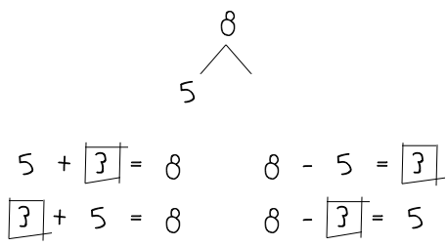
Number Bond Addition and Subtraction (5 minutes)

Materials: (S) Personal white board, 1 die per pair
Note: This fluency activity addresses Grade 1’s core fluency of sums and differences through 10 and strengthens understanding of the relationship between addition and subtraction.
- Assign partners of equal ability and an appropriate range of numbers for each pair.
- Allow partners to choose a number for their whole greater than or equal to 6 and roll the die to determine one of the parts.
- Both students write two addition and two subtraction sentences with a box for the unknown number in each equation and solve for the missing number.
NOTES ON
MULTIPLE MEANS
OF ACTION AND EXPRESSION:
Some students may find this fluency activity challenging or need more time finishing problems. Scaffold tasks by carefully selecting the number of problems to be completed for certain partners. Give students who need a challenge a pair of dice, and have them choose a whole equal to or greater than 12 and roll the dice to find one of the parts.

- They then exchange boards and check each other’s work.

Shape Flash (3 minutes)
Materials: (T) Two-dimensional shape flash cards (Fluency Template), three-dimensional shapes used in
Lesson 3
Note: This fluency activity reviews the attributes and names of two-dimensional (trapezoid, rhombus, square, rectangle, triangle) and three-dimensional (cone, cube, cylinder,
sphere, rectangular prism) shapes. For three-dimensional shapes, hold up a sample of the shape, rather than a picture of the shape. As soon as students are ready to visualize, flash the shape instead.
Flash a shape card or a three-dimensional shape for three seconds. Ask a question to review an attribute or a vocabulary word students learned over the past few lessons. Pause long enough to provide thinking time, and then snap to signal students to answer.
Alternate between flashing a two-dimensional shape flash card or a three-dimensional shape. For three-dimensional shapes, ask questions such as the ones listed below:
- What’s it called?
- How many faces did you see?
- How many points did this shape have?
- How many faces were square?
- Was the shape open or closed?

Application Problem (7 minutes)
Anton made a tower 5 cubes high. Ben made a tower 7 cubes high. How much taller is Ben’s tower than Anton’s?
Note: If students struggled with the compare with difference unknown problem in Lesson 3, use a guided approach. Have students follow the steps outlined below:
- Read the story’s first two sentences.
- Draw and label a picture.
- Analyze their drawing. Who has the taller tower? How many more cubes does Anton need to have a tower as tall as Ben’s?
- Read the question: How much taller is Ben’s tower than Anton’s?
- Reflect on their peers’ work. Show two students’ drawings and strategies using the document camera, and invite them to explain how they solved the problem.

Concept Development (30 minutes)
Materials: (T) Pattern blocks, chart paper, colored marker (S) Pattern blocks (set of 1–2 hexagons, 6 squares, 6–10 triangles, 2–4 trapezoids, 2–4 blue rhombuses, 2–4 tan rhombuses), personal white board (optional)
Note: Students will use the same set of pattern blocks during Lesson 7. It may be useful for students to place a set in their personal toolkit. Tell students that pattern blocks are actually three-dimensional solids that the class will use to create two-dimensional shapes. For example, when a student traces the yellow shape, he gets a two-dimensional hexagon on the paper.
Distribute materials, and have students seated at their desks or tables.
T: For the next few days, we will be using pattern blocks to learn more about shapes. Take two minutes to explore the kinds of shapes you can make using these materials.
As students explore, walk around and take note of examples that can be used during the lesson. If available, use a camera that can be easily plugged in to display images on the board to take pictures of any compositions that might be useful, or have students compose shapes on their personal white boards to easily share with the class.
T: What shapes do the pattern blocks come in?
S: Hexagons. Squares. Triangles. Trapezoids. Two different types of rhombuses.
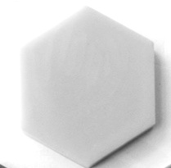T: Do we have any rectangles?
1 hexagon
S: A square is a special kind of rectangle!
T: You’re right. We DO have a special kind of rectangle in the square. The square is also a special kind of rhombus, so we actually have three types of rhombuses.
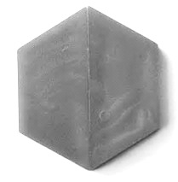T: Most of you made lots of bigger shapes, or composite shapes, by putting the pieces together. Try to make a larger rectangle using your squares.
2 trapezoids
S: (Use squares of varying number to make a rectangle.)
T: How did you make a larger rectangle?
S: I put two squares next to each other. I used all of my squares to make it really long.
T: I’m going to record the composite shapes that you are making. (Draw on chart paper while describing.) One person used two squares to make this size rectangle. Another person used four squares. (Quickly label the inside of each shape with the part, such as square. Label the outside of the shape with the word rectangle.) This whole rectangle is made of four parts that are squares. (Trace the whole rectangle with the colored marker.) Great!
T: Let’s move all of our blocks to the side and take out the hexagon. (Wait.)
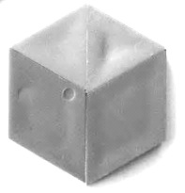T: Many of you made this same hexagon shape using other pieces. Try this again. Cover the hexagon with other shapes so that you make the exact same shape with other parts. (Give students 30 seconds or more to create a hexagon shape using parts.)
2 triangles and
2 rhombuses
T: Tell your partner what parts you used to make the hexagon.
S: I used six triangles. I used two trapezoids. I used three blue rhombuses.
T: Did anyone use different types of parts to make the hexagon?
S: I used two rhombuses and two triangles. I used one trapezoid and three triangles. I used four triangles and one rhombus.
T: Is there only one way to make one whole hexagon?
S: No!
Repeat the process with other composite shapes that can be named, such as the following: a large triangle, a large rhombus, a large square, and a large trapezoid.

NOTES ON
MULTIPLE MEANS
OF REPRESENTATION:
There are many directions to follow during this part of the lesson. Be sure to guide English language learners and students who have difficulty following multiple-step directions. These students would benefit from visual cues or possibly working with a partner at this time.
T: Now, move your pieces to the side again, and take out all of your square pieces. Make a rectangle with two rows of squares using all of your pieces. (Wait as students assemble the rectangle.)
T: How many small squares are in this rectangle?
S: Six squares. (Touch while counting the small squares together.)
T: Now, look closely. How many larger squares can you find hiding in the rectangle? Talk with a partner to decide. (Give students 20 to 30 seconds to look for the two larger squares.)
T: Where did you find a larger square?
S: The first four squares put together make a larger square.
If you start at the other end, you can make a square with the last four squares.
T: Great job! You can make six little squares from this rectangle, or you can make one large square using this side of the rectangle. (Point to or slide over the section on the left that forms a large square to help students visualize.
Then, slide this large square back.) You can also make one large square using this side of the rectangle. (Point to or slide over the section on the right that forms a large square to help students visualize. Then, slide this large square back.)
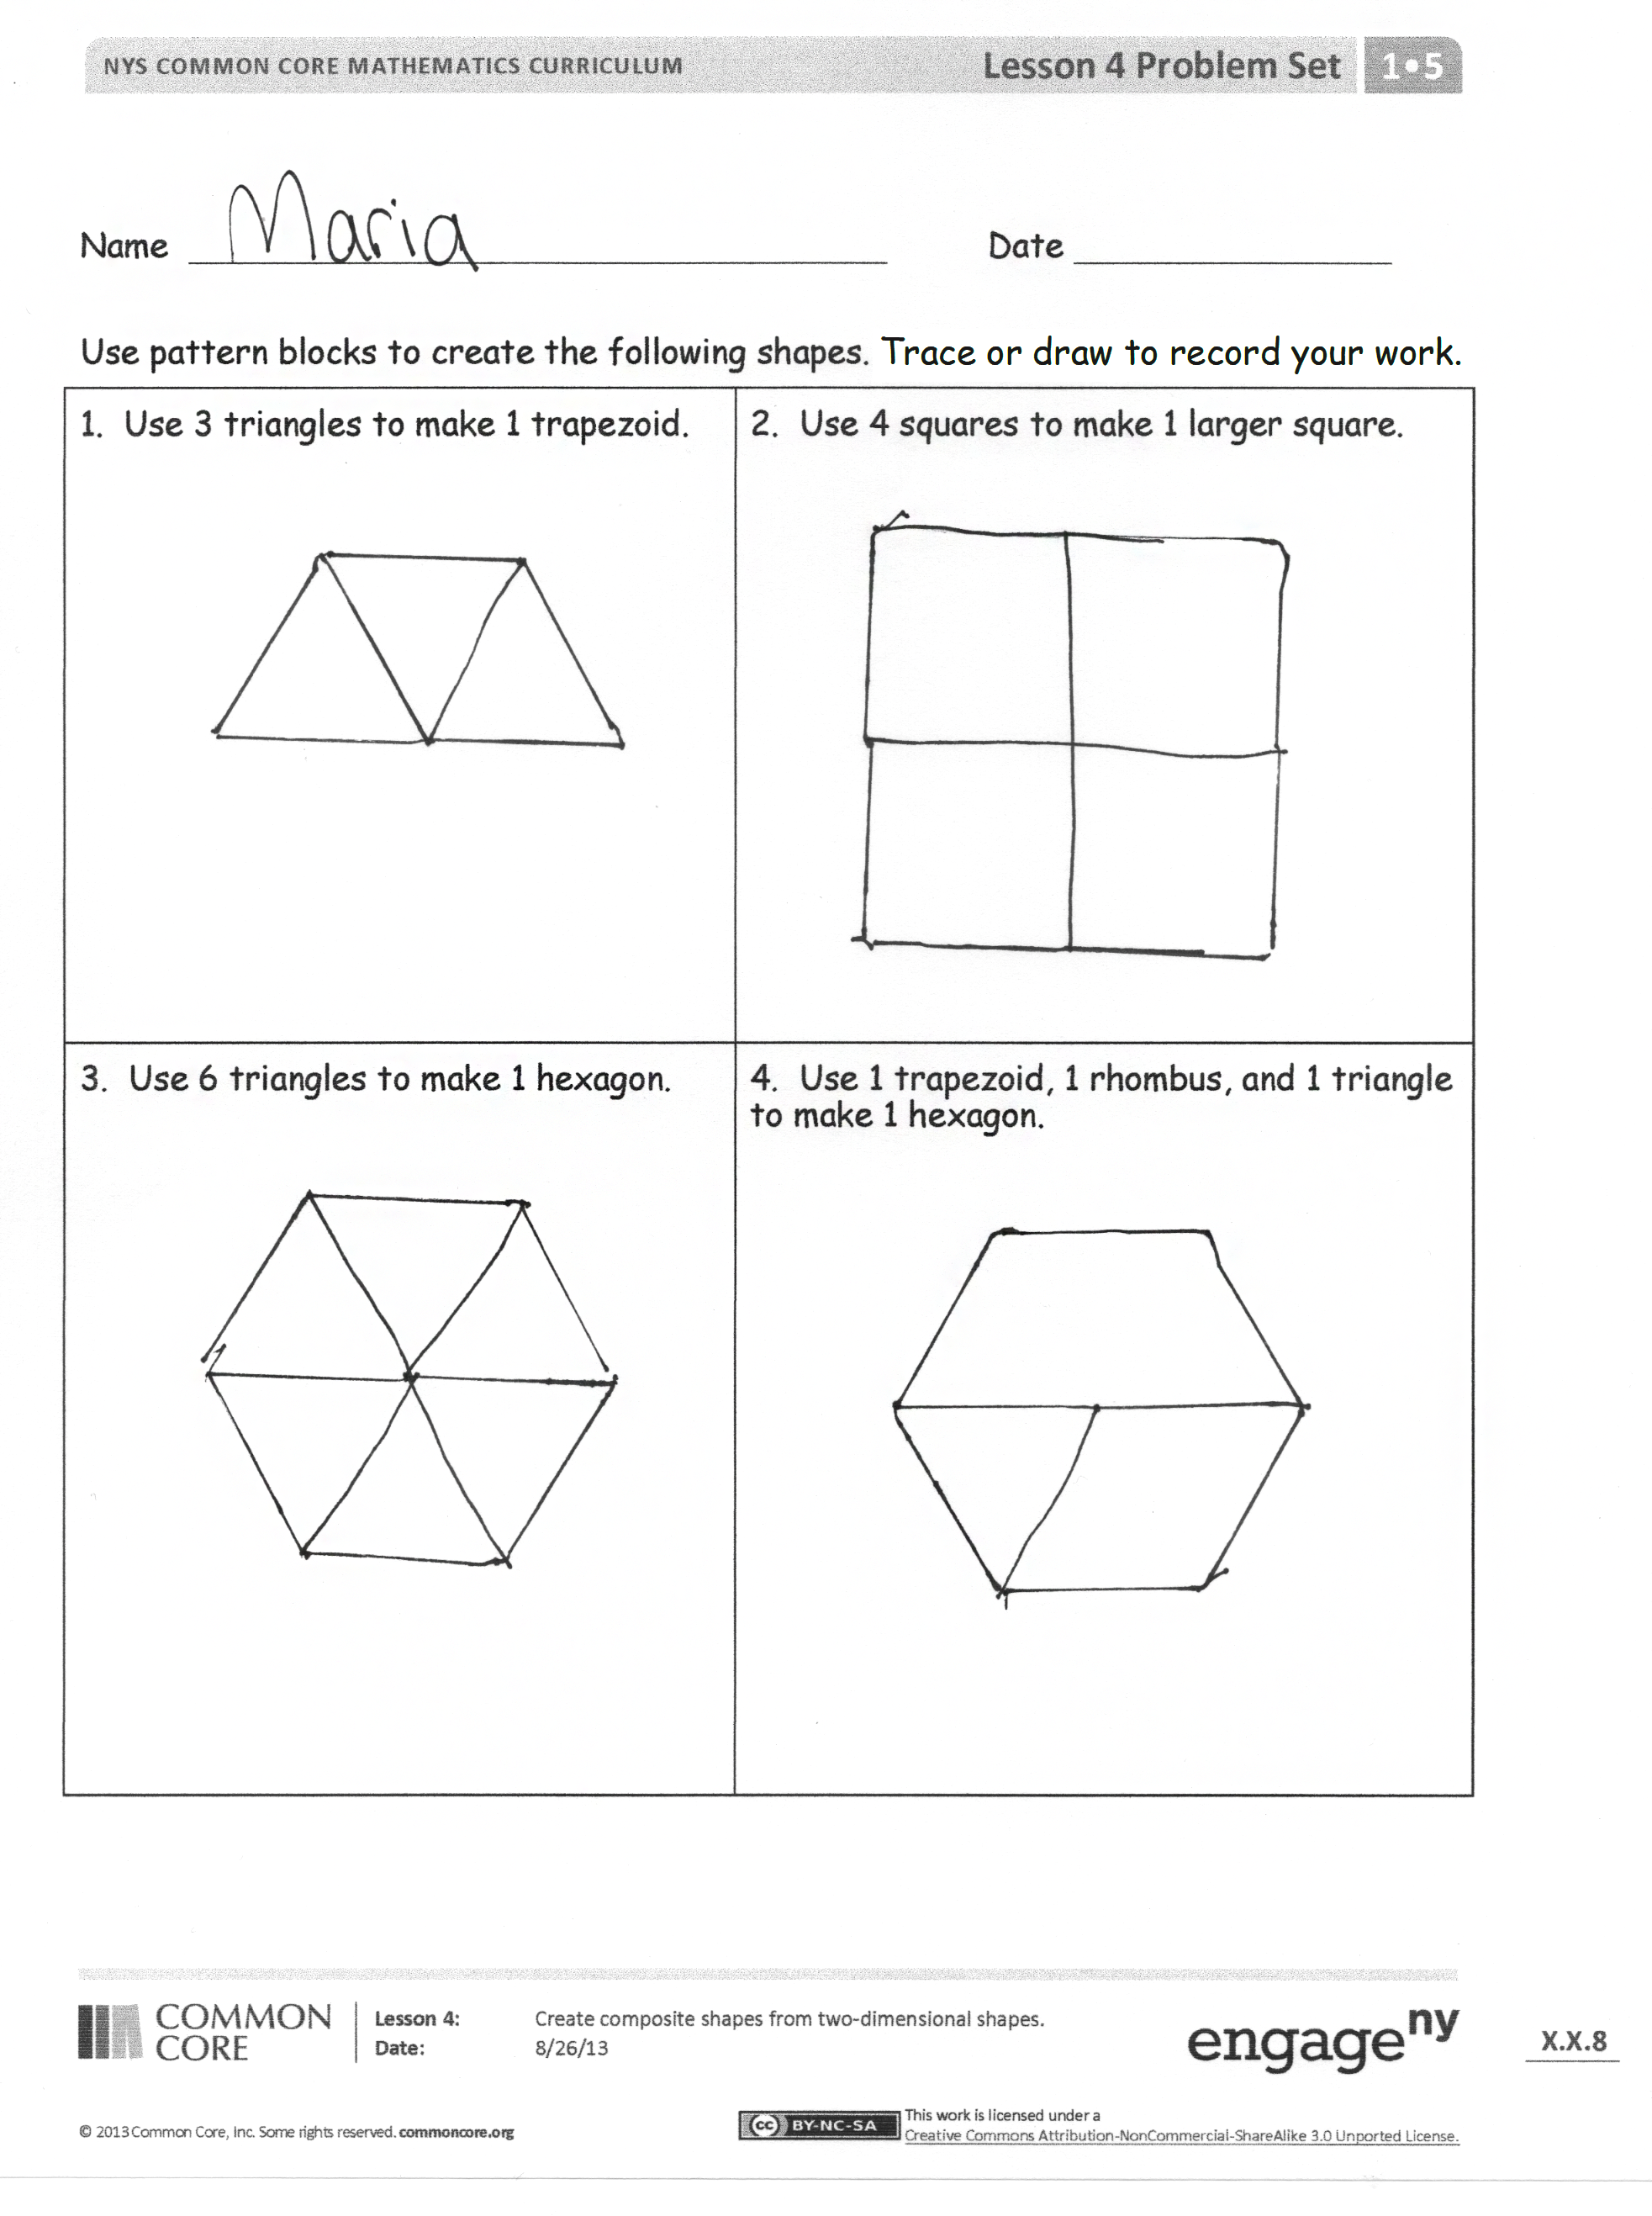
T: How many squares did we find all together?
S: Eight squares!
T: Although our composite shape of this rectangle is made of six squares, there are also larger squares composed of the smaller squares. Great detective work!

Problem Set (10 minutes)
Students should do their personal best to complete the Problem Set within the allotted 10 minutes. For some classes, it may be appropriate to modify the assignment by specifying which problems they work on first. Some problems do not specify a method for solving.

Student Debrief (10 minutes)
Lesson Objective: Create composite shapes from two-dimensional shapes.
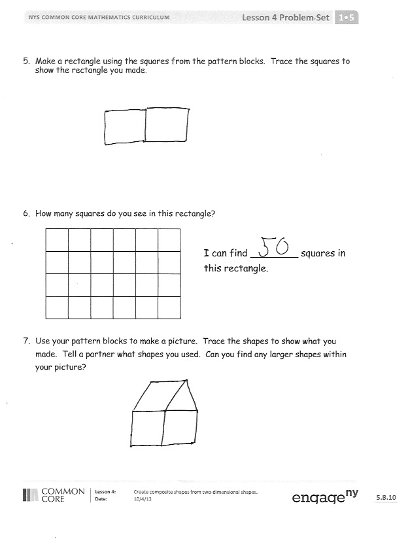
The Student Debrief is intended to invite reflection and active processing of the total lesson experience.
Invite students to review their solutions for the Problem Set. They should check work by comparing answers with a partner before going over answers as a class. Look for misconceptions or misunderstandings that can be addressed in the Debrief. Guide students in a conversation to debrief the Problem Set and process the lesson.
Any combination of the questions below may be used to lead the discussion.
- Compare Problem 1 and Problem 3. What do you notice?
- Look at Problem 4. How could your shape from Problem 1 help you come up with a new way to make a hexagon using the pattern blocks?
- Look at Problem 6. How many people found at least 20 squares? 22 squares? 25 squares? Can you find more squares than you have found so far? Work with a partner to share the squares you found and see if there are more that you can find together.
- Look at the picture you made in Problem 7. What composite shapes, or larger shapes made from smaller shapes, can you name within your picture? What smaller shapes were used to make these larger shapes?
- Think about today’s Fluency Practice. Name at least one addition problem that slows you down. Does anyone have a way to know that fact more easily?

Exit Ticket (3 minutes)
After the Student Debrief, instruct students to complete the Exit Ticket. A review of their work will help with assessing students’ understanding of the concepts that were presented in today’s lesson and planning more effectively for future lessons. The questions may be read aloud to the students.

Name Date
Use pattern blocks to create the following shapes. Trace or draw to record your work.
- Use 3 triangles to make 1 trapezoid. | - Use 4 squares to make 1 larger square.
- Use 6 triangles to make 1 hexagon. | - Use 1 trapezoid, 1 rhombus, and 1 triangle to make 1 hexagon.

- Make a rectangle using the squares from the pattern blocks. Trace the squares to show the rectangle you made.

- How many squares do you see in this rectangle?

I can find ________ squares in this rectangle.

- Use your pattern blocks to make a picture. Trace the shapes to show what you made. Tell a partner what shapes you used. Can you find any larger shapes within your picture?

Name Date
Use pattern blocks to create the following shapes. Trace or draw to show what you did.
- Use 3 rhombuses to make a hexagon. | - Use 1 hexagon and 3 triangles to make a large triangle.

Name Date
Cut out the pattern block shapes from the bottom of the page. Color them to match the key, which is different from the pattern block colors in class. Trace or draw to show what you did.
Hexagon—red Triangle—blue Rhombus—yellow Trapezoid—green

- Use 3 triangles to make 1 trapezoid. | - Use 3 triangles to make 1 trapezoid, and then add 1 trapezoid to make 1 hexagon.

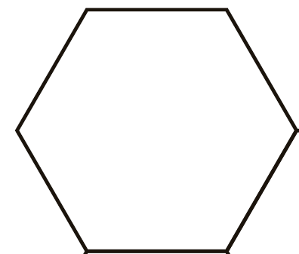

- How many squares do you see in this large square?

I can find ________ squares in this large square.

two-dimensional shape flash cards
two-dimensional shape flash cards
two-dimensional shape flash cards
two-dimensional shape flash cards

