|  |
| --- |
|  |

Lesson 4: Modeling a Context from a Graph

Student Outcomes

* Students create a two-variable equation that models the graph from a context. Function types include linear, quadratic, exponential, square root, cube root, and absolute value. They interpret the graph, function, and answer questions related to the model, choosing an appropriate level of precision in reporting their results.

Lesson Notes

In Lesson 1 of Module 5, students practiced formulating a function from a graph, making it through the first two steps in the modeling cycle: *interpreting* a problem situation and *formulating* a model. This lesson continues the modeling cycle by having students *compute, interpret,* and *validate*. This is an exploratory lesson, allowing students to practice modeling through prompts and then to discuss the process with the class. The lesson ends with a difficult modeling exercise dealing with a square root function.

Refer to the modeling cycle below when abstracting and contextualizing. (See page 61 of the CCLS and page 72 of the CCSS.)

Throughout this lesson, students work through the steps in the full modeling cycle. When presented with a problem, they will make sense of the given information, analyze the presentation, define the variables involved, look for entry points to a solution, and create an equation to be used as a model. After formulating a model they perform computations, interpret the model, validate their results, make adjustments to the model when needed, and report results.

**MP.1**

**&**

**MP.4**

Classwork

Exploratory Challenge (10 minutes)

Print and cut out the cards at the end of the lesson before class begins. A card should have either a graph or a function, not both. Once the students are seated, hand out only one card to each student. Make sure to shuffle the cards so that the matches are not sitting right together. There are cards all together: with graphs and with functions in equation form. Be sure to count ahead of time so that every function card has a matching graph. If there are an odd number of students, then you will need to take a card and play the matching game as well. Instruct students to look at their cards and decide what the graph/function will look like for their match. Then have them hold up their cards so others can see it, and move around the room to look for their match. When the matches have found each other, have them stand next to each other. Check to make sure each pair is accurate before students return to their seats. Note that this activity requires some estimation of values on the graphs.

Discussion (**5** minutes)

* What was your strategy when trying to find your graph or function match?
  + *For the graph: I looked at the overall shape first to identify what type of graph it was (quadratic, linear, exponential, piecewise, square root, or cube root). I looked at the end behavior of the graph to determine the sign of the slope (linear) or leading coefficient (quadratic). I also looked at the - and   
    -intercepts, domain, range, and any minimum or maximum -values. Then, I looked for an equation to match these characteristics.*
  + *For the equation: I first looked for the function type, which narrowed my search considerably. Then, I looked for key features that are evident from the equation like transformations, - and/or -intercepts, end behavior, slope, etc. Then, I looked for a graph with those characteristics.*
* If you had to come up with a function based only on looking at a graph (rather than having a function to match it to), what might some possible steps be?
  + *Identify what type of function it is (Linear, quadratic, cubic, exponential, piecewise, square root, cube root, etc.).*
  + *Compare the graph to the parent function; look for transformations (shifts and/or stretching/shrinking).*
* *Look for key features of the graph that may be recognized in the function’s equation.*
* *Check the equation by testing a couple of points that can be read from the graph or from a given table of values.*
* *Make a table of known ordered pairs to help analyze the values in the graph.*

The next example will take us further into the modeling cycle. Display the modeling cycle on the board or screen and point out the parts of the activity that relate to the steps in the cycle.

**Example 1 (8 minutes)**

The following example is used to connect the students’ exploration results to the modeling cycle. Work through the problem together as a class, and use the questions that follow to stimulate a discussion of how to apply the steps in the full modeling cycle. Students may need to have the parent function provided since they may be somewhat unfamiliar with the square root function.

Example 1

Read the problem below. Your teacher will walk you through the process of using the steps in the modeling cycle to guide your solution.

The relationship between the length of one of the legs, in feet, of an animal and its walking speed, in feet per second, can be modeled by the graph below. Note: This function applies to walking not running speed. Obviously, a cheetah has shorter legs than a giraffe but can run much faster. However, in a walking race, the giraffe has the advantage.

A T-Rex’s leg length was . What was the T-Rex’s speed in ?

* What are the units involved in this problem? Define the quantities and variables you would use to model this graph.
  + *Leg length is in feet, and speed is measured in feet per second, so time is measured in seconds. Use to represent the number of feet in leg length and to represent the speed based on leg length.*
* What type of function does this graph represent? What clues in the graph helped you recognize the function?
  + *There are only positive values and it starts at , so this is probably a square root function, but it could be the right half of a cube root function. I need to check a few points to be sure.*

After you get the correct response to the first question, draw or project the following three transformations of the square root function on the board or screen: ,,.

* Which transformation of the function does this graph represent? How can we determine that?
  + *Sample Response: cannot be the form because the square root of is not, so it is either or . We can test both forms by substituting the - and -values from the points provided to us.*

*First, check the form: .*

*Since we got for both ordered pairs, it appears that is the correct form and that   
.*

*To make sure, we will also check the form: .*

*The function cannot be .*

* Is the problem solved?
  + *We are not finished. Now we need to use the function we found to calculate the speed of the T-Rex with a -foot leg using .*
* What is the walking speed of the T-Rex?
  + *, or about feet per second.*
* What if we doubled the length of T-Rex’s legs? Would the T-Rex walk twice as fast?
  + *A square root function does not double if the input is doubled. The graph shows that when the input went from to , the output does not quadruple. A proportional relationship would have a double-the-input-double-the-output effect, but a square root function is not proportional. A proportional relationship between two quantities must be linear. If we look at the Eduardo graph (Exercise 1), we can see a proportional relationship.*

Exercises (18 minutes)

Have students work in pairs or small groups on the following three exercises. You may want to do the first one as a guided exercise, depending on the needs of your students.

Remind the students that they saw Eduardo’s work graph (shown below) in Lesson 1. At that time, we only formulated a model that could be used for that context. Now, we will further examine this context.

Exercises

Now practice using the modeling cycle with these problems:

1. Eduardo has a summer job that pays him a certain rate for the first hours per week and time and a half for any overtime. The graph below is a representation of how much money he earns as a function of the hours he works in one week.

Eduardo’s employers want to make him a salaried employee, which means he does not get overtime. If they want to pay him per week but have him commit to hours a week, should he agree to the salary change? Justify your answer mathematically.

* 1. Formulate(recall this step from Lesson 1).
     1. What type of function can be represented by a graph like this (e.g., quadratic, linear, exponential, piecewise, square root, or cube root)?

The graph is of a function that is piecewise defined and made up of two linear functions.

* + 1. How would you describe the end behavior of the graph in the context of this problem?

As gets infinitely large, so does the function. However, realistically there is a limit to how many hours per week he can work, so there is a maximum value for this function.

* + 1. How does this affect the equation of our function?

The slope for each graph is positive. We may need to state restrictions on the domain and also on the range.

* 1. Compute
     1. What strategy do you plan to use to come up with the model for this context?

Identify the domains for each piece (linear function) in the piecewise function. Find the slope and   
-intercept for each linear piece, and then put the equations in slope-intercept form.

* + 1. Find the function of this graph. Show all your work.

For the lower piece, domain: .

The -intercept is , and the given points in that domain are and . To calculate the slope

if

For the upper piece, domain: .

This part of the problem requires using not only the graph but also the context from the problem. Up to this point, Eduardo has worked hours and has earned dollars an hour. . This is the   
-value when for the second linear equation. Again, we find the slope of the equation by selecting two points and . . Looking at the graph, we also see that the second line was moved units to the right (translated), so is .

* 1. Interpret
     1. How much does Eduardo make an hour?

if and if .

* + 1. By looking only at the graphs, which interval has a greater average rate of change: or ? Justify your answer by making connections to the graph and its verbal description.

The verbal description states that Eduardo gets paid more after hours of work. If you look at how steep the graph is after hours, you can see that it is increasing at a faster rate than when it was hours or less.

* + 1. Eduardo’s employers want to make Eduardo a salaried employee, which means he does not get overtime. If they want to pay him per week but have him commit to hours a week, should he agree to the salary change? Justify your answer mathematically.

. He would get paid more as an hourly employee if he worked hours a week. It seems that it would be in his best interest to keep the hourly agreement rather than the salary. Students may come up with other responses but should at least understand that Eduardo earns more money for hours of work as an hourly employee than he would as a salaried employee. If students show that understanding, then they have answered the question correctly.

* 1. Validate

How can you check to make sure your function models the graph accurately?

For the values in our graph, we can substitute the -values into the function to see if the same given -value is a result.

Display this graph on the screen or board, and use the questions that follow to explore the modeling cycle.

1. The cross-section view of a deep river gorge is modeled by the graph shown below where both height and distance are measured in miles. How long is a bridge that spans the gorge from the point labeled to the other side? How high above the bottom of the gorge is the bridge?



*Scaffolding:*

* Have students build a table in their math journals/notebooks that lists all of the different function types and a picture of the parent function’s graph with key features highlighted.
* Encourage all students to use their math journals/notebooks as a reference.

* 1. Formulate
     1. What type of function can be represented by a graph like this (e.g., quadratic, linear, exponential, piecewise, square root, or cube root)?

Quadratic

* + 1. What are the quantities in this problem?

The quantities are height relative to the location of the bridge and horizontal distance from the point highest point in the gorge ().

* + 1. How would you describe the end behavior of the graph?

Opening upward

* + 1. What is a general form for this function type?
    2. How does knowing the function type and end behavior affect the equation of the function for this graph?

The equation is a second-degree polynomial where the leading coefficient is positive.

* + 1. What is the equation we would use to model this graph?

Using the three ordered pairs in the graph:

: From this pair, we see that and

Now substitute the other two ordered pairs to form a linear system:

:

:

From here we see thatand . So, substituting into the first linear equation, we have   
.

So, the equation is.

* 1. Compute
     1. What are the key features of the graph that can be used to determine the equation?

The -intercept and the other two given ordered pairs.

* + 1. Which key features of the function must be determined?

The zeros and the vertex must be determined.

* + 1. Calculate the missing key features and check for accuracy with your graph.

Using the sum-product property, we find . So, the other end of the bridge is at the point . The vertex is located midway between the -intercepts. Therefore, . .

* 1. Interpret
     1. What domain makes sense for this context? Explain.

Since is the horizontal distance from, the domain that makes sense is . In order to know the upper limits of the domain, we would need to know the height of the highest point on the other side of the gorge, which cannot be determined with much accuracy from the given graph. We could assume it is between and miles.

* + 1. How wide is the bridge with one side located at ?

It would be the difference between the -coordinates of the -intercepts.

miles wide

* + 1. How high is the bridge above the bottom of the gorge?

The minimum value of the function will represent the lowest point. Since the height shown on the graph is relative to the location of the bridge, the bridge would be miles above the bottom of the gorge. The -coordinate of the minimum point represents that height below the bridge.

* + 1. Suppose the gorge is exactly feet wide from its two highest points. Find the average rate of change for the interval from to . Explain this phenomenon. Are there other intervals that will behave similarly?

The average rate of change for that interval is . The two points are points of symmetry straight across the curve from each other. The line passing through them is horizontal. Any interval with endpoints that are symmetry points will be horizontal ( slope).

* 1. Validate

How can you check to make sure that your function models the graph accurately?

We can substitute any -value from the graph into the function to see if the resulting -value is reasonable for the graph.

1. Now compare four representations that may be involved in the modeling process. How is each useful for each phase of the modeling cycle? Explain the advantages and disadvantages of each.

The verbal description helps us define the quantities and, in this case, write the factored form of the equation for the function. We always need to find another representation to analyze or interpret the situation.

The graph is visual and allows us to see the overall shape and end behavior of the function. We can “see” some integer values of the function but must estimate any non-integer values. The graph is a good way to check calculations to make sure results are reasonable.

The table, in general, does not help us to see shapes (patterns in ) any better than the graph does. However, a table with equal -intervals does help us to see the patterns in -values very well.

The equation allows us to accurately calculate values of the function for any real number. It can be rewritten in various forms to help us see features of the function (vertex form, standard form, factored form). It allows deep analysis and is sometimes referred to as an analytical model.

Closing (2 minutes)

As a class, review the Lesson Summary below.

Lesson Summary

**When modeling from a graph use the full modeling cycle:**

* **Formulate: Identify the variables involved, classify the type of graph presented, point out the visible key features, and create a different representation of the relationship if needed.**
* **Compute: Decontextualize the graph from the application and analyze it. You might have to find a symbolic or tabular representation of the graph to further analyze it.**
* **Interpret: Contextualize the features of the function and your results and make sense of them in the context provided.**
* **Validate: Check your results with the context. Do your answers make sense? Are the calculations accurate? Are there possibilities for error?**
* **Report: Clearly write your results.**

Exit Ticket (2 minutes)

Name Date

Lesson 4: Modeling a Context from a Graph

Exit Ticket

1. Why might we want to represent a graph of a function in analytical form?
2. Why might we want to represent a graph as a table of values?

Exit Ticket Sample Solutions

1. Why might we want to represent a graph of a function in analytical form?

Graphs require estimation for many values, and for most we can calculate exact values using the function equation. Some key features that may not be visible or clear on a graph can be seen in the symbolic representation.

1. Why might we want to represent a graph as a table of values?

In a table of values, we can sometimes better see patterns in the relationship between the - and -values.

Problem Set Sample Solutions

Let the students know that these problems have little or no scaffolding and that they should use all the skills they learned in both Lessons 1 and 4 related to modeling a context from graphs.

1. During tryouts for the track team, Bob is running-foot wind sprints by running from a starting line to the far wall of the gym and back. At time, he is at the starting line and ready to accelerate toward the opposite wall. Asapproaches seconds he must slow down, stop for just an instant to touch the wall, then turn around, and sprint back to the starting line. His distance, in feet, from the starting line with respect to the number of seconds that has passed for one repetition is modeled by the graph below.

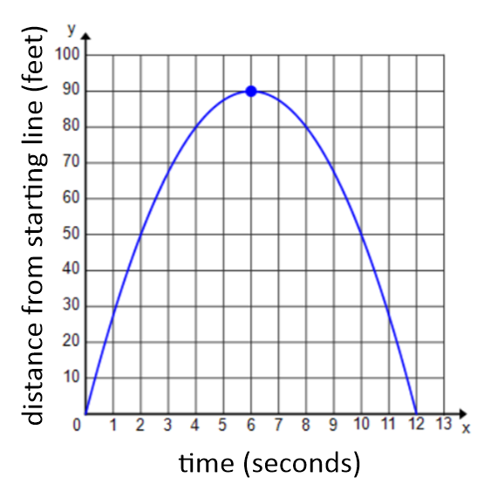

(Note: You may refer to Lesson 1, Problem Set 1 to help answer this question.)

How far was Bob from the starting line at seconds? seconds? (Distances, in feet, should be represented to the nearest tenth.)

So far we know: (Now we need to find .)

Substitute :

The final function is .

*Bob was and from the starting line, respectively.*

1. Kyle and Abed each threw a baseball across a field. The height of the balls is described by functions and , where is the number of seconds the baseball is in the air. (equation below left) models the height of Kyle’s baseball, and models the height of Abed’s baseball (graph below):

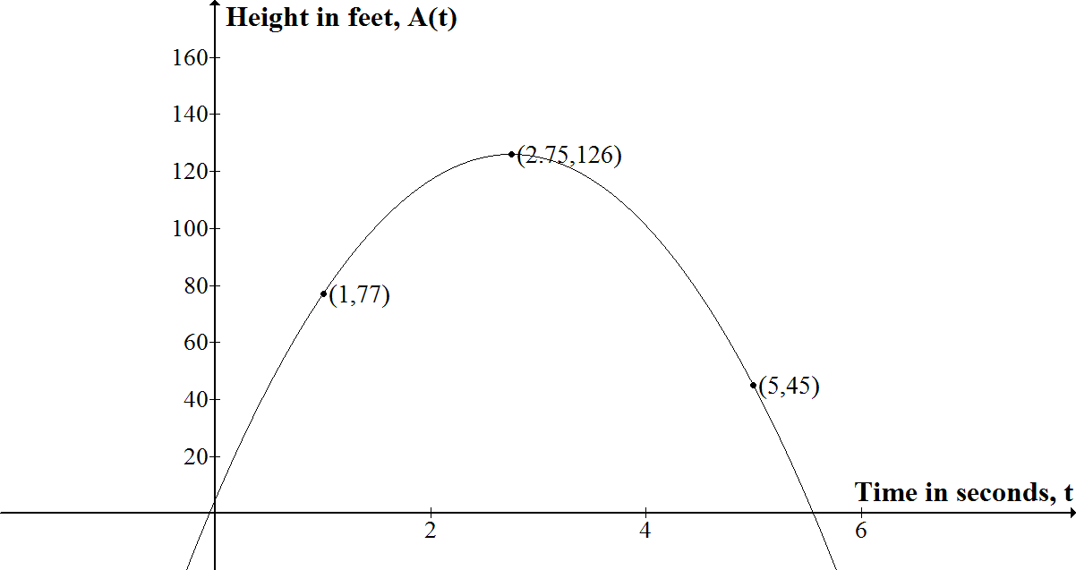

* 1. Which ball was in the air for a longer period of time?

We need to find the time when the ball is back on the ground (i.e., when the height function equals ). First .

We can see from the graph that the ball is in the air from to somewhere between and . So, just by reading the graph, we might estimate the time in the air to be a little more than seconds. We can get a more accurate number by formulating a model and then doing some calculations.

Using the vertex form:

If we substitute :

So, .

Now solve:

Only the positive value makes sense in this context, so Abed’s ball was in the air for seconds.

Now for :

Using the quadratic formula to find the zeros:

Only the positive value makes sense in this context. So Kyle’s ball was in the air for seconds.

Abed’s ball was in the air longer.

* 1. Whose ball goes higher?

*We see in the graph of that the highest point for Abed’s ball is . Now we need to find the maximum value for . One way to find the maximum is to put the equation in vertex form:*

*So, the vertex for is and Kyle’s ball went about into the air. Abed’s ball went higher.*

* 1. How high was Abed’s ball when he threw it?

Now we are looking for the -intercept for (i.e., the height when time is ). We can either use the vertex form of the equation, or we can rewrite the equation in standard form.

*That means is the vertical-intercept, and the ball was at when thrown by Abed.*

Or we can substitute into the vertex form:

*So, the ball left Abed’s hand at a height of* .

|  |  |
| --- | --- |
|  |  |
|  |  |
|  |  |
|  |  |
|  |  |
|  |  |
|  |  |
|  |  |
|  |  |
|  |  |
|  |  |
|  |  |
|  |  |
|  |  |
|  |  |
|  |  |
| m5lf |  |