|  |
| --- |
|  |

Lesson 1: Analyzing a Graph

Student Outcomes

* From a graphic representation, students recognize the function type, interpret key features of the graph, and create an equation or table to use as a model of the context for functions addressed in previous modules (i.e., linear, exponential, quadratic, cubic, square root, cube root, absolute value, and other piecewise functions).

Lesson Notes

This lesson asks students to recognize a function type from a graph, from the function library studied this year (i.e., linear, exponential, quadratic, cubic, square root, cube root, absolute value, and other piecewise functions), and to formulate an analytical, symbolic model. For this lesson, students do not go beyond the second step in the modeling cycle, focusing instead on recognition and formulation only. Unlike in previous modules, no curriculum clues are provided (e.g., Lesson or Module title) to guide students toward the type of function represented by the graph. There will be a mix of function types, and students will learn to recognize the clues that are in the graph itself. They will analyze the relationship between the variables and key features of the graph and/or the context to identify the function type. Key features include the overall shape of the graph (to identify the function type), - and -intercepts (to identify zeros and initial conditions of the function), symmetry, vertices (to identify minimum or maximum values of the function), end behavior, slopes of line segments between two points (to identify average rates of change over intervals), sharp corners or cusps (to identify potential piecewise functions), and gaps or indicated end points (to identify domain and range restrictions).

Throughout this module, teachers should refer to the modeling cycle below (found on page 61 of the CCLS and page 72 of the CCSS):

Note: Writing in a math journal or notebook is suggested for this lesson and all of Module 5. Encourage students to keep and use their journal as a reference throughout the module.

**MP.1**

**&**

**MP.4**

The Opening Exercise and Discussion for this lesson involve students learning skills important to the modeling cycle. When presented with a problem, they will make sense of the given information, analyze the presentation, define the variables involved, look for entry points to a solution, and create an equation to be used as an analytical model.

Classwork

Opening Exercise (8 minutes)

The discussion following the Opening Exercise assumes students have already filled out the Function Summary Chart. Unless you have time to allow students to work on the chart during class, it would be best to assign the chart as the Problem Set the night before this lesson so that this discussion can be a discussion of the students’ responses. If time allows, you might use two days for this lesson, with the first day spent discussing the Function Summary Chart and the second day starting with Example 1.

Have students work independently, but allow them time to confer with a partner or small group as they fill in the chart below. Remember that students studied many of these functions earlier in the year and their memories may need to be refreshed. As needed, remind them of the key features that could provide evidence for the function types. Try to keep this exercise to about one minute per graph. You might even set a timer and have students come up with as many features as possible in one minute. Allow them to include the table in their journals or notebooks as a reference and to add to it as they work through this lesson and subsequent lessons in this module. The descriptions provided in the third column of the chart are not meant to be exhaustive. Students may have fewer or more observations than the chart provides. Observations may be related to the parent function but should also take into account the key features of transformations of the parent.

*Scaffolding:*

* Using a visual journal of the function families will help struggling students to conceptualize the various functions in their growing library and to more readily recognize those functions.
* For accelerated students who may need a challenge, ask them to explore cubic functions in factored form and comment on the differences in the key features of those graphs as compared to the basic parent cubic functions. For example, explore the key features of this cubic graph:



In the Function Summary Chart, and later in this module, the cubic functions we are exploring are basic transformations of the parent function only. We do not yet delve into the study of the general cubic function. The descriptions in the chart relate to features of a basic cubic function and its transformations only, (i.e., vertical or horizontal translation and/or vertical or horizontal scaling).

Opening Exercise

The graphs below give examples for each parent function we have studied this year. For each graph, identify the function type and the general form of the parent function’s equation; then offer general observations on the key features of the graph that helped you identify the function type. (Function types include linear, quadratic, exponential, square root, cube root, cubic, absolute value, and other piecewise functions. Key features may include the overall shape of the graph,  
 - and -intercepts, symmetry, a vertex, end behavior, domain and range values or restrictions, and average rates of change over an interval.)

|  |  |  |
| --- | --- | --- |
| Function Summary Chart | | |
| Graph | Function Type and Parent Function | Function Clues: Key Features, Observations |
|  | Linear | * Overall shape is a straight line. * Generally, there is one intercept for each axis, except in the case where the slope is . * In this graph of the parent function, the - and -intercept are the same point, . * The average rate of change is the same for every interval. * If a line is horizontal, it is still a function (slope is ) but not if it is vertical. * There is no symmetry. |
|  | Absolute value | * Overall shape is a V. * Has a vertex—minimum or maximum value depending on the sign of the leading coefficient. * The domain is all real numbers, and the range will vary. * Average rates of change are constant for all intervals with endpoints on the same side of the vertex. * Either goes up or down to infinity. * Reflects across a line of symmetry at the vertex. * May have one, two, or no -intercepts and always has one -intercept. * This is actually a linear piecewise function. |
|  | Exponential | * Overall shape is a growth or decay function. * For the parent shown here (growth), as increases, increases more quickly; for decay functions, as increases, decreases. * Domain: is all real numbers, the range varies but is limited. * For this growth parent, is always greater than . * For the decay parent, is also always greater than . * For growth or decay functions with a vertical shift, will be greater than the value of the shift. * The parent growth or decay function has no -intercepts (no zeros) and one-intercept, but those with a vertical shift down will have one -intercept and one -intercept, and those with a vertical shift up will have no -intercepts and one -intercept. * There is no minimum or maximum value. * Even though there will be range restrictions for growth, the average rate of change increases as the intervals move to the right; the average rate of change can never be . * There is no symmetry. |

|  |  |  |
| --- | --- | --- |
|  | Quadratic | * Overall shape is a U. * Has a vertex—minimum or maximum value depending on the sign of the leading coefficient. * Average rates of change are different for every interval with endpoints on the same side of the vertex. * Symmetry across a line of symmetry—for this parent function it is the -axis. * There may be none, one, or two -intercepts, depending on the position of the graph in relation to the -axis. * There is always one -intercept. |
|  | Square root | * Reflection and rotation of part of the quadratic function; no negative values for or . * Related to the graph of but only allows non-negative values. * There may be none or one - and -intercept, depending on the position of the graph in relation to the axes. * These graphs always have an endpoint, which can be considered a minimum or maximum value of the function. * There are domain and range restrictions depending on the position of the graph on the coordinate plane. * There is no symmetry. |
|  | Cubic | * The overall shape of the parent function is a curve that rises gently and then appears to level off then begin to rise again. * The parent function will have one - and one -intercept—in this parent graph both are the point . * The parent graph skims across either side of the -axis where it crosses. * If the leading coefficient is negative, the curve will reflect across the -axis. * There is no symmetry. |
|  | Cube root | * Overall shape is a rotation and reflection of the cubic (an S curve). * Domain: is all real numbers. * and have the same sign. * Will have one - and one -intercept. * For the parent graph, the -and -intercepts happen to be the same point . |

|  |  |  |
| --- | --- | --- |
| m5l4b | Piecewise defined (linear) | * Overall shape is sections (intervals) of different graphs—this example shows a piecewise linear function * It has a corner or cusp where the two pieces of the graph meet * This example is not absolute value because it is not a reflection * Domain and range depend on the definition of the function   Note: The general form of the equations might be different and still be correct. |

Hold a short discussion about the charts in the Opening Exercise. Have students refer to their charts to answer the questions below and add to their charts as they gain insights from the discussion. Let them know that this chart will be their reference tool as they work on the lessons in this module. Encourage students to fill it out as completely as possible and to add relevant notes to their math notebooks or journals.

* When presented with a graph, what is the most important key feature that will help you recognize the type of function it represents?
  + *Overall shape is the most readily apparent feature of each function.*
* Which graphs have a minimum or maximum value?
  + *Quadratic, absolute value, square root, and some piecewise functions*
* Which have domain restrictions? What are those restrictions?
  + *Square root (no negative numbers allowed under the radical) and sometimes piecewise (with defined restrictions in the domains)*
* Which will have restrictions on their range?
  + *Square root, absolute value, exponential, quadratic, and sometimes piecewise functions*
* Which have lines of symmetry?
  + *Absolute value and quadratic functions*
* Which of the parent functions are transformations of other parent functions?
  + *Cubic and cube root functions, quadratic and square root functions*
* How are you able to recognize the function if the graph is a transformation of the parent function?
  + *The overall shape will be the same, even though sometimes it is shifted (vertically or horizontally), stretched or shrunk, and/or reflected.*

**Example 1 (8 minutes)**

Project the graph that follows onto the board or screen. Make sure it is enlarged so that the coordinates are visible. Have students look closely at the piecewise function and talk them through the questions. Leave the graph on the screen while they work on Exercise 1, but discourage them from looking ahead.

* Piecewise defined functions have the most variety of all the graphs you have studied this year. Let’s look more closely at the piecewise function in your chart in the Opening Exercise.

Example 1

Eduardo has a summer job that pays him a certain rate for the first hours each week and time-and-a-half for any overtime hours. The graph below shows how much money he earns as a function of the hours he works in one week.



*Scaffolding:*

If students are unable to recognize the correct function for the piecewise graph, write the four functions shown below on the screen or board near the graph, and have the students consider each for a few seconds. Then, ask the questions that follow to guide the discussion.

* Which of these general functions below could be used to represent the graph above? How did you choose?

A:

B:

C:

D:

* + *C: . The graph is a piecewise function, so the only function that could be correct is a pair of expressions on different intervals of the domain.*

Start by asking students to consider the function equation for this graph, and ask them to justify their choices. If students are unable to come up with viable options, you might use this scaffolding suggestion. Otherwise skip to the questions that follow, and use them to guide the discussion. Try to use as little scaffolding as possible in this section so that students have an experience closer to a true modeling situation.

* Right now we are in the *formulate* stage of the modeling cycle. This means we are starting with a *problem* and selecting a model (symbolic, analytical, tabular, and/or graphic) that can represent the relationship between the variables used in the context. What are the variables in this problem? What are the units?
  + *Time worked (in hours); earnings (in dollars)*
* We have identified the variables. Now let’s think about how the problem defines the relationship between the variables.
  + *The number of dollars earned is dependent on the number of hours worked. The relationship is piecewise linear because the average rate of change is constant for each of the intervals (pieces), as depicted in the graph.*
* So what does this graph tell you about Eduardo’s pay for his summer job?
  + *He has a constant pay rate up to hours, and then the rate changes to a higher amount. (Students may notice that his pay rate from to hours is , and from hours on is .)*
* The graph shows us the relationship. In fact, it is an important part of the *formulating* step because it helps us to better understand the relationship. Why would it be important to find the analytical representation of the function as well?
  + *The equation captures the essence of the relationship succinctly and allows us to find or estimate values that are not shown on the graph.*
* How did you choose the function type? What were the clues in the graph?
  + *Visually, the graph looks like two straight line segments stitched together. So, we can use a linear function to model each straight-line segment. The presence of a sharp corner usually indicates a need for a piecewise defined function.*
* There are four points given on the graph. Is that enough to determine the function?
  + *In this case, yes. Each linear piece of the function has two points, so we could determine the equation for each.*
* What do you notice about the pieces of the graph?
  + *The second piece is steeper than the first; they meet where ; the first goes through the origin; there are two known points for each piece.*

Exercises (18 minutes)

Have students use the graph in Example 1 to find the function that represents the graph. They should work in pairs or small groups. Circulate throughout the room to make sure all students are able to create a linear equation of each piece. Then, debrief before moving on to the remaining exercises.

Exercises

1. Write the function in analytical (symbolic) form for the graph in Example 1.
   1. What is the equation for the first piece of the graph?

The two points we know are and . The slope of the line is (or /hour), and the equation is .

* 1. What is the equation for the second piece of the graph?

The second piece has the points and . The slope of the line is (or /hour), and the equation in point-slope form would be either or  
, with both leading to the function,

* 1. What are the domain restrictions for the context?

The graph is restricted to one week of work with the first piece starting at and stopping at . The second piece applies to -values greater than . Since there are hours in one week, the absolute upper limit should be hours. However, no one can work non-stop, so setting hours as an upper limit would be reasonable. Beyond hours, Eduardo would be starting the next week and would start over with /hour for the next hours.

* 1. Explain the domain in the context of the problem.

The first piece starts at and stops at . The second piece starts . From to hours the rate is the same: /hour. Then, the rate changes to /hour at . After hours, it is undefined since Eduardo would need to sleep.

Students may notice that the context may not be graphed as precisely as possible, since it is not known for sure whether Eduardo will be paid for partial hours. However, this would typically be the case. With the use of a time clock, pay would be to the nearest minute (e.g., for minutes of work during the first 40 hours he would get .) This could inspire a good discussion about precision in graphing and would show that your students are really thinking mathematically. You may or may not decide to broach that subject depending on the needs of your students.

Before having students continue with the exercises, pose the following question.

* Graphs are used to represent a function and to model a context. What would the advantage be to writing an equation to model the situation too?
  + *With a graph, you have to estimate values that are not integers. Having an equation allows you to evaluate for any domain value and determine the exact value of the function. Additionally, with an equation, you can more easily extend the function to larger domain and range values—even to those that would be very difficult to capture in a physical graph. This feature is very useful, for example, in making predictions about the future or extrapolations into the past based on existing graphs of recent data.*

Use the following exercises either as guided or group practice. For now, we are just building a knowledge base for formulating an equation that matches a graphic model. Remember that in later lessons we will be applying the functions from a context and taking the problems through the full modeling cycle. Remind students that using graphs often requires estimation of values and that using transformations of the parent function can help us create the equation more efficiently. If needed, offer students some hints and reminders for exponential and absolute value functions. If time is short, select the 2 to 3 graphs below that are likely to prove most challenging for your students (maybe the exponential and cubic or cube root), and assign the rest as part of the Problem Set.

Point out phenomena that occur in real-life situations are usually not as tidy as these examples. We are working on the skills needed to formulate a model and, for the sake of practice, will begin with mathematical functions that are friendly and not in a context. Later, we will use more complex and real situations.

For each graph below, use the questions and identified ordered pairs to help you formulate an equation to represent it.

|  |  |
| --- | --- |
|  | 1. Function type: **Exponential**   Parent function:  Transformations: **It appears that the graph could be that of a parent function because it passes through , and the -axis is a horizontal asymptote.**  Equation: **The fact that the graph passes through the point and the -axis is a horizontal asymptote indicates there is no stretch factor or translation.**  Finding using : |

|  |  |
| --- | --- |
|  | 1. Function type: **Square root**   Parent function:  Transformations: **Appears to be a stretch**  Equation:  Checking for stretch or shrink factor using :  Checking with :  Yes.  Note: Students may need a hint for this parent function since they have not worked much with square root functions. Additionally, the stretch factor could be inside or outside the radical. You might ask students who finish early to try it both ways and verify that the results are the same (you could use or ). |
|  | 1. Function type: **Cubic**   Parent function:  Transformations: **Appears to be a vertical shift of with no horizontal shift**  Equation:  Checking for stretch or shrink with :  (no stretch or shrink)  Checking with :  Yes. |
|  | 1. Function type:  **Cube root**   Parent function:  Transformations:  **Appears to be a shift to the right of**  Equation:  Checking for possible stretch or shrink using :  (no stretch or shrink)  Now check :  Yes. |

|  |  |
| --- | --- |
|  | 1. Function type: **Quadratic**   Parent function:  Transformations: **Shift up units and to the right unit**  Equation: **Using the vertex form with :**  Finding the stretch or shrink factor using :  Checking with :  Yes. There is a stretch factor of . |

Closing (3 minutes)

As a class, review the Lesson Summary below.

Lesson Summary

* **When given a context represented graphically, you must first:**
  + **Identify the variables in the problem (dependent and independent), and**
  + **Identify the relationship between the variables that are described in the graph or situation.**
* **To come up with a modeling expression from a graph, you must recognize the type of function the graph represents, observe key features of the graph (including restrictions on the domain), identify the quantities and units involved, and create an equation to analyze the graphed function.**
* **Identifying a parent function and thinking of the transformation of the parent function to the graph of the function can help with creating the analytical representation of the function.**

Exit Ticket (8 minutes)

Enlarging and displaying the graph for this Exit Ticket problem on the board or screen may be helpful and would be important for students with visual impairments.

Name ___________________________________________________ Date____________________

Lesson 1: Analyzing a Graph

Exit Ticket

Read the problem description, and answer the questions below. Use a separate piece of paper if needed.

A library posted a graph in its display case to illustrate the relationship between the fee for any given late day for a borrowed book and the total number of days the book is overdue. The graph, shown below, includes a few data points for reference. Rikki has forgotten this policy and wants to know what her fine would be for a given number of late days. The ordered pairs on the graph are , , , and .

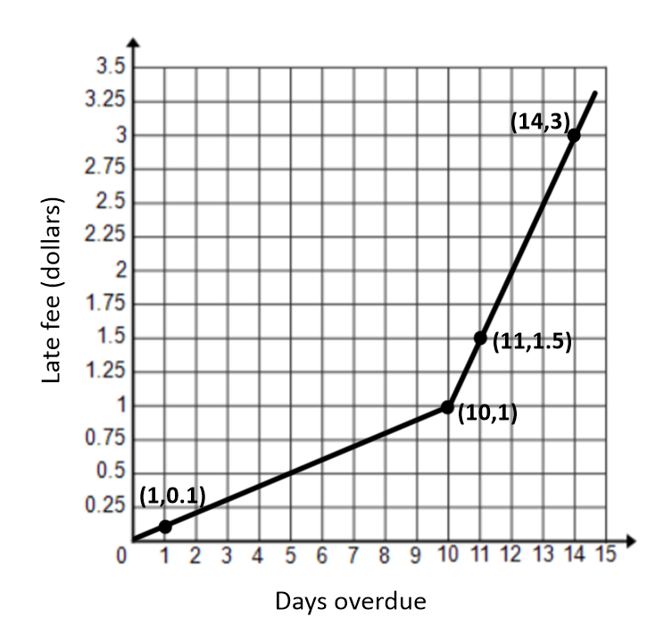

1. What type of function is this?
2. What is the general form of the parent function(s) of this graph?
3. What equations would you expect to use to model this context?
4. Describe verbally what this graph is telling you about the library fees.
5. Compare the advantages and disadvantages of the graph versus the equation as a model for this relationship. What would be the advantage of using a verbal description in this context? How might you use a table of values?
6. What suggestions would you make to the library for how it could better share this information with its customers? Comment on the accuracy and helpfulness of this graph.

Exit Ticket Sample Solutions

Read the problem description, and answer the questions below. Use a separate piece of paper if needed.

A library posted a graph in its display case to illustrate the relationship between the fee for any given late day for a borrowed book and the total number of days the book is overdue. The graph, shown below, includes a few data points for reference. Rikki has forgotten this policy and wants to know what her fine would be for a given number of late days. The ordered pairs on the graph are , , , and .



1. What type of function is this?

Piecewise linear.

1. What is the general form of the parent function(s) of this graph?
2. What equations would you expect to use to model this context?

Students may be more informal in their descriptions of the function equation and might choose to make the domain restriction of the second piece inclusive rather than the first piece since both pieces are joined at the same point.

1. Describe verbally what this graph is telling you about the library fees.

The overdue fee is a flat rate of per day for the first days and then increases to per day after days. The fee for each of the first days is , so the fee for full days is . Then, the fee for full days of late fees is , etc. (From then on, the fee increases to for each additional day.)

1. Compare the advantages and disadvantages of the graph versus the equation as a model for this relationship. What is the advantage of using a verbal description in this context? How might you use a table of values?

Graphs are visual and allow us to see the general shape and direction of the function. However, equations allow us to determine more exact values since graphs only allow for estimates for any non-integer values. The late-fee scenario depends on integer number of days only; other scenarios may involve independent variables of non-integer values (e.g., gallons of gasoline purchased). In this case, a table could be used to show the fee for each day but could also show the accumulated fees for the total number of days. For example, for days the fees would be for the first for the next , for a total of .

1. What suggestions would you make to the library about how it could better share this information with its customers? Comment on the accuracy and helpfulness of this graph.

Rather than displaying the late fee system in a graph, a table showing the total fine for the number of days late would be clearer. If a graph is preferred, it might be better to use a discrete graph, or even a step graph, since the fees are not figured by the hour or minute but only by the full day. While the given graph shows the rate for each day, most customers would rather know, at a glance, what they owe, in total, for their overdue books.

Problem Set Sample Solutions

This problem allows for more practice with writing quadratic equations from a graph. Suggest that students use the vertex form for the equation, as it is the most efficient when the vertex is known. Remind them to always use a second point to find the leading coefficient. (And it is nice to have a third method to check their work.)

1. During tryouts for the track team, Bob is running -foot wind sprints by running from a starting line to the far wall of the gym and back. At time , he is at the starting line and ready to accelerate toward the opposite wall. As approaches seconds, he must slow down, stop for just an instant to touch the wall, turn around, and sprint back to the starting line. His distance, in feet, from the starting line with respect to the number of seconds that has passed for one repetition is modeled by the graph below.
   1. What are the key features of this graph?

The graph appears to represent a quadratic function. The maximum point is at . The zeros are at and .

* 1. What are the units involved?

Distance is measured in feet and time in seconds.

* 1. What is the parent function of this graph?

We will attempt to model the graph with a quadratic function. The parent function could be

* 1. Were any transformations made to the parent functions to get this graph?

It has a negative leading coefficient, and it appears to shift up units and to the right units.

* 1. What general analytical representation would you expect to model this context?
  2. What do you already know about the parameters of the equation?

, ,

* 1. Use the ordered pairs you know to replace the parameters in the general form of your equation with constants so that the equation will model this context. Check your answer using the graph.

To find , substitute for and for :

Now check it with :

1. Spencer and McKenna are on a long-distance bicycle ride. Spencer leaves one hour before McKenna. The graph below shows each rider’s distance in miles from his or her house as a function of time since McKenna left on her bicycle to catch up with Spencer. (Note: Parts (e), (f), and (g) are challenge problems.)

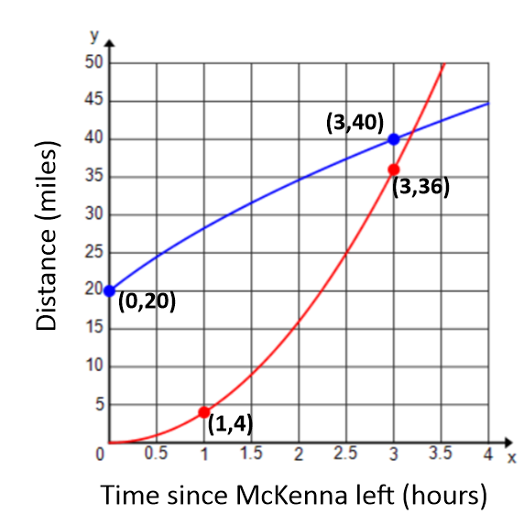

* 1. Which function represents Spencer’s distance? Which function represents McKenna’s distance? Explain your reasoning.

The function that starts at represents Spencer’s distance since he had a -hour head start. The function that starts at represents McKenna’s distance since the graph is described as showing distance since she started riding. That means at the time she started riding ( hours), her distance would need to be miles.

* 1. Estimate when McKenna catches up to Spencer. How far have they traveled at that point in time?

McKenna will catch up with Spencer after about hours. They will have traveled approximately miles at that point.

* 1. One rider is speeding up as time passes and the other one is slowing down. Which one is which, and how can you tell from the graphs?

I know that Spencer is slowing down because his graph is getting less steep as time passes. I know that McKenna is speeding up because her graph is getting steeper as time passes.

* 1. According to the graphs, what type of function would best model each rider’s distance?

Spencer’s graph appears to be modeled by a square root function. McKenna’s graph appears to be quadratic.

* 1. Create a function to model each rider’s distance as a function of the time since McKenna started riding her bicycle. Use the data points labeled on the graph to create a precise model for each rider’s distance.

If Spencer started hour before McKenna, then would be a point on his graph. Using a square root function in the form would be appropriate. To find , substitute into the function.

So, . Check with the other point :

For McKenna, using a quadratic model would mean the vertex must be at . A quadratic function in the form would be appropriate. To find , substitute into the function.

So, . Check with the other point : .

* 1. What is the meaning of the - and -intercepts of each rider in the context of this problem?

Spencer’s -intercept shows that he starts riding one hour before McKenna. McKenna’s -intercept shows that at time , her distance from home is , which makes sense in this problem. Spencer’s -intercept means that when McKenna starts riding one hour after he begins, he has already traveled miles.

* 1. Estimate which rider is traveling faster minutes after McKenna started riding. Show work to support your answer.

Spencer:

McKenna:

Spencer is traveling faster than McKenna minutes after McKenna begins riding because his average rate of change is greater than McKenna’s average rate of change.