Lesson 24: Modeling with Quadratic Functions

Classwork
Opening Exercise
Draw as many quadratic graphs as possible through the following two points on the graph. Check with your neighbors for ideas. These points are $(0,4)$ and $(1,9)$.
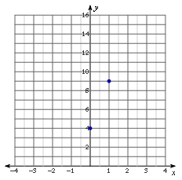
Two Points

Example
Use the example with the blue points $(0, 4)$, $(1, 9)$, and $(-3, 1)$ from above to write the equation for the quadratic containing the three points.

Exercise 1
Write in standard form the quadratic function defined by the points $\left(0, 5\right)$, $\left(5, 0\right)$, and $\left(3, -4\right)$.

Exercise 2
Louis dropped a watermelon from the roof of a tall building. As it was falling, Amanda and Martin were on the ground with a stopwatch. As Amanda called the seconds, Martin recorded the floor the watermelon was passing. They then measured the number of feet per floor and put the collected data into this table. Write a quadratic function to model the following table of data relating the height of the watermelon (distance in feet from the ground) to the number of seconds that had passed.
Height (distance from the ground) for a watermelon that was dropped from a tall building
Time ($t$) | $$0$$ | $$1$$ | $$2$$ | $$3$$ | $$4$$
Height $f(t)$ | $$300$$ | $$284$$ | $$236$$ | $$156$$ | $$44$$

  - How do we know this data will be represented by a quadratic function?

  - Do we need to use all five data points to write the equation?

  - Are there any points that are particularly useful? Does it matter which we use?

  - How does this equation for the function match up with what you learned about physics in Lesson 23? Is there a more efficient way to find this equation?

  - Can you use your quadratic function to predict at what time, t, the watermelon will hit the ground (i.e.,
$f\left(t\right)=0$)?

Problem Set
Lesson Summary
We can create a quadratic function from a data set based on a contextual situation, sketch its graph, and interpret both the function and the graph in context. We can then answer questions and make predictions related to the data, the quadratic function, and graph.
To determine a unique quadratic function from a table or graph, we must know at least three distinct points.

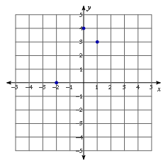
- Write a quadratic function to fit the following points, and state the $x$-values for both roots. Then, sketch the graph to show that the equation includes the three points.

- Write a quadratic function to fit the following points: $\left(0, 0.175\right),$ $\left(20, 3.575\right),$ $(30, 4.675)$.

