Lesson 24: Modeling with Quadratic Functions

Student Outcomes
- Students create a quadratic function from a data set based on a contextual situation, sketch its graph, and interpret both the function and the graph in context. They answer questions and make predictions related to the data, the quadratic function, and graph.

Lesson Notes
Throughout this lesson, students make sense of problems by analyzing the given information; make sense of the quantities in the context, including the units involved; look for entry points to a solution; consider analogous problems; create functions to model situations; use graphs to explain or validate their reasoning; monitor their own progress and the reasonableness of their answers; and report their results accurately and with an appropriate level of precision.
MP.1
MP.2
MP.4
&
MP.6
In this lesson, students understand that it takes three points to determine a unique quadratic function. They use data sets to write quadratic functions with and without context. For convenience, the points used in the following exercises have known$y$-intercepts and can be modeled precisely by quadratic functions with rational coefficients; however, teachers should remind students that in real life, data sets are unlikely to be able to be modeled with any function with $100\%$ accuracy.

Classwork
Opening Exercise (10 minutes)
Scaffolding:
- Students may incorrectly draw U-shaped graphs that are not quadratic. Remind them that quadratic graphs must be symmetrical: $x$-values on either side of the vertex must have matching $y$-values, and the curves continually grow wider for increasing values of $|x|$.
- Encourage students to draw quadratics that are concave down as well as up; there are many different quadratics sharing these two points.
Project the graph on the board or screen, and ask students to draw as many quadratic graphs as possible through the following two points on the graph, which is also found in their student materials. Encourage them to check with their neighbors for ideas. These points are$(0, 4)$and $(1, 9)$.
Opening Exercise
Draw as many quadratic graphs as possible through the following two points on the graph. Check with your neighbors for ideas. These points are$(0,4)$and$(1,9)$.
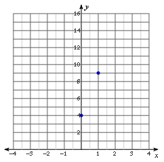
Two Points

After a few minutes, gather the class together, and have students share some of their graphs. You might have three or four students come to the board and sketch one of their graphs, each in a different color. There are an infinite number of solutions. Make sure that some of the sketches have one of the points as a vertex and that some open up and some down.
Now, introduce a third point and ask students to repeat the exercise. Now the points are $(0, 4)$, $(1, 9)$, and $(-3, 1)$.
Three Points

•

Ultimately, students should conclude that only one quadratic graph can pass through all three points simultaneously. Therefore, it requires no less than three points to determine a quadratic function.
Scaffolding:
- Students may remember from earlier lessons that in quadratic equations, “second differences” are equal. This supports the idea that any number of quadratic equations can be drawn through two points because the value of the second difference is not well defined. Here is an example showing a quadratic function with its 1st and 2nd differences.
$f\left(x\right)= -5{(x-1)}^{2} + 9$
$$x_{2}-x_{1}$$ | $$x$$ | $$y$$ | 1st $f$ Diff $y_{2}- y_{1}$ | 2nd Diff
 | $$0$$ | $$4$$
$$1$$ | $$1$$ | $$9$$ | $$5$$
$$1$$ | $$2$$ | $$4$$ | $$-5$$ | $$-10$$
$$1$$ | $$3$$ | $$-11$$ | $$-15$$ | $$-10$$
$$1$$ | $$4$$ | $$-36$$ | $$-25$$ | $$-10$$
Point out that the differences in the $x$-values do not have to be $1$ but must be regular. Ask why.
- Why must the differences in the $x$-values for the selected data points be at regular intervals?
- We are comparing rates of change. We need a constant change in $x$ so that we are comparing equal intervals.
- If the first differences represent the average rate of change for an interval (slope), how would you describe the second differences?
- They can be described as the average rate of change of the slope, or the slope of the slope.
Scaffolding:
Unlike in the previous example, advanced students may notice that when three points are known, the value of the “second difference” is fixed; therefore, the quadratic function is uniquely defined.
Students may be curious about what happens if a fourth point is introduced. Add a fourth point in two different places, and have them study the possibilities. Try adding a point in another color that is on the quadratic graph, $(-1, 1)$, and then add one that is not, $(2, 5)$.
Fourth Point #1
• •
Fourth Point #2
•
•
Explain that a fourth point, in this case $(2, 5)$, may either belong to the quadratic (see: Fourth Point #1 graph) or not (see: Fourth Point #2 graph), but the function has already been determined by the first three (blue) points.

Example (10 minutes)
Example
Use the example with the blue points $(0, 4)$,$(1, 9)$, and$(-3, 1)$ from above to write the equation for the quadratic containing the three points.

Demonstrate for students how, if we know the $y$-intercept and two other points for a quadratic, we can form a system of linear equations to determine the standard form of the quadratic function defined by those points. Use the example with the blue points above: $(0, 4)$, $(1, 9)$, and $(-3, 1)$.
- Notice that we have the $y$-intercept, which allows us to find the value of $c$ quickly and first. After that, we can substitute the other two coordinates into the equation, giving us two linear equations to solve simultaneously.
Using $(0, 4)$  $$f\left(x\right)=ax^{2}+bx+c \\ 4=a{(0)}^{2}+b\left(0\right)+c \\ 4=c$$ | Using $(1, 9)$  $$f\left(x\right)=ax^{2}+bx+4 \\ 9=a{(1)}^{2}+b\left(1\right)+4 \\ 9=a+b+4 \\ a+b=5$$ | Using $(-3, 1)$  $$f\left(x\right)=ax^{2}+bx+4 \\ f\left(x\right)=a{\left(-3\right)}^{2}+b\left(-3\right)+4 \\ 1=9a-3b + 4 \\ 9a-3b=-3$$
- Since $c=4$, the resulting system has two variables: $\left\{\begin{aligned}a+b=5 \\ 9a-3b=-3\end{aligned}\right.$. Use substitution or elimination to determine that $a=1$ and $b=4$.
- Substitute $a=1$, $b=4$, and $c=4$ into standard form: $f\left(x\right)=x^{2}+4x+4$ is the quadratic function that contains the given points.

Demonstrate that the graph of the function we just found does, in fact, pass through all three points by showing the graph on the board or screen.
- Notice that in the graph below, we have included the two different fourth points from the Opening Exercise, $(-1, 1)$ and $(2, 5)$. Clearly $(-1, 1)$ is on the graph of the function, but $(2, 5)$ is not.
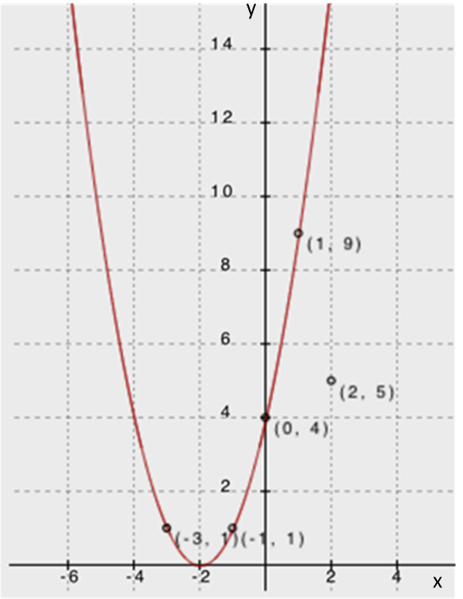

Exercise 1 (10 minutes)
Have students complete the following exercise independently.
Exercise 1
Write in standard form the quadratic function defined by the points$(0, 5)$, $(5, 0)$, and$(3, -4)$.
Using $(0, 5)$  $$f(x)=ax^{2}+bx+c \\ 5=a{(0)}^{2}+b(0)+c \\ 5=c$$ | Using $(5, 0)$  $$f(x)=ax^{2}+bx+5 \\ 0=a{\left(5\right)}^{2}+b\left(5\right)+5 \\ 0=25a+5b+5 \\ 25a+5b=-5 \\ 5a+b=-1$$ | Using $(3, -4)$  $$f(x)=ax^{2}+bx+5 \\ -4=a{(3)}^{2}+b(3)+5 \\ -4=9a+3b+5 \\ 9a+3b=-9 \\ 3a+b=-3$$
Since $c=5$, the resulting system has two variables: $\left\{\begin{aligned}5a+b=-1 \\ 3a+b=-3\end{aligned}\right.$.
Use substitution or elimination, and find that $a=1$ and $b=-6$.
Substitute $a=1$, $b=-6$, and $c=5$ into standard form: $f\left(x\right)=x^{2}-6x+5$ is the quadratic function that contains the given points.

Exercise 2 (10 minutes)
Have students work with a partner or in small groups to write the quadratic equation for the function defined by the following data set. Have them read the description of the experiment and study the collected data. Then, use the guiding questions to walk the students through the process of writing the quadratic equation to represent the data.

Exercise 2
Louis dropped a watermelon from the roof of a tall building. As it was falling, Amanda and Martin were on the ground with a stopwatch. As Amanda called the seconds, Martin recorded the floor the watermelon was passing. They then measured the number of feet per floor and put the collected data into this table. Write a quadratic function to model the following table of data relating the height of the watermelon (distance in feet from the ground) to the number of seconds that had passed.
Height (distance from the ground) for a watermelon that was dropped from a tall building
Time ($t$) | $$0$$ | $$1$$ | $$2$$ | $$3$$ | $$4$$
Height $f(t)$ | $$300$$ | $$284$$ | $$236$$ | $$156$$ | $$44$$
  - How do we know this data will be represented by a quadratic function?
The relationship between height and time for all free-falling objects is represented by a quadratic equation. Also, we can see mathematically that the function values have a first difference of $-16$, $-48$, $-80$, and $-112$. The second differences are constant at $-32$.

  - Do we need to use all five data points to write the equation?
No, only three are needed.

  - Are there any points that are particularly useful? Does it matter which we use?
$\left(0, 300\right)$is useful because it is the $y$-intercept. We will need to use $\left(0, 300\right),$ but the other two can be selected based on efficiency (the least messy or smallest numbers).

Encourage different groups of students to use different sets of three points and then compare their results.

Use $(0, 300)$  $$f(t)=at^{2}+bt+c \\ 300=a{(0)}^{2}+b(0)+c \\ 300=c$$ | Use $(1, 284)$  $$f(t)=at^{2}+bt+c \\ 284=a{(1)}^{2}+b(1)+300 \\ -16=a+b$$ | Use $(2, 236)$  $$f(t)=at^{2}+bt+c \\ 236=a{(2)}^{2}+b(2)+300 \\ -64=4a+2b$$
Since $c=300$, the resulting system has two variables$: \left\{\begin{aligned}-16=a+b \\ -64=4a+2b\end{aligned}\right.$.
Use substitution or elimination and find that $a=-16$ and $b=0$.
Substitute $a=-16$, $b=0$, and$c=300$ into standard form: $f\left(t\right)=-16t^{2}+300$.

Note: The same values for $a$, $b$, and $c$ will occur no matter which points are used to write the function. However, the point $(0, 300)$ is particularly useful because it solves the system for $c$ right away. Not using $(0, 300)$ first means that the students will need to solve a$3×3$system of equations. Students learn in Grade 8 to solve a $2×2$ system of equations (8.EE.C.8), but solving a $3×3$ system is considered an advanced topic in Algebra II (A.APR.D.7). Students could also point out that smaller values for $t$ yield smaller coefficients for the system, making it easier to solve.

  - How does this equation for the function match up with what you learned about physics in Lesson 23? Is there a more efficient way to find this equation?
It matches perfectly. This equation shows that the initial position (height) of the object is $300 ft.$ and that the initial velocity is $0$. It correctly uses $-16$ as the leading coefficient. We could have written the equation directly from the information provided since we already know the initial height and velocity.
  - Can you use your quadratic function to predict at what time, t, the watermelon will hit the ground (i.e., $f\left(t\right)=0$)?
Yes.
$$f\left(t\right)=-16t^{2}+300 \\ 0=-16t^{2}+300 \\ -300=-16t^{2} \\ 18.75=t^{2} \\ ±4.33≈t$$
So, the watermelon hit the ground after about $4.33 sec.$

Closing (1 minute)
To determine a unique quadratic function from a table or graph, we must know at least three distinct points.
Lesson Summary
We can create a quadratic function from a data set based on a contextual situation, sketch its graph, and interpret both the function and the graph in context. We can then answer questions and make predictions related to the data, the quadratic function, and graph.
To determine a unique quadratic function from a table or graph, we must know at least three distinct points.

Exit Ticket (4 minutes)

Name ___________________________________________________ Date____________________
Lesson 24: Modeling with Quadratic Functions

Exit Ticket

Write a quadratic function from the following table of data.

Fertilizer Impact on Corn Yields
Fertilizer, $x$ ($kg/m^{2}$) | $$0$$ | $$100$$ | $$200$$ | $$300$$ | $$400$$
Corn Yield, $y$ ($1000$ bushels) | $$4.7$$ | $$8.7$$ | $$10.7$$ | $$10.7$$ | $$8.7$$

Exit Ticket Sample Solutions

Write a quadratic function from the following table of data.
Fertilizer Impact on Corn Yields
Fertilizer, $x$ ($kg/m^{2}$) | $$0$$ | $$100$$ | $$200$$ | $$300$$ | $$400$$
Corn Yield, $y$ (1000 bushels) | $$4.7$$ | $$8.7$$ | $$10.7$$ | $$10.7$$ | $$8.7$$
Using the three points:
Use $(0, 4.7)$  $$f(x)=ax^{2}+bx+c \\ 4.7=a{(0)}^{2}+b(0)+c \\ 4.7=c$$ | Use $(100, 8.7)$  $$f(x)=ax^{2}+bx+c \\ 8.7=a{(100)}^{2}+b(100)+4.7 \\ 4=10,000a+100b$$ | Use $(200, 10.7)$  $$f(x)=ax^{2}+bx+c \\ 10.7=a{(200)}^{2}+b(200)+4.7 \\ 6=40,000a+200b$$
Since $c=4.7$, the resulting system has two variables: $\left\{\begin{aligned}4=10,000a+100b \\ 6=40,000a+200b\end{aligned}\right.$.
Use substitution or elimination and find that $a=\frac{-1}{10,000}=-0.0001$ and $b=\frac{1}{20}=0.05$.
Substitute $a=-0.0001$, $b=0.05$, and $c=4.7$ into standard form: $f\left(x\right)=-0.0001x^{2}+0.05x+4.7$.

Problem Set Sample Solutions

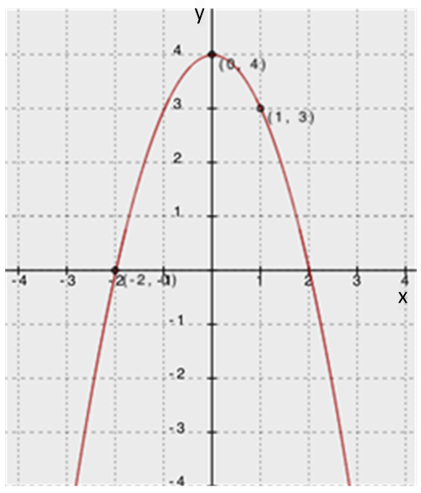
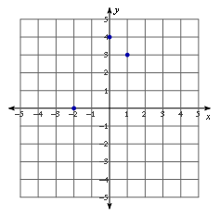
- Write a quadratic function to fit the following points, and state the $x$-values for both roots. Then, sketch the graph to show that the equation includes the three points.

Using the three points:
Use $(0, 4)$  $$f\left(x\right)=ax^{2}+bx+c \\ 4=a{(0)}^{2}+b(0)+c \\ 4=c$$ | Use $(-2, 0)$  $$f\left(x\right)=ax^{2}+bx+c \\ 0=a{(-2)}^{2}+b(-2)+4 \\ -4=4a-2b$$ | Use $(1, 3)$  $$f\left(x\right)=ax^{2}+bx+c \\ 3=a{(1)}^{2}+b(1)+4 \\ -1=a+b$$
Since $c=4$, the resulting system has two variables: $\left\{\begin{aligned}-4=4a-2b \\ -1=a+b\end{aligned}\right.$ .
Use substitution or elimination and find that $a=-1$ and $b=0.$
Substitute $a=-1$, $b=0$, and $c=4$ into standard form: $f\left(x\right)={-x}^{2}+4.$
- Write a quadratic function to fit the following points: $\left(0, 0.175\right)$, $\left(20, 3.575\right)$, $(30, 4.675)$.
Use $(0, 0.175)$  $$f(x)=ax^{2}+bx+c \\ f(x)=ax^{2}+bx+c \\ 0.175=a{(0)}^{2}+b(0)+c \\ 0.175=c$$ | Use $(20, 3.575)$  $$f\left(x\right)=ax^{2}+bx+c \\ 3.575=a{\left(20\right)}^{2}+b\left(20\right)+0.175 \\ 3.4=400a+20b$$ | Use $(30, 4.675)$  $$4.675=a{\left(30\right)}^{2}+b\left(30\right)+0.175 \\ 4.5=900a+30b$$
Since $c=0.175$, the resulting system has two variables: $\left\{\begin{aligned}3.4=400a+20b \\ 4.5=900a+30b\end{aligned}\right.$.
Use substitution or elimination and find that $a= -0.002$ and $b=0.21.$
Substitute $a=-0.002$, $b=0.21$, and $c=0.175$ into standard form:
$f\left(x\right)=-0.002x^{2}+0.21x+0.175$.
Lagrange’s Interpolation Method: An Extension for Accelerated Students
Lagrange’s Interpolation Method allows mathematicians to write a polynomial from a given set of points. Because three points determine a unique quadratic function, students can use interpolation to write a quadratic function without having to solve a system of equations to find the coefficients.
Given the points $(a, b)$, $(c, d)$, $(e, f)$, the quadratic function defined by these points can be written as follows:
$$f\left(x\right)= b∙\frac{\left(x-c\right)\left(x-e\right)}{\left(a-c\right)\left(a-e\right)}+d∙\frac{\left(x-a\right)\left(x-e\right)}{\left(c-a\right)\left(c-e\right)}+f∙\frac{\left(x-a\right)\left(x-c\right)}{\left(e-a\right)\left(e-c\right)}.$$
This works because, for each $x$ substituted into the function, two of the terms disappear by the zero–multiplication rule, and the third term divides to$f(x)∙1$. For example, write the quadratic function uniquely defined by the points: $(-1, 2)$, $(2, 23)$, $(-4, -1)$.
$$f\left(x\right)= 2∙\frac{\left(x-2\right)\left(x+4\right)}{\left(-3\right)\left(3\right)}+ 23∙\frac{\left(x+1\right)\left(x+4\right)}{\left(3\right)\left(6\right)}-1∙\frac{\left(x+1\right)\left(x-2\right)}{\left(-3\right)\left(-6\right)};$$
Then, $f\left(2\right)= 2∙\frac{\left(2-2\right)\left(2+4\right)}{\left(-3\right)\left(3\right)}+ 23∙\frac{\left(2+1\right)\left(2+4\right)}{\left(3\right)\left(6\right)}-1∙\frac{\left(2+1\right)\left(2-2\right)}{\left(-3\right)\left(-6\right)}$,
and $f\left(2\right)=0+23∙\frac{\left(3\right)\left(6\right)}{\left(3\right)\left(6\right)}-0$,
so $f\left(2\right)=23∙1=23.$

This process can be repeated for each of the three points, and so this function is clearly a degree two polynomial containing the three given points. This form may be considered perfectly acceptable; however, by multiplying out and collecting like terms, we can rewrite this function in standard form.
$$f\left(x\right)=\frac{-2}{9}\left(x^{2}+2x-8\right)+\frac{23}{18}\left(x^{2}+5x+4\right)-\frac{1}{18}(x^{2}-x-2) \\ 18f\left(x\right)=-4x^{2}-8x+32+23x^{2}+115x+92-x^{2}+x+2 \\ 18f\left(x\right)=18x^{2}+108x+126 \\ f\left(x\right)=x^{2}+6x+7$$

For students who love a challenge, design a short set of exercises with which accelerated students may practice interpolation. These exercises should not necessarily reduce to integer or even rational coefficients in standard form, and students may want to consider the potential pros and cons of leaving the function in its original interpolated form.

