Lesson 23: Modeling with Quadratic Functions

Student Outcomes
- Students write the quadratic function described verbally in a given context. They graph, interpret, analyze, check results, draw conclusions, and apply key features of a quadratic function to real-life applications in business and physics.

Lesson Notes
MP.1
MP.2
MP.4
&
MP.6
Throughout this lesson, students make sense of problems by analyzing the given information; make sense of the quantities in the context, including the units involved; look for entry points to a solution; consider analogous problems; create functions to model situations; use graphs to explain or validate their reasoning; monitor their own progress and the reasonableness of their answers; and report their results accurately and with an appropriate level of precision.
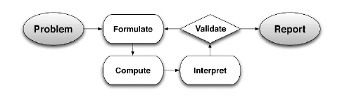
This real-life descriptive modeling lesson is about using quadratic functions to understand the problems of the business world and of the physical world (i.e., objects in motion). This lesson runs through the problem, formulate, compute, interpret, validate, report modeling cycle (see page 61 of the CCLS or page 72 of the CCSS). For this lesson, students will need calculators (not necessarily graphing calculators) and graph paper.
Scaffolding:
Students with a high interest in physics may benefit from some independent study of motion problems. Send them to websites such as The Physics Classroom http://www.physicsclassroom.com/
for more information.

Notes to the teacher about objects in motion:
Any object that is free falling or projected into the air without a power source is under the influence of gravity. All free-falling objects (on earth) accelerate toward the center of the earth (downward) at a rate of $9.8 m/s^{2}$, or $32 ft/s^{2}$.
The model representing the motion of falling or thrown objects, using standard units, is a quadratic function,
$h\left(t\right)=-16t^{2}+v_{0}t+h_{0}$, where $h$ represents the distance from the ground (height of the object in feet) and $t$is the number of seconds the object has been in motion, or if units are metric, $h\left(t\right)=-4.9t^{2}+v_{0}t+h_{0}$. In each case, $v_{0}$ represents the initial velocity of the object and $h_{0}$ the initial position (i.e., initial height). Note that this section will be included in the student materials for this lesson.

Classwork
Opening (5 minutes): The Mathematics of Objects in Motion
Opening: The Mathematics of Objects in Motion
Read the following explanation of the Mathematics of Objects in Motion:
Any object that is free falling or projected into the air without a power source is under the influence of gravity. All free-falling objects on earth accelerate toward the center of the earth (downward) at a constant rate ($-32$ $ft/s^{2}$, or $-9.8 m/s^{2}$) because of the constant force of earth’s gravity (represented by $g$). That acceleration rate is included in the physics formula used for all objects in a free-falling motion. It represents the relationship of the height of the object (distance from earth) with respect to the time that has passed since the launch or fall began. That formula is
$h\left(t\right)=\frac{1}{2}gt^{2}+v_{0}t+h_{0}$.
For this reason, the leading coefficient for a quadratic function that models the position of a falling, launched, or projected object must either be $-16$ or $-4.9$. Physicists use mathematics to make predictions about the outcome of a falling or projected object.
The mathematical formulas (equations) used in physics commonly use certain variables to indicate quantities that are most often used for motion problems. For example, the following are commonly used variables for an event that includes an object that has been dropped or thrown:
- $h$is often used to represent the function of height (how high the object is above earth in feet or meters);
- $t$ is used to represent the time (number of seconds) that have passed in the event;
- $v$ is used to represent velocity (the rate at which an object changes position in $ft/s$ or $m/s$);
- $s$ is used to represent the object’s change in position, or displacement (how far the object has moved in feet or meters).
We often use subscripts with the variables, partly so that we can use the same variables multiple times in a problem without getting confused, but also to indicate the passage of time. For example:
- $v_{0}$ indicates the initial velocity (i.e., the velocity at $0$ seconds);
- $h_{0}$ tells us the height of the object at$0$ seconds, or the initial position.
So putting all of that together, we have a model representing the motion of falling or thrown objects, using U.S. standard units, as a quadratic function:
$h\left(t\right)=-16t^{2}+v_{0}t+h_{0}$,
where $h$ represents the height of the object in feet (distance from the earth), and $t$ is the number of seconds the object has been in motion. Note that the negative sign in front of the $16$ (half of $g=32$) indicates the downward pull of gravity. We are using a convention for quantities with direction here; upward is positive and downward is negative. If units are metric, the following equation is used:
$h\left(t\right)=-4.9t^{2}+v_{0}t+h_{0}$,
where everything else is the same, but now the height of the object is measured in meters and the velocity in meters per second.
These physics functions can be used to model many problems presented in the context of free-falling or projected objects (objects in motion without any inhibiting or propelling power source, such as a parachute or an engine).

Mathematical Modeling Exercise 1 (15 minutes)
After students have read the explanation in the student materials of the physics of free-falling objects in motion, discuss the variables and parameters used in the function to describe projectile motion on earth.
Provide graph paper for the following problem. Have students work in pairs or small groups; read the problem from the student materials and discuss an entry point for answering the related questions. Then, walk students through the problem-solving process using the guiding questions provided below.
Mathematical Modeling Exercise 1
Use the information in the Opening to answer the following questions.
Chris stands on the edge of a building at a height of $60 ft.$ and throws a ball upward with an initial velocity of $68 ft/s$. The ball eventually falls all the way to the ground. What is the maximum height reached by the ball? After how many seconds will the ball reach its maximum height? How long will it take the ball to reach the ground?
  - What units will we be using to solve this problem?
Scaffolding:
Visual learners might benefit from a graphing tool to see this function’s graph. An online tool can be found here: www.desmos.com/calculator.
Feet for height, seconds for time, and feet per second for velocity.

  - What information from the contextual description do we need to use in the function equation?
Gravity $=-32 ft/s^{2}$
Initial Velocity ($v_{0}$)$=68 ft/s$
Initial Height ($h_{0}$)$=60 ft.$
So, the function is $h(t)=-16t^{2}+68t+60$.

  - What is the maximum point reached by the ball? After how many seconds will it reach that height? Show your reasoning.
The maximum function value is at the vertex. To find this value, we first notice that this function is factorable and is not particularly friendly for completing the square. So, we will rewrite the function in factored form, $f\left(t\right)=-4(4t^{2}-17t-15)$ $f\left(t\right)=-4(4t + 3)(t-5)$.
Second, we find the zeros, or the $x$-intercepts, of the function by equating the function to zero (zero height).
So, $-4 \left(4t+3\right)\left(t-5\right)=0.$
Then, $(4t+3)=0$ or$\left(t-5\right)=0.$
$t$-intercepts are $t=-\frac{3}{4}$ or $t=5.$
Then, using the concept of symmetry, we find the midpoint of the segment connecting the two $t$-intercepts (find the average of the $t$-coordinates): $t=\frac{- \frac{3}{4} +5}{2}= 2\frac{1}{8}$, or $2.125$.
Now, we find $h(2.125)$ in the original function, $h\left(t\right)=-16t^{2}+68t+60$, $h\left(2.125\right)=132.25$
Therefore, the ball reached its maximum height of $132.25 ft.$after $2.125 sec.$
(Note that students may try to complete the square for this function. The calculations are very messy but the results will be the same:
$h\left(t\right)=-16{\left(t-\frac{17}{8}\right)}^{2}+\frac{529}{4}=-16{(t-2.125)}^{2}+132.25$. Students may also opt to use the vertex formula.)

  - How long will it take the ball to land on the ground after being thrown? Show your work.
We factored in the previous question and found the zeros of this function to be $t=-\frac{3}{4}$ and $t=5$. The ball begins its flight at $0 sec.$ and ends at $5 sec.$ Therefore, it will be in flight for $5 sec.$

  - Graph the function of the height ($h$) of the ball in feet to the time ($t$) in seconds. Include and label key features of the graph such as the vertex, axis of symmetry, and $t$- and $y$-intercepts.
The graph should include identification of the intercepts, vertex, and axis of symmetry.
Vertex: $(2.125, 132.25)$
$t$-intercepts: $(-0.75, 0)$and $(5, 0)$
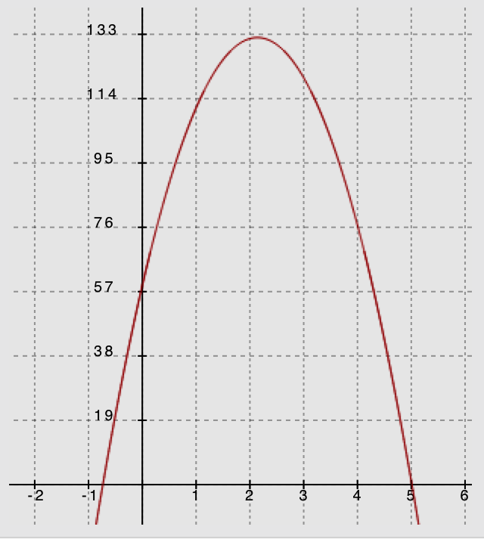
$y$-intercept: $(0, 60)$ (See graph of $y=h\left(t\right)$)
•
$$(5, 0)$$
$$\left(-\frac{3}{4} , 0\right)$$
•

• $(0, 60)$
Axis of symmetry: $t = 2.125$
Vertex $(2.125, 132.25)$

Mathematical Modeling Exercise 2 (10 minutes)
Have students review the terminology for business applications and read the context of the problem. Discuss the quantities in the problem and the entry point for solving the problem. Then, solve the problem below. Walk them through the steps to solve the problem using the guiding questions and commentary provided.
Notes to the teacher about business applications:
The following business formulas will be used in business applications in this module. Refer your students to Lesson 12 if they need a more detailed review.
$$Total Production Cost=(cost per item)(total number of items sold)$$
$$Total Revenue=(price per item)(total number of items sold)$$
$$Profit=Total Revenue-Total Production Cost$$
Mathematical Modeling Exercise 2
Read the following information about Business Applications:
Many business contexts can be modeled with quadratic functions. This is because the expressions representing price (price per item), the cost (cost per item), and the quantity (number of items sold) are typically linear. The product of any two of those linear expressions will produce a quadratic expression that can be used as a model for the business context. The variables used in business applications are not as traditionally accepted as variables that are used in physics applications, but there are some obvious reasons to use $c$for cost, $p$ for price, and $q$for quantity (all lowercase letters). For total production cost we often use $C$ for the variable, $R$ for total revenue, and $P$ for total profit (all uppercase letters). You have seen these formulas in previous lessons, but we will review them here since we use them in the next two lessons.
Business Application Vocabulary
Unit Price (Price per Unit): The price per item a business sets to sell its product, sometimes represented as a linear expression.
Quantity: The number of items sold, sometimes represented as a linear expression.
Revenue: The total income based on sales (but without considering the cost of doing business).
Unit Cost (Cost per Unit) or Production Cost: The cost of producing one item, sometimes represented as a linear expression.
Profit: The amount of money a business makes on the sale of its product. Profit is determined by taking the total revenue (the quantity sold multiplied by the price per unit) and subtracting the total cost to produce the items (the quantity sold multiplied by the production cost per unit): $Profit=Total Revenue-Total Production Cost$.
The following business formulas will be used in this lesson:
$$Total Production Costs=(cost per unit)(quantity of items sold)$$
$$Total Revenue=(price per unit)(quantity of items sold)$$
$$Profit=Total Revenue-Total Production Costs$$
Now answer the questions related to the following business problem:
A theater decided to sell special event tickets at $\$10$ per ticket to benefit a local charity. The theater can seat up to $1,000$ people and the manager of the theater expects to be able to sell all $1,000$ seats for the event. To maximize the revenue for this event, a research company volunteered to do a survey to find out whether the price of the ticket could be increased without losing revenue. The results showed that for each $\$1$ increase in ticket price, $20$ fewer tickets will be sold.
  - Let $x$ represent the number of $\$1.00$ price-per-ticket increases. Write an expression to represent the expected price for each ticket.
Let $x=$ number of $\$1$ increases. If each ticket is$\$10$, plus a possible price increase in $\$1$ increments, the price per ticket will be $\$10+\$1(x)=10+1x$.
Price per ticket $=10+x$

  - Use the survey results to write an expression representing the possible number of tickets sold.
Since $20$ fewer seats will be sold for each $\$1$ increase in the ticket price, $20x$ represents the number of seats fewer than $1,000$ that will be sold.
$1,000-20x$ is the expected number of tickets sold at this higher price.

Point out that if there are no price increases, we would expect to sell all $1,000$ seats ($x=0$), but there will be $20$ fewer for each $\$1.00$ in price-per-ticket increase.

  - Using $x$as the number of $\$1$-ticket price increases and the expression representing price per ticket, write the function, $R$, to represent the total revenue in terms of the number of $\$1$-ticket price increases.
$$Total Revenue=(price per ticket)(number of tickets)$$
$R\left(x\right)=\left(1,000-20x\right)\left(10+x\right)=10,000+1,000x-200x-20x^{2} =$ $-20x^{2}+800x+10,000$

Point out that quadratic expressions are usually written in standard form with exponents in descending order. However, there is no requirement to do so, and students would be equally correct to leave the equation in factored form.

  - How many $\$1$-ticket price increases will produce the maximum revenue? (In other words, what value for$x$ produces the maximum$R$ value?)
We need to find the vertex of the revenue equation. The equation is originally in factored form, so we can just go back to that form, or we can complete the square (which seems to be pretty efficient).
- By completing the square: $R\left(x\right)=-20(x^{2}-40x+___)+10,000$
$-20(x^{2}-40x+400)+10,000+8000$
$-20{(x-20)}^{2}+18,000$, so the vertex is$\left(20, 18000\right)$.
- Using the factors, set the equation equal to zero to find the zeros of the function:
$$R\left(x\right)=\left(1,000-20x\right)\left(10+x\right)=0$$$x=-10$ and $50$ are the zeros, and the vertex will be on the axis of symmetry (at the midpoint between
$-10$ and $50$), which is $x=20$.
Finally, we reach the conclusion that after $20$ price increases, the theater will maximize its revenue.

  - What is the price of the ticket that will provide the maximum revenue?
Price per ticket expression is $10+x$, so the price will be $\$10+\$20=\$30$.

  - What is the maximum revenue?
According to the $R$-value at the vertex, the maximum revenue will be $\$18,000$.

  - How many tickets will the theater sell to reach the maximum revenue?
With the maximum revenue of $\$18,000$ at $\$30$/ticket, the theater is selling $600$ tickets.

  - How much more will the theater make for the charity by using the results of the survey to price the tickets than they would had they sold the tickets for their original $\$10$ price?
At $\$10$ per ticket, the theater would have brought in $\$10,000$ after selling all $1,000$ seats. The theater will make an additional $\$8,000$ by using the survey results to price their tickets.

The next two exercises may be completed in class (if time permits) or added to the Problem Set. Working in pairs or small groups, have students strategize entry points to the solutions and the necessary problem-solving process. They should finish as much as possible in about 5 minutes for each exercise. Set a 5-minute timer after the start of Exercise 1 and again for Exercise 2. Remind them to refer to the two examples just completed if they get stuck. They should not think that they can finish the tasks in the 5-minute time but should get a good start. What they do not finish in class, should be completed as part of the Problem Set.

Exercise 1 (5 minutes)
Use a timer and start on Exercise 2 after 5 minutes.
Exercise 1
Two rock climbers try an experiment while scaling a steep rock face. They each carry rocks of similar size and shape up a rock face. One climbs to a point $400 ft.$ above the ground, and the other climbs to a place below her at $300 ft.$ above the ground. The higher climber drops her rock, and $1$ second later the lower climber drops his. Note that the climbers are not vertically positioned. No climber is injured in this experiment.
  - Define the variables in this situation, and write the two functions that can be used to model the relationship between the heights, $h_{1}$ and $h_{2}$, of the rocks, in feet, after $t$ seconds.
$h_{1}$ represents the height of the rock dropped by the higher climber,
$h_{2}$ represents the height of the rock dropped by the lower climber,
$t$ represents the number of seconds passed since the higher climber dropped her rock,
$t-1$ represents the number of seconds since the lower climber dropped his rock.
$h_{1}\left(t\right)=-16t^{2}+400$ and $h_{2}\left(t\right)=-16{(t-1)}^{2}+300$

  - Assuming the rocks fall to the ground without hitting anything on the way, which of the two rocks will reach the ground last? Show your work, and explain how you know your answer is correct.
We are looking for the zeros in this case. Setting each function equal to zero we get:
$$h_{1}\left(t\right)=-16t^{2}+400=0 \\ -16(t^{2}-25)=0 \\ -16(t+ 5)(t-5)=0$$$t= -5$ or $5 seconds$
For this context, it will take $5 seconds$ for the higher climber’s rock to hit the ground.
$h_{2}\left(t\right)=-16{\left(t-1\right)}^{2}+300=0$ The standard form for this equation is $h_{2}\left(t\right)=-16t^{2}+32t+284$, which is not factorable. We will solve from the completed-square form.
$$-16{\left(t-1\right)}^{2}+300=0 \\ -16{\left(t-1\right)}^{2}=-300$$
${(t-1)}^{2}=\frac{300}{16}$ [square root both sides]
$$t-1 = ±\frac{\sqrt{300}}{4}$$$t = 1 ±\frac{\sqrt{300}}{4}$ ≈ approximately $-3.3$ or $5.3$
For this context, it will take $5.3 seconds$ for the lower climber's rock to hit the ground.
The rock dropped from the higher position will hit the ground approximately $0.3 seconds$before the rock dropped from the lower position. (Notice that the first function equation is easy to factor, but the other is not. Students may try to factor but may use the completed-square form to solve or may opt to use the quadratic formula on the second one.)
  - Graph the two functions on the same coordinate plane, and identify the key features that show that your answer to part (b) is correct. Explain how the graphs show that the two rocks hit the ground at different times.
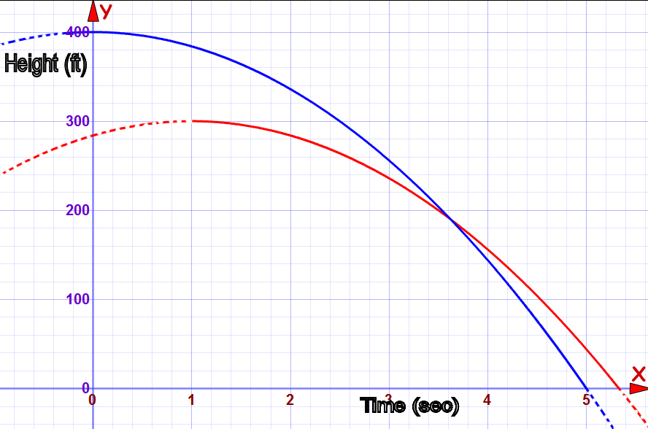
The two times are indicated on the $x$-axis as the $x$-intercepts. The red graph shows the height-to-time relationship for the rock dropped from $300 ft.$, and the blue graph shows the same for the rock dropped from $400 ft.$ For the red graph, $h(t)=0$ when $t=5.3$, and for the blue graph, $h(t)=0$ when $t=5$.

  - Does the graph show how far apart the rocks were when they landed? Explain.
No, the graph only shows the height of the rocks with respect to time. Horizontal position and movement are not indicated in the function or the graph.

Exercise 2 (5 minutes)
Use a timer and start on the Exit Ticket after $5$ minutes.
Exercise 2
Amazing Photography Studio takes school pictures and charges $\$20$ for each class picture. The company sells an average of $12$ class pictures in each classroom. They would like to have a special sale that will help them sell more pictures and actually increase their revenue. They hired a business analyst to determine how to do that. The analyst determined that for every reduction of $\$2$in the cost of the class picture, there would be an additional $5$ pictures sold per classroom.
  - Write a function to represent the revenue for each classroom for the special sale.
Let $x$ represent the number of $\$2$ reductions in price.
Then the price expression would be $\$20-\$2\left(x\right)=20-2x$.
The quantity expression would be $12+5x$.
So, the revenue is$R\left(x\right)=\left(20-2x\right)\left(12+5x\right)=240+100x-24x-10x^{2}=-10x^{2}+76x+240$.

  - What should the special sale price be?
Find the vertex for $R\left(x\right)=-10x^{2}+76x+240$.
$$-10(x^{2}-7.6x+ ____)+240 \\ -10(x^{2}-7.6x+{3.8}^{2})+240+{3.8}^{2}(10)=-10{(x-3.8)}^{2}+240+144.40$$
So, $R\left(x\right)=-10{(x-3.8)}^{2}+384.4$, and the studio should reduce the price by between three or four $\$2$-increments.
If we check the revenue amount for $3$ reductions, the price is $\$20-\$2(3)=\$14$. The quantity will be $12+5(3)=27$ pictures per classroom, so the revenue would be $\$378$.
Now check $4$ reductions: The price is $\$20-\$2\left(4\right)=\$12.$ The quantity will be$12+5(4)=32$ pictures per classroom, and the revenue for $4$ reductions would be $\$384$.
The special sale price should be $\$12$ since the revenue was greater than when the price was $\$14.$

  - How much more will the studio make than they would have without the sale?
The revenue for each class will be $\$384$ during the sale. They would make $\$20$ per picture for $12$ pictures, or $\$240$. They will increase their revenue by $\$144$ per classroom.

To ensure students understand, have them look at the revenue for five $\$2$-increments of price reduction. The price expression is $20-2(5)=\$10$. The quantity will be $12+5(5)=37$. That makes the revenue for five $\$2$-increments in price reduction $\$370$. The revenue is going back down. Are you surprised?

Closing (1 minute)
Lesson Summary
We can write quadratic functions described verbally in a given context. We can also graph, interpret, analyze, or apply key features of quadratic functions to draw conclusions that help us answer questions taken from the problem’s context.
- We find quadratic functions commonly applied in physics and business.
- We can substitute known $x$- and $y$-values into a quadratic function to create a linear system that, when solved, can identify the parameters of the quadratic equation representing the function.

Exit Ticket (4 minutes)
Name ___________________________________________________ Date____________________
Lesson 23: Modeling with Quadratic Functions

Exit Ticket

What is the relevance of the vertex in physics and business applications?

Exit Ticket Sample Solutions

What is the relevance of the vertex in physics and business applications?
By finding the vertex, we know the highest or lowest value for the function and also the $x$-value that gives that minimum or maximum. In physics, that could mean the highest point for an object in motion. In business, that could mean the minimum cost or the maximum profit or revenue.

Problem Set Sample Solutions

- Dave throws a ball upward with an initial velocity of $32 ft/s$. The ball initially leaves his hand $5 ft.$ above the ground and eventually falls back to the ground. In parts (a)–(d), you will answer the following questions: What is the maximum height reached by the ball? After how many seconds will the ball reach its maximum height? How long will it take the ball to reach the ground?
  - What units will we be using to solve this problem?
Height is measured in feet, time is measured in seconds, and velocity is measured in feet per second.

  - What information from the contextual description do we need to use to write the formula for the function $h$ of the height of the ball versus time? Write the formula for height of the ball in feet, $h(t)$, where $t$ stands for seconds.
Gravity: $-32 ft/s^{2}$
Initial height ($h_{0}$): $5 ft.$ above the ground
Initial velocity ($v_{0}$): $32 ft/s$
Function: $h\left(t\right)=-16t^{2}+32t+5$

  - What is the maximum point reached by the ball? After how many seconds will it reach that height? Show your reasoning.
Complete the square:
$h\left(t\right)=-16t^{2}+32t+5$
$h\left(t\right)=-16\left(t^{2}-2t+\boxed{}\right)+5+\boxed{}$
$h\left(t\right)=-16\left(t^{2}-2t+1\right)+5+16$ Completing the square
$h\left(t\right)=-16{\left(t-1\right)}^{2}+21$ The vertex (maximum height) is $21 ft.$ and is reached at $1 sec.$

  - How long will it take for the ball to land on the ground after being thrown? Show your work.
The ball will land at a time $t$ when $h\left(t\right)=0$, that is, when $0=-16t^{2}+32t+5$:
$$0=-16\left(t^{2}-2t-\frac{5}{16}\right)$$ | $$t=\frac{-b±\sqrt{b^{2}-4ac}}{2a} \\ t=\frac{-\left(-2\right)±\sqrt{{\left(-2\right)}^{2}-4\left(1\right)\left(-\frac{5}{16}\right)}}{2\left(1\right)} \\ t=\frac{2±\sqrt{4+\frac{20}{16}}}{2} \\ t=\frac{2±\sqrt{\frac{21}{4}}}{2} \\ t=1±\frac{\sqrt{21}}{4} \\ t≈2.146 \text{and} t≈-0.146$$
The negative value does not make sense in the context of the problem, so the ball reaches the ground in approximately $2.1 sec$.

  - Graph the function of the height of the ball in feet to the time in seconds. Include and label key features of the graph such as the vertex, axis of symmetry, and $x$- and $y$-intercepts.
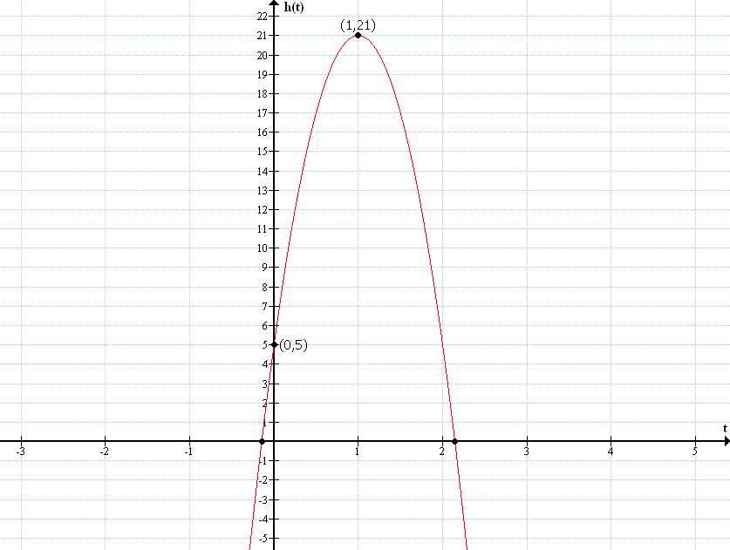
[Graph]
Axis of symmetry
$t=1$
Vertex (maximum height)
$y$-intercept (initial height)
$t$-intercept (time at which the ball hits the ground)
Graph of $h$

- Katrina developed an app that she sells for $\$5$ per download. She has free space on a website that will let her sell $500$downloads. According to some research she did, for each $\$1$ increase in download price, $10$ fewer apps are sold. Determine the price that will maximize her profit.
Profit equals total revenue minus total production costs. Since the website that Katrina is using allows up to $500$ downloads for free, there is no production cost involved, so the total revenue is the total profit.
Let $x$ represent the number of $\$1$ increases to the cost of a download.
Cost per download: $5+1x$
Apps sold: $500-10x$
$Revenue=\left(unit price\right)\left(quantity sold\right)$
$R\left(x\right)=(5+1x)(500-10x)$
$0=(5+1x)(500-10x)$
$0=5+x$ or $0=500-10x$
$x=-5$ or $x=50$
The average of the zeros represents the axis of symmetry.
$\frac{-5+50}{2}=22.5$ Katrina should raise the cost by $\$22.50$ to earn the greatest revenue.
$R\left(x\right)=(5+x)(500-10x)$
$R\left(x\right)=-10x^{2}+450x+2500$ Written in standard form
$R\left(22.5\right)=-10{\left(22.5\right)}^{2}+450\left(22.5\right)+2500$
$R\left(22.5\right)=7562.50$
Katrina will maximize her profit if she increases the price per download by $\$22.50$ to $\$27.50$ per download. Her total revenue (and profit) for each case would be $\$7,562.50.$

- Edward is drawing rectangles such that the sum of the length and width is always six inches.
  - Draw one of Edward’s rectangles, and label the length and width.
$$4 in.$$

$$2 in.$$

  - Fill in the following table with four different possible lengths and widths.
Width (inches) | Length (inches)
$$1$$ | $$5$$
$$2$$ | $$4$$
$$3$$ | $$3$$
$$2.5$$ | $$3.5$$

  - Let $x$ be the width. Write an expression to represent the length of one of Edward’s rectangles.
If $x$ represents the width, then the length of the rectangle would be $6-x$.

  - Write an equation that gives the area, $y$, in terms of the width, $x$.
$$Area=length×width \\ y=x(6-x)$$

  - For what width and length will the rectangle have maximum area?
$y=x(6-x)$
$y=-x^{2}+6x$
$y=-1\left(x^{2}-6x+\boxed{}\right)+\boxed{}$
$y=-1\left(x^{2}-6x+9\right)+9$ By completing the square
$y=-1{\left(x-3\right)}^{2}+9$ The vertex is $(3,9)$.
The rectangle with the maximum area has a width of $3 in.$ (also length $3 in.$) and an area of $9 in^{2}$.

  - Are you surprised by the answer to part (e)? What special name is given for the rectangle in your answer to part (e)?
Responses will vary. The special rectangle in part (e) is a square.

- Chase is standing at the base of a $60$-foot cliff. He throws a rock in the air hoping to get the rock to the top of the cliff. If the rock leaves his hand $6 ft.$ above the base at a velocity of $80 ft/s$, does the rock get high enough to reach the top of the cliff? How do you know? If so, how long does it take the rock to land on top of the cliff (assuming it lands on the cliff)? Graph the function, and label the key features of the graph.
I will consider the top of the cliff as $0 ft.$ so that I can find the time when the rock lands by finding the zeros of the function. Since Chase is standing at the bottom of the cliff, his initial height is negative; therefore, the initial height of the rock is negative.
Gravity: $-32 ft/s^{2}$
Initial height: $-54 ft.$
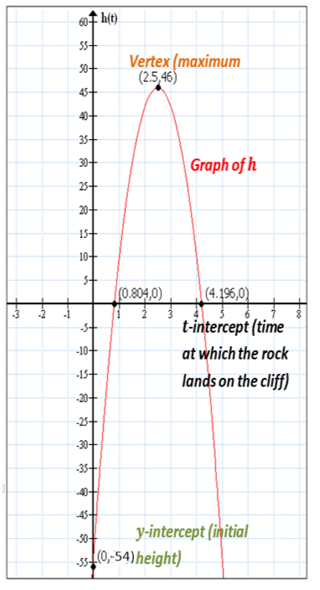
Initial velocity: $80 ft/s$
$h\left(t\right)=-16t^{2}+80t-54$
$h\left(t\right)=-16\left(t^{2}-5t+\boxed{}\right)-54+\boxed{}$
$h\left(t\right)=-16\left(t^{2}-5t+6\frac{1}{4}\right)-54+100$ By completing the square
$h\left(t\right)=-16{\left(t-\frac{5}{2}\right)}^{2}+46$
In completed square form, the vertex of the function is $\left(\frac{5}{2},46\right)$.
The rock reaches the top of the cliff because it reaches a maximum height of $46 ft.$ above the cliff at $2\frac{1}{2}sec.$ after the rock was thrown.
To find how much time it takes to reach the top of the cliff, I found the zeros of the function. I can see by the graph that the function has two possible zeros; however, given the context of the problem, only the latter of the two makes sense because the rock must go beyond the top of the cliff in order to land on the top of the cliff.
$$h\left(t\right)=-16t^{2}+80t-54 \\ h\left(t\right)=-2(8t^{2}-40t+27)$$ | $$t=\frac{-b±\sqrt{b^{2}-4ac}}{2a} \\ t=\frac{-(-40)±\sqrt{{(-40)}^{2}-4(8)(27)}}{2(8)} \\ t=\frac{40±\sqrt{1600-864}}{16} \\ t=\frac{5}{2}±\frac{\sqrt{46}}{4} \\ t≈0.804 \text{or} t≈4.196$$
The rock lands on the top of the cliff at approximately $4.2 sec$. after it was thrown.

