Lesson 22: Comparing Quadratic, Square Root, and Cube Root Functions Represented in Different Ways

Student Outcomes
- Students compare two different quadratic, square root, or cube root functions represented as graphs, tables, or equations. They interpret, contextualize, and abstract various scenarios to complete the comparative analysis.

Classwork
Scaffolding:
Provide students with the discussion questions ahead of time so that they have time to brainstorm responses prior to the class discussion.
Opening Exercise (10 minutes)
Project the graph on the board or screen. Have students work in pairs or small groups to select domain values and fill in the table based on the graph.
Opening Exercise
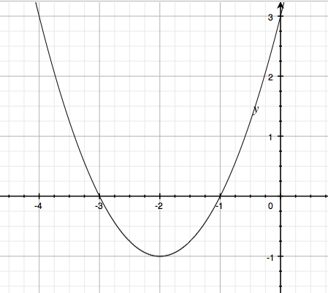
Populate the table on the right with values from the graph.
$$x$$ | $$y$$
$$-4$$ | $$3$$
$$-3$$ | $$0$$
$$-2$$ | $$-1$$
$$-1$$ | $$0$$
$$0$$ | $$3$$

Briefly discuss ways to recognize key features in both representations of this function.
- What is the vertex for the function? Find it and circle it in both the table and the graph.
  - $(-2, -1)$
- What is the $y$-intercept for the function? Find it and circle it in both the table and the graph.
  - $(0, 3)$
- What are the$x$-intercepts for the function? Find them and circle them in both the table and the graph.
  - $(-3, 0)$ and $(-1, 0)$
- What components of the equation for a function give us clues for identifying the key features of a graph?
  - Given a quadratic function in the form$f(x)=ax^{2}+bx+c$, the$y$-intercept is represented by the constant, $c$; the vertex $(h, k)$ can be seen in the completed-square form, $f(x)=a{(x-h)}^{2}+k$; and the zeros of the function are found most readily in the factored form, $f(x)=a(x-m)(x-n)$.
- How can the key features of the graph of a quadratic function give us clues about how to write the function the graph represents?
  - Given a graph of a quadratic function, $(h, k)$ represents the vertex (i.e., maximum or minimum point). These values,$h$ and $k$, can be substituted into the vertex form. Then, substituting any other ordered pair for $(x,y)$, which represents a point on the quadratic curve (e.g., the $y$-intercept), will allow you to solve for the leading coefficient, $a$, of the vertex form of a quadratic function.
  - When both$x$-intercepts are visible, we can write the equation of the graph in factored form using the coordinates of any other point to determine the leading coefficient. And when the$y$-intercept and only one $x$-intercept is visible, we can most easily write the function by using standard form. In this case, the $y$-intercept tells us the value of the constant term, $c$, and we can use two other points to substitute for $x$ and $y$ into the form $f(x)=ax^{2}+bx+c$ to determine the specific values for $a$ and $b$.

Exploratory Challenges 1–3 (25 minutes)
Have students work on the exercises below in pairs or small groups. Note that the equation for $S(t)$ will be messy to complete the square. Some students may need help with the fractions or decimals, and all will need a calculator.
Exploratory Challenges 1–3
Solve each problem, and show or explain how you found your answers.
- Xavier and Sherleese each threw a baseball straight up into the air. The relationship between the height (distance from the ground in feet) of Sherleese’s ball with respect to the time since it was thrown, in seconds, is given by the function:
$$S\left(t\right)=-16t^{2}+79t+6.$$

The graph of the height as a function of time of Xavier’s ball is represented below.
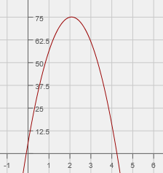
$t$ (seconds)
Height (feet)
Scaffolding:
Struggling students may use graphing calculators to compare the equation with the graph or to check their answers.

Xavier claims that his ball went higher than Sherleese’s. Sherleese disagrees. Answer the questions below, and support your answers mathematically by comparing the features found in the equation to those in the graph.
t

  - Who is right?
Sherleese is right. Xavier’s baseball went$75 ft.$ at its highest point (based on the maximum point of the graph), which was lower than Sherleese’s. The maximum height of Sherleese’s ball is approximately $103.5 ft.$ This could be determined by completing the square, $S\left(t\right)=-16{\left(t-\frac{79}{32}\right)}^{2}+103.5$, or using the vertex formula to find the vertex, or approximated by using a table.
  - For how long was each baseball airborne?
Sherleese’s baseball was airborne for approximately $5 sec.$, the zeros of $S(t)$ are $(5.01, 0)$ and $(-0.07, 0)$. Since the ball lands on the ground at about $5 sec.$, that is approximately how long it was in flight. Xavier’s baseball was airborne for approximately $4.3 sec.$

  - Construct a graph of Sherleese’s throw as a function of time ($t$) on the same set of axes as the graph of Xavier’s, and use the graph to support your answers to parts (a) and (b).
In the graph below, you can see that Sherleese’s baseball clearly has a higher vertex. You can also read the $t$- axis to find the length of time each baseball was airborne (the distance between$t=0$ and the positive$t$- intercept).
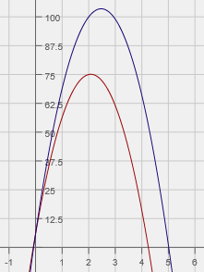
$t$ (seconds)
Height (feet)

- At an amusement park, there is a ride called The Centre. The ride is a cylindrical room that spins as the riders stand along the wall. As the ride reaches maximum speed, riders are pinned against the wall and are unable to move. The model that represents the speed necessary to hold the riders against the wall is given by the function
$s(r)=5.05\sqrt{r}$, where$s=$required speed of the ride (in meters per second) and$r=$ the radius (in meters) of the ride.
In a competing ride called The Spinner, a car spins around a center post. The measurements in the table below show the relationship between the radius ($r$) of the spin, in meters, and the speed ($s$) of the car, in meters per second.

$r$(meters) | $s$ (meters per second)
$$0$$ | $$0$$
$$1$$ | $$7.7942$$
$$2$$ | $$11.023$$
$$3$$ | $$13.5$$
$$4$$ | $$15.588$$
$$5$$ | $$17.428$$
Due to limited space at the carnival, the maximum spin radius of rides is $4$ meters. Assume that the spin radius of both rides is exactly $4$ meters. If riders prefer a faster spinning experience, which ride should they choose? Show how you arrived at your answer.
At$r=4$, The Centre’s speed is $5.05\sqrt{4}=10.1 m/sec$. The Spinner’s speed, when $r=4$, is $15.588 m/sec$. (reading from the table). The Spinner is the faster ride.
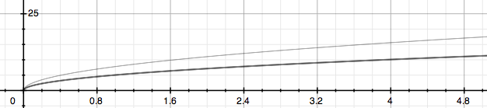
Students might graph both given functions using a graphing calculator or develop a table for The Centre to find and compare the coordinates. They need to compare the representations at $r=4$.
Speed ($s$)
in meters per second
Radius ($r$) in meters
•
$(4, 10.1)$
 $(4, 15.588)$
•
Centre
Spinner
- The growth of a Great Dane puppy can be represented by the graph below, where $y$ represents the shoulder height (in inches) and $x$ represents the puppy’s age (in months).
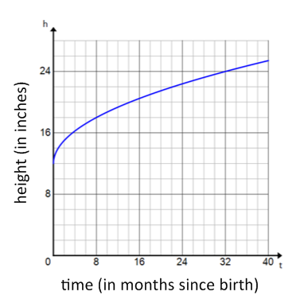
The growth of a lion cub can be modeled by the function represented in the table below.
Scaffolding:
- As an extension, you might ask students the month when both animals will have the same shoulder height, or what the shoulder height difference is at $64$ months.
- For students who love a challenge, you might ask whether this graph will work for the entire life of the animal (and why or why not?). Have them think about whether a piecewise function may be needed to indicate that the animals may actually begin to shrink in height as they reach old age.

$x$(months  since birth) | $y$ (height in inches)
$$0$$ | $$8$$
$$8$$ | $$18$$
$$16$$ | $$20.599$$
$$24$$ | $$22.422$$
$$32$$ | $$23.874$$

  - Which animal has the greater shoulder height at birth?
The Great Dane has the taller shoulder height at birth, which is around $12 in$. The lion cub has a shoulder height of only $8 in.$ at birth.

  - Which animal will have the greater shoulder height at $3$years of age (the age each animal is considered full-grown)?
The lion’s shoulder height, which is between $24$ and $25 in.$, will be slightly greater than that of the Great Dane, which is $24 in.$, at $3$ years of age. This answer will vary depending on how the students estimate using the graph and using the table.

For part (b) of this exercise, students must estimate from a table and from a graph. In comparing those estimates, they will need to make some decisions about the precision of each answer.
MP.6

  - If you were told that the domain for these functions is the set of all real numbers, would you agree? Why or why not?
There are physical limitations on time and height, so the domain must be greater than or equal to zero but must not exceed the finite limit of their life spans, and the range must both be greater than or equal to the finite heights recorded at birth, and less than or equal to their maximum possible heights. Both the domain and range may have other limitations as well. For example, neither animal will grow continuously for their lifetime; rather, both are likely to shrink if they live to an old age.

Closing (5 minutes)
- The critical values of a function, which are the zeros (roots), the vertex, and the leading coefficient, can be used to create and interpret the function in a context (e.g., the vertex represents the maximum or minimum value of a quadratic function).
- Graphing calculators and bivariate data tables are useful tools when comparing functions of the same type.
Lesson Summary
The key features of a quadratic function, which are the zeros (roots), the vertex, and the leading coefficient, can be used to interpret the function in a context (e.g., the vertex represents the maximum or minimum value of the function). Graphing calculators and bivariate data tables are useful tools when comparing functions.

Exit Ticket (5 minutes)

Name ___________________________________________________ Date____________________
Lesson 22: Comparing Quadratic, Square Root, and Cube Root Functions Represented in Different Ways

Exit Ticket

- Two people, each in a different apartment building, have buzzers that don’t work. They both must throw their apartment keys out of the window to their guests, who will then use the keys to enter.
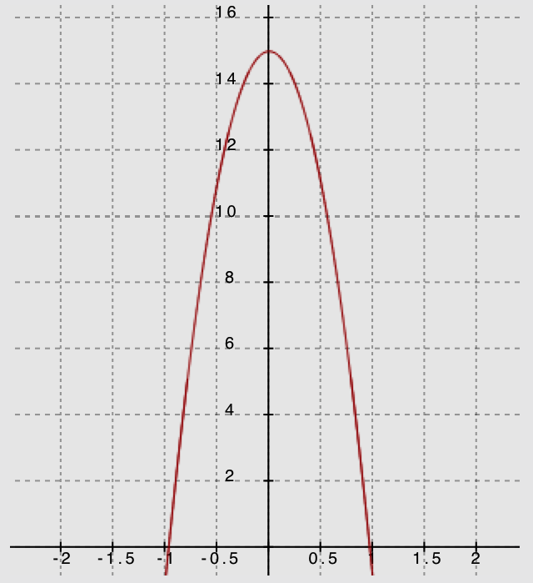
Tenant 1 throws the keys such that the height-time relationship can be modeled by the graph below. On the graph, time is measured in seconds, and height is measured in feet.

Tenant 2 throws the keys such that the relationship between the height of the keys (in feet) and the time that has passed (in seconds) can be modeled by $h\left(t\right)=-16t^{2}+18t+9$.

  - Whose window is higher? Explain how you know.

  - Compare the motion of Tenant 1’s keys to that of Tenant 2’s keys.

  - In this context, what would be a sensible domain for these functions?

Exit Ticket Sample Solutions

- Two people, each in a different apartment building, have buzzers that don’t work. They both must throw their apartment keys out of the window to their guests, who will then use the keys to enter.
Tenant 1 throws the keys such that the height-time relationship can be modeled by the graph below. On the graph, time is measured in seconds, and height is measured in feet.

Tenant 2 throws the keys such that the relationship between the height of the keys (in feet) and the time that has passed (in seconds) can be modeled by $h\left(t\right)=-16t^{2}+18t+9$.

  - Whose window is higher? Explain how you know.
The window for Tenant 1 is higher ($15 ft.$) than that of Tenant 2 ($9 ft.$), which can be seen by comparing the values of the $y$-intercepts. You can see this in the graph below, showing both functions on the same coordinate plane.
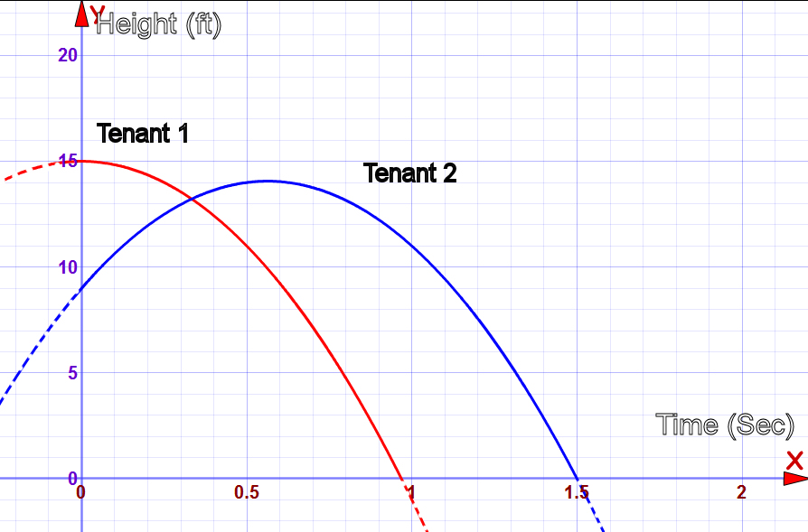

  - Compare the motion of Tenant 1’s keys to that of Tenant 2’s keys.
Tenant 2’s keys reach a maximum height at the vertex and then fall back toward the ground. (See the graph above.) The vertex for the graph of $h$ can be found by completing the square:
$$h\left(t\right)= -16\left(t^{2}-\left(\frac{18}{16}\right)t + \right) + 9 \\ = -16\left(t^{2}-\left(\frac{9}{8}\right)t + {\left(\frac{9}{16}\right)}^{2}\right)+ 9 + 16{\left(\frac{9}{16}\right)}^{2} \\ = -16{\left(t-\frac{9}{16}\right)}^{2} +\frac{225}{16}.$$
So, the keys will reach a height of $\frac{225}{16}ft.$, or about $14 ft.$, before beginning the descent.
By comparison, Tenant 1’s keys’ motion is free falling. No linear term for Tenant 1 means an initial velocity of $0 ft/sec$ initial velocity; this is a quadratic graph whose axis of symmetry is the $y$-axis.

  - In this context, what would be a sensible domain for these functions?
Both domains would be positive. For Tenant 2, the zeros are $(-0.375, 0)$ and $(1.5, 0)$, so the domain is $[0, 1.5]$. For Tenant 1, the domain is $[0, 1]$ since the keys would be on the ground at about $1$ second.

Problem Set

- One type of rectangle has lengths that are always two inches more than their widths. The function $f$ describes the relationship between the width of this rectangle in $x$ inches and its area, $f(x)$, in square inches, and is represented by the table below.
$$x$$ | $$f(x)$$
$$0$$ | $$0$$
$$1$$ | $$3$$
$$2$$ | $$8$$
$$3$$ | $$15$$
$$4$$ | $$24$$
$$5$$ | $$35$$
A second type of rectangle has lengths that are always one-half of their widths. The function $g\left(x\right)=\frac{1}{2}x^{2}$ describes the relationship between the width given in $x$ inches and the area, $g(x)$, given in square inches of such a rectangle.
  - Use $g(x)$ to determine the area of a rectangle of the second type if the width is $20$ inches.
$$g\left(x\right)=\frac{1}{2}x^{2} \\ g\left(20\right)=\frac{1}{2}{\left(20\right)}^{2} \\ g\left(20\right)=200$$
The area of the rectangle is $200 in^{2}$.

  - Why is $(0,0)$ contained in the graphs of both functions? Explain the meaning of $(0,0)$ in terms of the situations that the functions describe.
For the first type of rectangle (with length two inches more than its width), a width of $0 in.$ means that the rectangle’s length is $2 in.$ However, if the width is $0 in.$, its area is $0 in^{2}$, and there is no rectangle. For the second type of rectangle (represented by $g(x)$), a width of $0 in.$ means that the rectangle’s area is $0 in^{2}.$ Although the point $(0,0)$ is contained in the graphs of both functions, it does not represent any rectangle width area pair because rectangles by definition have positive widths and lengths.

  - Determine which function has a greater average rate of change on the interval $0≤x≤3$.
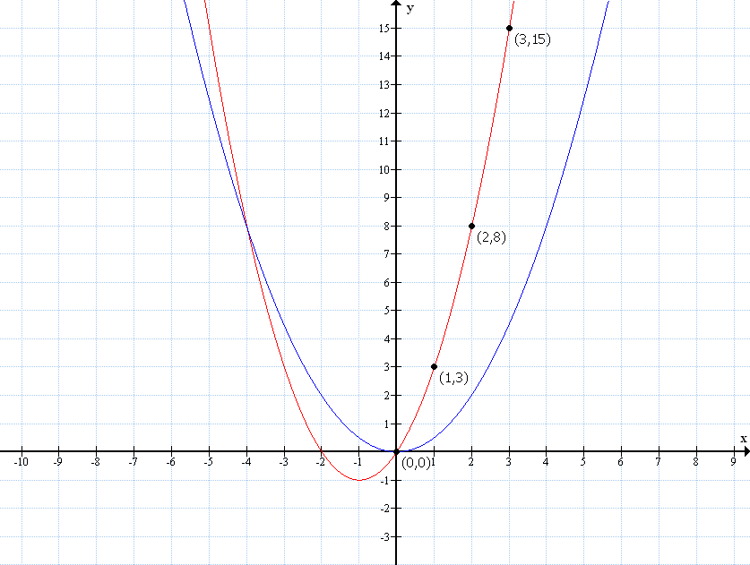
$f(x)$

$g(x)$

On the interval $0≤x≤3$, $f$ has a greater average rate of change than $g$, as seen in the graphs of the functions above. The average rate of change for $f$ is $\frac{f\left(3\right)-f\left(0\right)}{3-0}=5$, while the average rate of change for $g$ is $\frac{g\left(3\right)-g\left(0\right)}{3-0}=\frac{3}{2}$.

  - Interpret your answer to part (c) in terms of the situation being described.
The area of rectangles, on average, over the interval from $0$ to $3$ is growing a little more than $3$times faster for rectangles described by the function $f$ than those described by the function $g$ of a certain width.

  - Which type of rectangle has a greater area when the width is $5$ inches? By how much?
According to the table, the first rectangle will have an area of $35 in^{2}$ if its width is $5 in.$ Using the equation for $g(x)$, $g\left(5\right)=12.5$, the second rectangle will have an area of $12.5 in^{2}$ if its width is $5 in.$ The first type of rectangle has an area that is $22.5 in^{2}$ greater than the second type of rectangle when their widths are $5 in$.

  - Will the first type of rectangle always have a greater area than the second type of rectangle when widths are the same? Explain how you know.
If we consider rectangles with width $c$, where $c>0$, then $c+2>\frac{1}{2}c$, so $\left(c+2\right)⋅c>\left(\frac{1}{2}c\right)⋅c$. This means that the areas of the first type of rectangle will always be greater than the areas of the second type of rectangle when they have the same width.

- The function given by the equation $y=\sqrt{x}$ gives the edge length, $y$ units, of a square with area $x$ square units. Similarly, the graph below describes the length of a leg of an isosceles right triangle whose area is $x$ square units.
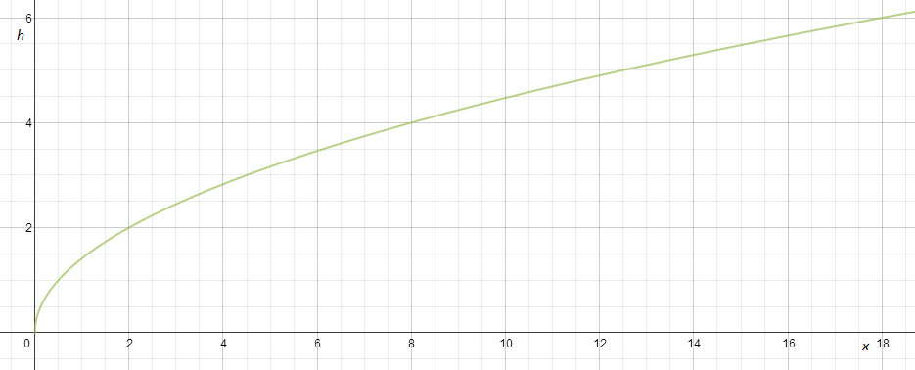
Graph of Isosceles Triangle Leg Lengths for Given Areas

  - What is the length of a leg of an isosceles right triangle with an area of $12$ square units?
The length of a leg of an isosceles triangle with an area of $12$ square units is approximately $4.9$ units.

  - Which function has a greater average rate of change on the interval $0≤x≤3$?
The graphs of both functions intersect at the origin. According to the provided graph, when the area is $3$, the length of a leg is $2.4$. Thus, the average rate of change is $0.8$. Using the equation $y=\sqrt{x}$, if $x=3$, $y≈1.7$. Thus, the average rate of change is approximately $0.6$. Thus, the average rate of change of the legs of an isosceles triangle is greater than the average rate of change of the sides of a square on the interval
$0≤x≤3$.
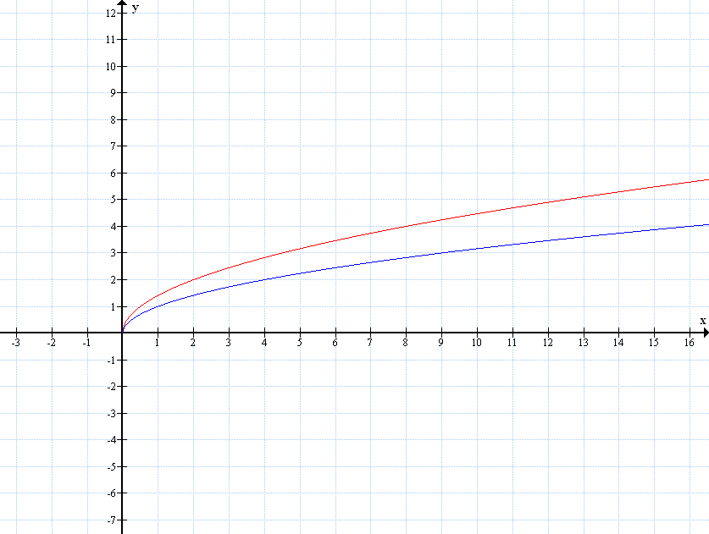
Graph of $y=\sqrt{x}$
Graph of isosceles triangle leg lengths for given areas.

  - Interpret your answer to part (b) in terms of the situation being described.
Over the interval $0≤x≤3$, the average rate of change for the lengths of the legs of an isosceles triangle per a given area is approximately $\frac{4}{3}$ greater than the average rate of change for the sides of the square. In other words, for every unit of change in area, the legs grow (on average) by $0.2$ units more over the interval $0≤x≤3$.

  - Which will have a greater value: the edge length of a square with area $16$ square units or the length of a leg of an isosceles right triangle with an area of $16$ square units? Approximately by how much?
According to the graph, the length of the leg of an isosceles right triangle with an area of $16$ square units is approximately $5.7$ units. Using the equation $y=\sqrt{x}$, the length of the sides of a square with an area of $16$ square units is $4$ units. The leg of the isosceles right triangle is approximately $1.7$ units greater than the side lengths of the square when their areas are $16$ square units.

