Lesson 21: Transformations of the Quadratic Parent Function,
$$f\left(x\right)=x^{2}$$

Classwork
Example 1: Quadratic Expression Representing a Function
- A quadratic function is defined by $g\left(x\right)={2x}^{2}+12x+1$. Write this in the completed-square (vertex) form and show all the steps.

- Where is the vertex of the graph of this function located?

- Look at the completed-square form of the function. Can you name the parent function? How do you know?

- What transformations have been applied to the parent function to arrive at function $g$? Be specific.

- How does the completed-square form relate to the quadratic parent function $f(x)=x^{2}$?

Example 2
The graph of a quadratic function $f(x)=x^{2}$ has been translated $3$ units to the right, vertically stretched by a factor of $4$, and moved $2$ units up. Write the formula for the function that defines the transformed graph.

Exercises
- Without using a graphing calculator, sketch the graph of the following quadratic functions on the same coordinate plane, using transformations of the graph of the parent function $f(x)=x^{2}$.
  - $g\left(x\right)=-2{(x-3)}^{2}+4$
  - $h\left(x\right)=-3{(x+5)}^{2}+1$
  - $k\left(x\right)=2{\left(x+4\right)}^{2}-3$
  - $p\left(x\right)=x^{2}-2x$
  - $t\left(x\right)=x^{2}-2x+3$
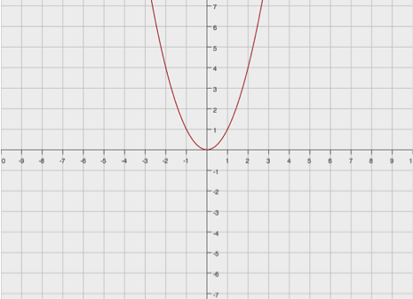
$$y=f(x)$$

- Write a formula for the function that defines the described transformation of the graph of the quadratic parent function $f(x)=x^{2}$.
  - $3$ units shift to the right
  - Vertical shrink by a factor of $0.5$
  - Reflection across the $x$-axis
  - $4$ units shift up
Then, graph both the parent and the transformed functions on the same coordinate plane.

- Describe the transformation of the quadratic parent function $f\left(x\right)=x^{2}$ that results in the quadratic function $g\left(x\right)=2x^{2}+4x+1$.

- Sketch the graphs of the following functions based on the graph of the function $f(x)=x^{2}$. If necessary, rewrite some of the functions in the vertex (completed-square) form. Label your graphs.
  - $g\left(x\right)=-{(x-4)}^{2}+3$
  - $h\left(x\right)=3{\left(x-2\right)}^{2}-1$
  - $k(x)={2x}^{2}+8x$
  - $p(x)=x^{2}+6x+5$

$$y=f(x)$$

Lesson Summary
Transformations of the quadratic parent function, $f(x)=x^{2}$, can be rewritten in form $g(x)=a{(x-h)}^{2}+k$, where $(h, k)$ is the vertex of the translated and scaled graph of $f$, with the scale factor of $a$, the leading coefficient. We can then quickly and efficiently (without the use of technology) sketch the graph of any quadratic function in the form $f(x)=a{(x-h)}^{2}+k$ using transformations of the graph of the quadratic parent function, $f(x)=x^{2}$.

Problem Set

- Write the function $g\left(x\right)=-{2x}^{2}-20x-53$ in completed-square form. Describe the transformations of the graph of the parent function $f(x)=x^{2}$ that result in the graph of $g$.

- Write the formula for the function whose graph is the graph of $f\left(x\right)=x^{2}$translated $6.25$ units to the right, vertically stretched by a factor of$8$, and translated $2.5$units up.

- Without using a graphing calculator, sketch the graphs of the functions below based on transformations of the graph of the parent function $f(x)=x^{2}$. Use your own graph paper and label your graphs.
  - $g\left(x\right)={\left(x+2\right)}^{2}- 4$
  - $h\left(x\right)=-{(x-4)}^{2}+ 2$
  - $k\left(x\right)={2x}^{2}-12x+19$
  - $p\left(x\right)=-{2x}^{2}-4x-5$
  - $q(x)={3x}^{2}+6x$

