Lesson 21: Transformations of the Quadratic Parent Function, $f\left(x\right)=x^{2}$

Student Outcomes
- Students make a connection between the symbolic and graphic forms of quadratic equations in the completed-square (vertex) form. They efficiently sketch a graph of a quadratic function in the form, $f\left(x\right)=a{(x-h)}^{2}+k$, by transforming the quadratic parent function, $f\left(x\right)=x^{2}$, without the use of technology. They then write a function defined by a quadratic graph by transforming the quadratic parent function.

Lesson Notes
In the two preceding lessons, students learned how to translate the graph of the parent function by adding or subtracting a constant $k$ to it or to its $x$-values, and how to stretch or shrink the graph of the parent function by multiplying a constant $k$ by it or by its $x$-values. In this lesson, the students are expected to do a combination of both, that is, translating and stretching or shrinking of the graph of the quadratic parent function, $f\left(x\right)=x^{2}$.
Throughout this lesson, students use the structure of the equations that are used to represent functions to determine the transformations of the quadratic parent function. They complete the square for quadratic functions given in other forms in order to identify when and by how much a function shifts and stretches or shrinks.
MP.7
Scaffolding:
- For students who struggle with this process, it may be helpful to guide them through the steps. At first, you may give a simpler function, such as $f\left(x\right)=x^{2}+6x$, and help them complete the square. Then, they can try Example 1.
- In Step 3 of this example, pause to ask students why there is a need to subtract $18$ outside the parentheses after adding $9$ on the inside.
Classwork
Have students work in pairs or small groups to complete the square for the function below. You might want to ask for justification for each step, but definitely pause at Step 3 to remind students about how balancing the equality should work for this problem.

Example 1 (8 minutes): Quadratic Expression Representing a Function
Example 1: Quadratic Expression Representing a Function
  - A quadratic function is defined by $g\left(x\right)={2x}^{2}+12x+1$. Write this in the completed-square (vertex) form and show all the steps.
$g\left(x\right)={2x}^{2}+12x+1$
Step 1 $=({2x}^{2}+12x)+1$ Gather variable terms.
Step 2 $=2(x^{2}+6x)+1$ Factor out the GCF.
Step 3 $=2\left(x^{2}+6x + 9\right)+1-18$ Complete the square and balance
the equality.
Step 4 $=2{(x+3)}^{2}-17$ Factor the perfect square.
$g\left(x\right)=2{\left(x+3\right)}^{2}-17$
  - Where is the vertex of the graph of this function located?
The vertex is at $(-3, -17)$.

  - Look at the completed-square form of the function. Can you name the parent function? How do you know?
The parent function is $f(x)=x^{2}$. The function is quadratic.

  - What transformations have been applied to the parent function to arrive at function $g$? Be specific.
The parent function $f(x)=x^{2}$ is translated $3$ units to the left, stretched vertically by a factor of $2$, and translated $17$ units down.

  - How does the completed-square form relate to the quadratic parent function $f(x)=x^{2}$?
The completed-square form can be understood through a series of transformations of the quadratic parent function $f$.

Example 2 (5 minutes)
Scaffolding:
Visual learners may benefit from using their graphing calculator to verify that their function in Example 2 is indeed the correct transformation of $f\left(x\right)=x^{2}$.
Have students work with a partner or small group to determine the function.
Example 2
The graph of a quadratic function $f(x)=x^{2}$ has been translated $3$ units to the right, vertically stretched by a factor of $4$, and moved $2$ units up. Write the formula for the function that defines the transformed graph.
$$g(x)=4{(x-3)}^{2}+2$$

- How did you arrive at your answer?
  - The parent function is $f(x)=x^{2}$. Below are the steps in the process:
Translating $3$ units to the right: ${(x-3)}^{2}$
Stretching vertically by a factor of $4$: ${4(x-3)}^{2}$
Translating $2$units up: ${4(x-3)}^{2}+2$
New function: $g\left(x\right)=4{(x-3)}^{2}+2$

Exercise 1 (8 minutes)
Have students work with a partner or small group to sketch the graphs of the following quadratic functions using the transformations of the parent function $f(x)=x^{2}$. Remind them that some of the functions need to be written in the completed-square form. Do not allow graphing calculators for this exercise.

Exercises
- Without using a graphing calculator, sketch the graph of the following quadratic functions on the same coordinate plane, using transformations of the graph of the parent function $f(x)=x^{2}$.
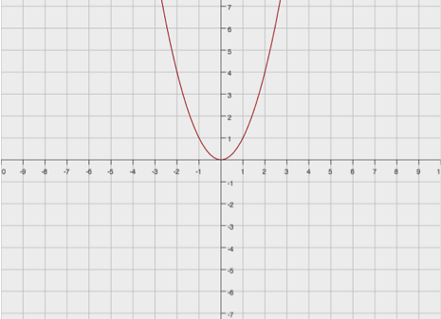
  - $g\left(x\right)=-2{(x-3)}^{2}+4$
$$y=f(x)$$
  - $h\left(x\right)=-3{(x+5)}^{2}+1$
  - $k\left(x\right)=2{\left(x+4\right)}^{2}-3$
  - $p\left(x\right)=x^{2}-2x$
  - $t\left(x\right)= x^{2}-2x+3$

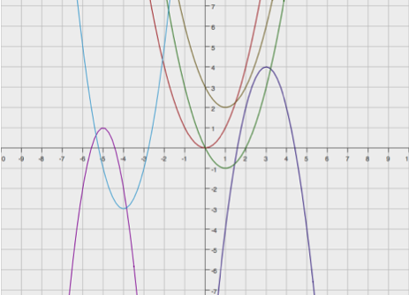
Note: By completing the square, we have $p\left(x\right)={\left(x-1\right)}^{2}-1$ and $t(x)={(x-1)}^{2}+2$.
$$y=k(x)$$
$$y=p(x)$$
$$y=t(x)$$
$$y=h(x)$$
$$y=g(x)$$
$$y=f(x)$$

Exercises 2–4 (15 minutes)

- Write a formula for the function that defines the described transformations of the graph of the quadratic parent function $f(x)=x^{2}$.
  - $3$ units shift to the right
  - Vertical shrink by a factor of $0.5$
  - Reflection across the $x$-axis
  - $4$ units shift up
Then, graph both the parent and the transformed functions on the same coordinate plane.
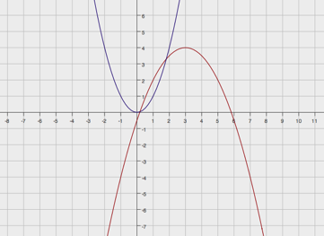
$g\left(x\right)=-0.5{(x-3)}^{2}+4$
$$y=f(x)$$
$$y=g(x)$$

- Describe the transformation of the quadratic parent function $f(x)=x^{2}$ that results in the quadratic function
$g(x)={2x}^{2}+4x+1$.
First, rewrite $g(x)$ into the completed-square form.
$$g(x) = {2x}^{2}+4x+1 \\ = ({2x}^{2}+4x)+1 \\ = 2(x^{2}+2x)+1 \\ = 2\left(x^{2}+2x+1\right)+1-2 \\ = 2\left(x^{2}+2x+1\right)-1 \\ g\left(x\right)= 2{\left(x+1\right)}^{2}-1$$
This means that the graph of $f$ is translated $1$ unit to the left, vertically stretched by a factor of $2$, and translated $1$ unit down.

- Sketch the graphs of the following functions based on the graph of the function $f(x)=x^{2}$. If necessary, rewrite some of the functions in the vertex (completed-square) form. Label your graphs.
  - $g\left(x\right)=-{(x-4)}^{2}+3$
  - $h\left(x\right)=3{\left(x-2\right)}^{2}-1$
  - $k(x)={2x}^{2}+8x$
  - $p(x)=x^{2}+6x+5$

  - $k\left(x\right)=2{\left(x+2\right)}^{2}-8$
  - $p\left(x\right)={\left(x+3\right)}^{2}-4$
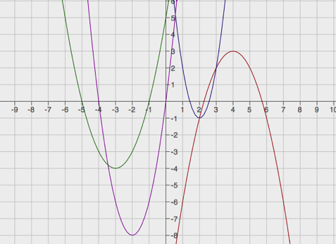
$$y=g(x)$$
$$y=h(x)$$
$$y=p(x)$$
$$y=k(x)$$

Closing (4 minutes)
- How would you sketch the graph of any non-parent quadratic function written in the standard form without using a calculator or creating a table of values?
  - For any non-parent quadratic function in standard form, we need to rewrite it in the completed-square form, and then identify the translations and the vertical shrink or stretch factor. We can also determine whether or not the graph faces up or down by the sign of the shrink or stretch factor.
Lesson Summary
Transformations of the quadratic parent function, $f(x)=x^{2}$, can be rewritten in form $g(x)=a{(x-h)}^{2}+k$, where $(h, k)$ is the vertex of the translated and scaled graph of $f$, with the scale factor of $a$, the leading coefficient. We can then quickly and efficiently (without the use of technology) sketch the graph of any quadratic function in the form $f(x)=a{(x-h)}^{2}+k$ using transformations of the graph of the quadratic parent function, $f(x)=x^{2}$.

Exit Ticket (5 minutes)

Name ___________________________________________________ Date____________________
Lesson 21: Transformations of the Quadratic Parent Function, $f\left(x\right)=x^{2}$

Exit Ticket

Describe in words the transformations of the graph of the parent function $f(x)=x^{2}$ that would result in the graph of $g\left(x\right)={\left(x+4\right)}^{2}-5$. Graph the equation $y=g(x)$.
Exit Ticket Sample Solutions

Describe in words the transformations of the graph of the parent function $f(x)=x^{2}$ that would result in the graph of $g\left(x\right)={\left(x+4\right)}^{2}-5$. Graph the equation $y=g(x)$.
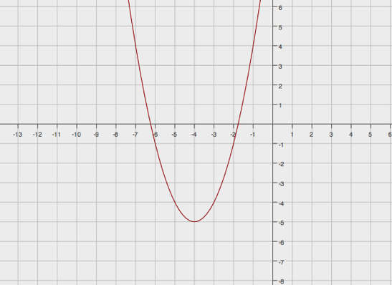
The graph of $g$ is a translation of the graph of $f$, $4$units to the left and $5$ units down.
$$y=g(x)$$
•
$$(-4, -5)$$

Problem Set Sample Solutions
This Problem Set should be given as homework to reinforce what has been learned in the classroom. Encourage students to try working without calculators. The following solutions indicate an understanding of the objectives of this lesson.

- Write the function $g\left(x\right)=-{2x}^{2}-20x-53$ in completed-square form. Describe the transformations of the graph of the parent function $f(x)=x^{2}$ that result in the graph of $g$.
$$g\left(x\right)=-{2x}^{2}-20x-53 \\ =\left(-{2x}^{2}-20x\right)-53 \\ =-2 \left(x^{2}+10x\right)-53 \\ =-2 \left(x^{2}+10x+25\right)-53+50 \\ =-2\left(x^{2}+10x+25\right)-3 \\ g\left(x\right)=-2{\left(x+5\right)}^{2}-3$$
The graph of $f$ is translated $5$ units to the left, vertically stretched by a factor of $2$, and translated $3$ units down. The graph of$f$ is facing up, while the graph of $g$ is facing down because of the negative value of $a$.

- Write the formula for the function whose graph is the graph of $f\left(x\right)=x^{2}$ translated $6.25$ units to the right, vertically stretched by a factor of$8$, and translated $2.5$units up.
$$g(x)=8{(x-6.25)}^{2}+2.5$$

- Without using a graphing calculator, sketch the graphs of the functions below based on transformations of the graph of the parent function $f(x)=x^{2}$. Use your own graph paper and label your graphs.
  - $g\left(x\right)={\left(x+2\right)}^{2}- 4$
  - $h\left(x\right)=-{(x-4)}^{2}+2$
  - $k\left(x\right)={2x}^{2}-12x+19$
  - $p\left(x\right)=-{2x}^{2}-4x-5$
  - $q(x) ={3x}^{2}+6x$

  - $k\left(x\right)=2{\left(x-3\right)}^{2}+1$
  - $p\left(x\right)=-2{\left(x+1\right)}^{2}-3$
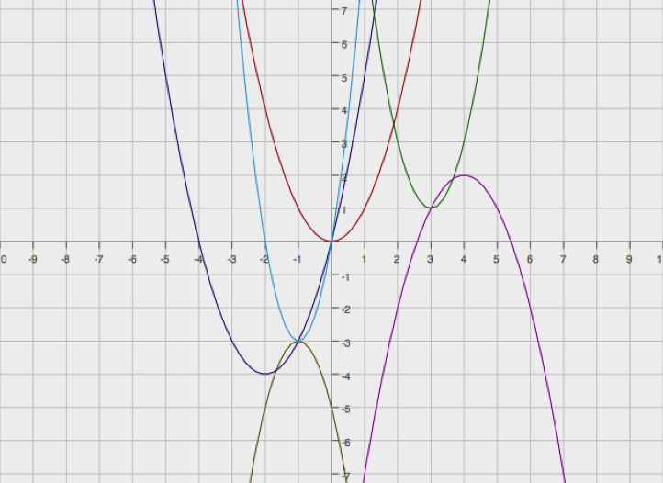
  - $q\left(x\right)=3{\left(x+1\right)}^{2}-3$
$$y=f(x)$$
$$y=g(x)$$
$$y=h(x)$$
$$y=k(x)$$
$$y=q(x)$$
$$y=p(x)$$

