Lesson 20: Stretching and Shrinking Graphs of Functions

Classwork
Opening Exercise
The graph of a quadratic function defined by $f\left(x\right)=x^{2}$ has been translated $5$ units to the left and $3$ units up. What is the formula for the function, $g$, depicted by the translated graph?

Sketch the graph of the equation $y=g(x)$.
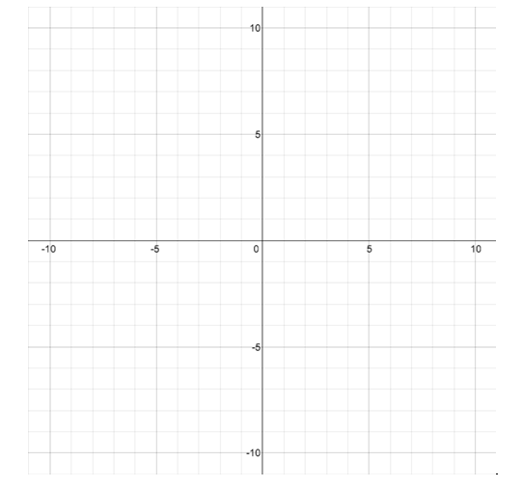
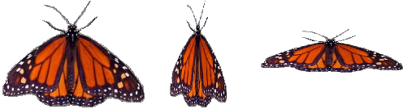
Example

Exploratory Challenge
Complete the following to review Module 3 concepts:
  - Consider the function $f(x)=|x|$. Complete the table of values for $f(x)$. Then, graph the equation $y=f(x)$ on the coordinate plane provided for part (b).
$$x$$ | $$f(x)$$
$$-4$$
$$-2$$
$$0$$
$$2$$
$$4$$

  - Complete the following table of values for each transformation of the function $f$. Then, graph the equations $y=g(x)$, $y=h(x)$, $y=j(x)$, and $y=k(x)$ on the same coordinate plane as the graph of $y=f(x)$. Label each graph.
$$x$$ | $$f(x)$$ | $$g\left(x\right)=3f(x)$$ | $$h\left(x\right)=2f(x)$$ | $$j\left(x\right)=0.5f(x)$$ | $$k\left(x\right)=-2f(x)$$
$$-4$$
$$-2$$
$$0$$
$$2$$
$$4$$

  - Describe how the graph of $y=kf(x)$ relates to the graph of $y=f(x)$ for each case.
    - $k>1$

    - $0<k<1$

    - $k=-1$

    - $-1<k<0$

    - $k<-$1

  - Describe the transformation of the graph of $f$ that results in the graphs of $g$, $h$, and $k$given the following formulas for each function. Then, graph each function and label each graph.

$$f\left(x\right)=x^{3}$$
$$g\left(x\right)={2x}^{3}$$
$$h\left(x\right)={0.5x}^{3}$$
$$k\left(x\right)={-3x}^{3}$$

  - Consider the function $f\left(x\right)=\sqrt[3]{x}.$Complete the table of values, then graph the equation $y=f(x)$.
$$x$$ | $$f(x)$$
$$-8$$
$$-1$$
$$0$$
$$1$$
$$8$$

  - Complete the following table of values, rounding each value to the nearest hundredth. Graph the equations $y=g(x)$, $y=h(x)$, and $y=j(x)$ on the same coordinate plane as your graph of $y=f(x)$ above. Label each graph.
$$x$$ | $$f(x)$$ | $$g(x)=f(2x)$$ | $$h(x)=f(0.5x)$$ | $$j(x)=f(-2x)$$
$$-8$$
$$-1$$
$$0$$
$$1$$
$$8$$

  - Describe the transformations of the graph of $f$ that result in the graphs of $g$, $h$, and $j$.

  - Describe how the graph of $y=f\left(\frac{1}{k}x\right)$ relates to the graph of $y=f(x)$ for each case.
    - $k>1$

    - $0<k<1$

    - $k=-1$

    - $-1<k<0$

    - $k<-$1

Exercise 1
For each of the sets below, answer the following questions:
- What are the parent functions?
- How does the translated graph relate to the graph of the parent function?
- Write the formula for the function depicted by the translated graph.
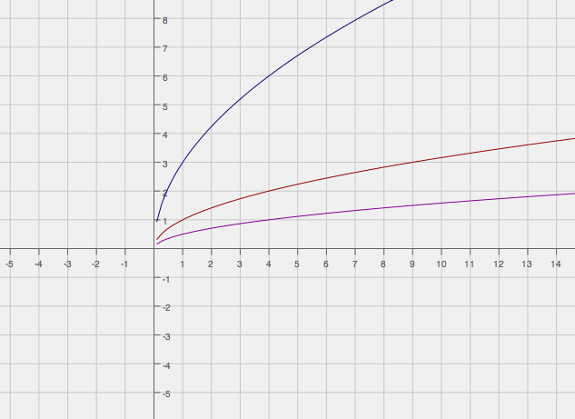

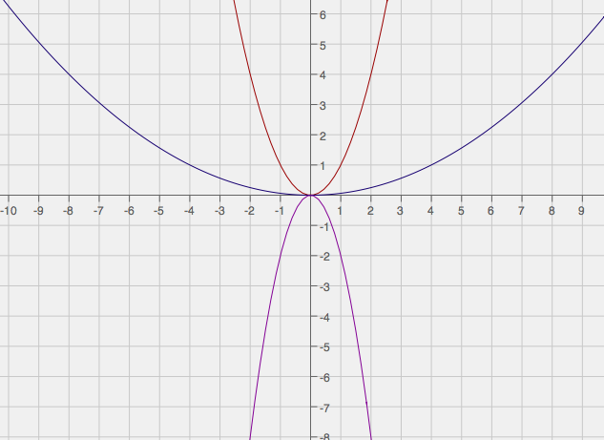

Exercise 2
Graph each set of functions in the same coordinate plane. Do not use a graphing calculator.
- $f\left(x\right)=\left|x\right|$  $g\left(x\right)=4\left|x\right|$  $h\left(x\right)=\left|2x\right|$  $$k\left(x\right)=-2\left|2x\right|$$ | - $g\left(x\right)=\sqrt[3]{x}$  $$p\left(x\right)=2\sqrt[3]{x}$$  $$q\left(x\right)=-2\sqrt[3]{2x}$$

Problem Set

- Graph the functions in the same coordinate plane. Do not use a graphing calculator.
$$f(x)=|x|$$
$$g(x)=2|x|$$
$$h(x)=|3x|$$
$$k\left(x\right)=-3|3x|$$

- Explain how the graphs of functions $g(x)=3|x|$and $h(x)=|3x|$ are related.

- Explain how the graphs of functions $q(x)=-3|x|$and $r(x)=|$ $-3x|$ are related.

- Write a function, $g$ in terms of another function $f$, such that the graph of $g$ is a vertical shrink of the graph $f$ by a factor of $0.75$.

- A teacher wants the students to write a function based on the parent function $f\left(x\right)=\sqrt[3]{x}$. The graph of $f$is stretched vertically by a factor of $4$ and shrunk horizontally by a factor of $\frac{1}{3}$. Mike wrote $g\left(x\right)=4\sqrt[3]{3x}$ as the new function, while Lucy wrote $h\left(x\right)=3\sqrt[3]{4x}$. Which one is correct? Justify your answer.

- Study the graphs of two different functions below. Which is a parent function? What is the constant value(s) multiplied to the parent function to arrive at the transformed graph? Now write the function defined by the transformed graph.
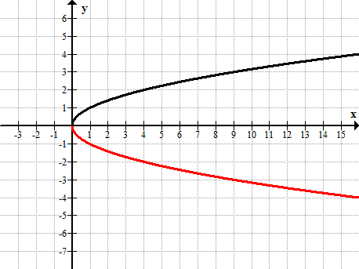
$$y=f(x)$$
$$y=g(x)$$

