Lesson 20: Stretching and Shrinking Graphs of Functions

Student Outcomes
- Students recognize and use parent functions for absolute value, quadratic, square root, and cube root to perform transformations that stretch and shrink the graphs of the functions. They identify the effect on the graph of $y=f(x)$ when $f(x)$ is replaced with $kf(x)$ and $f(kx)$, for any specified value of $k$, positive or negative, and identify the constant value, $k$, given the graphs of the parent functions and the transformed functions. Students write the formulas for the transformed functions given their graphs.

Lesson Notes
In Lesson 19, students learned how to write the formulas for the graphs of parent functions (including quadratic, square root, and cube root) that were translated up, down, right, or left by $k$ units. In this lesson, students extend what they learned in Module 3 about how multiplying the parent function by a constant or multiplying the $x$-values of the parent function results in the shrinking or stretching (scaling) of the graph of the parent function and, in some cases, results in the reflection of the function about the $y$- or $x$-axis. In this lesson, we will review some of Module 3’s work with quadratic functions but will focus on cubic, square root, and cube root functions.

Classwork
Opening Exercise (4 minutes)
Opening Exercise
The graph of a quadratic function defined by $f\left(x\right)=x^{2}$ has been translated $5$ units to the left and $3$ units up. What is the formula for the function, $g$, depicted by the translated graph?
$$g\left(x\right)={(x+5)}^{2}+3$$
Sketch the graph of the equation $y=g(x)$.
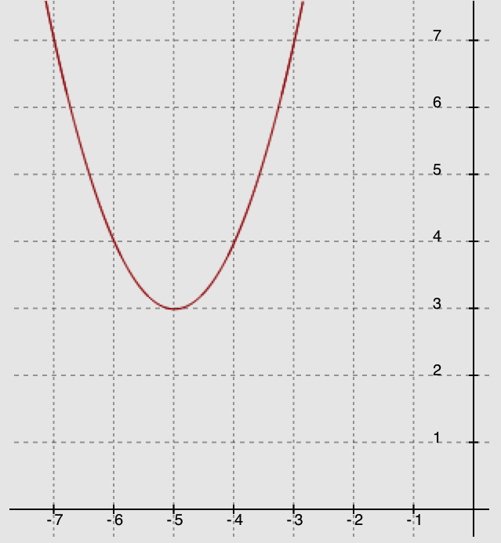
• $(-5, 3)$

Example (1 minute)
Scaffolding:
If students do not readily see the possibilities of stretching or shrinking a function, you might try asking them to look at the graphs of $y=x^{2}$, $y=\frac{1}{2}x^{2}$, and $y=2x^{2}$.
You may need to guide them to the conclusion that multiplying by a number greater than $1$ makes the curve narrower, while multiplying by a number between $0$ and $1$ makes the graph wider. While on the subject, try $y={-x}^{2}$ to show that multiplying by a negative number turns the function upside down.
Have students compare the photographs below of a monarch butterfly; then, ask a few to share their observations.
- What do you notice about the three pictures of the same monarch butterfly?
  - The picture of the butterfly has been stretched (enlarged) and shrunk (compressed).
Example
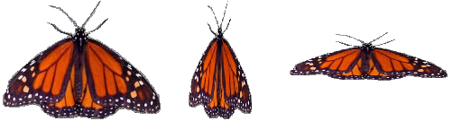

- Is it possible to shrink or stretch the graph of a function? If so, how might that happen?
  - Yes, since we discovered that adding or subtracting a value to the parts of a parent function shifts its graph horizontally or vertically, it is possible that multiplying or dividing will shrink or stretch a function. Note that students may respond with comments about the points of the graph being pushed together or spread apart.
In Exercise 1, students analyze the graphs and tables of parent functions and their transformations. They make use of the structure of the equations representing the functions and look for patterns in the tables and graphs that will allow them to make generalizations about how to recognize when a function is being enlarged or compressed and how to quickly sketch a graph of a function under those circumstances.
MP.7
&
MP.8

Exploratory Challenge (20 minutes)
Have students work in pairs or small groups. Have the groups pause after each part to have a class discussion and to compare their findings. Make sure students have calculators and enough graph paper for at least four good-sized graphs. Remind them that this is largely a review of work done in Module 3.
Exploratory Challenge
Complete the following to review Module 3 concepts:
  - Consider the function $f(x)=|x|$. Complete the table of values for $f(x)$. Then, graph the equation $y=f(x)$ on the coordinate plane provided for part (b).
$$x$$ | $$f(x)$$
$$-4$$ | $$4$$
$$-2$$ | $$2$$
$$0$$ | $$0$$
$$2$$ | $$2$$
$$4$$ | $$4$$
  - Complete the following table of values for each transformation of the function $f$. Then, graph the equations $y=g(x)$, $y=h(x)$, $y=j(x)$, and $y=k(x)$ on the same coordinate plane as the graph of $y=f(x)$. Label each graph.
$$x$$ | $$f(x)$$ | $$g(x)=3f(x)$$ | $$h(x)=2f(x)$$ | $$j(x)=0.5f(x)$$ | $$k\left(x\right)=-2f(x)$$
$$-4$$ | $$4$$ | $$12$$ | $$8$$ | $$2$$ | $$-8$$
$$-2$$ | $$2$$ | $$6$$ | $$4$$ | $$1$$ | $$-4$$
$$0$$ | $$0$$ | $$0$$ | $$0$$ | $$0$$ | $$0$$
$$2$$ | $$2$$ | $$6$$ | $$4$$ | $$1$$ | $$-4$$
$$4$$ | $$4$$ | $$12$$ | $$8$$ | $$2$$ | $$-8$$
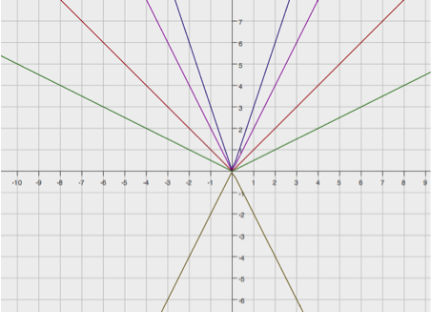
$$y=f(x)$$
$$y=g(x)$$
$$y=h(x)$$
$$y=j(x)$$
$$y=k(x)$$

Scaffolding:
For visual learners, ask students to identify two points on the parent function, say $(1, 1)$ and $(2, 2)$. Then, have them draw vertical lines passing through these points. Now name the points on the graph of $y=h(x)$. These points are $(1, 2)$ and $(2, 4)$. Have them find the ratio of the $y$-values of the transformed graph and the $y$-values of the parent function as follows:
For $(1, 1)$ and $(1, 2)$:
$$\frac{2}{1}=2;$$
For $(2, 2)$ and $(2, 4)$:
$$\frac{4}{2}=2.$$
This common ratio, $2$, is the stretch or shrink-scaling factor.
  - Describe how the graph of $y=kf(x)$ relates to the graph of $y=f(x)$ for each case.
    - $k>1$
The graph is stretched vertically by a factor equal to $k$.

    - $0<k<1$
The graph is shrunk vertically by a factor equal to $k$.

    - $k=-1$
The graph is reflected across the $x$-axis.

    - $-1<k<0$
The graph is reflected across the $x$-axis and shrunk vertically by a factor equal to $|k|$.

    - $k<-$1
The graph is reflected across the $x$-axis and stretched vertically by a factor equal to $|k|$.

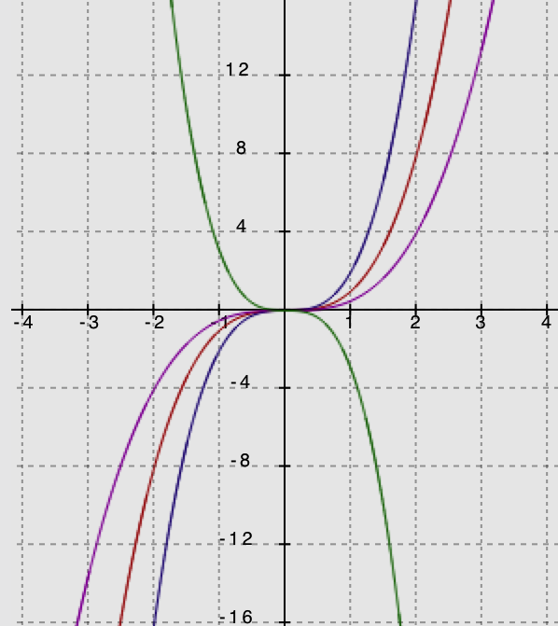
  - Describe the transformation of the graph of $f$ that results in the graphs of $g$, $h$, and $k$given the following formulas for each function. Then, graph each function and label each graph.
$y=k(x)$ $y=g(x)$
$y=f(x)$
$$y=h(x)$$
$$f\left(x\right)=x^{3}$$
$$g\left(x\right)={2x}^{3}$$
$$h\left(x\right)={0.5x}^{3}$$
$$k\left(x\right)={-3x}^{3}$$

The graph of $g$ shows a vertically stretched graph of$f$with a scale factor of $2$. The graph of$h$ is a vertically shrunk, or compressed, graph of$f$with a scale factor of $0.5$. The graph of $k$ shows a vertically stretched graph of$f$ with a scale factor of $3$ and is reflected across the $x$-axis.

  - Consider the function $f\left(x\right)= \sqrt[3]{x}$. Complete the table of values, then graph the equation $y=f(x)$.
$$x$$ | $$f(x)$$
$$-8$$ | $$-2$$
$$-1$$ | $$-1$$
$$0$$ | $$0$$
$$1$$ | $$1$$
$$8$$ | $$2$$

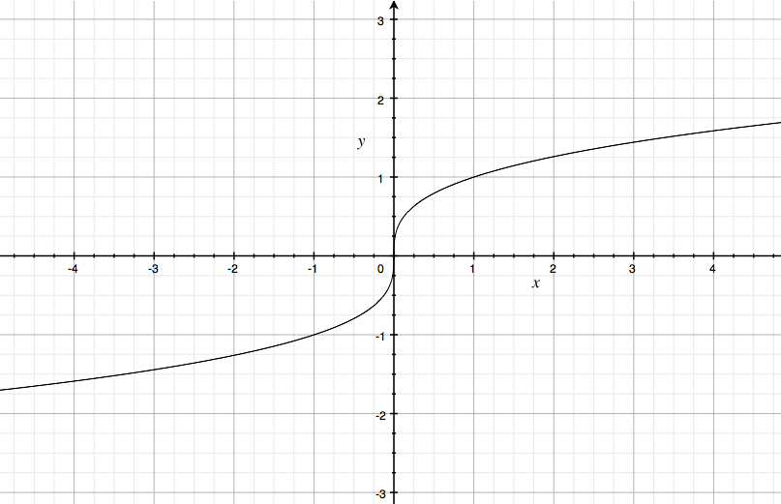

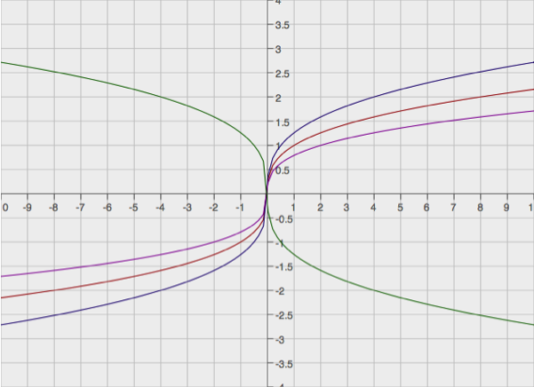
  - Complete the following table of values, rounding each value to the nearest hundredth. Graph the equations
$y=g(x)$, $y=h(x)$, and $y=j(x)$ on the same coordinate plane as your graph of $y=f(x)$ above. Label each graph.
$$y=f(x)$$
$$y=g(x)$$
$$y=h(x)$$
$$y=j(x)$$

$$x$$ | $$f(x)$$ | $$g(x) = f(2x)$$ | $$h(x) = f(0.5x)$$ | $$j(x) =$$  $$f(-2x)$$
$$-8$$ | $$-2$$ | $$-2.52$$ | $$-1.59$$ | $$2.52$$
$$-1$$ | $$-1$$ | $$-1.26$$ | $$-0.79$$ | $$1.26$$
$$0$$ | $$0$$ | $$0$$ | $$0$$ | $$0$$
$$1$$ | $$1$$ | $$1.26$$ | $$0.79$$ | $$-1.26$$
$$8$$ | $$2$$ | $$2.52$$ | $$1.59$$ | $$-2.52$$

  - Describe the transformations of the graph of $f$ that result in the graphs of $g$, $h$, and $j$.
When the $x$-values of$f$ are multiplied by $2$, the graph is shrunk horizontally by a factor of $0.5$. When the $x$-values of$f$ are multiplied by$0.5$, the graph is stretched horizontally by a factor of $2$. When the $x$-values of $f$ are multiplied by $-2$, the graph is shrunk horizontally by a factor of $0.5$ and is reflected about the $y$-axis.

  - Describe how the graph of $y=f\left(\frac{1}{k}x\right)$ relates to the graph of $y=f(x)$ for each case.
    - $k>1$
The graph is stretched horizontally by a factor equal to $k$.

    - $0<k<1$
The graph is shrunk horizontally by a factor equal to $k$.

    - $k=-1$
The graph is reflected across the $y$-axis.

    - $-1<k<0$
The graph is shrunk horizontally by a factor equal to $|k|$ and is reflected across the $y$-axis.

    - $k<-$1
The graph is stretched horizontally by a factor equal to $|k|$ and is reflected across the $y$-axis.

- Is it possible to transform the square root function by a horizontal stretch or shrink using a negative scale factor? Why or why not?
  - Yes, it will work for a different limited domain. For example, $f\left(x\right)=\sqrt{x}$ has all nonnegative numbers as its domain. However, multiplying the $x$-values by $-1$ gives us $g\left(x\right)=\sqrt{(-x)}$, which is a congruent graph but with a domain of all numbers less than or equal to $0$, and so is a reflection of $f$ across the $y$-axis.

Exercise 1 (8 minutes)
Work through Exercise 1 as a class, perhaps posting the graphs on the board as you go through the questions.
Exercise 1
For each set of graphs below, answer the following questions:
- What are the parent functions?
- How does the translated graph relate to the graph of the parent function?
- Write the formula for the function depicted by the translated graph.

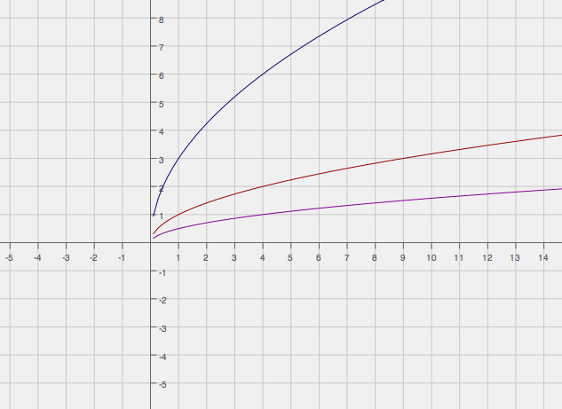

Scaffolding:
Lead struggling students to identify the stretch or shrink factor of the blue graph. They might not be able to identify the points readily from the graph of the parent function (red), so have them identify points on the blue graph first. Then, have them solve for the $y$-values on the red graph using the same $x$-value on the blue graph. Once the points are identified, they can find the ratio.

The parent function (in red) is $f\left(x\right)=\sqrt{x}$. The graph in blue is a vertical scaling of the graph of $f$ with a scale factor of $3$. The function depicted by the blue graph is $g\left(x\right)=3\sqrt{x}.$ The other graph (in pink) is a vertical scaling of the graph of $f$ with a scale factor of $0.5$. The function depicted by the graph is $h\left(x\right)=0.5\sqrt{x}$.

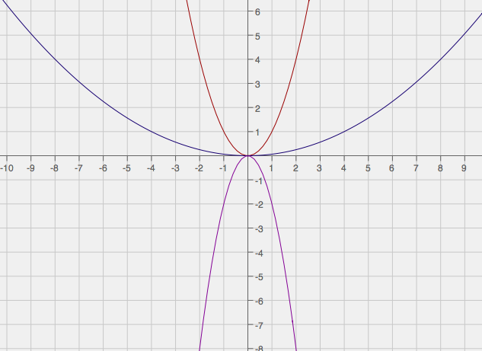

The parent function (in red) is $f\left(x\right)=x^{2}$. The graph in blue is a horizontal scaling of the graph of $f$with a scale factor of $4$. The function depicted by the blue graph is $g\left(x\right)={\left(\frac{1}{4}x\right)}^{2}$. The other graph (in pink) is a vertical scaling of the graph of $f$ with a scale factor of $2$ and is reflected over the $x$-axis. The function depicted by the graph is $h\left(x\right)={-2x}^{2}$.

For the graph in blue, the function could also be written as $g\left(x\right)={0.0625x}^{2}$. In this case, the students could also say that the graph of $f\left(x\right)=x^{2}$ has been shrunk vertically by a factor of $0.0625$. The two interpretations of $f$ and $g$ are both correct. This reflects the nature of the specific (quadratic) function; however, it is not a general property of all functions.

Exercise 2 (8 minutes)
Exercise 2
Graph each set of functions in the same coordinate plane. Do not use a graphing calculator.
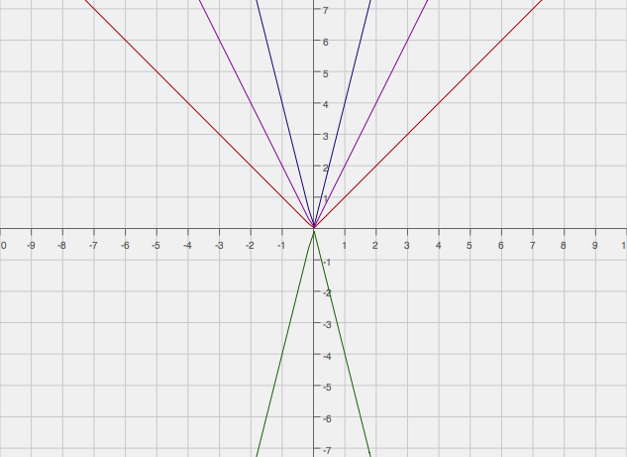
  - $f\left(x\right)=\left|x\right|$
$g\left(x\right)=4\left|x\right|$
$h\left(x\right)=\left|2x\right|$
$k\left(x\right)= -2\left|2x\right|$
$$y=f(x)$$
$$y=g(x)$$
$$y=h(x)$$
$$y=k(x)$$
$f(x)$ in red
$g(x)$ in purple
$h(x)$ in pink
$k(x)$ in green

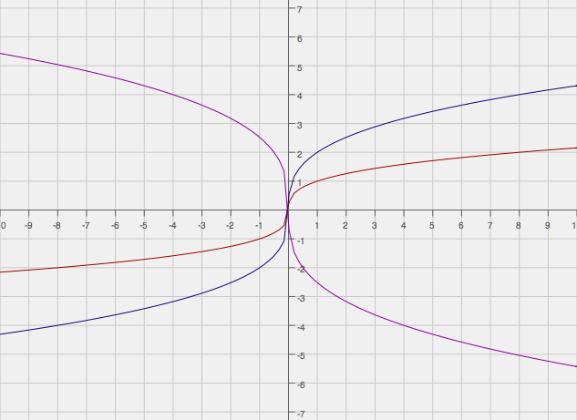
  - $g\left(x\right)=\sqrt[3]{x}$
$$p\left(x\right)=2\sqrt[3]{x}$$
$q\left(x\right)=-2\sqrt[3]{2x}$
$$y=p(x)$$
$g(x)$ in red
$p(x)$ in purple
$q(x)$ in pink
$$y=g(x)$$

$$y=q(x)$$

Closing (2 minutes)
Discuss how the vertical scaling by a scale factor of $k$ of the graph of a function $y=f(x)$ corresponds to changing the equation of the graph from $y=f(x)$ to $y=kf\left(x\right)$. Investigate the four cases of $k$:
- $k>1$
- $0<k<1$
- $-1<k<0$
- $k<-1$
Then, discuss how the horizontal scaling by a scale factor of $k$ of the graph of a function $y=f(x)$ corresponds to changing the equation of the graph from $y=f(x)$ to $y=f\left(\frac{1}{k}x\right)$. Investigate the four cases of $k$:
- $k>1$
- $0<k<1$
- $-1<k<0$
- $k<-1$

Exit Ticket (2 minutes)

Name ___________________________________________________ Date____________________
Lesson 20: Stretching and Shrinking Grphs of Functions

Exit Ticket

- How would the graph of $f\left(x\right)=\sqrt{x}$ be affected if it were changed to $g\left(x\right)=-2\sqrt{x}$?

- Sketch and label the graphs of both $f$ and $g$ on the grid below.
Exit Ticket Sample Solutions

- How would the graph of $f\left(x\right)=\sqrt{x}$ be affected if it were changed to $g\left(x\right)=-2\sqrt{x}$?
The graph of$f$would be stretched vertically by a factor of $2$ and reflected across the $x$-axis.

- Sketch and label the graphs of both $f$and $g$ on the grid below.
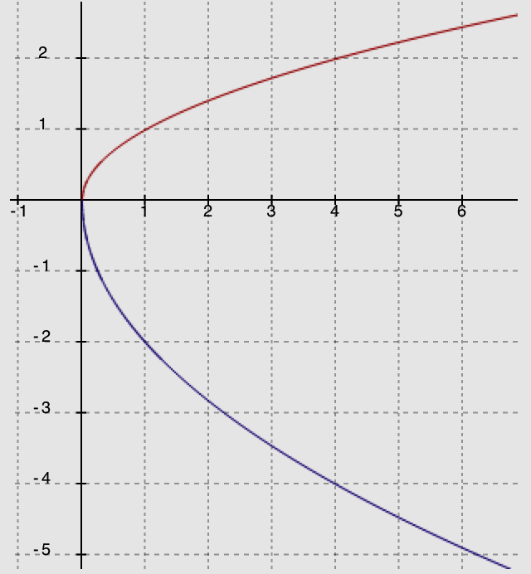
$$y=f(x)$$
$$y=g(x)$$

Problem Set Sample Solutions

- Graph the functions in the same coordinate plane. Do not use a graphing calculator.
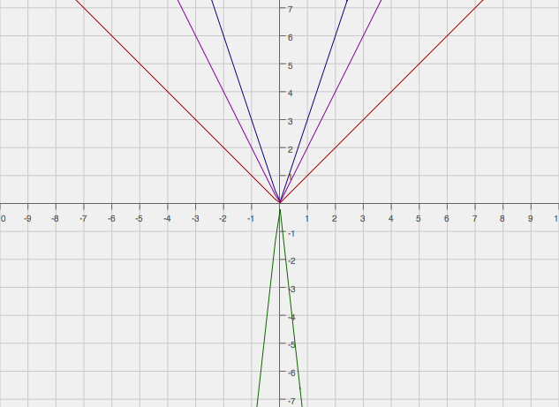
$f(x)= |x|$
$$y=f(x)$$
$$y=h(x)$$
$$y=g(x)$$
$$y=k(x)$$
$$g(x)=2|x|$$
$$h(x)=|3x|$$
$$k\left(x\right)=-3|3x|$$

- Explain how the graphs of functions $g(x)=3|x|$and $h(x)=|3x|$ are related.
Each of these transformations of the absolute value functions creates the same graph.
- Explain how the graphs of functions $q(x)=-3|x|$and $r(x)=|-3x|$ are related.
The two graphs have the same scaling factor of $3,$ but they are reflections of each other across the $x$-axis. Multiplying an absolute value by a negative number will reflect it across the $x$-axis. However, multiplying by a negative number INSIDE the absolute value has the same effect as multiplying by a positive number on the outside.

- Write a function, $g$, in terms of another function, $f$, such that the graph of $g$ is a vertical shrink of the graph $f$ by a factor of $0.75$.
$$g(x)=0.75 f(x)$$

In Problem 5, students critique the reasoning of each answer, determine which of the two is correct, and provide a justification for their response.
MP.3

- A teacher wants the students to write a function based on the parent function $f\left(x\right)=\sqrt[3]{x}$. The graph of $f$is stretched vertically by a factor of $4$ and shrunk horizontally by a factor of $\frac{1}{3}$. Mike wrote $g\left(x\right)=4\sqrt[3]{3x}$ as the new function, while Lucy wrote $h\left(x\right)=3\sqrt[3]{4x}$. Which one is correct? Justify your answer.
Mike is correct. A vertical stretch by a factor of $4$ means multiplying $f(x)$by$4$, and a horizontal shrink by a factor of $\frac{1}{3}$ means that the $x$-values of $f(x)$must be multiplied by $3$.

- Study the graphs of two different functions below. Which is a parent function? What is the constant value(s) multiplied to the parent function to arrive at the transformed graph? Now write the function defined by the transformed graph.
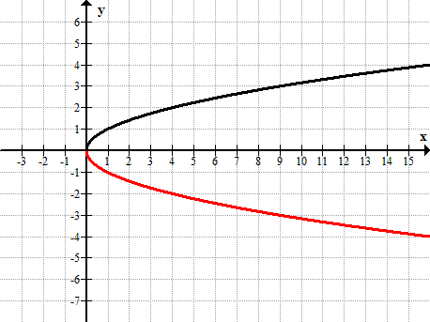
$$y=f(x)$$
$$y=g(x)$$

The parent function is $f\left(x\right)=\sqrt{x}$. The graph of $y=g\left(x\right)$ is the graph of $y=f\left(x\right)$reflected across the $x$-axis. The function depicted by the transformed graph is $g\left(x\right)=-\sqrt{x}$.

