Lesson 19: Translating Functions

Classwork
Opening Exercise
Graph each set of three functions in the same coordinate plane (on your graphing calculator or a piece of graph paper). Then, explain what similarities and differences you see among the graphs.
- $f(x)=x$  $$g(x)=x+5$$  $$h\left(x\right)=x-6$$ | - $f(x)=x^{2}$  $$g(x)=x^{2}+3$$  $h\left(x\right)=x^{2}-7$ | - $f(x)=|x|$  $$g(x)=|x+3|$$  $$h(x)=|x-4|$$

Example
For each graph, answer the following:
- What is the parent function?
- How does the translated graph relate to the graph of the parent function?
- Write the formula for the function depicted by the translated graph.
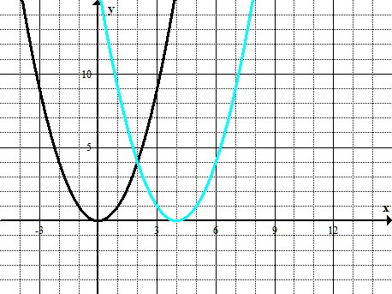

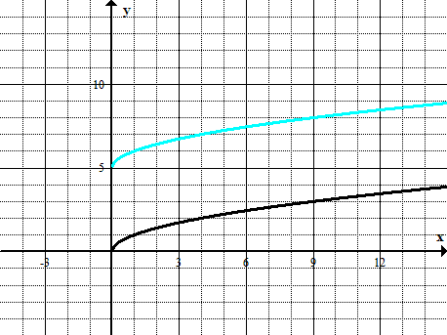

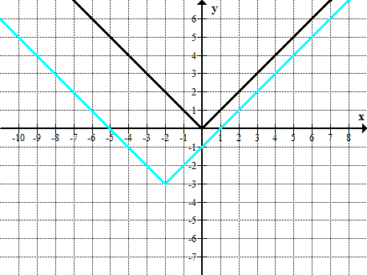

Exercises 1–3
- For each of the following graphs, use the formula for the parent function $f$ to write the formula of the translated function.
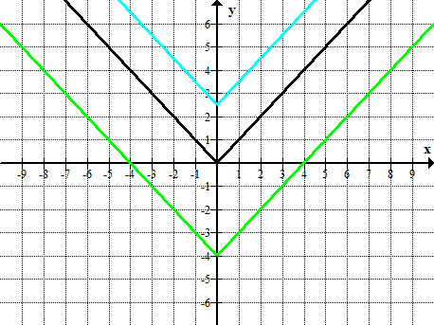
$$y=f(x)$$
$$y=g(x)$$
$$y=h(x)$$

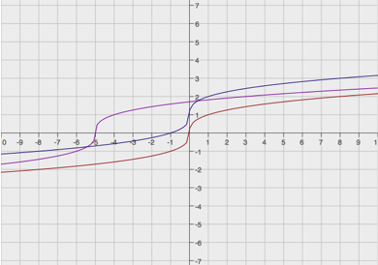
$$y=g(x)$$
$$y=h(x)$$

$$y=f(x)$$

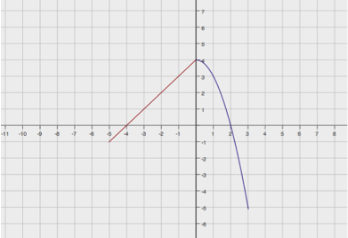
- Below is a graph of a piecewise function $f$ whose domain is $-5≤x≤3$. Sketch the graphs of the given functions on the same coordinate plane. Label your graphs correctly.
$$y=f(x)$$
$g(x)=f(x)+3$ $h(x)=f(x-4)$
- Match the correct equation and description of the function with the given graphs.
Graphs | Equation | Description
$$y=f(x)$$  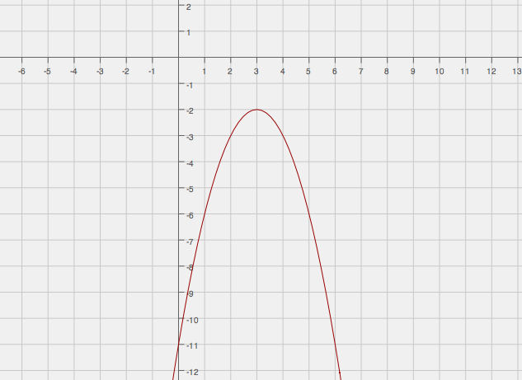  Equation _________ Description ___________ | E1. $y={(x-3)}^{2}$  E2. $y={(x+2)}^{2}-3$  E3. $y={-(x-3)}^{2}-2$  E4. $y={(x-2)}^{2}-3$ | D1. The graph of the parent function is translated down $3$ units and left $2$ units.  D2. The graph of the function does not have an $x$-intercept.  D3. The coordinate of the $y$-intercept is $(0, 1)$, and both $x$-intercepts are positive.  D4. The graph of the function has only one $x$-intercept.
$$y=g(x)$$
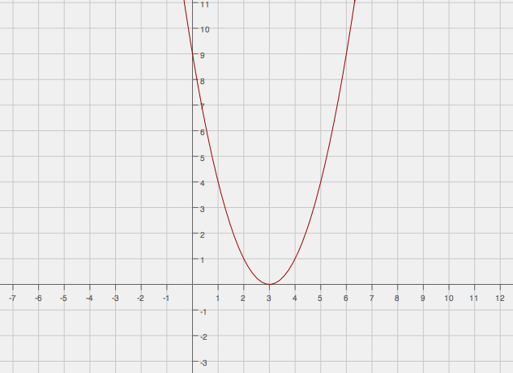

Equation _________ Description ___________
$$y=h(x)$$
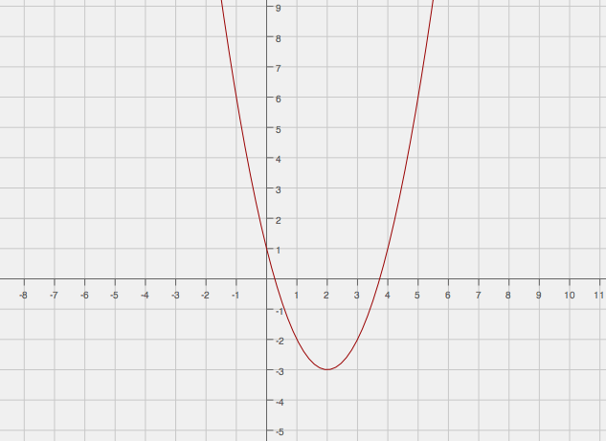

Equation _________ Description ___________
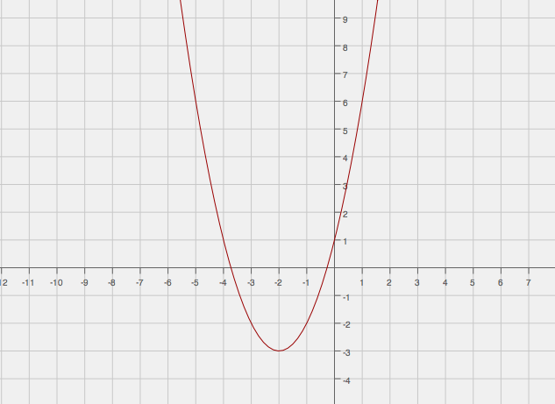
$y=p(x)$

Equation _________ Description ___________
Problem Set

- Graph the functions in the same coordinate plane. Do not use a graphing calculator.

$$f\left(x\right)=\sqrt{x}$$
$$p(x)=10+\sqrt{x}$$
$$q\left(x\right)=\sqrt{x+8}$$

- Write a function that translates the graph of the parent function $f\left(x\right)=x^{2}$ down $7.5$ units and right $2.5$ units.

- How would the graph of $f(x)=|x|$ be affected if the function were transformed to $f(x)=|x+6|+10$?

- Below is a graph of a piecewise function $f$ whose domain is the interval $-4≤x≤2$. Sketch the graph of the given functions below. Label your graphs correctly.
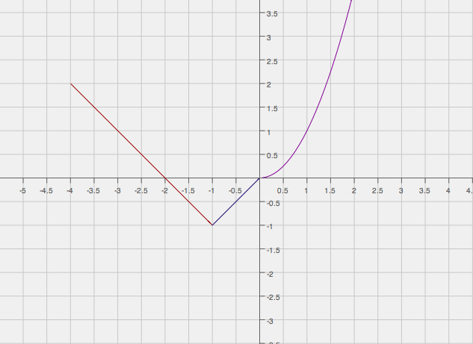
$g\left(x\right)=f\left(x\right)-1$ $h(x)=g(x-2)$ (Be careful, this one might be a challenge.)
$$y=f(x)$$
- Study the graphs below. Identify the parent function and the transformations of that function depicted by the second graph. Then, write the formula for the transformed function.
